


https://www.youtube.com/watch?v=SJ4_nONtYeY
WATCH FOR TESTIMONIALS

WATCH FOR TESTIMONIALS

GRADE 10 TERM 1 TEST MARKS: 100
TIME: 2 HOURS
QUESTION 1: GENERAL DRAWING PRINCIPLES AND CONVENTIONS (20 MARKS)
1.1 Define the following terms: (5)
a) Scale
b) Line types
c) Dimensioning
d) Orthographic projection
e) Isometric drawing

1.2 Identify and describe the use of five different line types used in technical drawings. (5)

1.3 Explain the importance of dimensioning in technical drawings. (3)

1.4 Given a simple drawing with missing dimensions, complete the dimensioning correctly. (7)

QUESTION 2: GEOMETRICAL CONSTRUCTION (20 MARKS)
2.1 Construct an inscribed regular hexagon in a given circle of 50mm diameter. (6)

2.2 Bisect the given angle of 65° and construct a perpendicular bisector for a given line. (6)

2.3 Draw an ellipse using the concentric circle method, given the major axis of 100mm and minor axis of 60mm. (8)

QUESTION 3: ORTHOGRAPHIC PROJECTION (30 MARKS)
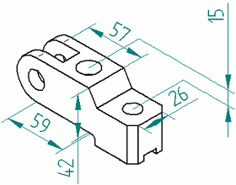
3.1 Given a 3D pictorial view of an object, draw its first-angle orthographic projections, showing: (30)
- Front view
- Top view
- Right view
Use the correct line types and include dimensions.

QUESTION 4: ISOMETRIC DRAWING (20 MARKS)
4.1 Draw an isometric projection of a given orthographic drawing. Include isometric axes and correct dimensions. (20)
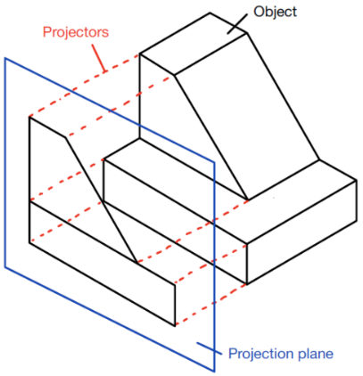

QUESTION 5: SECTIONAL VIEWS (10 MARKS)
5.1 Given an orthographic projection of a mechanical part, draw a sectional front view along the indicated cutting plane. Use appropriate hatching to indicate materials. (10)
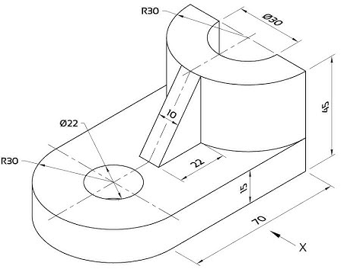

TOTAL: 100 MARKS

