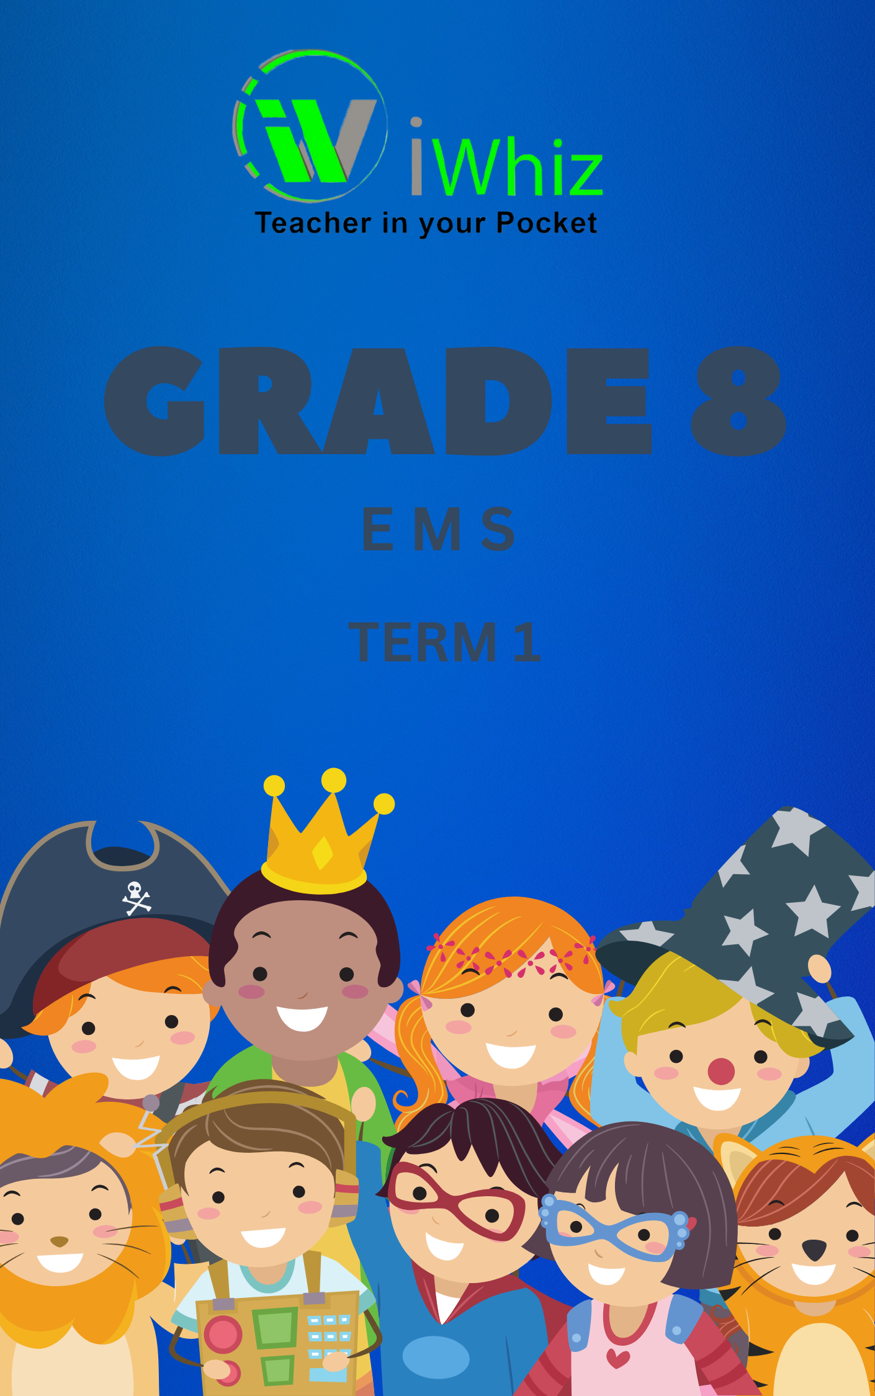

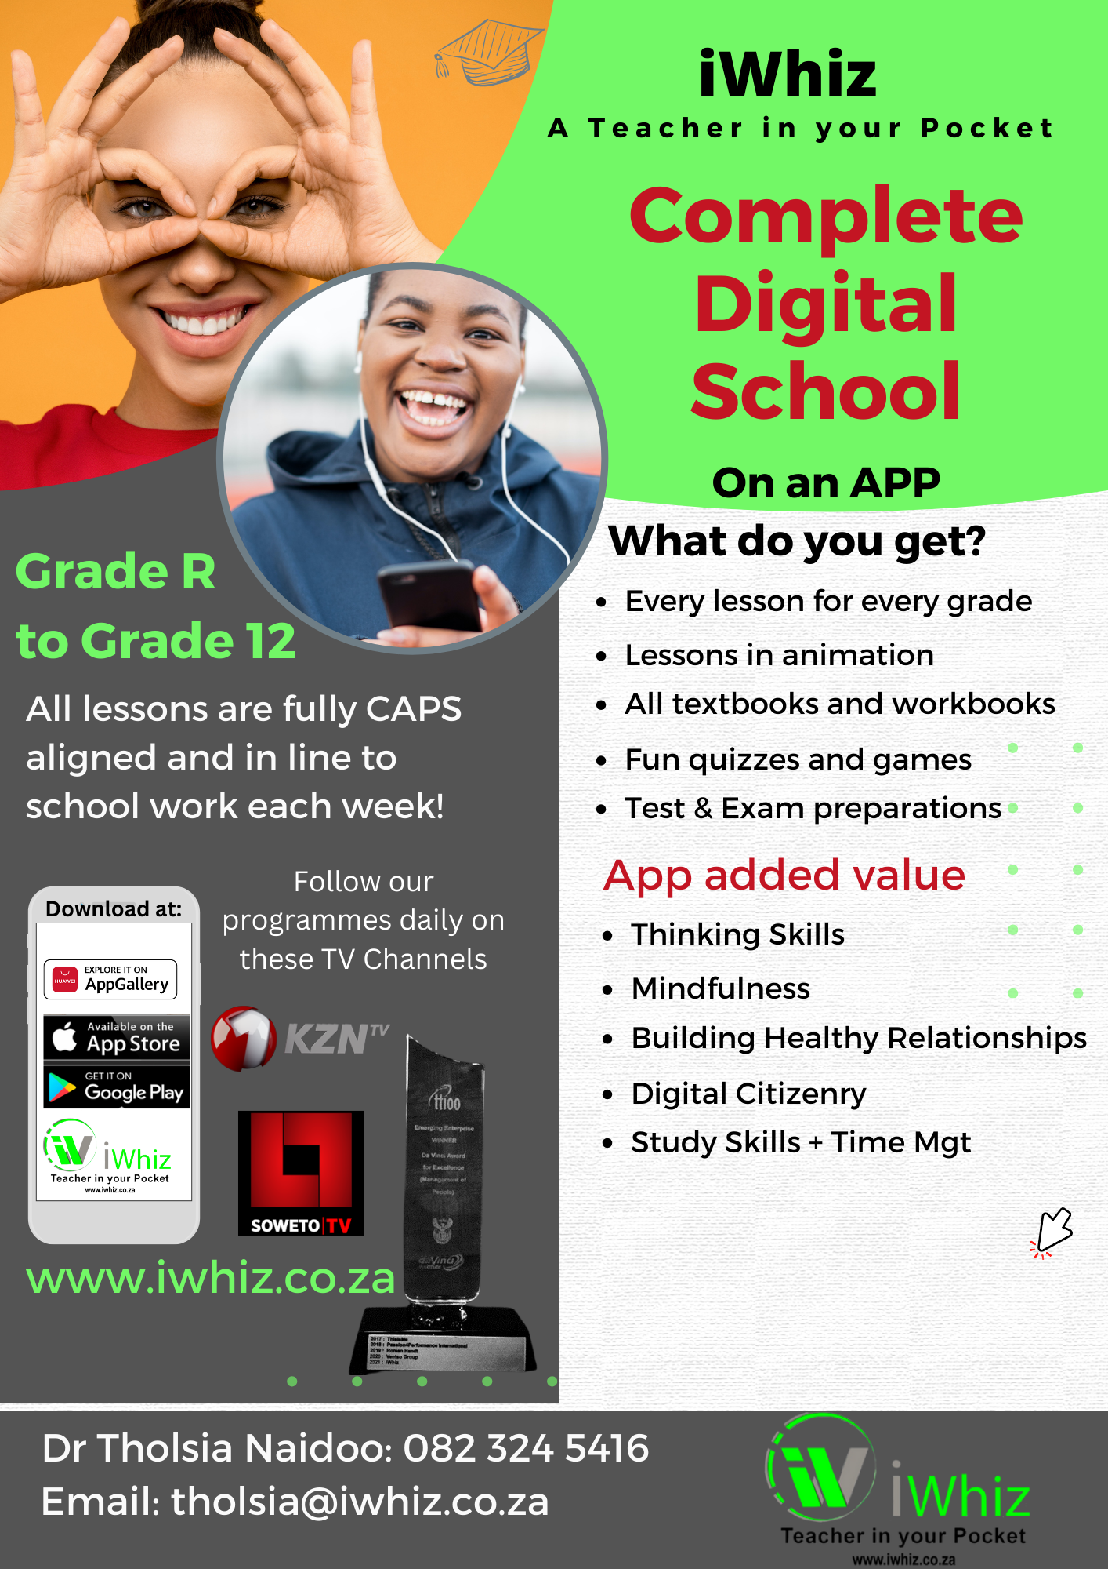
Grade 8 EMS Term 1 Test
Total Marks: 50

Section A: Multiple Choice Questions (10 marks)

Choose the correct answer and write the letter of the answer in your answer sheet.
- Which of the following is an example of a want? (1 mark)
a) Food
b) A television
c) Clean water
d) Shelter
- Which of the following is NOT an economic sector? (1 mark)
a) Primary sector
b) Secondary sector
c) Tertiary sector
d) Quaternary sector
- The role of a bank is to: (1 mark)
a) Manufacture goods
b) Sell goods and services
c) Provide loans and manage money
d) Transport goods
- Which of the following is an example of a business’s fixed costs? (1 mark)
a) Wages
b) Rent
c) Raw materials
d) Advertising
- What is the purpose of a budget? (1 mark)
a) To monitor production levels
b) To plan income and expenses
c) To advertise products
d) To calculate taxes

- Which of the following would be considered a liability for a business? (1 mark)
a) Machinery
b) Cash
c) Loans
d) Stock
- The basic economic problem is: (1 mark)
a) The lack of money
b) The unlimited wants and limited resources
c) Inflation
d) High unemployment rates
- Which of the following best describes a partnership? (1 mark)
a) A business owned by one person
b) A business owned by shareholders
c) A business owned by two or more people who share profits and losses
d) A business owned by the government
- Which of the following is an example of a consumer good? (1 mark)
a) A factory machine
b) A smartphone
c) A raw material
d) A delivery truck
- What does VAT stand for? (1 mark)
a) Value Added Tax
b) Value Average Tax
c) Vehicle Annual Tax
d) Voluntary Account Tax

Section B: Short Answer Questions (20 marks)

- What is the difference between a need and a want? (2 marks)

- Explain the term ‘opportunity cost’ and provide an example. (3 marks)

- Identify two differences between a sole proprietorship and a partnership. (4 marks)

- What are fixed costs and variable costs in a business? Provide an example for each.
(4 marks)

- What is the importance of record keeping for a small business? (2 marks)

- Explain what is meant by a ‘business plan.’ Why is it important for a business to have one? (2 marks)

- Draw a simple flow diagram showing the circular flow of money in an economy. (3 marks)

Section C: Case Study and Application (20 marks)
Read the case study and answer the questions that follow.

Case Study:
Sarah has just opened a small business selling homemade crafts. She is planning to expand her business but needs to create a budget to manage her money effectively. Her main expenses include raw materials, rent for the shop, utilities, and wages for her employee, John. Sarah expects to make R10,000 in sales next month. Her total expenses for the month amount to R8,000. She wants to save R2,000 for future growth.

- What is Sarah’s expected profit for the month? (3 marks)

- If Sarah’s sales increase by 20% next month, how much will her total income be? (3 marks)

- What is the importance of saving R2,000 for future growth? (4 marks)

- Identify two potential sources of funding Sarah could consider if she wanted to expand her business. (4 marks)

- Based on the information in the case study, list three fixed costs Sarah would likely have.
(3 marks)

- If Sarah needs to cut down her expenses, which one of her costs (raw materials, rent, utilities, wages) do you think she should prioritize reducing and why? (3 marks)

Total: 50 marks

