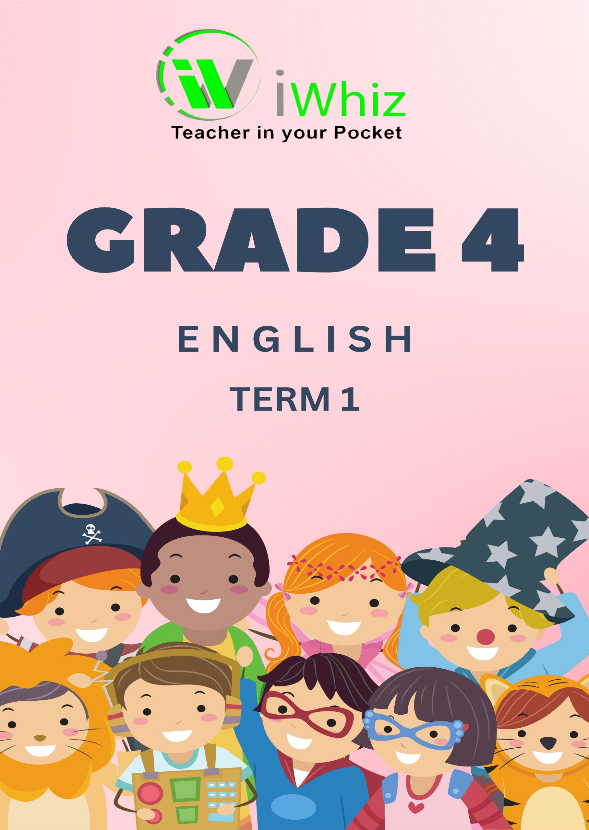
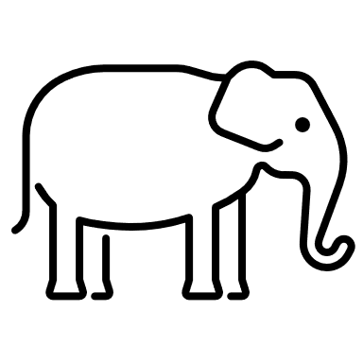


Section A: Comprehension (14 Marks)
Read the passage below and answer the questions.
The Clever Tortoise
One day, the animals of the forest were arguing about who was the strongest. The elephant boasted, “I am the strongest because I can lift a tree with my trunk.” The lion roared, “I am the strongest because I can scare all the animals with my loud roar.” The monkey laughed, “I may not be big, but I can swing high in the trees and escape from danger.”
The tortoise listened quietly. “Strength is not only about size or power,” he said. The other animals laughed at him. “What do you know about strength?” the lion asked. The tortoise just smiled. “Let’s have a contest,” he said. “I will race the elephant and prove that I am strong in my own way.”
The animals laughed again. “A race? Against the elephant? You will never win!” they said. But the tortoise had a clever plan. He asked his tortoise friends to hide along the path. When the race started, the elephant ran ahead, but at each checkpoint, a tortoise appeared and said, “I am here!” The elephant was confused. “How did you get here so fast?” he asked.

Finally, at the finish line, the tortoise was already waiting. The elephant was shocked! The tortoise had won by using his intelligence. The animals cheered, learning that strength is not just about power, but also about clever thinking.

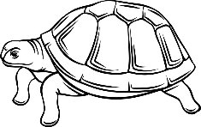

Questions
- What were the animals arguing about in the beginning? (1)

- Name two animals that believed they were the strongest. (2)
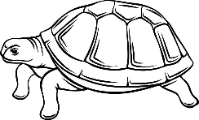
- What clever plan did the tortoise use to win the race? (2)
- Why was the elephant confused during the race? (1)

- What lesson did the animals learn at the end of the story? (2)

- Find a word in the story that means the same as "shouted loudly." (1)

- Give a synonym for the word "clever." (1)

- Identify whether the following statement is true or false: "The tortoise won the race by running very fast." (1)

- Why did the other animals laugh at the tortoise? (1)

- If you were one of the animals in the story, what lesson would you learn? (2)

Section B: Language Structures and Conventions (30 Marks)
Question 1: Nouns (6 Marks)
- Circle the three nouns in this sentence: (3)
The brave lion chased the small rabbit across the field.

- Write one proper noun and one common noun from the story. (2)

Proper noun:

Common Noun:

- Is "tortoise" a countable or uncountable noun? Circle the correct answer. (1)

Countable Uncountable
Question 2: Verbs (6 Marks)
- Circle the two verbs in this sentence:
The monkey swings in the trees and eats bananas. (2)

- Rewrite the sentence in past tense:
The lion runs through the jungle. (2)

- What is the past tense of "win"? (1)

- What is the future tense of "run"? (1)

Question 3: Adjectives (6 Marks)
- Circle the adjectives in this sentence:
The small, clever tortoise won the tricky race. (3)

- Write a sentence using the word "strong" as an adjective. (3)

Question 4: Punctuation (6 Marks)
Rewrite the sentence with correct punctuation:
- where is my book asked tom (3)

- the elephant said i am the strongest animal (3)

Question 5: Word Meaning (6 Marks)
- Give an antonym (opposite) of "big." (1)

- Give a synonym (similar word) for "happy." (1)

- Circle the correct word: A tortoise moves very ____. (slow / fast) (1)

- Choose the correct word: The lion is (more / most) powerful than the rabbit. (1)

- What type of word is "quickly"? (noun, verb, adjective, or adverb?) (1)

- What do we call a word that describes a person, place, or thing? (1)

Section C: Writing (16 Marks)
Instructions for Learners:
- Put the story in the correct order (beginning, middle, and end). (10)
- What is the lesson of the story? (2)
- Find two describing words in the story. (2)
- Check the sentences—do they have capital letters and full stops? (1)
- Bonus Question: How do you think Benny felt when he finally flew? (1)

Jumbled Short Story: Benny the Brave Bird
- Benny flapped his wings and soared high, feeling proud and happy.
- He jumped off a low branch, but instead of flying, he tumbled to the ground.
- He had finally learned that listening and practicing helped him become stronger.
- I was too impatient before, but now I know that learning takes time," he thought.
- One morning, Benny, a young bird, watched the older birds flying high in the sky.
- Soon, he was flying higher and higher without falling.
- I don’t need to practice! I can fly just like them," benny said, flapping his little wings.
- His mother helped him up and said, "Benny, learning to fly takes patience and practice. Keep trying, and you will get there."
- Benny listened to his mother and practiced every day.
- From that day on, benny knew that patience and practice always lead to success.

Total Marks: 60

