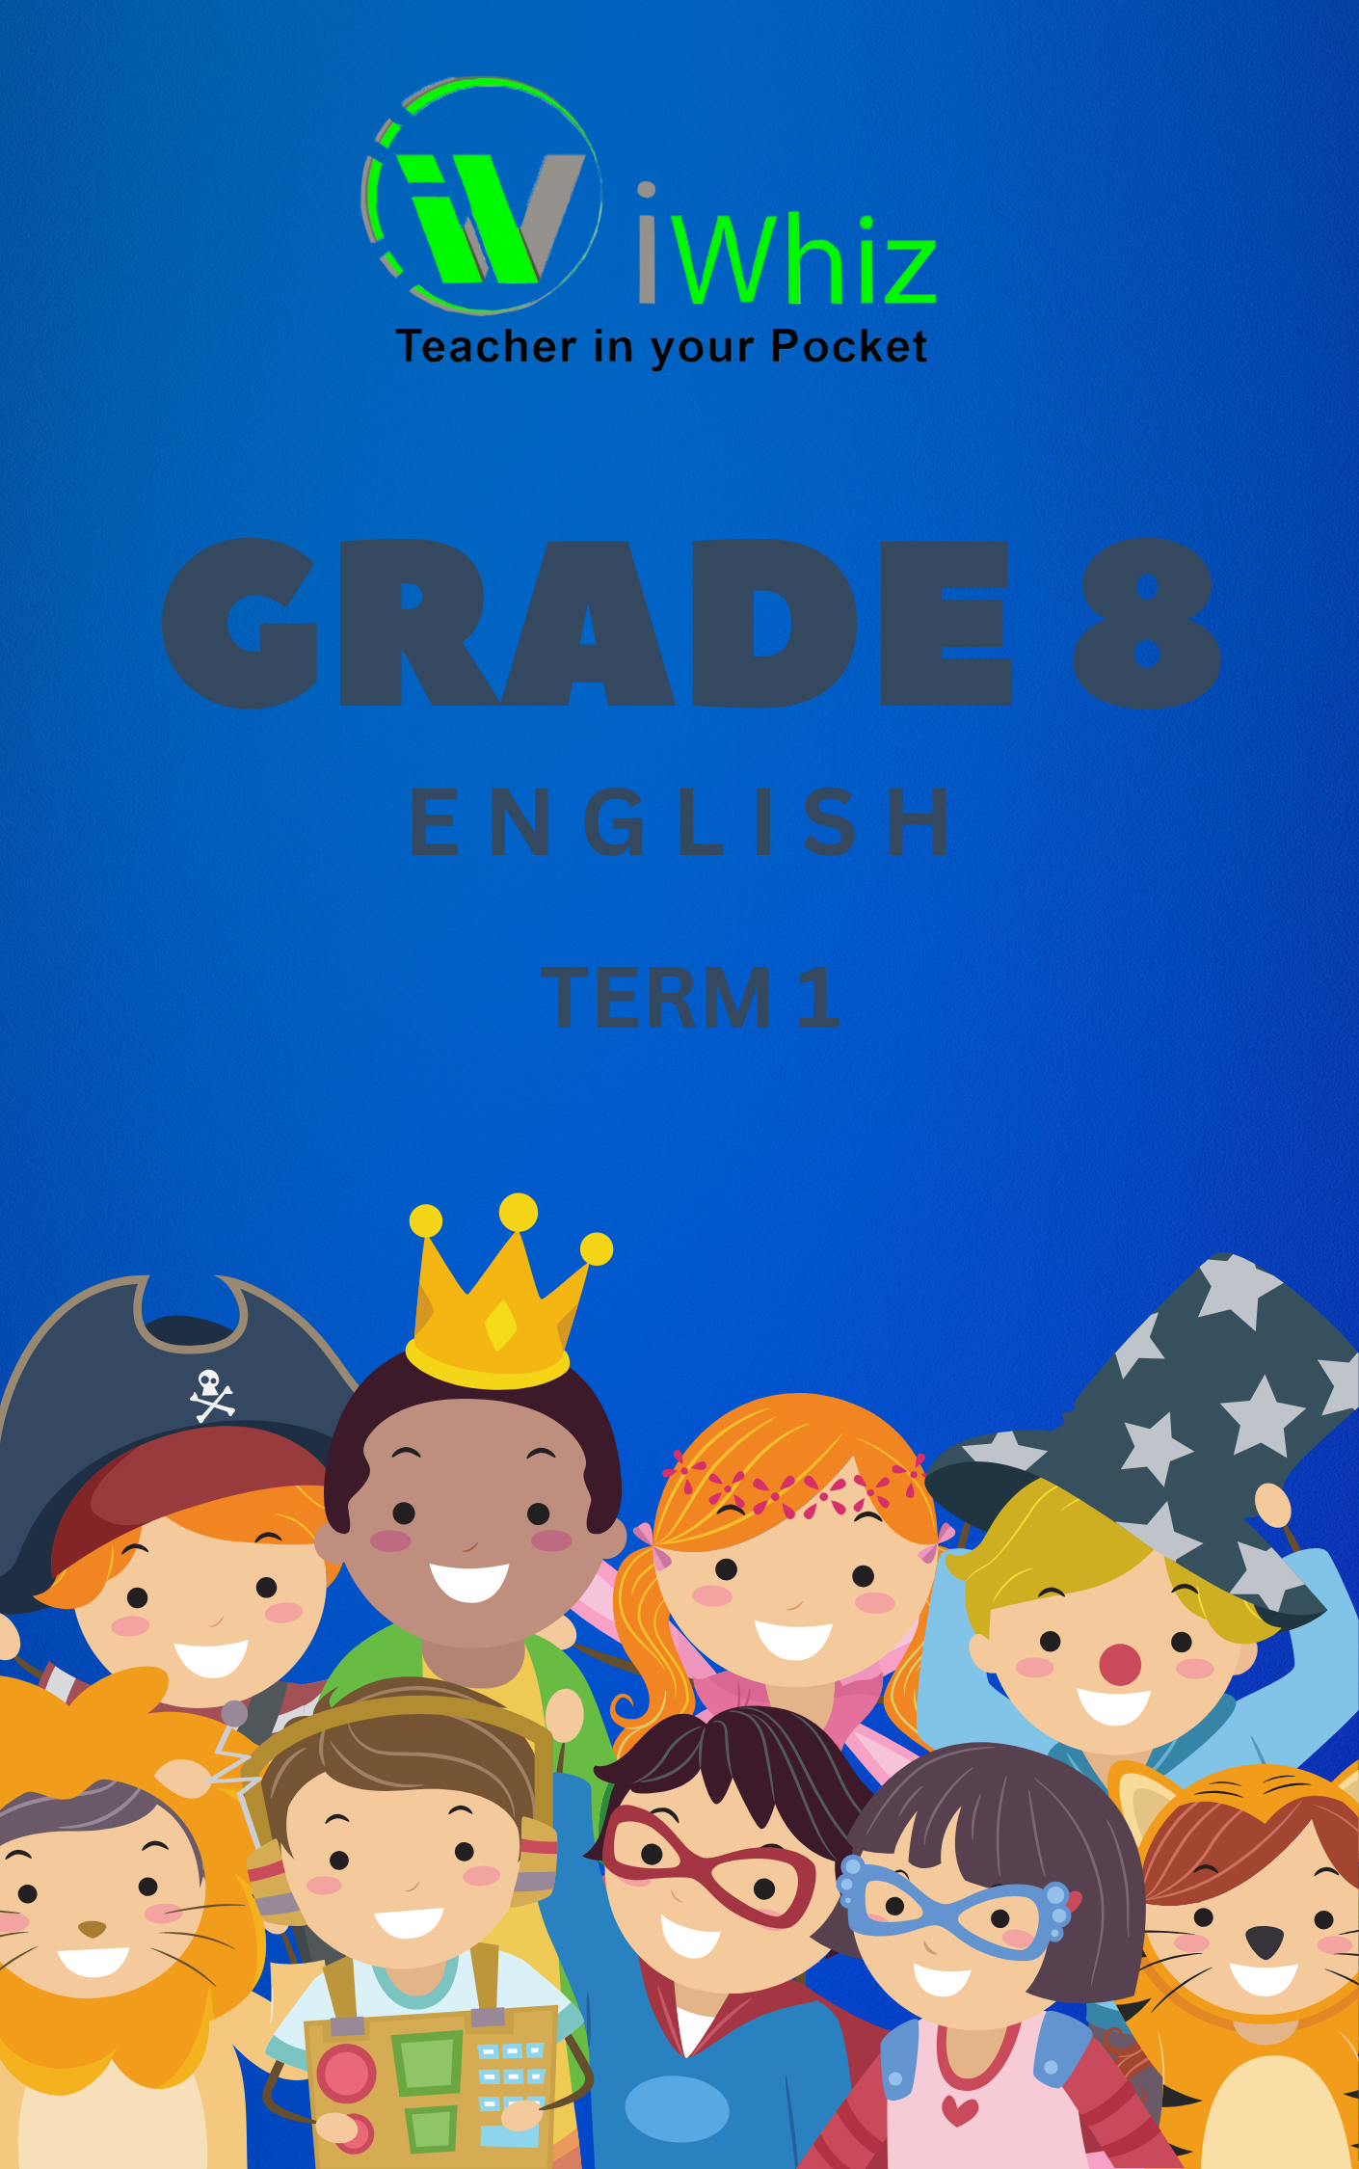


Grade 8 English Term 1 Test
Duration: 1 hour
Total Marks: 30

SECTION A: LANGUAGE AND COMPREHENSION
Read the passage below and answer the questions that follow.

Passage:
The importance of trees cannot be overstated. Trees provide oxygen, improve air quality, conserve water, preserve soil, and support wildlife. They also provide shade and can cool the environment. In cities, trees help to reduce energy consumption by decreasing the need for air conditioning in the summer.
In addition to their environmental benefits, trees also hold cultural and economic value. Many communities rely on trees for their timber, fruits, and other resources. Traditional rituals and festivals are often associated with certain tree species, underscoring their cultural significance.
Despite their many benefits, trees face numerous challenges. Urbanization, deforestation, and climate change threaten the existence of trees worldwide. It is important that we take action to protect and conserve trees to ensure a healthier environment for future generations.

Questions:
- Multiple Choice. Circle the letter of the correct answer. (1 mark)
What is the main idea of the passage?
a) The beauty of trees
b) The environmental and cultural significance of trees
c) How trees affect climate change
d) The economic value of trees

- True or False (1 mark)
Trees only provide oxygen and improve air quality.

- Short Answer (2 marks)
List two benefits of trees mentioned in the passage.
- Vocabulary in Context (1 mark)
What is meant by the word "urbanization" in the context of the passage?

- Referencing (1 marks)
According to the passage, what is one threat that trees face?

- Illustration Question (5 marks)
Draw a simple diagram or illustration of a tree and label at least four parts of it (e.g., roots, trunk, branches, leaves).

SECTION B: GRAMMAR
Choose the correct option to complete each sentence.
- Fill in the blanks with the correct word: (2 marks)
a) She __________ (run/runs) to the bus stop every morning.
b) The team __________ (is/are) ready for the match.
- Rewrite the sentence correctly: (2 marks)
"me and my friends went to the park."

- Punctuation (1 mark)
Correct the punctuation in the following sentence:
"what time does the train leave"

- Identify the part of speech: (2 marks)
Underline the noun in the sentence:
"The cat jumped onto the table."

- Plural forms (2 marks)
Write the plural form of the following words:
a) child
b) box

SECTION C: CREATIVE WRITING (10 marks)
- Creative Writing
Write a short story (approximately 150–200 words) about an adventure you had while on a school trip. Be sure to include the following:
- An introduction that sets the scene
- A problem or challenge that occurs during the trip
- A resolution or lesson learned at the end of the story
(10 marks)

END OF TEST

TOTAL: 30 MARKS

