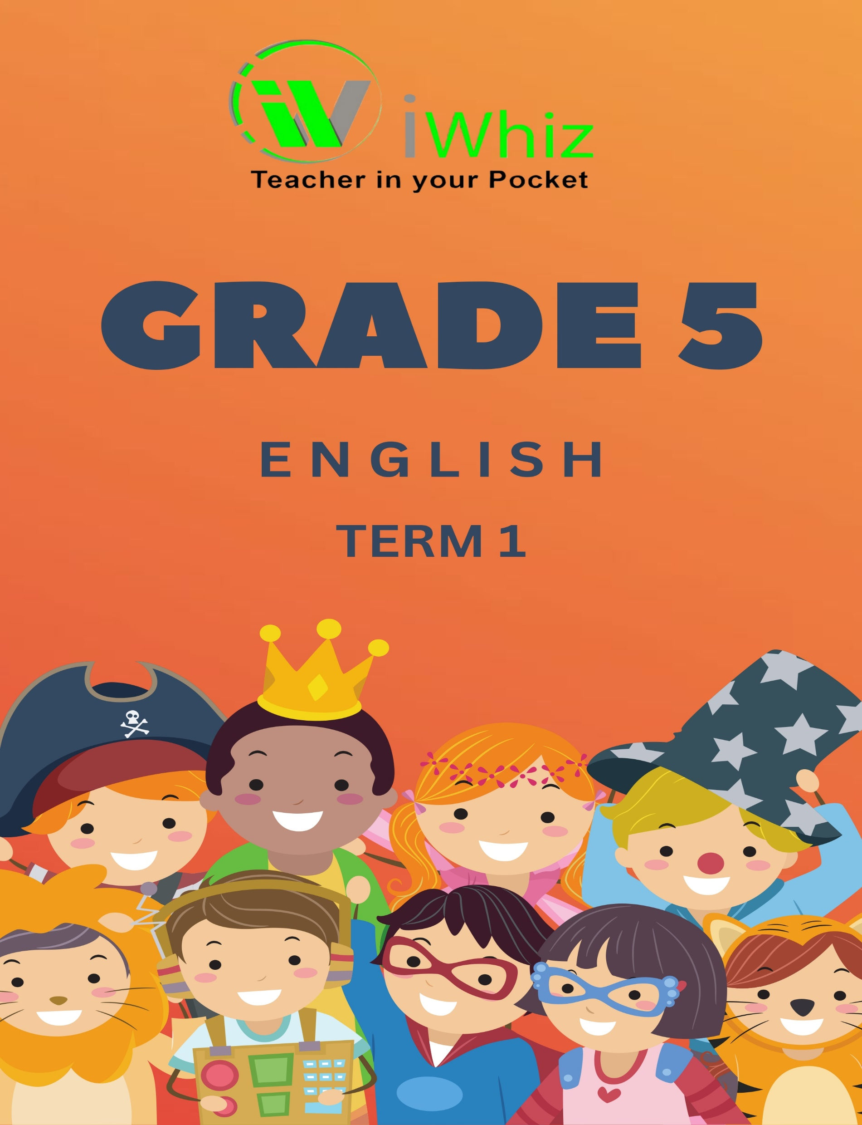
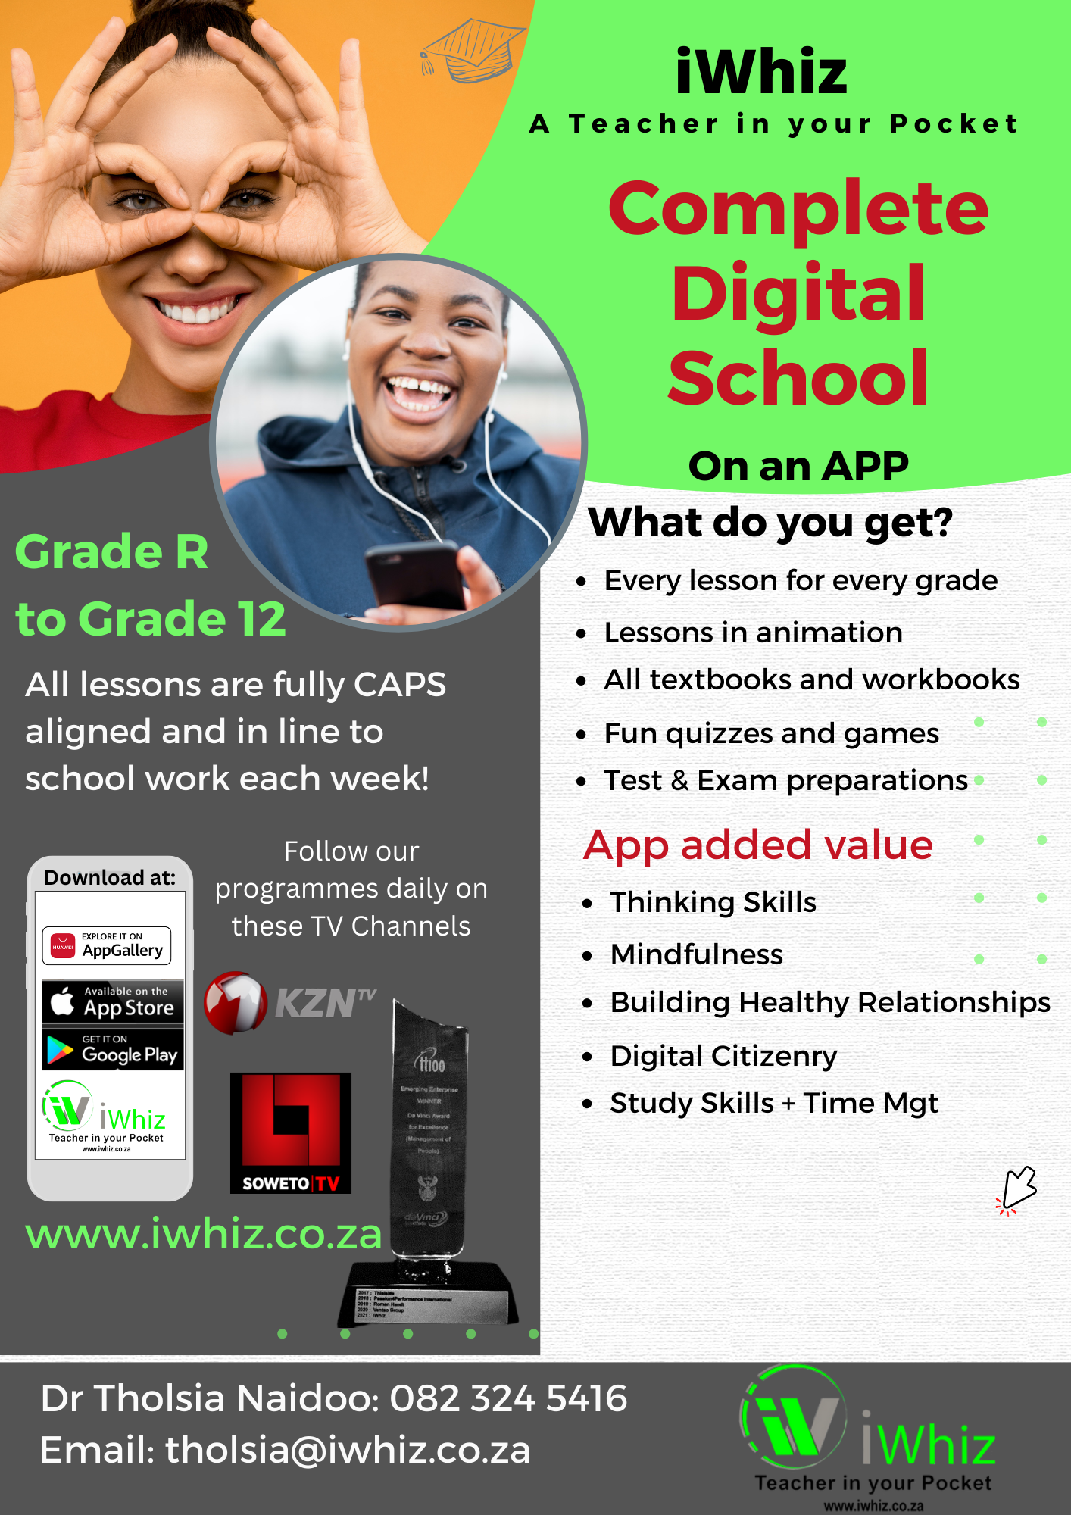
https://www.youtube.com/watch?v=SJ4_nONtYeY
WATCH FOR TESTIMONIALS

WATCH FOR TESTIMONIALS

- Which word is a noun? (1)
Grade 5 English Test
There are three sections, i.e. Section A, B, and C
Time Allowed: 10minutes Max Marks: 15

Section-A
INSTRUCTIONS
- Attempt this section on MCQs sheet only.
- Use Black ball point pen or marker for only one circle for correct option of a question.
- No marks will be awarded for cutting, overwriting, and multiple circle shading.

- Run
- Happy
- Table
- Quickly

- What is the correct plural of “baby”? (1)

- Babys
- Babyes
- Babies
- Baby’s

- Choose the correct past tense of the verb: “She______to the shop yesterday.” (1)

- Goes
- Gone
- Went
- Going

- Which sentence is correct? (1)

- The cat is sleeping under the tree.
- The cats sleeping under the tree
- The cat sleep under the tree.
- The cat sleeps under the tree.

- Identify the adjective in this sentence: "The small boy played outside.” (1)

- The
- Boy
- Small
- Played

- What is the correct pronoun for this sentence? (1)
"John and I went to the park. ____ played soccer together."

- They
- We
- Us
- He

- Choose the correct word to complete the sentence: (1)
“I have ______ apples in my bag."

- Some
- Any
- Much
- A

- Which word is a verb? (1)

- Chair
- Jump
- Blue
- School

- What is the correct conjunction in this sentence? (1)
"She wanted to go outside, _____ it was raining."

- And
- But
- So
- Because

- Choose the correct punctuation: (1)
“Can you help me”

- Can you help me!
- Can you help me.
- can you help me
- Can you help me?

- Identify the preposition in the sentence: (1)
“The book is on the table.”

- Book
- On
- The
- Table

- What type of sentence is this? "Wow! That was amazing!” (1)

- Statement
- Question
- Exclamation
- Command

- Which sentence is written in future tense? (1)

- She runs to school
- She ran to school
- She will run to school
- She is running to school

- Choose the correct spelling: (1)

- Necessary
- Necessary
- Necissary
- Necessary

- Which of these is a synonym for “big”? (1)

- Small
- Huge
- Tiny
- Then

Column A | Column B | Answer
1. A word that describes a person, place, or thing | A) Ran
2. The plural form of "child" | B) Hot
3. A verb in the past tense | C) Because
4. The opposite of "cold" | D) Children
5. A word that describes how an action is done | E) Necessary
6. The correct punctuation for a question | F) Noun
7. A sentence that expresses strong emotion | G) Exclamation mark
8. The correct pronoun for "John and I" | H) Why are you late? (?)
9. The correct spelling | I) Quickly (Adverb)
10. A conjunction used to join two sentences | J) We
Max marks: 10
INSTRUCTIONS
- Match each question in Column A with the correct answer in Column B.
- Write the correct matching Alphabet or Answer in the Answer column provided.
- Answer all questions carefully.
Section-B

Max marks: 10

Max marks: 25
Section-C

INSTRUCTIONS
- Read each question carefully before writing your answer.
- Answer in full sentence where required.
- There is essay, matching and paragraph questions.
- Write neatly and legibly.

Nelson Mandela was born in the town of Mthatha on 18 July 1918. In 1950 he was elected as the president of the Youth League. He was accused of treason. In June 1964 he was sent to prison on Robben Island. He spent 27 years in prison as a political prisoner. He was released from prison in 1990. In 1993 he was awarded the Nobel Prize for Peace.
In 1994 at the age of 75 years he became South Africa's first democratically elected president. He brought about many changes for the people of South Africa. He has also opened a home for orphans and has funded this from various projects. He has retired from politics and lives in Gauteng. He married Graça on 18 July 1998.
Worldwide, he is regarded as an icon. We should all learn from him and be inspired by his teachings. 18 July of every year has been set aside in recognition of him and is called 'International Mandela Day’. All of us should use this day to do something inspirational.
Read the text below carefully and then answer Questions

Circle the letter of the correct-t answer in Questions

- The above text teaches us to…. (1)
- Be inspired.
- Fight with others.
- Be grateful.
- Be respectful.

- Where was Nelson Mandela born? (1)
- Gauteng
- Mthatha
- Robben Island
- Cape Town

- What prize did Mandela receive in 1993? (1)
- The Nobel Prize for Peace
- The Nobel Prize for Democracy
- The Peace Prize for Harmony
- The Nobel Prize for Humanity

- Who is Nelson Mandela's wife? (1)
- Zinzi
- Graça
- Lerato
- Thandi

Put the following events in the correct order as they took place in Mandela's life. Use numbers 1 to 6 to show the correct order.

 | EVENT | CORRECT ORDER
1. | Nelson Mandela was elected as the president of South Africa in 1994
2. | He went to prison in 1964.
3. | He married Graça on 18 July 1998.
4. | Nelson Mandela was born on 18 July 1918.
5. | He was released from prison in 1990.
6. | Mandela was elected as president of the Youth League in 1950.
(6)
Rewrite the following sentences in the future tense.
- We miss the strong leadership of Nelson Mandela. (2)

- The elections were free and fair. (2)

Join the following two sentences into one sentence.
Use 'but' or 'however'.
- Mandela was treated very badly. Mandela did not give up hope for freedom. (3)

Rewrite the sentence below by using correct punctuation.
- bishop tutu said Nelson Mandela is a true inspiration to all South Africans (3)

Use the information on the table below to complete the paragraph.
MENU FOR THE LAST WEEK OF THE TERM
DAYS OF THE WEEK | FIRST BREAK: BREAKFAST | SECOND BREAK: LUNCH
MONDAY | Porridge with milk Fruit: Apple | Fish and chips
TUESDAY | Cheese sandwich Fruit: Pear | Pie, gravy and chips
WEDNESDAY | Porridge with milk Fruit: Orange | Chicken soup served with a brown roll
THURSDAY | Porridge with milk Fruit: Banana | Fish and chips
FRIDAY | Porridge with milk Fruit: Apple | Packed lunch and one chocolate bar

In our school we are served two meals every day. During the first break
we eat a healthy (9.) _________________ and during the second break, we eat lunch. On Mondays and (10.) _________________________ we eat the same lunch. Every day we eat a (11.) ________________________ with our breakfast. Our school encourages healthy eating habits. We have (12.) ___________________ soup on Wednesdays. On Fridays we get a (13.) ________________________ lunch and one chocolate bar, because we finish school early. We are allowed to take our lunch home with us.

Totalmarks:50

