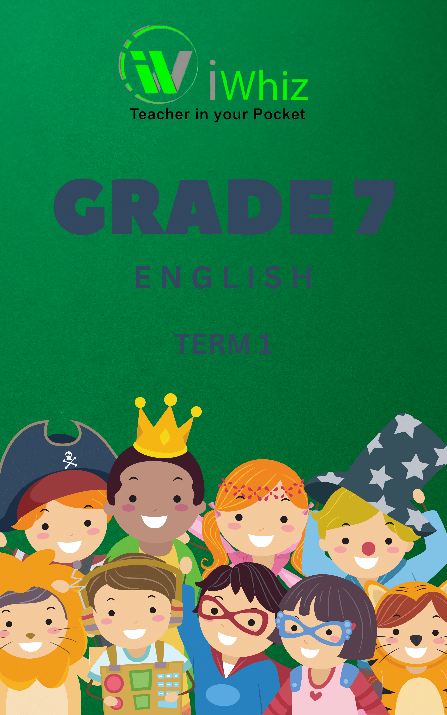

GRADE 7

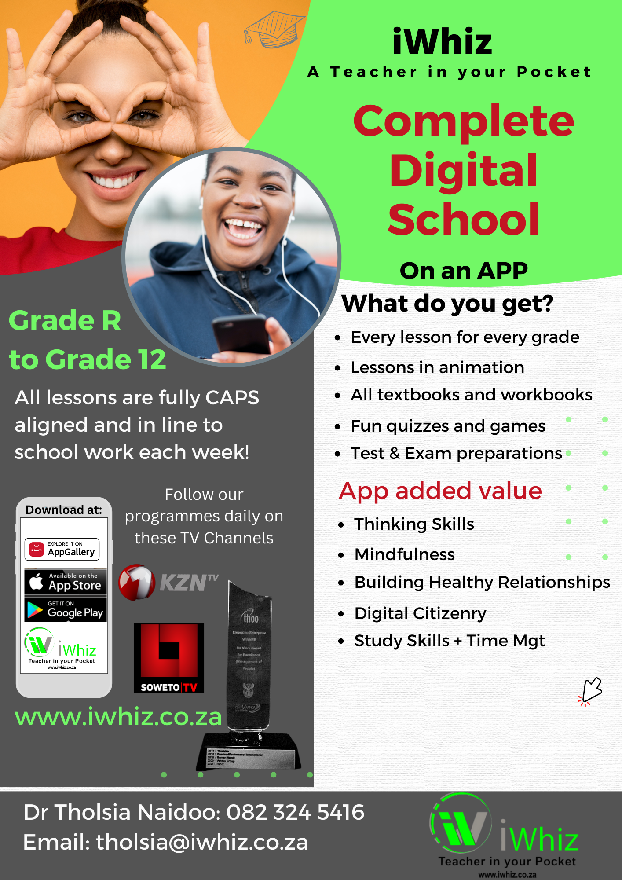

ENGLISH HOME LANGUAGE BASELINE ASSESSMENT TIME: 1 HOUR
JANUARY 2024

MARKS: 30

Name & Surname
Grade 7

INSTRUCTIONS AND INFORMATION.

- This question paper consists of TWO QUESTIONS:
- QUESTION 1: Reading Comprehension (15 marks)
- QUESTION 2: Language Structures and Conventions in context (15 marks)

- Read all the instructions carefully.

- Answer ALL the questions.

- Pay special attention to spelling and sentence construction.

- Write neatly and legibly

QUESTION 1: READING COMPREHENSION
Read the passage below and answer the questions that follow.

1  2  3  4  5 | Teenagers (kids between 13 and 19 years old) are growing up in a world that's changing a lot. Technology, people moving to different places, climate changes, and conflicts are making society different. This means that everyone, including teenagers, needs to learn new things and be ready for unexpected changes.  To do well in this changing world, teenagers need to keep learning throughout their lives. They need education and skills to get good jobs and make smart decisions.  They also need to be involved in their communities in a positive way.  If teenagers don't have the chance to learn and develop skills, they will face big challenges in the future. Right now, 617 million kids and teenagers can't read and do math very well, even though most of them go to school. This is a big problem for getting ready for jobs in the modern world.  We need to invest in and organize education systems so that all teenagers, especially those who have a harder time, can learn the skills they need to do their best. Groups like UNICEF work with governments and communities to help remove obstacles to learning, especially for girls, teenagers who move to new places, and those who are poor or have disabilities.  UNICEF is also making sure that schools are safe and have things like good food, clean water, and proper hygiene. In 2018, UNICEF started a program called "Generation Unlimited" to help all young people connect to education, training, jobs, and starting their own businesses.

Questions

  - Why is it mentioned that teenagers need to be lifelong learners?
It is mentioned because … (1)
- the world is changing, and they need to keep learning to do well.
- their parents insist on continuous learning.
- they enjoy studying all the time.
- they dislike challenges in life.

  - What does the text suggest about the "Generation Unlimited" program? It… (1)
- helps teenagers connect to education, training, jobs, and entrepreneurship.
- focuses on teaching traditional subjects.
- is a new technology.
- is only for girls.

  - Why do some teenagers face challenges in the twenty-first century? They… (1)
- lack opportunities and skills.
- have too much free time.
- have too many friends.
- don't like change.

  - According to the text, what is the biggest challenge for preparing teenagers for the modern employment market? (1)
- Learning crisis in reading and mathematics.
- Lack of interest in education.
- Technology advancements.
- Climate change

  - What is UNICEF's role in helping teenagers facing challenges in education? (1)
- Creating new video games to promote learning.
- Working to remove obstacles to learning.
- Focusing only on boys' education.
- Providing cooking classes.

  - What does the word "obstacles" mean in the context of the text? (1)
- Rewards and incentives for overcoming difficulties.
- Challenges or things that make it hard to do well.
- Resources and support for education.
- Things that help you learn.

  - What does the word "hygiene" mean in the context of the text? (1)
- Balancing work and leisure.
- Staying clean and healthy.
- Doing regular exercises.
- Studying science.

  - According to the passage, what challenges do many teenagers face in the modern world? (1)
- Availability of educational resources.
- Lots of involvement in communities.
- Lack of access to video games.
- Difficulty finding a good job.

  - What is the main purpose of the text? The purpose is to … (1)
- complain about the government not supporting education.
- show how well teenagers are doing in the modern world.
- highlight the importance for teenagers to keep learning.
- talk about problems with technology for teenagers.

  - Match the meaning in Column B with the term in Column A, write only the
letter of the correct meaning in Column C. (3)

Column A | Column B | Column C
1.10.1 migration | A The practice of starting a business or businesses | 1.10.1
1.10.2 hygiene | B Being excluded or treated unfairly, often in society. | 1.10.2
1.10.3  entrepreneurship | C The movement of people from one place to another, especially for work or living. | 1.10.3
 | E Conditions or practices conducive to maintaining health and preventing disease.

  - Is the statement below True or False? Give a reason for your answer. (2)

Teenagers are mentioned as individuals aged 20-29 years in the text.

  - According to the text how many children cannot read and do maths well? (1)

[15]

QUESTION 2: LANGUAGE STRUCTURES AND CONVENTIONS IN CONTEXT

  - Underline the conjunction in the sentence below. (1)
Technology, migration, climate change, and conflict are reshaping society.

  - Underline the verb in the sentence below. (1)

" Groups like UNICEF work with governments."

  - Identify the tense of the following sentence. (1)
Teenagers will face big challenges in the future.
- Present tense
- Past tense
- Future tense
- Progressive tense

  - Choose the correct homophone in the sentence below. (1)
People must adapt to unexpected changes in (there/their) lives and work.

  - What is the antonym of "smart" in the context of the text? (1)
- Intelligent
- Clever
- Bright
- Stupid

  - What is a synonym for "decisions"? (1)
- Choices
- Answers
- Problems
- Solutions

  - Rewrite the sentence in the negative form. (1)
They need education and skills to get good jobs.

  - Write the prefix of the word “unable”. (1)

  - Add a suffix to the word “help” to complete the sentence below. (1)
The information has been helping .

  - Write the sentence in the passive voice. (1)
The programmed helped many teenagers.

  - Punctuate the sentence below. (1)
subjects like math’s languages and science are very important

  - Write down the plural form of ‘society’. (1)

  - Write down the opposite gender of ‘girls. (1)

  - Underline the demonstrative pronoun in the sentence below. (1)
Those living in poverty and with disabilities are also assisted.

  - What does the idiom "Hit the books" mean? (1)
- Start reading and studying
- Watch television
- Take a break
- Play sports

Total: 30 Marks

