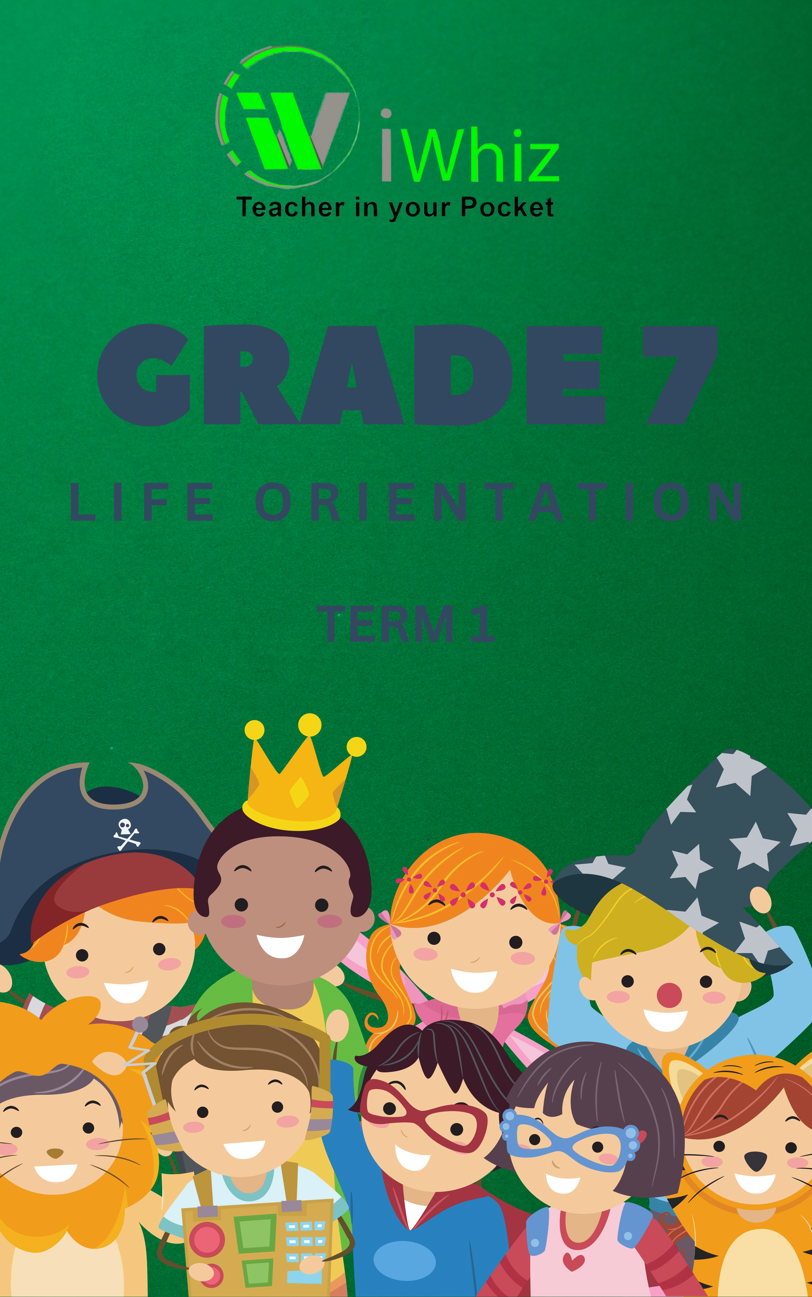

GRADE: 7

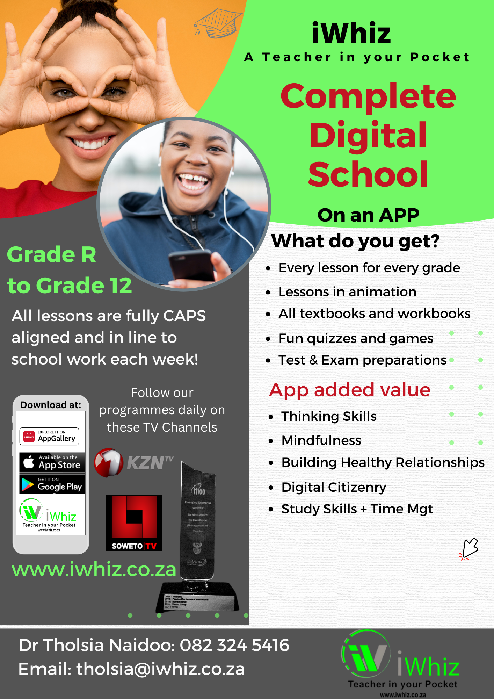

SECTION A
QUESTION 1: POSITIVE PERSONAL QUALITIES
List any 5 positive qualities or attributes you can identify from a person.
  - ___________________
  - ___________________
  - ___________________
  - ___________________
  - ___________________ (1 x 5 = 5)


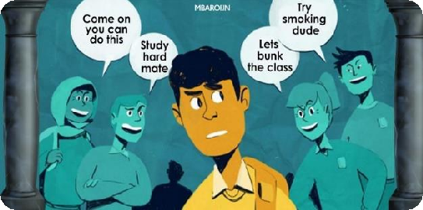
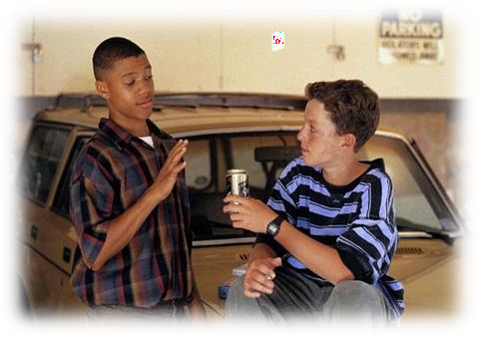
QUESTION 2: PEER PRESSURE

State whether the following statements are True of False. Write the answer on the space next to the statement.

  - Peer pressure can have a negative effect on the teenagers’ sexual behaviour.

  - Rebellious (unruly/defiant) teenagers end up joining cliques (gangs) because they want to be popular.

  - Cyber bullying occurs when people write negative things about you in the newspaper.

  - Assertive (confident/bold) people respond calmly and polite to conflict.

  - Becoming involved helping the Police to stop the use of illegal substances at schools is an example of negative peer pressure.

(1 x 5 = 5)

QUESTION 3: PUBERTY

- Match the explanations in Column A with the concepts in Column B.
- Write your answer in Column C, using the Letters A-F

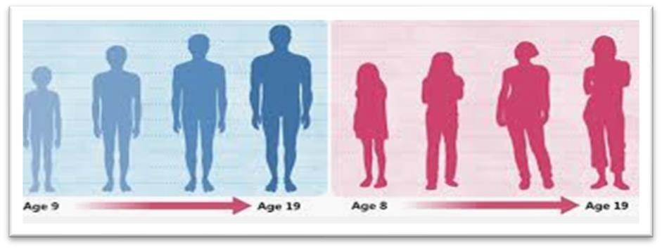

Column A | Column B | Column C
EXAMPLE |  | 6. H
1. Causes physical change associated with puberty in women | A. Puberty | 1.
2. Having pimples or growing beard in your face during puberty | B. Hormones | 2.
3. The process of which a child’s body matures (grow up) into an adult  body | C. Menstruation | 3.
4. Experiencing a feeling of wanting to be alone during puberty | D. Physical change | 4.
5. Causes change and mood swings during puberty. | E. Estrogen | 5.
 | F. Emotional change

(1 x 5 = 5)


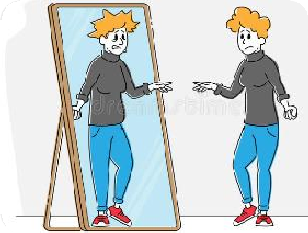
QUESTION 4: SELF- IMAGE

- Choose the correct answer from the options given in brackets.
- Show your answer by writing your choice on the spaces provided.

  - Abilities that can develop into something successful in the future can be described as your (talent/ potential).

  - People with (positive / negative) self-image has respect for others and self.

  - (Diversity/ Respect) refers to human’s different culture, gender and lifestyle.

  - Improving self-image includes (trying new things/ giving up on your dreams).

  - When you doubt yourself and feel ashamed of the pimples in your face, then your self-image is (positive/negative).
(1 x 5 = 5)

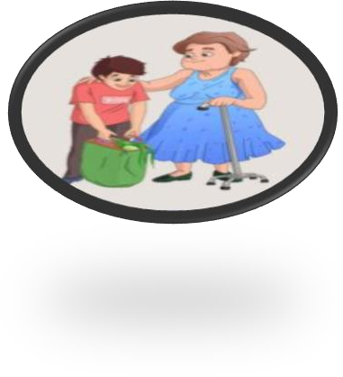
QUESTION 5: RESPECT FOR OTHERS AND DIVERSITY
    - Answer the question below.
    - Write your answers on the spaces provided.

5.1 Name 5 things that you can do to show that you have respect for others and respect for diversity.
5.1.1
5.1.2
5.1.3
5.1.4
5.1.5
(1 x 5 = 5)

TOTAL SECTION A = 25

SECTION B
QUESTION 6: RESPONSES TO PEER PRESSURE

- As a young person growing up, you can respond differently to pressure. The 3 reactions are explained below.
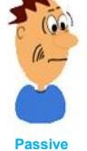
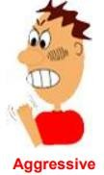
Assertive/ confident | Stand up for yourself
Passive/inactive | You don’t stand up for yourself/ not sure of your position
Aggressive/ violent | Want things to go your way

- Use the table above with explanations to classify(organize) the given scenarios related to responses to pressure correctly.
- Choose your answer between the following: Assertive; Passive; Aggressive

SCENARIO | ANSWER
Example: Having a friendly face | Assertive
6.1 Don’t want to listen to other people’s opinions or views
6.2 Give in easily to others
6.3 Listen to other people’s opinions
6.4 Getting angry and shouting at others
6.5 Stand up for their rights

(1 X 5 = 5)

QUESTION 7: CASE STUDY – SELF-IMAGE (20 MARKS)
Read the case study and answer the questions that follow:

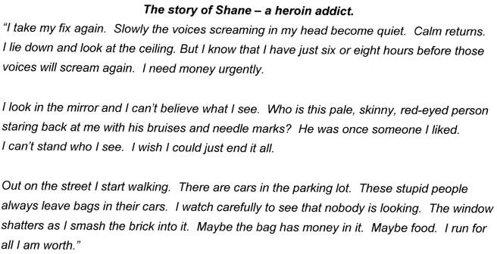





  - Name 3 ways that substance abuse affected Shane’s life negatively. (1 x 3)

7.1.1

7.1.2

7.2 Why is Shane in need of money urgently? (2)

7.3 Explain how Shane got bruises and needle marks on his body? (1)

7.4 Do you think that Shane has always been a thief? Give reason for your answer. (3)

  - Comment on Shane’s plan to get/access money that he needed urgently by identifying the plan and say whether it was a good or bad thing to do. (2)

  - If you were in Shane’s position, where would you go to find help about your stressful situation. (2x2=4)
7.6.1

7.6.2

  - In your opinion is Shane’s self- image negative or positive? Quote a sentence. from the text to justify your answer (3)

  - If Shane was your friend, what advice would you give him about his behavior? Write a full sentence. (2)

TOTAL SECTION B = 25

SECTION C

- Section C consists of 3 questions.
- Choose 2 questions from the 3 questions given.
- If you answer 3 questions, only the first 2 will be marked.

QUESTION 8: PUBERTY

One of your classmates does not understand the changes that are happening to him during puberty. Explain to him what puberty is, furthermore, discuss any 4 physical changes that could happen to boys when they reach puberty stage.
MARKS ALLOCATION:

CRITERIA | MAXIMUM MARKS | LEARNER’S MARKS
Explaining puberty | 2 marks
Discussion of 4 changes | 2x4=8
Total mark | 10 marks

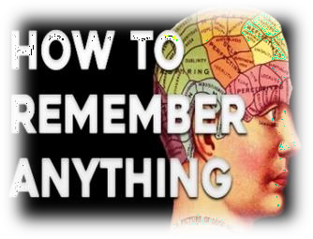
QUESTION 9: SKILLS TO DEVELOP MEMORY

Developing a good memory would be advantageous in any learning environment. In a paragraph, discuss 5 key factors (studied in class),
that should be remembered when you are developing your memory. Your discussion should focus on preparations for the examinations. (10)

CRITERIA
Discussion of the factors | 0 or 1 key factor  (0-1) | 2-3 key factors  (2-3) | 4-5 factors and  discussed (8)
Link to examination preparation | The factors are not linked (0) | One factor is linked (1) | Two OR more factors are linked (2)


QUESTION 10: PEER PRESSURE
Write a paragraph where you explain how peer pressure may influence individual. Highlight the 5 effects in your response.
MARKS ALLOCATION:

CRITERIA | MAXIMUM MARKS | LEARNER’S MARKS
Naming 5 correct effects | 1x5=5
Explaining the effects | 1x5=5
Total mark | 10 marks

TOTAL SECTION C = 20

TOTAL = 70 MARKS

