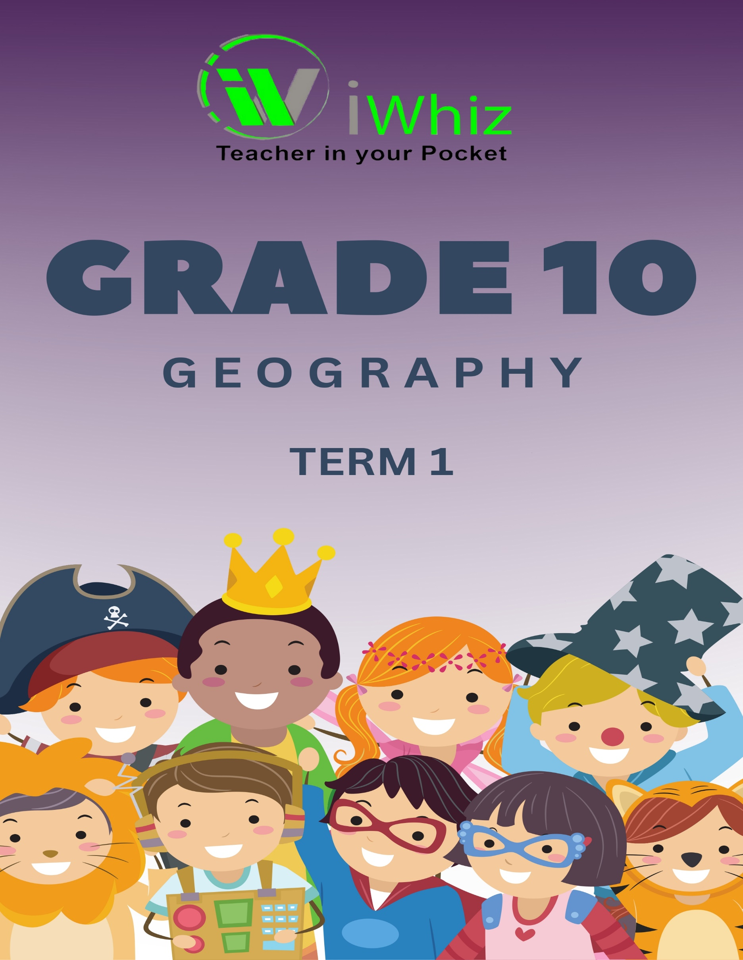


https://www.youtube.com/watch?v=SJ4_nONtYeY
WATCH FOR TESTIMONIALS

WATCH FOR TESTIMONIALS

Total: 100 Marks Time: 2 Hours
SECTION A: Multiple-Choice & Short Questions (20 marks)
(Answer all questions. Each question is worth 2 marks.)
- Which layer of the Earth is composed mainly of solid iron and nickel?
A) Crust
B) Mantle
C) Outer core
D) Inner core
- The term isobars refers to:
A) Lines on a weather map showing areas of equal temperature
B) Lines on a weather map showing areas of equal pressure
C) Boundaries between tectonic plates
D) The highest points of a mountain range
- Name two processes involved in mechanical weathering.

- Define the term watershed.

- Give one difference between weather and climate.

- Explain why low-pressure systems are associated with cloudy and rainy conditions.

- Identify one human activity that contributes to global warming.

- Name the two main types of convergent plate boundaries.

- State one advantage and one disadvantage of deforestation.

- What does the term GIS stand for in geography?

SECTION B: Source-Based Questions (30 marks)
(Study the following sources and answer the questions.)
Question 11: Tectonic Activity (15 marks)
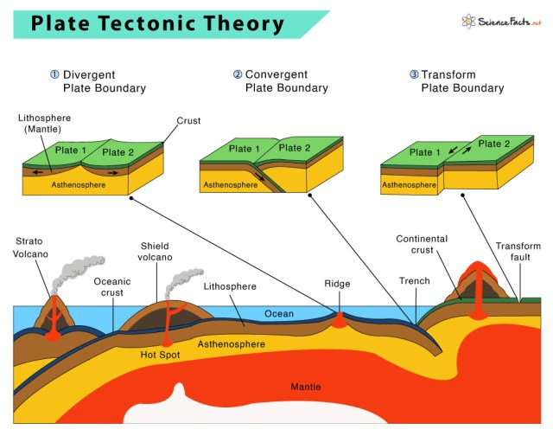
(A diagram of tectonic plate movement is provided, showing convergent, divergent, and transform boundaries.)
11.1 Name the three types of plate boundaries shown in the diagram. (3)
11.2 Which type of plate boundary is most likely to cause earthquakes? (2)

11.3 Explain how convection currents in the mantle cause plate movement. (4)
11.4 Describe the difference between an oceanic and a continental plate. (4)
11.5 Identify one real-world example of a divergent boundary. (2)

Question 12: Climate & Weather (15 marks)
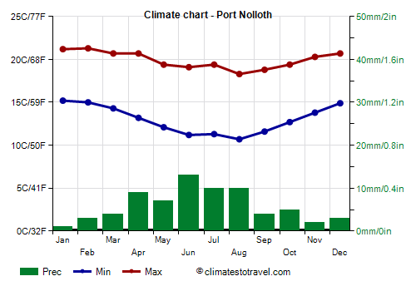
(A climate graph of a city in South Africa is provided, showing monthly temperature and rainfall.)

12.1 Identify the hottest and coldest months from the climate graph. (2)
12.2 What type of climate does this city experience? (2)
12.3 Explain the relationship between temperature and rainfall in the given climate. (3)
12.4 Describe how altitude affects temperature. (4)
12.5 Explain why coastal cities experience moderate temperatures compared to inland cities. (4)

SECTION C: Map Work & Geographic Skills (30 marks)
Question 13: Topographic Map Interpretation (15 marks)
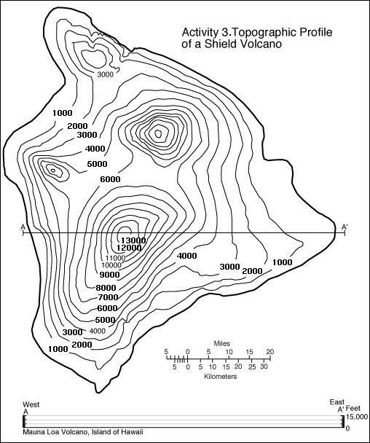
(A simplified topographic map is provided with contour lines, scale, and symbols.)
13.1 What does the term contour interval mean? (2)
13.2 If the scale of the map is 1:50 000, what does this mean in real-world distance? (2)
13.3 Identify one physical and one human-made feature on the map. (4)
13.4 Calculate the gradient between two given points. (4)
13.5 Explain why rivers follow the V-shaped contour pattern on a topographic map. (3)

Question 14: GIS & Remote Sensing (15 marks)
14.1 Define remote sensing. (2)
14.2 Explain one practical use of GIS in disaster management. (3)

14.3 List two advantages of using satellite imagery in studying the environment. (4)
14.4 Describe how Google Earth uses GIS technology. (3)

14.5 Suggest one way GIS can be used for urban planning. (3)

SECTION D: Extended Writing (20 marks)
(Answer ONE of the following questions in a structured essay of 150-200 words.)
Question 15: Human Impact on the Environment
Discuss the causes and effects of deforestation. Include possible solutions that can reduce the negative impact of deforestation on the environment.
OR
Question 16: Natural Disasters & Climate Change
Explain how climate change has contributed to extreme weather events such as cyclones, droughts, and heatwaves. Suggest ways that humans can reduce the impact of climate change.

TOTAL: 100 MARKS

