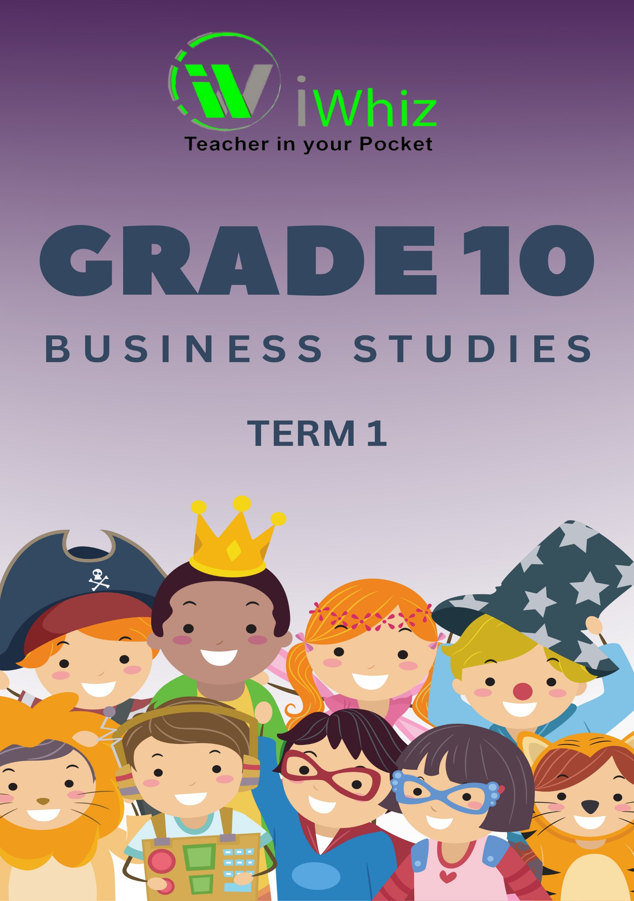


https://www.youtube.com/watch?v=SJ4_nONtYeY
WATCH FOR TESTIMONIALS

WATCH FOR TESTIMONIALS

GRADE 10 BUSINESS STUDIES EXAM
SECTION A: Answer all questions in Section A
Question 1: Choose the correct option
1.1 The _______ describes the purpose and daily activities of a business:
a) Business plan
b) Vision
c) Objectives
d) Goals
1.2 Stock control is NOT used for this purpose:
a) To determine the quantity of available stock.
b) To make sure there is enough stock.
c) To determine the overall value of the stock.
d) To set selling prices directly for customers.
1.3 Which of the following is not an example of a long-term investment:
a) Shares
b) Money market accounts
c) Fixed deposits
d) Property
1.4 The National Credit Act was implemented in:
a) May 2005
b) October 2006
c) June 2008
d) April 2009
1.5 Intermediaries: a) Add value to a product
b) Facilitate the movement of goods
c) Make ownership possible
d) All of the above
(5 x 2 = 10 marks)

Question 2: Give one word/term for each of the following:
2.1 The _____________ of the business provides direction to meet its objectives.
2.2 The _____________ is a diagram that represents the hierarchy of roles in a business.
2.3 The _____________ function is responsible for converting raw materials into finished goods.
2.4 Profit that is distributed among the shareholders of a company is called _____________
2.5 The _____________ is a regulatory body that deals with consumer complaints about financial agreements.
(5 x 2 = 10 marks)
TOTAL: 20 marks

SECTION B: One question must be answered
Question 3 (40 marks)
Natural Essentials is an organic skincare company that sells its products through e-commerce and pop-up stores. They focus on sustainability and ensure their ingredients are ethically sourced. Their employees undergo extensive training to educate customers on the benefits of natural skincare.

Read the information about Natural Essentials and answer the following questions:
3.1 Which business function is responsible for creating the organisational culture? (2)

3.2 Define the term ‘organisational culture.’ (2)

3.3 Do you think Natural Essentials employs more marketing specialists or logistics managers? Provide a reason for your answer. (4)

3.4 Which business function is responsible for employee training? (2)

3.5 One of the eight functions of a business is responsible for maintaining a good public image. List four methods used by this function. (8)

3.6 Explain the difference between advertising and publicity. (4)

3.7 Customers form part of which business environment? (2)

3.8 Name three (3) factors that influence consumer buying behavior apart from cultural factors. (6)

3.9 Loans and retained earnings fall under which type of organisational resources? (2)

3.10 Differentiate between fixed capital and working capital. Provide an example of each. (6)

3.11 Fill in the missing word: Banks and investors are regarded as ______ of capital. (2)

Question 4 (40 marks)
Mr. Liam Adams owns a furniture manufacturing business, Adams Creations. He recently gave his employees a 6% salary increase, but they feel it should be higher. Some competitors only offered 5%. Additionally, raw material costs have risen, leading Liam to increase his selling prices. Recently, he secured an exclusive supply contract with a luxury home retailer, Elegant Living, which will now sell his products. Liam prefers focusing on production rather than customer interactions.
Read the information and answer the following questions:
4.1 The internal factors of this business, Adams Creations, form part of which business environment? (2)

4.2 The term ______ refers to when a third party performs a business function that is normally done internally, as seen in the contract between Adams Creations and Elegant Living. (2)

4.3 List the remaining four (4) steps of the purchasing process in sequential order. (8)

4.4 Identify two (2) ways in which Adams Creations can maintain a good relationship with its suppliers. (4)

4.5 Provide the full name of the act that regulates credit transactions. (2)

4.6 According to this act, name three (3) actions that credit providers are prohibited from doing. (6)

4.7 If employees are unhappy with their wage increase, where can they seek assistance? Provide one example in South Africa. (2)

4.8 Provide two (2) other types of short-term investments that Liam can consider. (4)

4.9 Which short-term investment would you recommend if he wants to earn the highest interest possible? (2)

4.10 Name and briefly discuss two (2) regulatory bodies that oversee different parts of civil society. (6)

4.11 Civil society is a component of which business environment? (2)

SECTION C: One question must be answered
Question 5 (40 marks)
Discuss the role of managers in achieving business objectives. Explain the three levels of management, providing an example of a position at each level. Discuss what each level focuses on and the types of decisions they make. Identify which management level is most concerned with organising, controlling, and planning. Finally, discuss four key management tasks required for business success.
OR
Question 6 (40 marks)
Quality products ensure business longevity.
- Analyse the concept of quality in the micro environment of a business.
- Discuss how different business functions contribute to quality.
- Explain the role of quality in business success.

