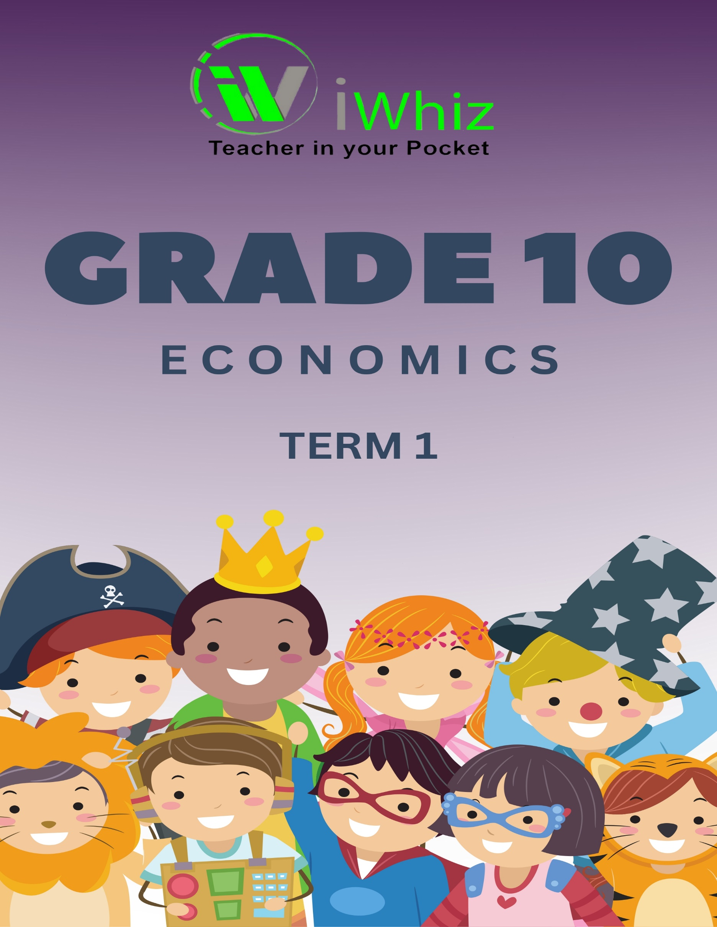


https://www.youtube.com/watch?v=SJ4_nONtYeY
WATCH FOR TESTIMONIALS

WATCH FOR TESTIMONIALS

GRADE 10 ECONOMICS
MARKS: 100 TIME: 2 HOURS
SECTION A: MULTIPLE-CHOICE QUESTIONS (20 MARKS)
Answer all questions. Write only the correct letter (A, B, C, or D) next to the question number.
- Which of the following is considered a primary sector activity in the South African economy?
A. Manufacturing of clothing
B. Providing banking services
C. Mining of gold and platinum
D. Selling electronic goods in a retail store

- What is the main purpose of monetary policy in South Africa?
A. To control government spending
B. To regulate the supply of money and interest rates
C. To collect taxes from businesses and households
D. To manage imports and exports
- Which of the following is an example of a scarce resource?
A. Air
B. Water
C. Gold
D. Sunlight
- What is the term used to describe the total value of goods and services produced by a country in a given period?
A. Gross Domestic Product (GDP)
B. National Debt
C. Tax Revenue
D. Inflation Rate
- Which of the following is NOT a characteristic of a market economy?
A. Private ownership of resources
B. Government control over production
C. Profit-driven production
D. Consumer sovereignty
- The opportunity cost of attending a concert is…
A. The money spent on tickets
B. The time spent enjoying the concert
C. The next best alternative forgone, such as working or studying
D. The enjoyment of the concert experience
- Which of the following factors causes a shift in the demand curve?
A. Changes in production technology
B. Changes in consumer tastes and preferences
C. Changes in the price of inputs
D. Changes in wages
- In economics, what does the term "market failure" refer to?
A. When businesses make profits
B. When goods and services are allocated inefficiently
C. When the government regulates the economy
D. When consumers demand more than what is produced
- Which of the following is a key feature of a command economy?
A. Private ownership of businesses
B. Government determines what goods and services are produced
C. Consumers decide what to produce
D. Profit is the main motivation for production
- What is the primary goal of monetary policy?
A. To reduce inflation
B. To increase government spending
C. To increase exports
D. To lower taxes
- Which of the following best describes the term "economic growth"?
A. A decrease in the cost of living
B. An increase in the number of goods and services produced
C. A decrease in the level of unemployment
D. A rise in consumer spending
- The law of supply states that…
A. As the price of a good increases, the quantity supplied decreases
B. As the price of a good increases, the quantity supplied increases
C. As the price of a good decreases, the quantity supplied decreases
D. As the price of a good increases, the quantity demanded increases
- A positive externality occurs when…
A. The cost of a product rises
B. The benefits of a good spill over to third parties
C. The government imposes a tax on a good
D. A firm sets high prices for its products

- In which type of economic system does the government own and control all means of production?
A. Capitalism
B. Socialism
C. Communism
D. Mixed economy
- Which of the following is an example of a public good?
A. A movie ticket
B. National defense
C. A private park
D. A new smartphone
- The price mechanism in a market economy helps to…
A. Ensure equal distribution of wealth
B. Allocate resources efficiently based on supply and demand
C. Control inflation
D. Prevent government intervention in markets
- In economics, the term "utility" refers to…
A. The total cost of production
B. The satisfaction or benefit derived from consuming goods and services
C. The government’s regulation of prices
D. The money spent on goods and services
- What is a key assumption of the law of demand?
A. Higher prices decrease the quantity demanded
B. Lower prices increase the quantity supplied
C. Consumers do not have limited income
D. Government subsidies increase demand
- What does "elasticity of demand" measure?
A. The relationship between income and quantity demanded
B. The responsiveness of quantity demanded to a change in price
C. The total amount of goods demanded at all price levels
D. The government’s influence on the demand curve
- What role does competition play in a market economy?
A. It increases monopolies
B. It helps keep prices high
C. It encourages innovation and efficiency
D. It reduces the number of suppliers in the market

SECTION B: MATCHING QUESTIONS (20 MARKS)
Match the terms in Column A with the correct description in Column B. Write only the letter of the correct answer next to the question number.
Column A |  | Column B
1. Opportunity cost |  | A. The study of the economy as a whole
2. Microeconomics |  | B. The next best alternative forgone
3. Public goods |  | C. A situation where unlimited wants exceed limited resources
4. Scarcity |  | D. Goods provided by the government for collective use
5. Demand |  | E. The quantity of goods and services consumers are willing and able to buy

SECTION C: SHORT QUESTIONS (30 MARKS)
- Define the following economic terms:
a) Opportunity cost (2)
b) Scarcity (2)
c) Economic system (2)

d) Demand (2)
e) Supply (2)

- Differentiate between the following concepts:
a) Microeconomics and Macroeconomics (4)
b) Public goods and Private goods (4)

- List and explain three types of economic systems. (6)
- Briefly explain three factors that influence demand. (6)

- Name and describe two participants in the circular flow model. (6)

SECTION D: EXTRACT AND QUESTIONS (20 MARKS)
Read the extract below and answer the questions that follow.
EXTRACT:
"In recent months, the price of basic food items has risen due to inflation and supply chain disruptions. Consumers are struggling to afford necessities, while businesses are facing higher production costs. The government is considering interventions to stabilize prices and ensure food security."
QUESTIONS:
8.1 Identify two economic issues mentioned in the extract. (4)
8.2 Explain how inflation affects consumers and businesses. (6)
8.3 Suggest two ways in which the government can intervene to stabilize prices. (6)

8.4 Discuss the role of supply and demand in determining food prices. (4)

SECTION E: LONG QUESTIONS (30 MARKS)
Answer any TWO of the following questions. Each question is worth 15 marks.
- Economic Problem and Choices:
Discuss the basic economic problem of scarcity and explain how different economic systems attempt to solve this problem. Use examples to support your answer. (15)

- Demand and Supply:
a) Explain the law of demand and the law of supply with the help of diagrams. (8)
b) Discuss any three factors that can shift the demand curve. (7)

- Circular Flow Model:
a) Explain the roles of households and firms in the circular flow model. (8)

b) Discuss the role of government in the economy and provide two examples of government intervention. (7)

TOTAL: 100 MARKS

