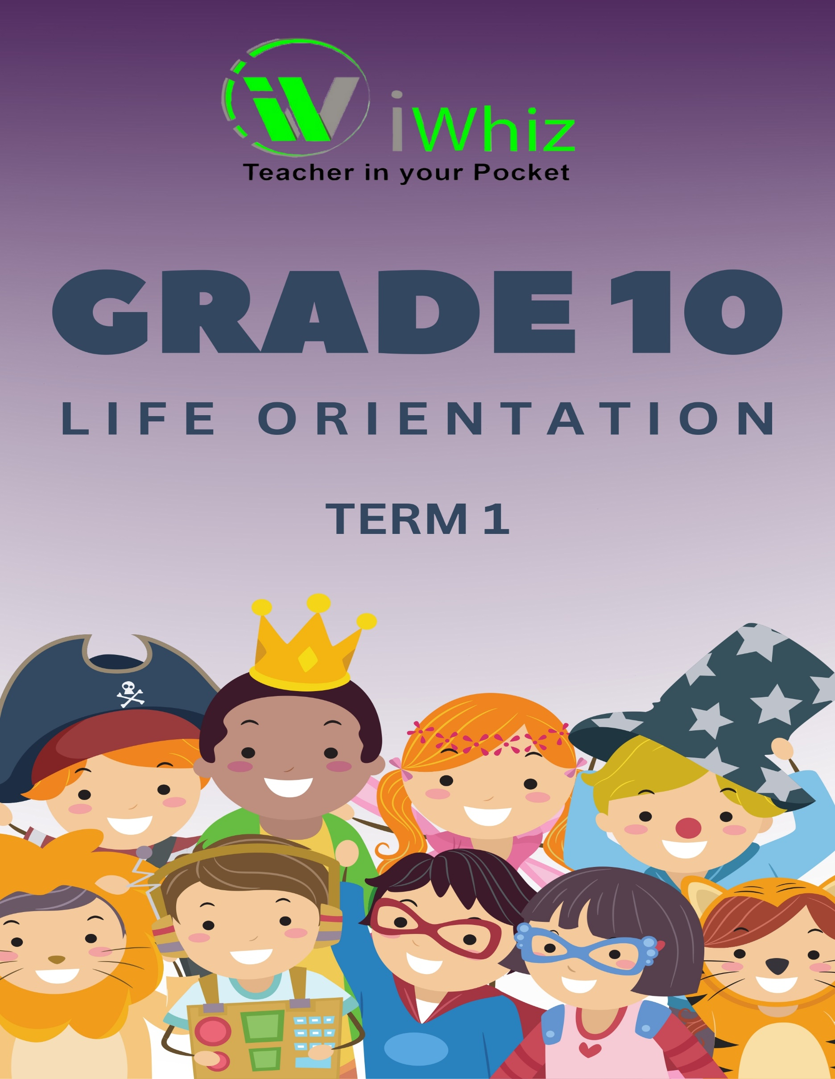
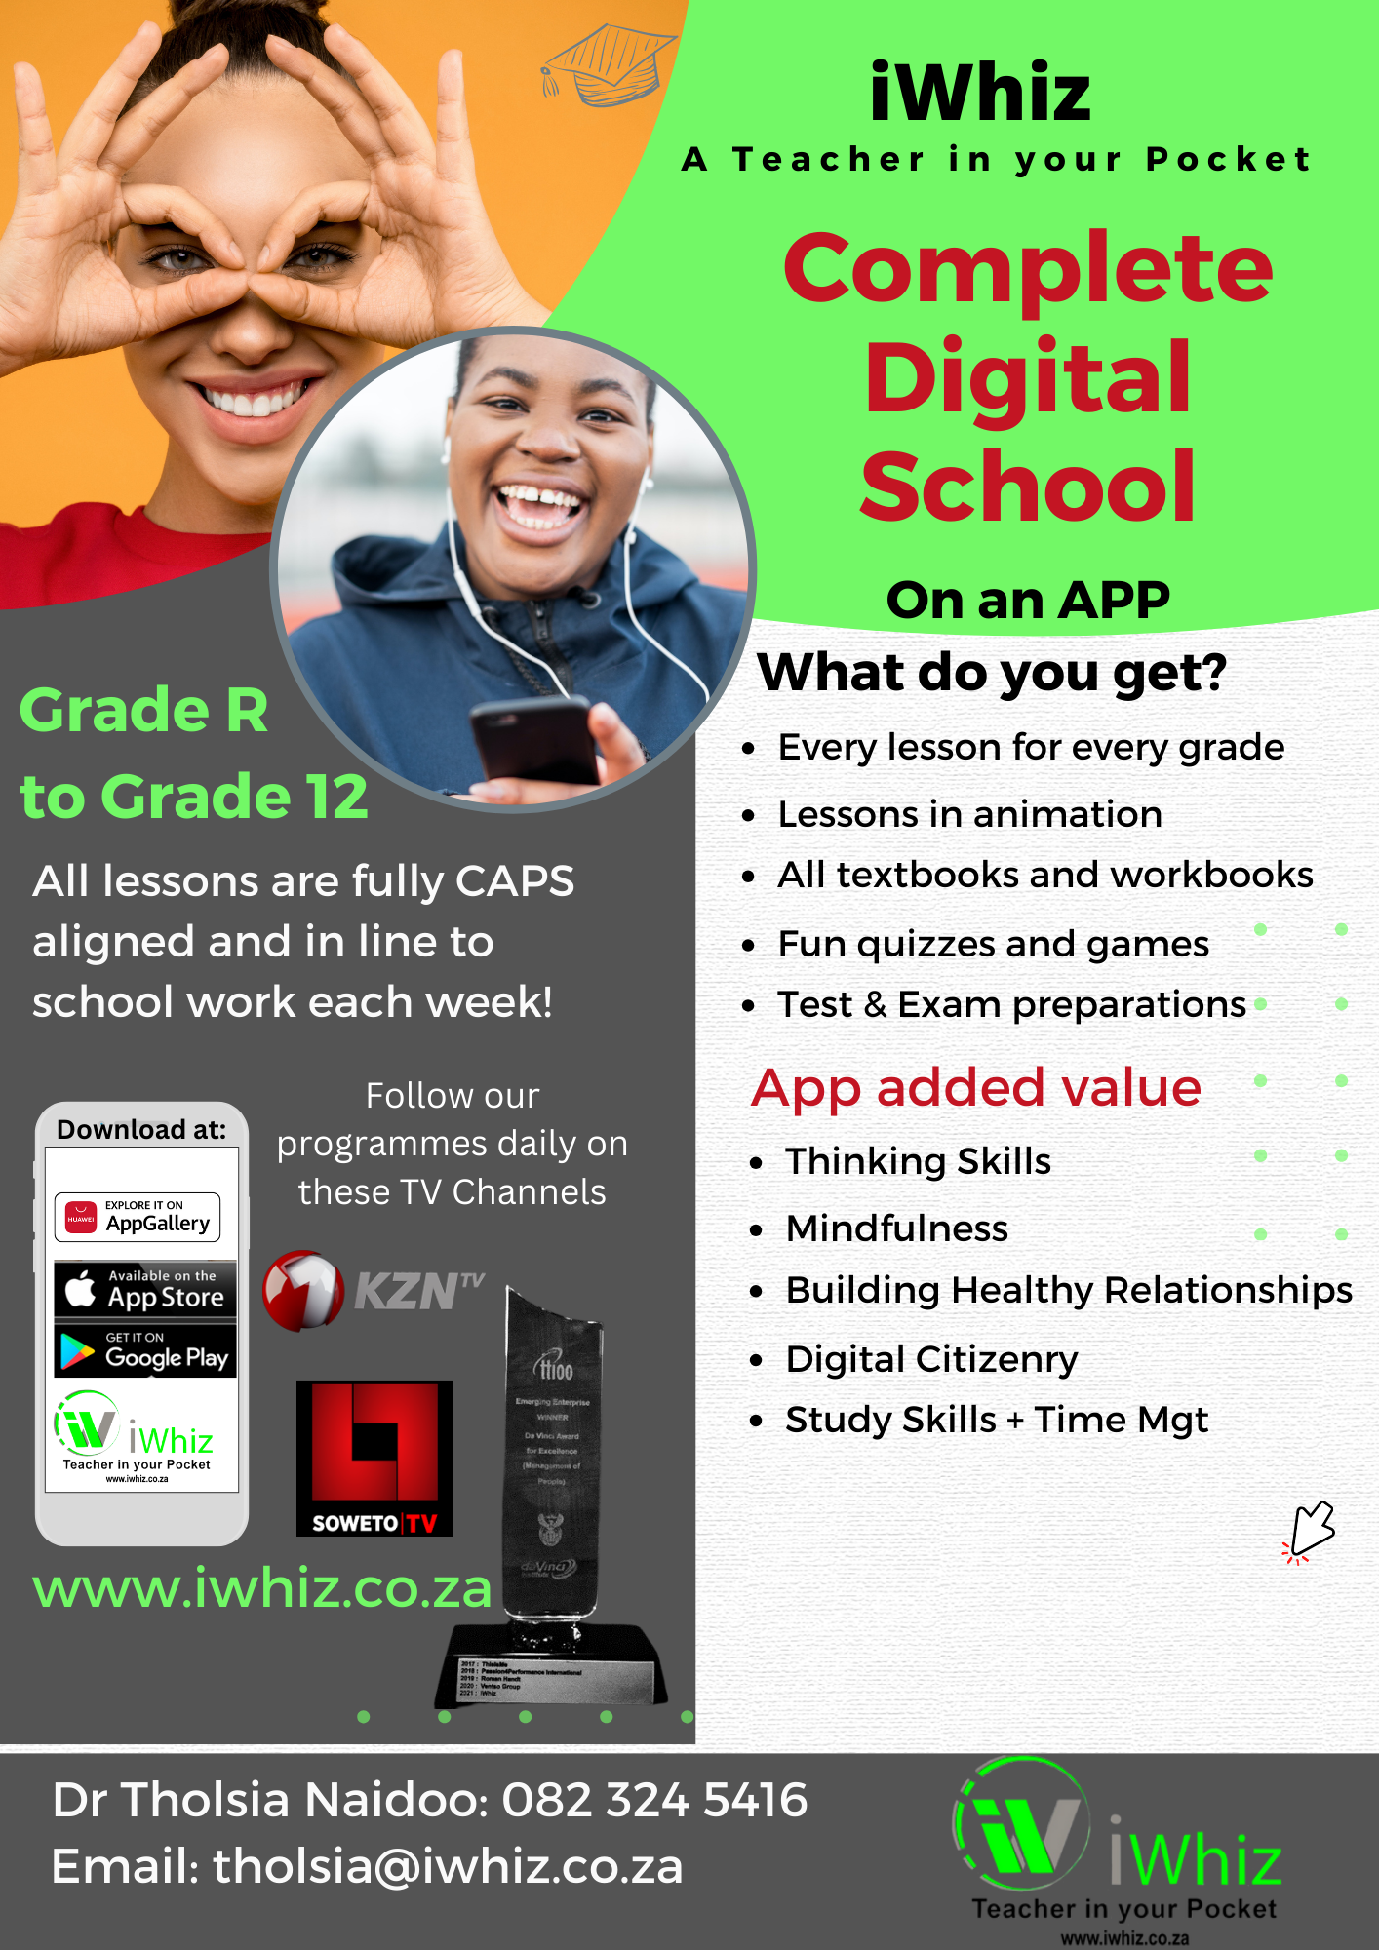

https://www.youtube.com/watch?v=SJ4_nONtYeY
WATCH FOR TESTIMONIALS

WATCH FOR TESTIMONIALS

Time: 2 hours Total Marks: 100
SECTION A: MULTIPLE CHOICE QUESTIONS (20 marks)
Choose the correct answer from the options given. (5 marks each)
- Which of the following is an example of a physical need?
a) Good relationships
b) Education
c) Food and water
d) Belongingness
- Which of the following is a core value in South Africa’s Constitution?
a) Respect for human rights
b) Gender bias
c) Autocracy
d) Individualism
- Which of the following is a consequence of substance abuse?
a) Improved academic performance
b) Personal and relationship problems
c) Better decision-making skills
d) Increased self-esteem
- Which of the following is a factor that influences personal and social development?
a) Financial planning
b) Peer pressure
c) Working conditions
d) None of the above
- What is the purpose of goal setting?
a) To create opportunities for failure
b) To give direction and motivation to one’s life
c) To compete with others
d) To make decisions for others
SECTION B: SHORT ANSWER QUESTIONS (30 marks)
Answer the following questions. (6 marks each)
- Explain the difference between personal and social development.

- What is the role of effective communication in building healthy relationships?

- List three ways in which one can deal with stress in a healthy manner.

- Discuss the importance of setting SMART goals.

- How does the media influence the development of self-esteem in adolescents?

SECTION C: ESSAY QUESTIONS (50 marks)
Answer the following questions. (25 marks each)
- Discuss the impact of peer pressure on the decision-making process of adolescents. Provide examples and suggest strategies to handle peer pressure in a positive way.
- Explain the importance of physical and mental health in personal development. Discuss how maintaining a balanced lifestyle contributes to overall well-being.

