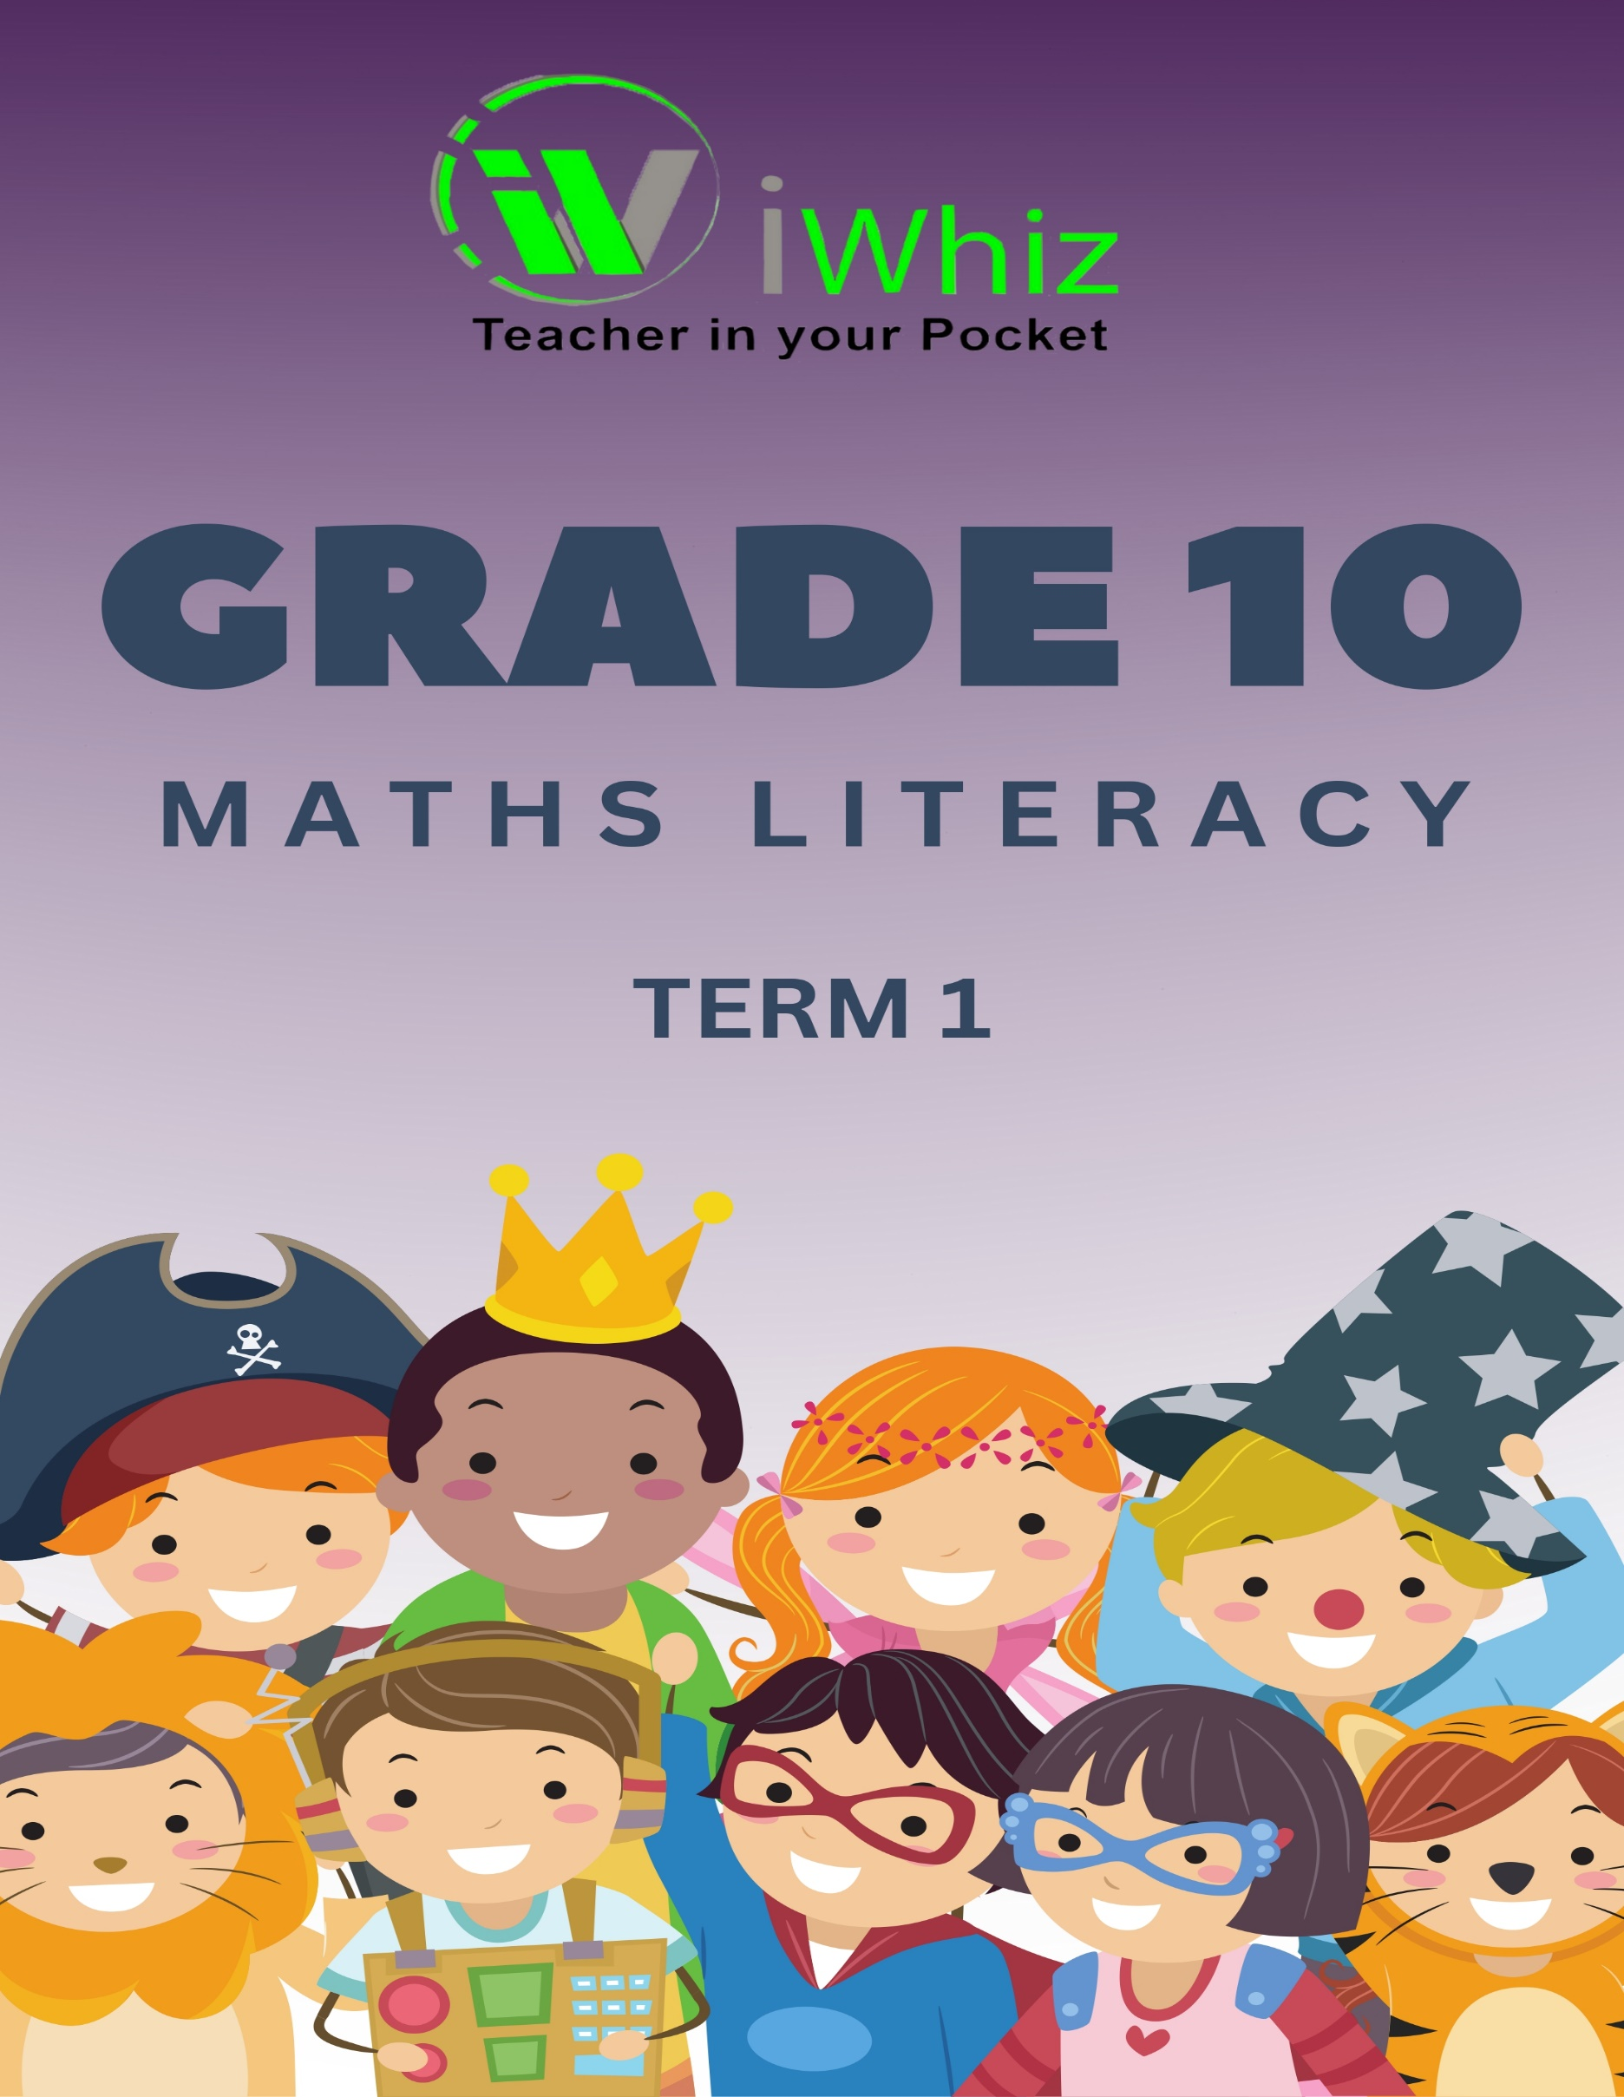
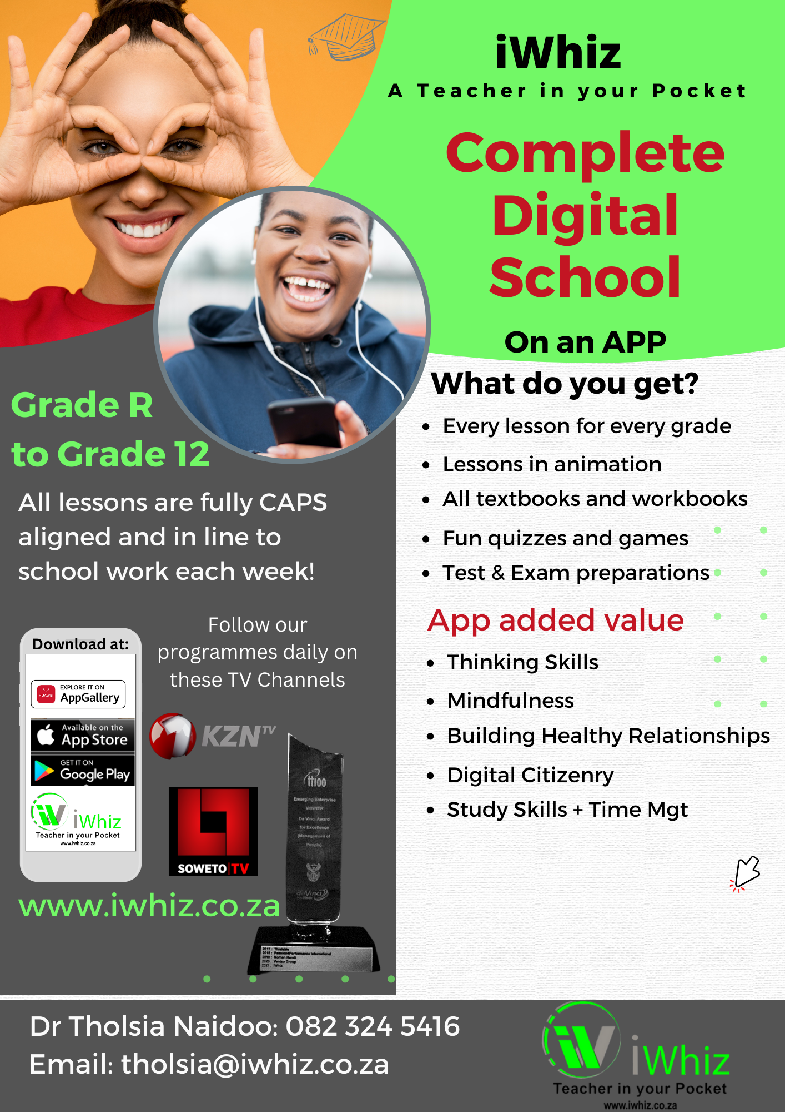

https://www.youtube.com/watch?v=SJ4_nONtYeY
WATCH FOR TESTIMONIALS

WATCH FOR TESTIMONIALS

Assessment (100 Marks)
SECTION A: NUMERIC LITERACY (40 Marks)
- Understanding and Interpreting Numbers (10 Marks)
a) A local store sells an item for R120. A discount of 15% is offered. Calculate the discount in rand and the final price of the item after the discount. (5)
b) A class has 30 learners. 60% of them are girls. How many girls are in the class? (5)

- Fractions, Decimals, and Percentages (15 Marks)
a) Express 0.75 as a percentage. (3)

b) Convert 45% into a fraction in its simplest form. (4)
c) A school received 240 applications for a new course. 80% were accepted. How many applications were not accepted? (4)
d) Simplify the following expression: (8/12) × (3/5) (4)

- Measurement and Conversions (15 Marks)
a) Convert 500 milliliters to liters. (2)

b) A piece of fabric is 3.5 meters long. If 1 meter equals 100 centimeters, how many centimeters is the fabric? (4)

c) Calculate the area of a rectangle with length 15 cm and width 8 cm. (4)
d) A car travels 250 kilometers on 25 liters of petrol. Calculate the distance traveled per liter. (5)

SECTION B: DATA HANDLING AND PROBABILITY (30 Marks)
- Data Collection and Representation (15 Marks)
The ages of 10 learners in a class are as follows: 12, 14, 14, 13, 15, 13, 12, 14, 16, and 12.
    - Calculate the mean, median, and mode of the ages. (6)
b) Draw a bar graph to represent the number of learners in each age group. (Use appropriate scales) (9)

- Probability (15 Marks)
a) A bag contains 5 red, 3 green, and 2 blue marbles. If one marble is picked at random, what is the probability that it will be red? (3)
b) A die is rolled once. What is the probability of rolling a number greater than 4? (3)
c) A deck of 52 playing cards has 12 face cards. If a card is drawn randomly, what is the probability of drawing a face card? (4)
d) In a survey of 200 students, 150 reported that they prefer online learning. What is the probability that a randomly selected student prefers online learning? (5)

SECTION C: FINANCIAL LITERACY (30 Marks)
- Budgeting and Financial Planning (15 Marks)
a) A person earns R8,000 per month. They spend the following on their expenses:
  - Rent: R3,000
  - Groceries: R2,000
  - Transport: R1,000
  - Savings: R500 Calculate the total expenses and determine how much is left for other needs. (5)
b) A student wants to buy a laptop that costs R6,500. They save R750 every month. How many months will it take for the student to save enough to buy the laptop? (5)

c) A loan of R10,000 is taken with an interest rate of 12% per annum. Calculate the amount of interest the borrower will pay after 2 years. (5)

- Interest and Loans (15 Marks)
a) A savings account earns simple interest at a rate of 6% per annum. If R5,000 is deposited for 3 years, calculate the interest earned. (5)
b) A loan of R4,000 is taken at 10% simple interest for 6 months. What is the total amount to be paid back at the end of the loan period? (5)
c) If a shop offers an item at R3,500 and offers a 20% discount, calculate the sale price of the item. (5)

TOTAL: 100 MARKS

