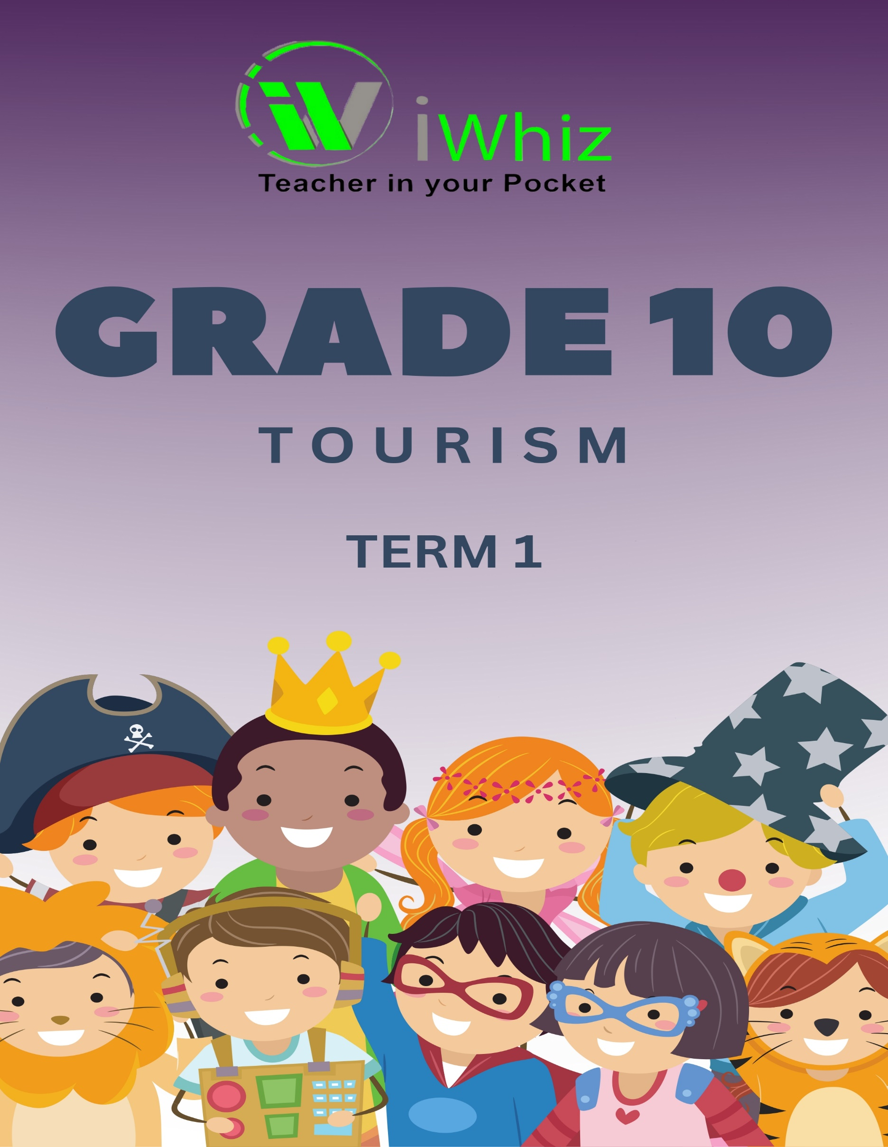


https://www.youtube.com/watch?v=SJ4_nONtYeY
WATCH FOR TESTIMONIALS

WATCH FOR TESTIMONIALS

Total: 100 Marks Time: 2 Hours
SECTION A: Multiple Choice & Short Questions (20 marks)
(Answer all questions. Each multiple choice question is worth 2 marks and short answer is worth 4 marks.)
- Which of the following is an example of a domestic tourist?
A) A South African visiting the UK
B) A person from Durban traveling to Cape Town
C) A French tourist visiting Johannesburg
D) A businessperson from Germany attending a conference in Pretoria
- What does SADC stand for in relation to tourism?
A) South African Development and Conservation
B) Southern African Development Community
C) South African Domestic Council
D) Sustainable African Destination Committee
- Identify two positive and two negative impact of tourism on the environment. (4 marks)

- List four services provided by a travel agency. (4 marks)

- Name two official languages spoken in South Africa that can assist with guiding international tourists. (2 x 2 marks)

- How does tourism affect the economy of an area? (4 marks)

SECTION B: Source-Based Questions (30 marks)
(Study the following extract and answer the questions that follow.)
Extract:
"Tourism in South Africa contributes significantly to the economy. Attractions such as Kruger National Park, Table Mountain, and Robben Island draw international and domestic visitors. However, issues like environmental degradation and seasonality affect tourism growth. Government initiatives, such as the Blue Flag beach program and visa relaxations, aim to promote sustainable tourism."
- Define the term sustainable tourism. (2)

- Based on the extract, name two major tourist attractions in South Africa. (2)

- Explain how seasonality can affect the tourism industry. (4)

- Suggest two ways the government can encourage responsible tourism. (4)

- The extract mentions the Blue Flag beach program. What does this program ensure? (4)

- Discuss one economic and one environmental benefit of tourism in South Africa. (4)

- Why is visa relaxation important for international tourism? (4)

- Identify one threat to tourism in South Africa and suggest a solution. (4)

SECTION C: Map Work & Case Study (30 marks)
Question 15: Map Interpretation (15 marks)
Study the map of South Africa below, showing major tourism regions, and answer the questions that follow.
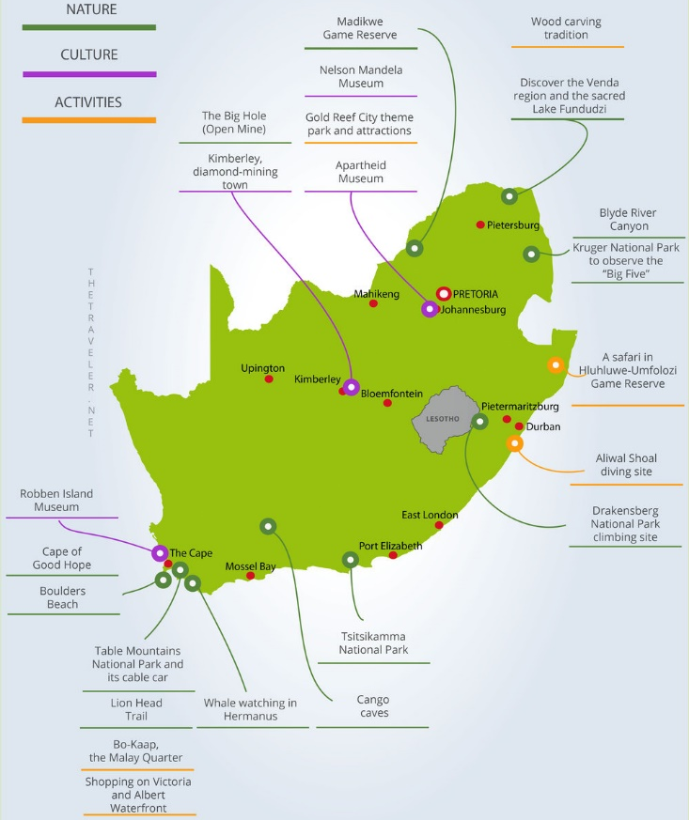
15.1 Identify the two provinces where the Kruger National Park is located. (2)
15.2 Which city is closest to Table Mountain? (2)
15.3 Name the ocean located along the Durban coastline. (2)
15.4 Why is Johannesburg a major tourism hub despite not having a coastline? (4)
15.5 Suggest one challenge faced by the tourism sector in rural areas of South Africa. (5)

Question 16: Case Study (15 marks)
Read the case study on Heritage Tourism in South Africa and answer the questions that follow.
Robben Island, situated off the coast of Cape Town, is a site of immense cultural and historical significance in South Africa. It is most famously known for housing political prisoners, including Nelson Mandela, during apartheid. The island, a symbol of the country's struggle for freedom, has become a popular heritage tourism destination, attracting both local and international visitors. The island was declared a UNESCO World Heritage Site in 1999, recognizing its importance in the global struggle for human rights.
Robben Island served as a prison for political prisoners during the apartheid era, with the most notable being Nelson Mandela, who spent 18 years on the island. The harsh conditions of the prison, combined with the struggles of its prisoners, make the island a powerful symbol of resistance against oppression. Visitors can tour the prison, visit Mandela’s cell, and learn about the lives of the prisoners through guides who are often former inmates themselves. The island also served as a leper colony and a military base in the 19th and 20th centuries.
Heritage tourism at Robben Island offers a chance to educate visitors about South Africa's difficult past and its journey towards reconciliation and democracy. Tourists can experience guided tours that provide insights into the island's history, the lives of the prisoners, and the broader context of apartheid. The tours include visits to important sites such as the infamous prison cell of Nelson Mandela, the quarry where many prisoners worked, and the Robben Island lighthouse.
In addition to the educational value, the island has become a symbol of triumph over adversity, attracting tourists interested in South Africa's history and its journey toward justice and equality. Visitors learn about the resilience of the human spirit in the face of great adversity, and the site also provides a platform for dialogue on human rights and reconciliation.
Heritage tourism on Robben Island plays a vital role in the local economy. The island is a significant source of revenue for the surrounding community and the tourism industry in Cape Town. It generates income through entry fees, boat rides, and merchandise sales. Furthermore, the tourism sector has contributed to job creation for local guides, operators, and staff working on the island. The revenue also supports conservation and maintenance efforts, ensuring the site's long-term sustainability.
Despite its success, heritage tourism at Robben Island faces several challenges. Maintaining the site’s historical integrity while accommodating large numbers of tourists is a delicate balance. Environmental issues, such as the erosion of the island’s natural features, also pose a threat to its preservation. Additionally, ensuring that the tourism experience remains respectful to the heritage and history of the island, while being commercially viable, requires careful management and oversight.
Robben Island serves as an exemplary model of heritage tourism, highlighting the importance of preserving and sharing historical sites to educate and inspire future generations. It stands as a powerful reminder of South Africa’s painful past and its ongoing journey of healing and reconciliation. The island’s transformation into a major heritage tourism destination demonstrates how cultural and historical sites can be preserved while contributing to economic development and fostering greater awareness of social justice and human rights.
16.1 Define heritage tourism. (2)
16.2 Name the UNESCO World Heritage Site mentioned in the case study. (2)
16.3 Explain why preserving heritage sites is important for tourism. (4)

16.4 How can local communities benefit from heritage tourism? (4)
16.5 Propose one marketing strategy to promote heritage tourism in South Africa. (3)

SECTION D: Extended Writing (20 marks)
(Answer ONE of the following questions in a well-structured essay of 150-200 words.)
Question 17: Tourism Careers
Discuss the various career opportunities in the tourism industry, including tour guiding, hospitality, and travel services. Explain the skills required and the importance of professionalism in the sector.
OR
Question 18: Sustainable Tourism Development
Explain the concept of sustainable tourism and discuss three strategies that South Africa can implement to make tourism more sustainable.

TOTAL: 100 MARKS

