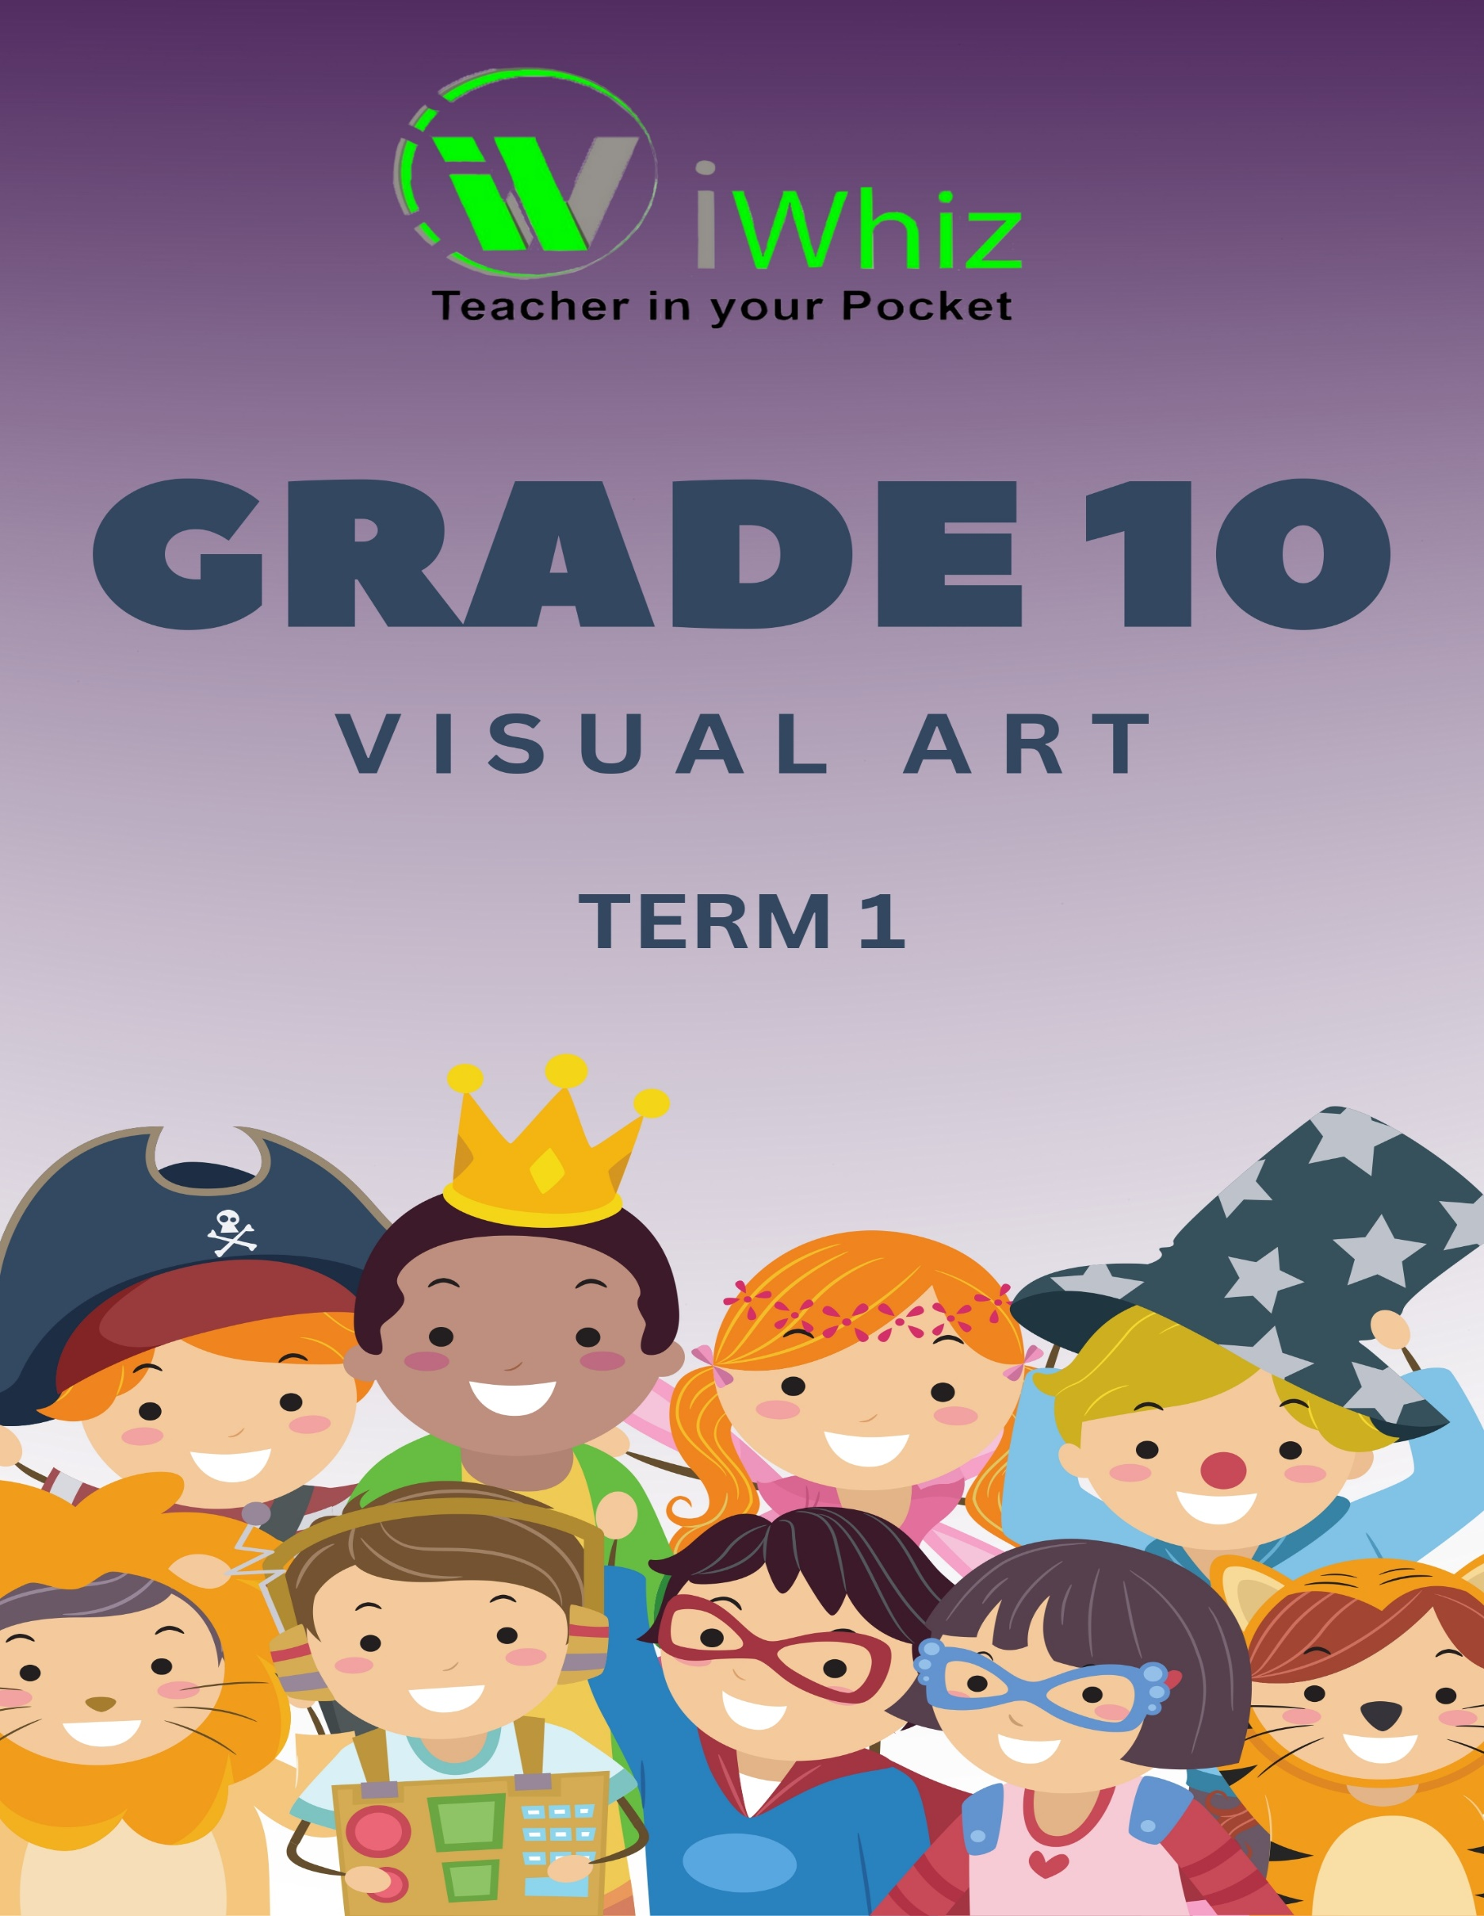


https://www.youtube.com/watch?v=SJ4_nONtYeY
WATCH FOR TESTIMONIALS

WATCH FOR TESTIMONIALS

Time: 2 Hours Total Marks: 100
Section A: Multiple Choice Questions (20 Marks)
Answer all the questions by choosing the correct option. (1 mark per question)
- Which of the following is an example of two-dimensional art?
a) Sculpture
b) Drawing
c) Architecture
d) Installation art
- Which of the following is the most commonly used material in traditional painting?
a) Charcoal
b) Oil paint
c) Clay
d) Wood
- What is the primary purpose of a sketch in visual arts?
a) To display completed work
b) To express final design decisions
c) To plan or explore ideas
d) To color the artwork
- The use of light and shadow in a work of art to create the illusion of depth is called:
a) Contrast
b) Perspective
c) Texture
d) Chiaroscuro
- Which element of art refers to the tactile quality of the surface of an artwork?
a) Shape
b) Texture
c) Line
d) Color
- In a painting, what is the term used to describe the area of the artwork that is in the background?
a) Foreground
b) Middle ground
c) Horizon
d) Background
- What is a complementary color?
a) A color that is next to another color on the color wheel
b) A color that enhances the brightness of a painting
c) A color that is opposite to another color on the color wheel
d) A color that lacks hue
- Which of the following is NOT a characteristic of sculpture?
a) Three-dimensional
b) Created from materials like clay or stone
c) Primarily uses line and color
d) Can be freestanding or in relief
- Which of the following is the focus of abstraction in art?
a) Realistic depiction of the subject matter
b) Emphasis on form, color, and structure rather than the subject
c) Representing the subject in a stylized way
d) Detailed representation of the human figure
- What does the term "composition" in visual arts refer to?
a) The use of only one element in a work of art
b) The way the elements of art are arranged in a work
c) The color palette used in an artwork
d) The texture applied to the artwork

- Which of the following is an example of an organic shape?
a) Square
b) Circle
c) Triangle
d) Leaf
- Which technique involves creating texture through small marks or dots?
a) Cross-hatching
b) Stippling
c) Smudging
d) Blending
- What is the term for the arrangement of objects in a work of art in a way that creates a sense of balance and harmony?
a) Symmetry
b) Proportion
c) Composition
d) Rhythm
- Which of the following artists is considered one of the pioneers of Cubism?
a) Leonardo da Vinci
b) Pablo Picasso
c) Vincent van Gogh
d) Claude Monet
- What is a monoprint?
a) A type of printmaking where multiple copies can be made from one plate
b) A printmaking technique where only one print is made
c) A print made using only a single color
d) A print made on fabric

- Which of the following colors is considered a primary color in subtractive color mixing?
a) Green
b) Blue
c) Purple
d) Yellow
- What is the process of using small pieces of material, such as glass or stone, to create an artwork called?
a) Mosaic
b) Collage
c) Printmaking
d) Drawing
- What is the term for the space around, between, and within objects in an artwork?
a) Line
b) Shape
c) Form
d) Space
- Which of the following best describes a still life painting?
a) An artwork that depicts the human figure
b) An artwork that depicts inanimate objects
c) An artwork that represents abstract forms
d) An artwork that depicts a landscape
- The process of applying a thin layer of paint or ink to paper through a stencil is called:
a) Etching
b) Screen printing
c) Lithography
d) Watercolor

Section B: Short Answer Questions (30 Marks)
Answer all the questions. (3 marks per question)
- Define "proportion" in the context of visual arts and explain its importance in creating realistic artwork.

- What is "perspective" in art? Briefly describe how it can create the illusion of depth.

- Explain the difference between "form" and "shape" in visual arts.

- What is the significance of color theory in art? Mention one example of how artists use it.

- Define "texture" in visual arts. How can texture be created in painting?
- Discuss the role of light and shadow in artwork. How does it contribute to the overall effect?

- Briefly explain the difference between fine art and applied art.

- What is "contrast" in art, and how does it enhance an artwork?

- What is the difference between "abstract art" and "realistic art"?

- Explain how the element of "line" can be used to convey emotion in an artwork.

Section C: Longer Answer Questions (50 Marks)
Answer all the questions. (10 marks per question)
- Discuss the importance of visual arts in cultural expression. Provide examples of how artists have used art to reflect cultural beliefs or historical events.

- Explain the process and techniques involved in creating a collage artwork. What are the key considerations when selecting materials for a collage?

- Choose one of the following art movements: Renaissance, Impressionism, or Cubism. Discuss its key characteristics and how it influenced the development of modern art.

- Describe the process of printmaking, highlighting at least two different techniques used in creating prints. Include an explanation of the materials and tools involved.

- In your opinion, how do artists use symbolism to convey deeper meanings in their work? Choose an artwork or artist and explain how symbolism is used to communicate a message.

