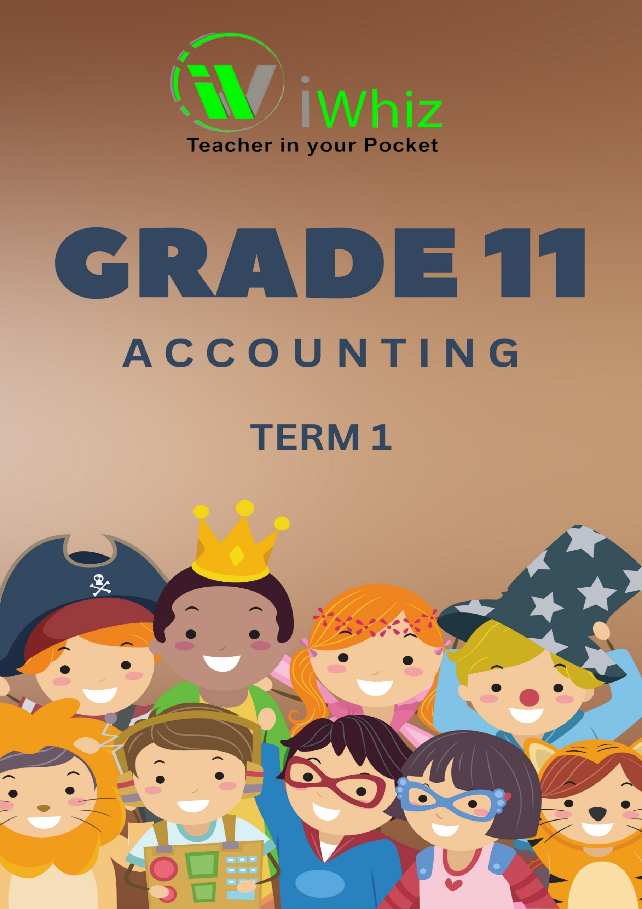



https://www.youtube.com/watch?v=SJ4_nONtYeY
WATCH FOR TESTIMONIALS

WATCH FOR TESTIMONIALS

GRADE 11: ACCOUNTING
TERM 1 TEST
DURATION: 1 HOUR MARKS: 100
INSTRUCTIONS AND INFORMATION
- The question paper consists of TWO questions.

- Answer BOTH questions in the special answer-pages provided.

- Show workings to score part marks.

- Non-programmable calculators may be used.

- You may use a blue/black ink to answer the questions.

- Questions and time-guide is as follows: Manage your time effectively to complete within the prescribed time allocated.

QUESTION 1: 60 Marks, 40 minutes
TOPIC: | ASPECT:
Reconciliations | - Preparing the Bank and Creditors Reconciliation Statements.  - Interpretation and internal Controls.
QUESTION 2: 40 Marks, 20 minutes
TOPIC: | ASPECT:
Fixed Assets | - Calculating and recording fixed asset transactions and depreciation  - Asset disposal.

QUESTION 1: RECONCILIATIONS (60 marks; 40 minutes)
BANK RECONCILIATION
The information relates to Kabi Traders for February 2016.

REQUIRED:
  - Complete the cash journal of Kabi Traders on 29 February 2016. (20)

  - Calculate the Bank Account balance on 29 February 2016. (5)

1.3 Prepare the Bank Reconciliation statement on 29 February 2016. (12)

1.4 Provide TWO reasons why it is important to prepare a bank reconciliation statement
at the end of each month. (4)

1.5 Provide a reason for the date (13 May 2016) written next to cheque 299 on the
January 2016 bank reconciliation statement. (2)

1.6 The owner suspects that cash receipts are not being deposited on a regular basis.
- Provide TWO reasons why it is important that cash be deposited regularly. (4)
- State TWO internal control measures to solve this problem. (4)

INFORMATION:
- The following was taken from the Bank reconciliation statement on 31 January 2016.
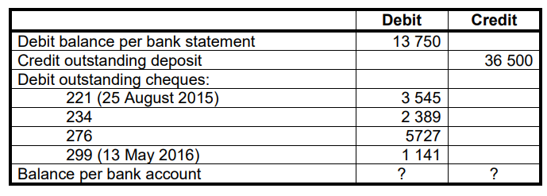

- Provisional totals in the cash journals before the bank statement:
CRJ R44 367 | CPJ R51 234

- A comparison of the Bank reconciliation statement on 31 January 2016 with the Bank Statement of February 2016 from Alma Bank, revealed:

- The outstanding deposit of R36 500 appeared on the February Bank statement.

- Cheque 234 was paid by the bank on 11 February 2016.

- Cheque 276, issued in favour of Mkwanasi Traders in settlement of our account was correctly reflected as R7 525 on the bank statement.

- Cheque 221 for R3 545 was issued to Bloem Soccer club as a donation.

This cheque is stale and must be cancelled. It must be replaced by cheque 389.

- A comparison of the February 2016 Bank statement with the cash journals, showed the following differences:

- The following items appeared on the bank statement only:
- A debit order of R5 480 for the monthly rent in favour Nosi Traders
- A direct deposit of R1 750 from debtor, K. Moroe, on account.
- A stop order for R3 600 for the loan from Alfa Bank.
- Interest of R213 credited.
- An unpaid cheque of R945, drawn by debtor, A. Leeuw, was
dishonoured by the bank on account of insufficient funds.
- Total bank charges, R258.

- A deposit of R32 900 made on 29 February 2016, does not appear on the Bank Statement.

- Cheques from the February 2018 CPJ not yet presented for payment:
- No. 315 for R3 411
- No. 322 for R3 219

- The bank statement showed a balance of R ? on 29 February 2016.

CREDITORS RECONCILIATION
The information relates to Naude Traders.

A statement of account received from BB Suppliers on 25 February 2016 reflects that Naude Traders owes R41 271. The Creditors' Ledger account of BB Suppliers in the books of Naude Traders reflects an outstanding balance of R48 064.

REQUIRED:
1.7 Calculate the correct balance for BB Suppliers in the Creditors' Ledger of Naude
Traders. Use R48 064 as your starting point. (7)

1.8 Prepare a Creditors' Reconciliation Statement on 29 February 2016. (6)

INFORMATION:

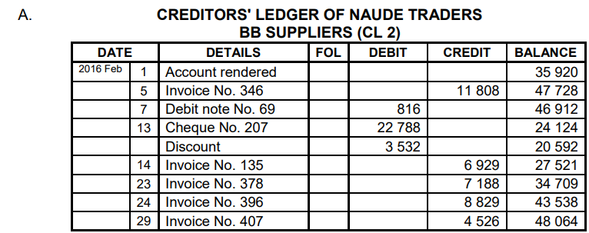

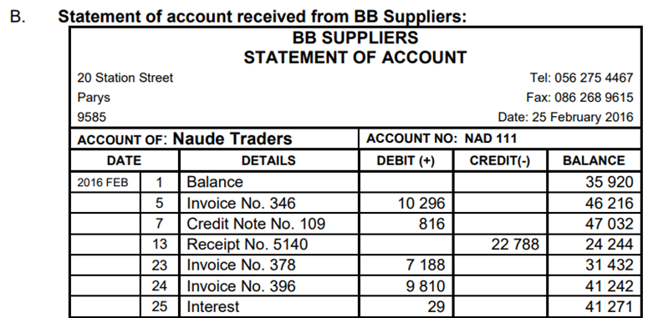

C. ADDITIONAL INFORMATION:
On comparing the statement received from BB Suppliers with the account in the Creditor’s Ledger the following were noted:
- Invoice No. 346 on 5 February 2016 was correctly recorded on the statement received from BB Suppliers.

- The return of goods on 7 February 2016 was incorrectly recorded by BB Suppliers.

- Naude Traders qualified for an early settlement discount with the payment on 13 February 2016. The statement from BB Suppliers did not show the discount. They stated that the discount amount is R2 532 and will be reflected on the next statement.

- Invoice No. 135 for R6 929 was recorded incorrectly in the Creditors' Ledger Account of BB Suppliers. This purchase was made from Mandla Suppliers.

- Naude Traders deducted a trade discount of 10% on invoice No. 396. BB Suppliers did not take this into account. BB Suppliers will correct this error next month.

- BB Suppliers has correctly levied interest of R29 on the account.

- Invoice No. 407 did not appear on the statement received from BB Suppliers as this transaction took place after their statement date.

QUESTION 2: FIXED ASSETS (40 MARKS; 20 MINUTES)
You are provided with information for ABC Traders, a retailer operating in the greater Durban Area. The financial year ends on 28 February each year.

REQUIRED:

2.1 Calculate the total amount for depreciation that will be recorded in the Statement of Comprehensive Income on 28 February 2024. (10)

2.2 Prepare the Asset Disposal account in the General Ledger for the sale of the vehicle on 31 December 2023. (16)

2.3 Calculate the amount that carrying value of vehicles, which will be recorded on the fixed / tangible assets note to the Statement of Financial Position (Balance Sheet) as at 28 February 2024. (10)

2.4 The owner notices that the milage on one of the vehicles is extremely high. He therefore concluded that the driver is misusing the vehicle. (4)
Suggest TWO control measures that can be implements to safeguard the business against misuse of vehicle.

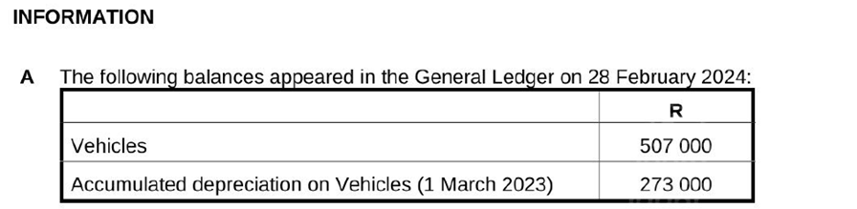

B. An old vehicle, with a cost price of R120 000, was traded in for R18 000, on 31 December 2023. The accumulated depreciation on this vehicle was R 84 000 on 1 March 2023, the beginning of the financial year. A new vehicle was purchased on this date for R261 000. No entry was made for the trade in or purchase of the new vehicle.

C. Vehicles are depreciated at 20% per annum according to the diminishing balance method of depreciation.

TERM 1 TEST- ANSWER BOOK
DURATION: 1 HOUR MARKS: 100

QUESTION 1: | QUESTION 2:
TOTAL MARKS:

QUESTION 1

RECONCILIATION AND CONTROL (60 MARKS; 40 MINUTES)

  - CASH RECEIPTS JOURNAL OF KABI TRADERS – FEBRAURY 2026

Doc | Day | Details | Bank | Sundry Accounts
no. |  |  |  | Amount | Details
 | 31 | Total | 44 367 | 44 367

CASH PAYMENTS JOURNAL OF KABI TRADERS – FEBRUARY 2016

Doc | Day | Details | Bank | Sundry Accounts
no. |  |  |  | Amount | Details
 | 31 | Total | 51 234 | 51 234
(20)

  - Calculate the Bank Account balance on 29 February 2016. (5)

  - BANK RECONCILIATION STATEMENT ON 29 FEBRUARY 2016

 | Debit | Credit
(12)

  - Provide TWO reasons why it is important to prepare a bank reconciliation statement at the end of each month. (4)

  - Provide a reason for the date (13 May 2016) written next to cheque 299 on the January 2016 bank reconciliation statement. (2)

1.6 The owner suspects that cash receipts are not being deposited on a regular basis.
  - Provide TWO reasons why it is important that cash be deposited regularly. (2)

State TWO internal control measures that can be used to solve this problem. (2)

CREDITORS RECONCILIATION

  - CREDITORS’ LEDGER OF NAUDE TRADERS
BB SUPPLIERS (CL7)
Details | Fol. | Debit | Credit | Balance
Balance |  |  |  | 48 064
(7)

1.8 CREDITORS RECONCILIATION STATEMENT ON 29 FEBRUARY 2016
Balance as per Creditor’s Statement | 41 271

QUESTION 2
FIXED ASSETS (40 MARKS; 20 MINUTES)

2.1 Calculate the total amount for depreciation that will be recorded in the Statement of Comprehensive Income (Income Statement).

(10)

2.2
Asset Disposal
(16)

2.3 Calculate the amount that carrying value of vehicles, which will be recorded on the
Fixed / Tangible Asset note to the Statement of Financial Position as at 28 February
2024.

(10)

2.4 The owner notices that the milage on one vehicle is extremely high. He therefore
concluded that the driver is misusing the vehicle.

Suggest TWO control measures that can be implemented to safeguard the business against misuse of vehicles.

(4)

