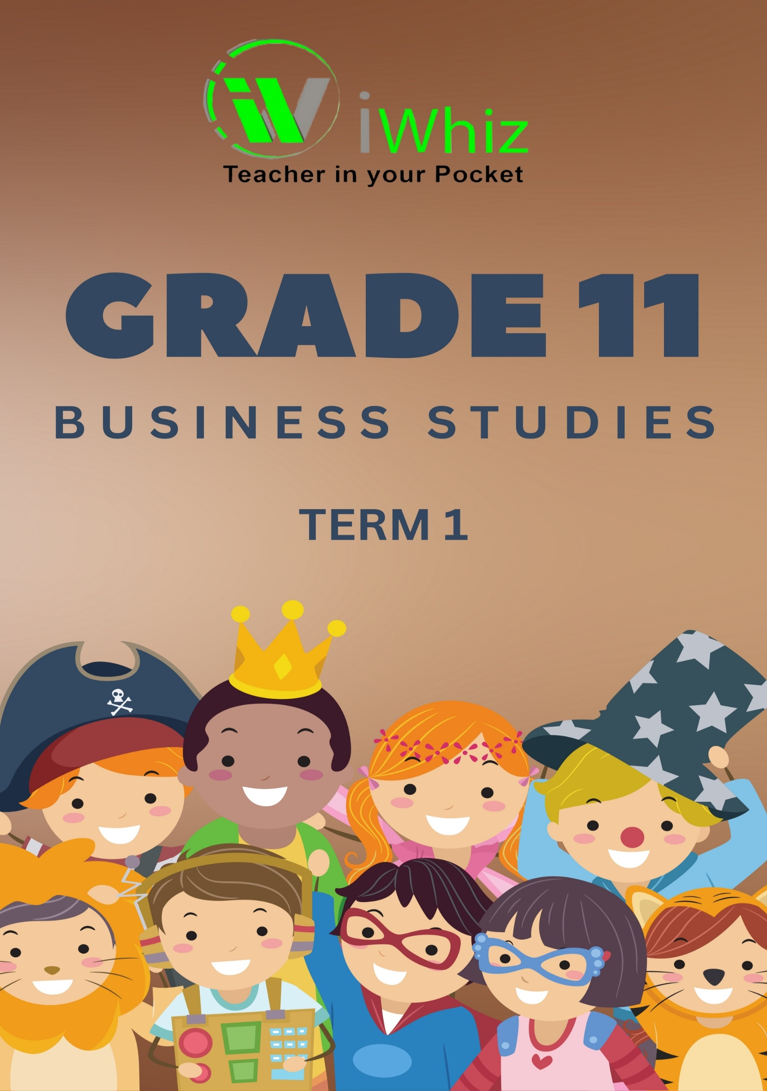



https://www.youtube.com/watch?v=SJ4_nONtYeY
WATCH FOR TESTIMONIALS

WATCH FOR TESTIMONIALS

GRADE 11 Term 1 Test

Total: 100 Marks Duration – 2 hours
INSTRUCTIONS AND INFORMATION

Read the following instructions before answering the questions.

- This question paper consists of THREE sections:

SECTION A: COMPULSORY

SECTION B: Consists of THREE questions
Answer any TWO of the THREE questions in this section.

SECTION C: Consists of TWO questions
Answer ONE of the TWO questions in this section.

- Read the instructions for each question carefully and take particular what is required.

- Number the answers correctly according to the numbering question paper. No marks will be awarded for answers that are numbered incorrectly.

- Except where other instructions are given, answers must be in full sentences.

- Use the mark allocation and nature of each question to determine the length and depth of an answer.

- Use the table below as a guide for mark and time allocation when answering each question.

SECTION | QUESTION | MARKS | TIME
- Objective-type questions COMPULSORY | 1 |  | 20 minutes
- THREE direct / indirect type (Answer any TWO) | 2  3  4 | 20  20  20 | 20 minutes  20 minutes  20 minutes
- Two essay type questions CHOICE (Answer any ONE essay) | 5  6 | 40  40 | 30 minutes  30 minutes
TOTAL |  | 100 | 90 minutes

- You may use a non-programmable calculator.

- Write neatly and legibly.

SECTION A
Question 1
1.1 Multiple Choice Questions: (1 x 5 = 5)
1.1.1 Which economic system is based on supply and demand with minimal
government intervention?
A. Command Economy
B. Market Economy
C. Mixed Economy
D. Traditional Economy

1.1.2 What is the main purpose of a business plan?
A. To manage personal finances
B. To guide business operations and strategy
C. To register a business name
D. To track stock market investments

1.1.3. When a business buys another business at an agreed price, this is known as:
- Acquisition
- merger
- alliances
- takeovers

1.1.4 The... company provides essential services such as water and electricity at
reasonable prices.
- personal liability
- state-owned
- public
- private

1.1.5 The business practice of hiring a party outside a company to perform
services that were traditionally performed in-house by the company's staff
is known as...
- leasing
- partnership
- outsourcing
- franchising

1.2 Match the Column: (1 mark each)
Match the business concept in Column A with its definition in Column B.

Column A | Answer | Column B
1.2.1. Inflation |  | - Sharing of business risks and rewards
1.2.2. Joint Venture |  | - Rise in prices reducing purchasing power
1.2.3. Corporate Social Responsibility |  | - Business contributes to community  development
1.2.4. Franchise |  | - Buying rights to operate under an  established brand
1.2.5. Break-even Point |  | - The point where total revenue equals total cost

1.3 Give the Term: (5 x 2 = 10)

1.3.1 The process of gathering information about consumers’ needs and preferences.

_____________________________________________________________________________

1.3.2 The practice of businesses behaving ethically and contributing to economic
development while improving the quality of life of employees and society at large.

______________________________________________________________________________

1.3.3 A business strategy that involves setting prices low to gain market share quickly.

______________________________________________________________________________

1.3.4 The amount of goods and services produced per unit of labour.

______________________________________________________________________________

1.3.5 The total income generated by a business before any expenses are deducted.

____________________________________________________________________________________________________________________________________________________________

TOTAL SECTION A: [20]

SECTION B
Answer any TWO questions in this section.

Question 2
2.1 Identify and explain the forms of business ownership: (10 marks)

- Define and provide an example of each of the following:

  - Sole Proprietorship

______________________________________________________________________________________________________________________________________________________________________________________________________________________________________________________________________________________________________________________________________________________________________________________________________
(2)
b) Partnership

______________________________________________________________________________________________________________________________________________________________________________________________________________________________________________________________________________________________________________________________________________________________________________________________________
(2)
c) Private Company

______________________________________________________________________________________________________________________________________________________________________________________________________________________________________________________________________________________________________________________________________________________________________________________________________
(2)

d) Public Company

________________________________________________________________________________________________________________________________________________________________________________________________________________________________________________________________________________________________________________________
(2)
e) Cooperative

______________________________________________________________________________________________________________________________________________________________________________________________________________________________________________________________________________________________________________________________________________________________________________________________________
(2)
2.2 Explain four advantages of owning a business:
  - Independence

______________________________________________________________________________________________________________________________________________________________________________________________________________________________________________________________________________________________________________________________________________________________________________________________________
(2)

  - Higher income potential

______________________________________________________________________________________________________________________________________________________________________________________________________________________________________________________________________________________________________________________________________________________________________________________________________
(2)

  - Job creation

______________________________________________________________________________________________________________________________________________________________________________________________________________________________________________________________________________________________________________________________________________________________________________________________________
(2)

2.3 Discuss three effects of an increase in interest rates on businesses:
  - Higher cost of borrowing (2)

______________________________________________________________________________________________________________________________________________________________________________________________________________________________________________________________________________________________________________________________________________________________________________________________________

  - Reduced consumer spending (2)

______________________________________________________________________________________________________________________________________________________________________________________________________________________________________________________________________________________________________________________________________________________________________________________________________

Question 3: BUSINESS ENVIRONMENTS
3.1 Outline any FOUR challenges of the market environment.

__________________________________________________________________________________________________________________________________________________________________________________________________________________________________________________________________________________________________________________________________________________________________________________________________________________________________________________________________________________________________________________________________________________________________
(4)
3.2 Read the scenario below and answer the questions that follow:
PRIMROSE TRADERS(PT), The manager of Primrose Traders (PT) lacked the necessary skills required to resolve a dispute between the business and its supplier. This resulted in its competitor taking its customers away.

Use the table below as a GUIDE to answer QUESTION 3.2.1 and 3.2.2 that follows.
CHALLENGES  (3.2.1) | BUSINESS ENVIRONMENT  (3.2.2)
1.
2.

3.2.1 Quote TWO challenges from the scenario above that PT has to deal with. (2)

________________________________________________________________________________________________________________________________________________________________________________________________________________________________________________________________________________________________________________________

3.2.2 Classify EACH challenge quoted in QUESTION 3.2.1 according to the business environment. (4)

________________________________________________________________________________________________________________________________________________________________________________________________________________________________________________________________________________________________________________________

3.3 Suggest ways in which businesses can be involved in the macro environment.

______________________________________________________________________________________________________________________________________________________________________________________________________________________________________________________________________________________________________________________________________________________________________________________________________
____________________________________________________________________________________________________________________________________________________________
(4)
3.4 Explain ways in which businesses can form power relationships.

__________________________________________________________________________________________________________________________________________________________________________________________________________________________________________________________________________________________________________________________________________________________________________________________________________________________________________________________________________________________________________________________________________________________________
(6)
[20]

Question 4: BUSINESS VENTURES
4.1 Outline aspects that must be included in the prospectus.

________________________________________________________________________________________________________________________________________________________________________________________________________________________________________________________________________________________________________________________________________________________________________________________________________________________________________________________________________________________________________________________________________________________________________________________________________________________________________________
(4)
4.2 Read the scenario below and answer the questions that follow.
BR ALUMINIUM (PTY) LTD(BRA)
BR Aluminium is a private company that specialises in the manufacturing of aluminium doors and windows. BRA made sure to include (Pty) Ltd at the end of their name. They chose a name that is original and not misleading. The company's name also appears on all company documents.

4.2.1 Quote TWO legal requirements of the name of the company from the
scenario above.

__________________________________________________________________________________________________________________________________________________________________________________________________________________________________________
(2)
4.2.2 Explain other legal requirements of the name of the company

____________________________________________________________________________________________________________________________________________________________________________________________________________________________________________________________________________________________________________________________________________________________________________________________________________________________________________________________________________________
(6)
4.3 Discuss the impact of outsourcing for a business.

______________________________________________________________________________________________________________________________________________________________________________________________________________________________________________________________________________________________________________________________________________________________________________________________________________________________________________________________________________________________________________________________________________________________________________________________________________________________________________________________________________________________________________________________________________________________________________________________________________________________________________________________________________________________________________________________________________________________________________________________________________________________________________________

(8)
[20]
TOTAL SECTION B: [40]

SECTION C
Answer ONE questions in this section. Each question is worth 40 marks.

Question 5: Forms of Business Ownership
Discuss the different forms of business ownership, focusing on their characteristics, advantages, and disadvantages. In your response, include:

- The definition and types of business ownership.
- A comparison between a sole proprietorship and a partnership.
- The benefits and challenges of private and public companies.
- How businesses choose the best ownership structure.

______________________________________________________________________________________________________________________________________________________________________________________________________________________________________________________________________________________________________________________________________________________________________________________________________________________________________________________________________________________________________________________________________________________________________________________________________________________________________________________________________________________________________________________________________________________________________________________________________________________________________________________________________________________________________________________________________________________________________________________________________________________________________________________________________________________________________________________________________________________________________________________________________________________________________________________________________________________________________________________________________________________________________________________________________________________________________________________________________________________________________________________________________________________________________________________________________________________________________________________________________________________________________________________________________________________________________________________________________________________________________________________________________________________________________________________________________________________________________________________________________________________________________________________________________________________________________________________________________________________________________________________________________________________________________________________________________________________________________________________________________________________________________________________________________________________________________________________________________________________________________________________________________________________________________________________________________________________________________________________________________________________________________________________________________________________________________________________________________________________________________________________________________________________________________________________________________________________________________________________________________________________________________________________________________________________________________________________________________________________________________________________________________________________________________________________________________________________________________________________________________________________________________________________________________________________________________________________________________________________________________________________________________________________________________________________________________________________________________________________________________________________________________________________________________________________________________________________________________________________________________________________________________________________________________________________________________________________________________________________________________________________________________________________________________________________________________________________________________________________________________________________________________________________________________________________________________________________________________________________________________________________________________________________________________________________________________________________________________________________________________________________________________________________________________________________________________________________________________________________________________________________________________________________________________________________________________________________________________________________________________________________________________________________________________________________________________________________________________________________________________________________________________________________________________________________________________________________________________________________________________________________________________________________________________________________________________________________________________________________________________________________________________________________________________________________________________________________________________________________________________________________________________________________________________________________________________
(40)
Question 6: The Impact of Inflation and Interest Rates on Businesses
Economic factors like inflation and interest rates affect business operations. Write an essay on:
- The definition and causes of inflation.
- How inflation affects businesses and consumers.
- The impact of rising interest rates on business financing.
- Strategies businesses can use to cope with inflation and high interest rates.

________________________________________________________________________________________________________________________________________________________________________________________________________________________________________________________________________________________________________________________
________________________________________________________________________________________________________________________________________________________________________________________________________________________________________________________________________________________________________________________
________________________________________________________________________________________________________________________________________________________________________________________________________________________________________________________________________________________________________________________
________________________________________________________________________________________________________________________________________________________________________________________________________________________________________________________________________________________________________________________
________________________________________________________________________________________________________________________________________________________________________________________________________________________________________________________________________________________________________________________
________________________________________________________________________________________________________________________________________________________________________________________________________________________________________________________________________________________________________________________
________________________________________________________________________________________________________________________________________________________________________________________________________________________________________________________________________________________________________________________
________________________________________________________________________________________________________________________________________________________________________________________________________________________________________________________________________________________________________________________
________________________________________________________________________________________________________________________________________________________________________________________________________________________________________________________________________________________________________________________
________________________________________________________________________________________________________________________________________________________________________________________________________________________________________________________________________________________________________________________
________________________________________________________________________________________________________________________________________________________________________________________________________________________________________________________________________________________________________________________
________________________________________________________________________________________________________________________________________________________________________________________________________________________________________________________________________________________________________________________
________________________________________________________________________________________________________________________________________________________________________________________________________________________________________________________________________________________________________________________
________________________________________________________________________________________________________________________________________________________________________________________________________________________________________________________________________________________________________________________
________________________________________________________________________________________________________________________________________________________________________________________________________________________________________________________________________________________________________________________
________________________________________________________________________________________________________________________________________________________________________________________________________________________________________________________________________________________________________________________
________________________________________________________________________________________________________________________________________________________________________________________________________________________________________________________________________________________________________________________
________________________________________________________________________________________________________________________________________________________________________________________________________________________________________________________________________________________________________________________
________________________________________________________________________________________________________________________________________________________________________________________________________________________________________________________________________________________________________________________
____________________________________________________________________________________________________________________________________________________________
[40]
TOTAL SECTION B: [40]

