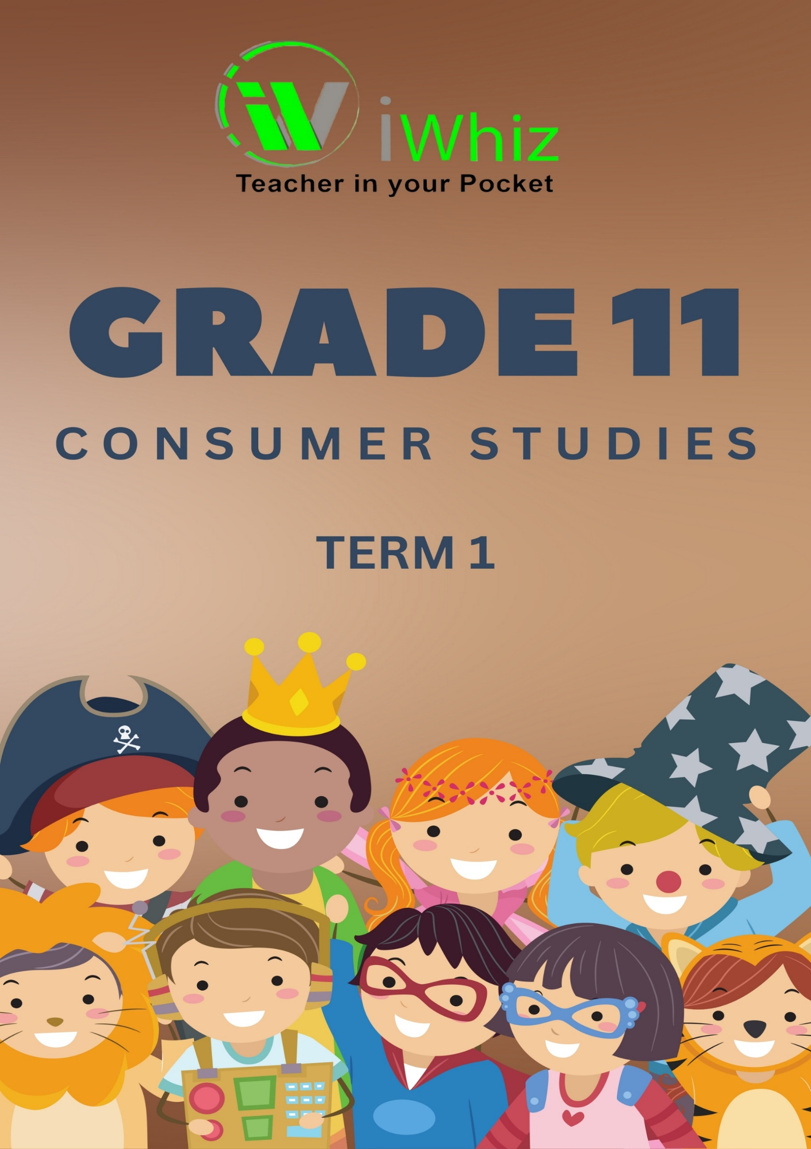



https://www.youtube.com/watch?v=SJ4_nONtYeY
WATCH FOR TESTIMONIALS

WATCH FOR TESTIMONIALS

Grade 11 – Term 1 Test

Marks – 80 TIME – 1 Hour

INSTRUCTIONS AND INFORMATION
Read the following instructions carefully before answering the questions.
- Answer ALL the questions.

- Start the answers to each question at the top of a NEW page.

- Number the answers correctly according to the numbering system used in this question paper.

- Present your answers according to the instructions of each question.

- Do not use informal language and slang.

- Use SHORT, well-structured sentences.

- Use the correct terminology.

- Write neatly and legibly.

Question 1
1.1 Various options are given as possible answers to the following questions.
1.1.1 To create a casual, relaxed effect in a home ... lines should be used.
A. horizontal
B. vertical
C. curved
D. diagonal

1.1.2 Shape refers to...
A. an area enclosed by lines.
B. the space within the shape.
C. the unoccupied area between the lines.
D. the surface quality of an object.

1.1.3 To create a calm, restful ambience in a room, use ...
A. diagonal lines.
B. warm colours.
C. cool colours.
D. smooth, shiny surfaces.

1.1.4 Identify the secondary colours:
A. Orange, green, purple
B. Red, blue, orange
C. Yellow, purple, green
D. Blue, red, yellow

1.1.5 Different objects that make up the design are arranged in a circle around a
central point.
A. Symmetrical balance
B. Asymmetrical balance
C. Radiation
D. Radial balance

1.1.6 Which colour combination should be used to achieve an analogous colour
harmony?
A. Cream, gold and golden brown
B. White, navy blue and red
C. Blue-purple, purple and red-purple
D. Brown, orange and blue

1.1.7 How many secondary colours are on the colour wheel?
A. 5
B. 6
C. 3
D. 4

1.1.8 Complex multi-coloured designs woven with coloured weft yarns and white
warp yarns.
A. Dobby weave
B. Jacquard weave
C. Basket weave
D. Twill weave

1.1.9 Sanforising is a process that...
A. Reduces piling
B. Conducts electricity
C. Makes fabric crease resistant
D. Prevents garments sinking in the wash

1.1.10 The following statement is not considered a statement of budgeting
A. Prioritize the families’ basic needs
B. File your purchase slips with guarantees
C. Put money aside for unexpected incidents
D. Pay the credit card account when you can.

[20]

Question 2
2.1 Match an expense category in COLUMN A with an example of this type of expense in
COLUMN B.

(Write only the number from COLUMN A and the corresponding letter from COLUMN B.)
COLUMN A | COLUMN B
2.1.1 Monthly car repayment | A. Unexpected hospital bill
2.1.2 Electricity bill | B. Money set aside for investment
2.1.3 Buying a new pair of shoes | C. Fixed expense
2.1.4 Repairing a leaking pipe | D. Variable expense
2.1.5 Money saved for future use | E. Emergency expense
 | F. Optional expense
 | G. Compulsory expense

(10)
2.2 Complete the following table on different sources of income.
Type of Income | Source of Income
2.2.1 Income received from Shoprite
Checkers shares.

2.2.2 Income received from a community
savings club.

2.2.3 Income received from selling
handmade jewellery

2.2.4 Income received from the
government for child support.

2.2.5 Income received from working as a
gardener.

(10)

Question 3: Clothing
3.1 Explain the following terms:

3.1.1 Primary colour scheme

________________________________________________________________________________________________________________________________________________________________________________________________________________________________________________________________________________________________________________________
(2)
3.1.2 Hue of colour

________________________________________________________________________________________________________________________________________________________________________________________________________________________________________________________________________________________________________________________
(2)
3.1.3 Value of colour

______________________________________________________________________________________________________________________________________________________________________________________________________________________________________________________________________________________________________________________________________________________________________________________________________
(2)

3.2 Fabric Construction and Finishing
3.2.1 Identify and name the method of fabric construction illustrated in Sketch A below.
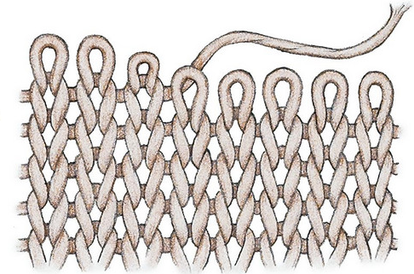
________________________________________________________________________________________________________________________________________________________________________________________________________________________________________________________________________________________________________________________
(2)
3.2.2 Fabric finishes help improve the durability and comfort of textiles. Explain
how sanforisation improves the performance of a fabric.

__________________________________________________________________________________________________________________________________________________________________________________________________________________________________________________________________________________________________________________________________________________________________________________________________________________________________________________________________________________________________________________________________________________________________
(3)

3.3 Explain how the following fabric properties affect the comfort of clothing:
3.3.1 Breathability

________________________________________________________________________________________________________________________________________________________________________________________________________________________________________________________________________________________________________________________
(2)
3.3.2 Drapability

________________________________________________________________________________________________________________________________________________________________________________________________________________________________________________________________________________________________________________________
(2)

3.4 Clothing Care and Maintenance
3.4.1 Why is it important to follow fabric care labels when washing clothes?

________________________________________________________________________________________________________________________________________________________________________________________________________________________________________________________________________________________________________________________
(2)

4.4.2 List two advantages of using synthetic fabrics over natural fabrics in
clothing production.

________________________________________________________________________________________________________________________________________________________________________________________________________________________________________________________________________________________________________________________
(4)

4.4.3 Identify one environmentally friendly way to dispose of old clothing.
________________________________________________________________________________________________________________________________________________________________________________________________________________________________________________________________________________________________________________________
(2)

4.5 Describe TWO characteristics of each of the following body shapes. Tabulate your
answer as follows:
Body shape | Characteristics
4.4.1 Triangular or A-frame | ______________________________________________  ______________________________________________  ______________________________________________
4.4.2 Hourglass frame | ______________________________________________  ______________________________________________  ______________________________________________
4.4.3 Apple or oval frame | ______________________________________________  ______________________________________________  ______________________________________________
(6)
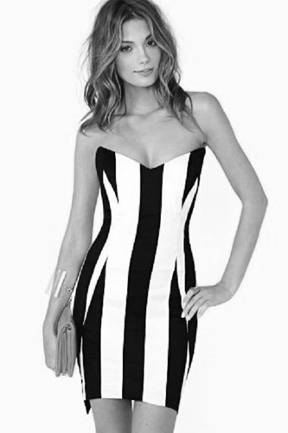
4.7 Study the pictures A and B below and answer the questions that follow.


Picture A Picture B

4.5.1 Explain how rhythm has been achieved in picture A.
________________________________________________________________________________________________________________________________________________________________________________________________________________________________________________________________________________________________________________________
(2)

4.5.2 Evaluate the suitability of the outfit in picture A for a tall and very slender
man.
__________________________________________________________________________________________________________________________________________________________________________________________________________________________________________________________________________________________________________________________________________________________________________________________________________________________________________________________________________________________________________________________________________________________________________________________________________________________________________________________________________________________________________________________________________________________________________________________________________________________________________________________________________________________
(5)

4.5.3 Analyse the suitability of the outfit in picture B for a short and stout lady.
__________________________________________________________________________________________________________________________________________________________________________________________________________________________________________________________________________________________________________________________________________________________________________________________________________________________________________________________________________________________________________________________________________________________________
(4)
GRAND TOTAL: 80

