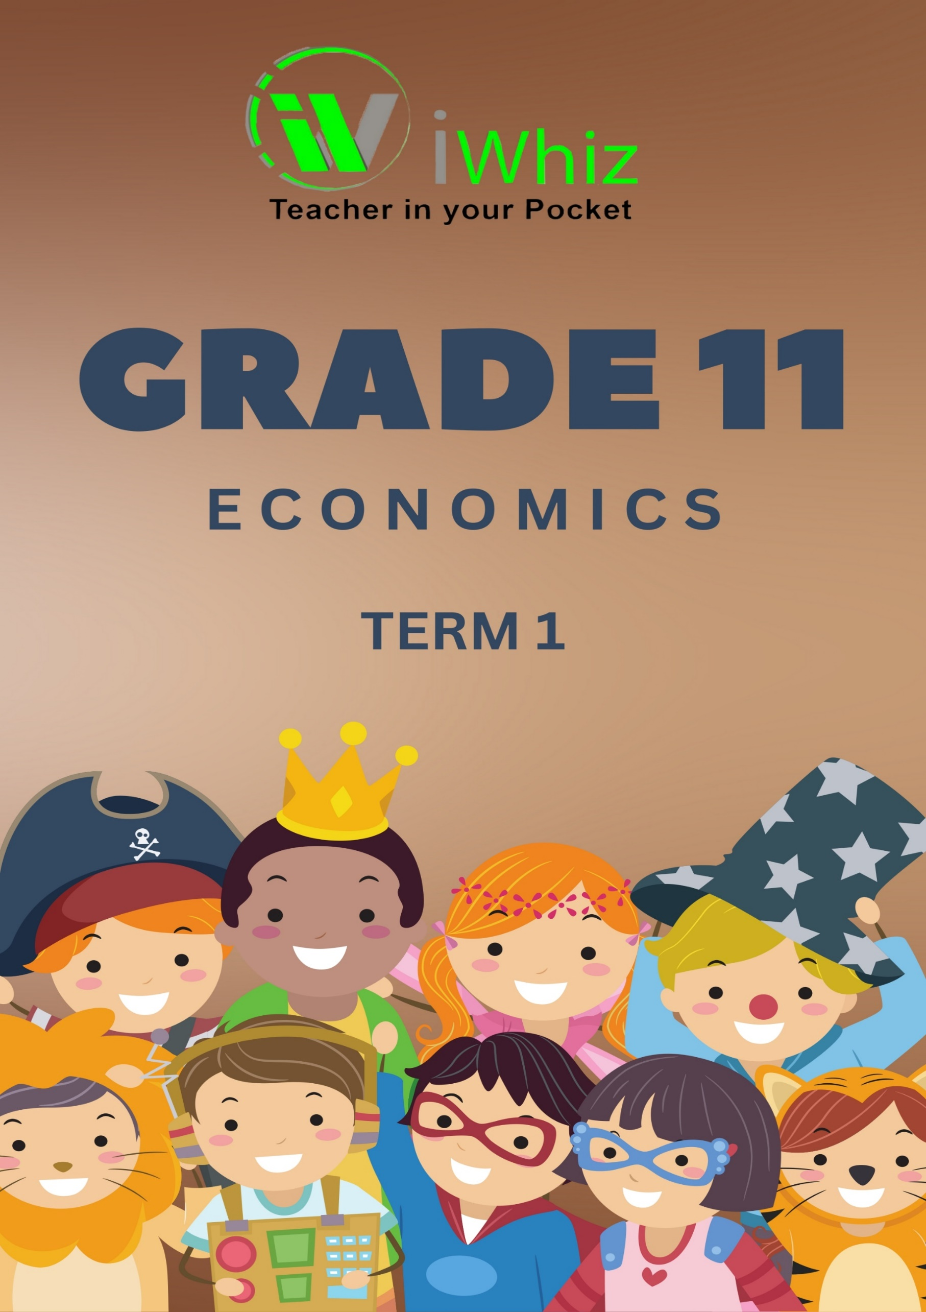



https://www.youtube.com/watch?v=SJ4_nONtYeY
WATCH FOR TESTIMONIALS

WATCH FOR TESTIMONIALS

GRADE 11 ECONOMICS TERM 1

Total Marks – 100 Duration – 2 Hours

INSTRUCTIONS AND INFORMATION
- This question paper consists of TWO SECTIONS:
SECTION A
SECTION B

- Number your answers correctly according to the numbering system used in this question paper.

- Read the questions CAREFULLY and star EACH question on a new page.

- Answer the questions in full sentences and ensure that the format, content and context of your responses comply with the cognitive requirements of the questions.

- Use only blue or black ink to write out or type out your answers.

- Non-programmable pocket calculators may be used.

- Write neatly and legibly.

SECTION A: [58 MARKS]

QUESTION 1: [1 x 7 = 7 MARKS]

Match the description in Column A with the word(s) in Column B. Write the correct answer next to the question number 1.1 – 1.7.

Column A | Answers | Column B
1.1 The remuneration for capital |  | A. Wages
1.2 The remuneration for land |  | B. Profit
1.3 The process transforming inputs into useable products that can satisfy a need. |  | C. Rent
1.4 The remuneration for labour. |  | D. Shares
1.5 The reward an entrepreneur receives for his hard work and the risk he is taking. |  | E. Interest
1.6 An example of inputs. |  | F. Factory building
1.7 An example of financial capital |  | G. Raw material

QUESTION 2: [1 x 12 = 12 MARKS]
Multiple Choice Questions
Read the questions below and select the most appropriate answer from the options given. E.g. 2.1 A

  - The remuneration or payment made for the skill to combine natural resources, labour and capital is called_____________
- economic rent.
- profit.
- wages.
- salary.

  - Money invested in machines and equipment that will be used in the production process____________
- wages
- capital goods.
- costs.
- capital

  - Individuals that use factors of production to start and manage a business.
- capital
- entrepreneur
- consumers
- households

  - Which sector of the economy removes or harvests products directly from the earth to extract raw materials or food?
- Secondary
- Primary
- Tertiary
- Linear

  - Which sector of the economy provides the goods and services to businesses and consumers?
  - Primary
  - Tertiary
  - Secondary
  - Quaternary

  - Which sector of the economy takes raw materials from the primary sector and manufactures them into goods?
  - Primary
  - Secondary
  - Tertiary
  - Quaternary

  - Which activity belongs in the primary sector?
- Automobile production
- Fishing
- Entertainment
- Transportation

  - The remuneration or payment made for the skill to combine natural resources, labour and capital is called____________
- economic rent.
- profit.
- wages.
- salary.

  - Money invested in machines and equipment that will be used in the production process …
- wages
- capital goods.
- costs.
- capital

  - Michael L. Smith was awarded the Physiology and Entomology Nobel prize in 2015 for his research on the sting of honey bees. He contributed to which modern economic sector?
- Secondary
- Tertiary
- Quaternary
- Quinary

  - The president of a land-grant college would be a part of which modern economic sector?
- Secondary
- Tertiary
- Quaternary
- Quinary

  - Homeowners can sell their houses if they wish so:
- Centrally planned economy
- Market economy
- Mixed economy
- Market economy

QUESTION 3: [31 MARKS]
3.1 Why is capital formation so important for the economy of South Africa? (5)

__________________________________________________________________________________________________________________________________________________________________________________________________________________________________________________________________________________________________________________________________________________________________________________________________________________________________________________________________________________________________________________________________________________________________

3.2 How is the government trying to empower previously disadvantaged groups? (4)

__________________________________________________________________________________________________________________________________________________________________________________________________________________________________________________________________________________________________________________________________________________________________________________________________________________________________________________________________________________________________________________________________________________________________

3.3 Name THREE characteristics of an entrepreneur. (3)

________________________________________________________________________________________________________________________________________________________________________________________________________________________________________________________________________________________________________________________

3.4 Mention any FOUR forms of community participation in local economic planning and activities. (4)

__________________________________________________________________________________________________________________________________________________________________________________________________________________________________________________________________________________________________________________________________________________________________________________________________________________________________________________________________________________________________________________________________________________________________

3.5 Name TWO social services provided by the government. (2)
______________________________________________________________________________________________________________________________________________________________________________________________________________________________________________________________________________________________________________________________________________________________________________________________________

3.6 Study the paragraph below and answer the questions that follow.
MIXED ECONOMIC SYSTEM
A mixed economic system is a system that combines aspects of both capitalism and socialism. A mixed economic system protects private property and allows a level of economic freedom in the use of capital but also allows for governments to interfere in economic activities in order to achieve social aims.
[Source: https://www.investopedia.com/]

3.6.1 What type of economic system is referred to in the above extract? (1)
__________________________________________________________________________________________________________________________________________________________________________________________________________________________________________

3.6.2 Who allocates the resources in the above extract? (2)
__________________________________________________________________________________________________________________________________________________________________________________________________________________________________________

3.6.3 Briefly describe the term economic system. (2)
________________________________________________________________________________________________________________________________________________________________________________________________________________________________________________________________________________________________________________________

3.6.4 Explain how service delivery can be improved in South Africa. (4)
__________________________________________________________________________________________________________________________________________________________________________________________________________________________________________________________________________________________________________________________________________________________________________________________________________________________________________________________________________________________________________________________________________________________________

3.6.5 Why is South Africa regarded as a mixed economy? (4)
__________________________________________________________________________________________________________________________________________________________________________________________________________________________________________________________________________________________________________________________________________________________________________________________________________________________________________________________________________________________________________________________________________________________________

QUESTION 4 [1 x 8 = 8 MARKS]
4.1 Indicate whether the following descriptions refer to skilled, semi-skilled or unskilled labour.

- Typist

____________________________________________________________________________________________________________________________________________________________

- Mechanic
____________________________________________________________________________________________________________________________________________________________

- Domestic worker

____________________________________________________________________________________________________________________________________________________________

- Factory cleaner

____________________________________________________________________________________________________________________________________________________________

- Nurse

____________________________________________________________________________________________________________________________________________________________

- Artisan in training

____________________________________________________________________________________________________________________________________________________________

- Lawyer

____________________________________________________________________________________________________________________________________________________________

- Teachers

____________________________________________________________________________________________________________________________________________________________

SECTION B: {42 MARKS}

QUESTION 1: [11 MARKS]

Read the scenario and then answer the questions that follow.
Precious Ndaba works for a cleaning business owned by Ms Betty Zulu in the rural areas of KwaZulu-Natal. She is a very hard worker but has AIDS and is constantly ill during the winter months. Her immune system is not able to protect her from colds and flu and she has already used all her sick leave for the 36 months cycle. Her employer decided not to pay her for the four days sick leave she has taken the previous week, because it is four days more than the maximum sick leave that she is entitled to. She never brings a medical certificate as proof. Precious is very upset and does not know what to do.

  - Name the labour law that will give Precious the information she needs to know about sick leave. (1)

____________________________________________________________________________________________________________________________________________________________

  - Describe what the law says about medical certificates. (3)

____________________________________________________________________________________________________________________________________________________________
______________________________________________________________________________________________________________________________________________________________________________________________________________________________________________________________________________________________________________________________________________________________________________________________________

  - Did the employer act within the rules of the law? Explain your answer. (4)

__________________________________________________________________________________________________________________________________________________________________________________________________________________________________________________________________________________________________________________________________________________________________________________________________________________________________________________________________________________________________________________________________________________________________

2. Give ONE term for each of the following descriptions. Write only the time next to the
question number. Acronyms and abbreviations will NOT be accepted.

2.1 People who are excluded from mainstream economic activities and are seen as
worse off than compared to others. (1)

____________________________________________________________________________________________________________________________________________________________

2.2 The use of text to provide public goods and services. (1)

____________________________________________________________________________________________________________________________________________________________

2.3 In economic systems which factors of production are viewed as communal
property. (1)
____________________________________________________________________________________________________________________________________________________________
QUESTION 3: [31 MARKS]
3.1 Answer the following questions.

3.1.1 Mention any two types of indirect taxes. (2)
________________________________________________________________________________________________________________________________________________________________________________________________________________________________________________________________________________________________________________________

3.1.2 Why is it important to use added value method when calculating gross domestic product (GDP) figures? (4)

____________________________________________________________________________________________________________________________________________________________________________________________________________________________________________________________________________________________________________________________________________________________________________________________________________________________________________________________________________________

3.2 Study the table below and answer the questions that follow.

THE INCOME METHOD
Value added (GVA) | 2017 | 2018
Compensation of employees | 875 162 | 874 395
Net Operating Surplus | 638 782 | (A)
Compensation of Fixed Capital | 236 380 | 197 910
Gross Value Added at Factor Cost | 1 750 234 | 1 748 800

3.2.1 Identify the item that represents remuneration for labour in the table. (1)

____________________________________________________________________________________________________________________________________________________________

3.2.2 Determine the difference between gross value added for 2017 and 2018. (4)
____________________________________________________________________________________________________________________________________________________________________________________________________________________________________________________________________________________________________________________________________________________________________________________________________________________________________________________________________________________

    - Describe the term gross domestic product. (4)

____________________________________________________________________________________________________________________________________________________________________________________________________________________________________________________________________________________________________________________________________________________________________________________________________________________________________________________________________________________

    - What is the importance of compensation of fixed capital on the national accounts? (4)

____________________________________________________________________________________________________________________________________________________________________________________________________________________________________________________________________________________________________________________________________________________________________________________________________________________________________________________________________________________

  - Explain what is meant by the primary sector. (2)

______________________________________________________________________________________________________________________________________________________________________________________________________________________________________________________________________________________________________________________________________________________________________________________________________

  - Name five reasons why the primary sector is important to South Africa. (5)

____________________________________________________________________________________________________________________________________________________________________________________________________________________________________________________________________________________________________________________________________________________________________________________________________________________________________________________________________________________

3.5 Provide one example of how the South African government is trying to redress discrimination in the primary sector. (1)

____________________________________________________________________________________________________________________________________________________________________________________________________________________________________________________________________________________________________________________________________________________________________________________________________________________________________________________________________________________

  - Explain what is meant by the term secondary sector. (2)

____________________________________________________________________________________________________________________________________________________________________________________________________________________________________________________________________________________________________________________________________________________________________________________________________________________________________________________________________________________

  - Give four reasons why the secondary sector industry is important to the economy. (4)

____________________________________________________________________________________________________________________________________________________________________________________________________________________________________________________________________________________________________________________________________________________________________________________________________________________________________________________________________________________

- How can South Africa benefit from processing its natural resources into finished goods before exporting them? (5)

____________________________________________________________________________________________________________________________________________________________________________________________________________________________________________________________________________________________________________________________________________________________________________________________________________________________________________________________________________________

