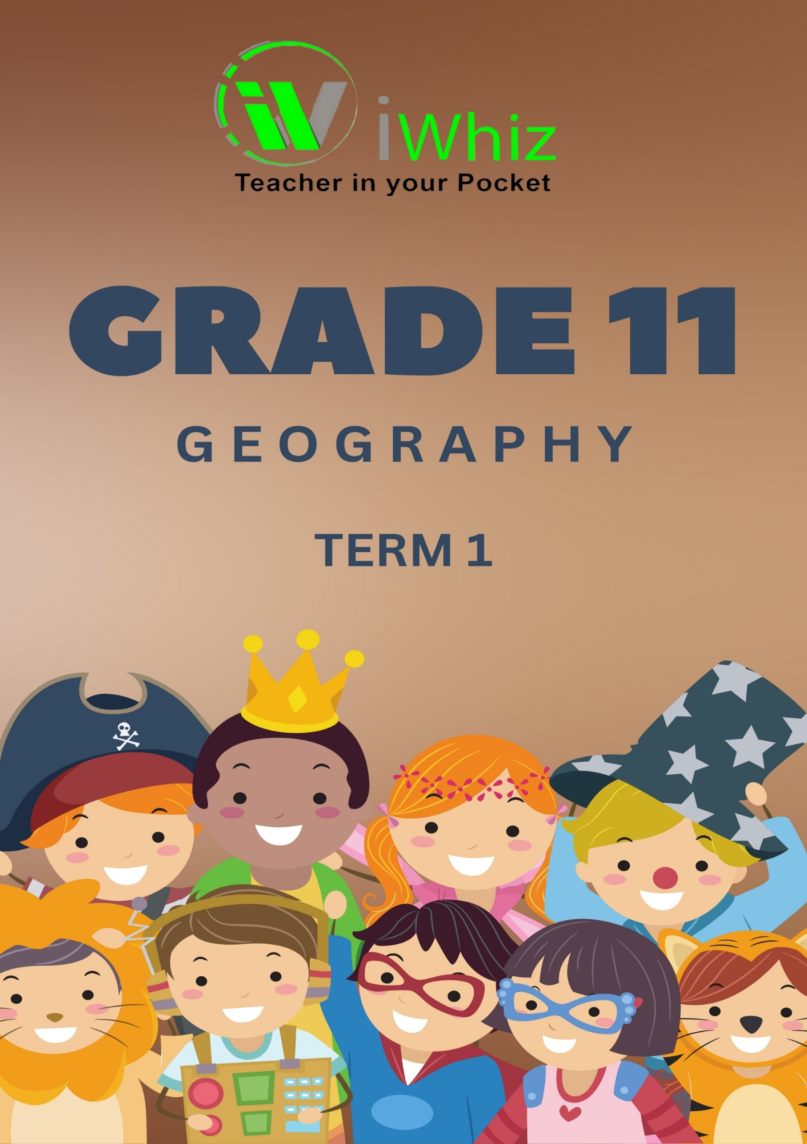



https://www.youtube.com/watch?v=SJ4_nONtYeY
WATCH FOR TESTIMONIALS

WATCH FOR TESTIMONIALS

MARCH TEST – Term 1

Total marks – 70 DURATION: 1.5 HOURS

INSTRUCTIONS AND INFORMATION
- This paper consists of:
- Section A – Theory [35 marks]
- Section B - Map-work [35 marks]

- Write neatly and legibly.
- Read ALL the instructions carefully.
- Answer ALL the questions.
- Start EACH section on a NEW page.
- Number the answers correctly according to the numbering system used in this question paper.
- Pay special attention to spelling and sentence construction.

SECTION 1 - THEORY
QUESTION 1: GLOBAL AIR CURCULATION
- Study the figure below showing global circulation and answer the questions that follow.

Figure 1.
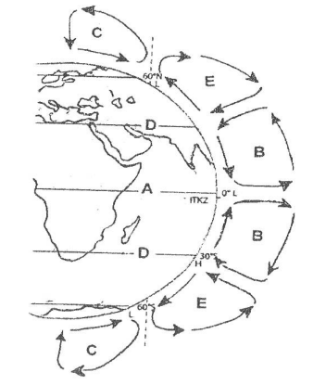

  - Identify surface winds at cell B and C.

__________________________________________________________________________________________________________________________________________________________________________________________________________________________________________
(2)

  - Fill the table below and compare the pressure system dominant at the area at 30° and 60° south of the equator. (6)

 | At 30° SOUTH | At 60° SOUTH
Rotation of air
Associated weather
Rising or descending air

  - Draw a simple (freehand) cross section to illustrate the pressure system at 30° SOUTH. (6)

  - Write a paragraph of eight lines explaining how the cell at the area marked C is formed.

______________________________________________________________________________________________________________________________________________________________________________________________________________________________________________________________________________________________________________________________________________________________________________________________________________________________________________________________________________________________________________________________________________________________________________________________________________________________________________________________________________________________________________________________________________________________________________________________________________________________________________________________________________________________________________________________________________________________________________________________________________________________________________________ (8)
[18]

QUESTION 2: THE ROLE OF OCEANS IN CLIMATE CONTROL
Refer to graph (Fig 2) below on the maximum and minimum temperatures of East London in Eastern Cape in degrees Celsius (°C).

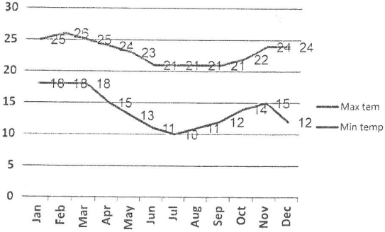

2.1 What is the difference in degrees between the maximum and minimum
temperatures in January and in June?
__________________________________________________________________________________________________________________________________________________________________________________________________________________________________________
______________________________________________________________________________
(2)
2.2 How do the temperature figures indicate that the sea has a moderating effect on
the temperatures of East London?

____________________________________________________________________________________________________________________________________________________________
(1)
2.3 Name two processes that directly regulate the temperature of coastal areas
between day and night.

________________________________________________________________________________________________________________________________________________________________________________________________________________________________________________________________________________________________________________________
(2)
2.4 Draw a bar graph from March to July to illustrate the temperature in figure 2

NB. Use the bar graph provided below. January and February have been drawn for you.

1 mark for correct maximum and minimum temperature per month March to June.
(10)
2.5 Explain the difference between a land and sea breeze.
________________________________________________________________________________________________________________________________________________________________________________________________________________________________________________________________________________________________________________________
(2)
[17]

SECTION 2 – MAPWORK

QUESTION 3: MAPWORK SKILLS AND CALCULATIONS
GENERAL INFORMATION ON MERRIVALE
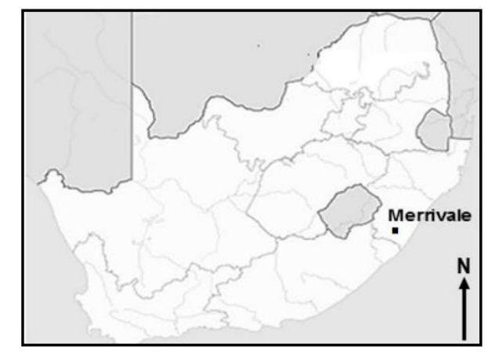

Coordinates:29˚31 'S; 30˚14'E Merrivale is a town in uMgungundlovu District Municipality in KwaZulu-Natal. The town is 145km north-west of Durban and 5km south-east of Howick. Merrivale experiences warm, wet summers and dry, winter seasons. The temperatures between winter and summer range from 5˚ C and 32˚ C. The topography within the surroundings of Merrivale varies in elevation from1018 metres to 2308,8 metres above sea level.

[Adapted from https://en.wikipedia.org/wiki/Merrivale]

Refer to the topographical map and the orthophoto map. Various options are provided as feasible answers to the following questions. Choose the answers. (1 x 5 = 5)

3.1 Merrivale is situated
- In KwaZulu-Natal
- In the Eastern Cape
- uGu District Municipality
- uMgungundlovu District Municipality
Choose the correct combination
- I and II
- II. and III
- II and IV
- I and IV

3.2 The contour interval of the extract from 2030 CA 5 MERRIVALE ortho-rectified image is…
- 20
- 15
- 10
- 5

3.3 The scale of the orthophoto map is … times larger than the scale of the topographic
map
- 5
- 15
- 15
- 20

3.4 On the topographical map, 1cm represents… in reality
- 50000 km
- 50 000 cm
- 15 km
- 15 cm

3.5 The manner in which the height is indicated at 29˚33'14.1" S; 30˚11'15.5"E
- Contour line
- Spot height
- Reservoir
- Benchmark
(5)

3.6 Choose a picture from column B that matches the description in Column A. Write
only the letter (A - C).
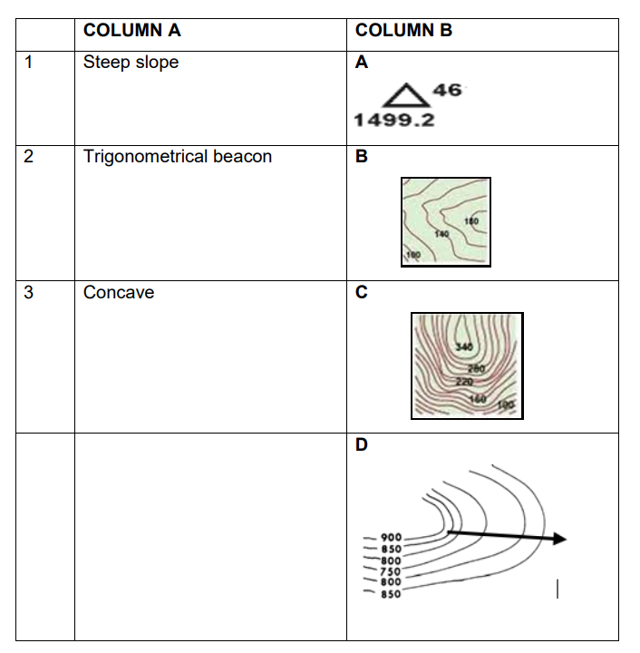
3.6.1 _______________________________________________________________
3.6.2 ______________________________________________________________
3.6.3 ______________________________________________________________
(3)

QUESTION 4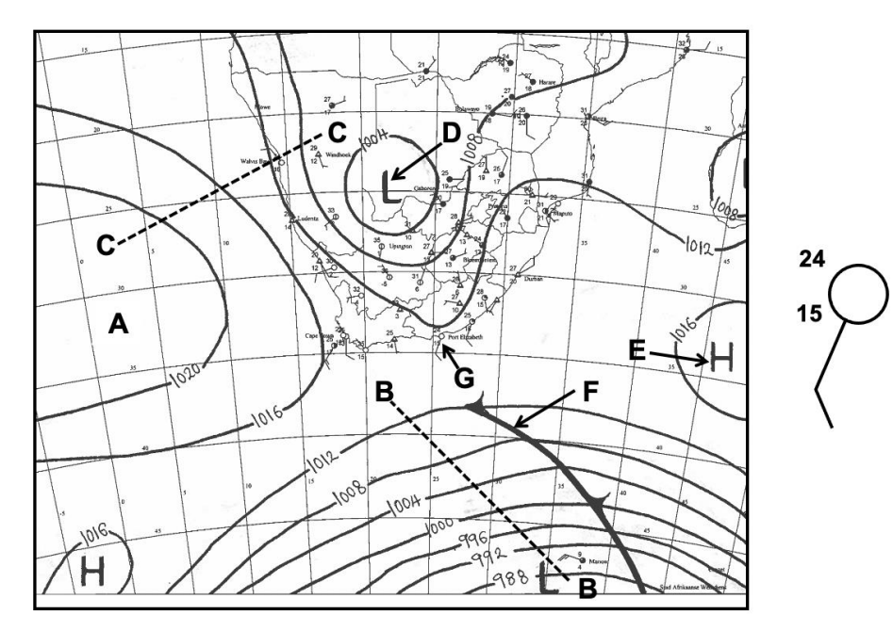

4.1 Does the synoptic weather map show summer or winter conditions?

______________________________________________________________________________
(1)
4.2 Give TWO reasons for your answer in question 3.1

________________________________________________________________________________________________________________________________________________________________________________________________________________________________________________________________________________________________________________________________________________________________________________________________________________________________________________________________________________________________________________________________________________________________________________________________________________________________________________
(4)
4.3 Is A high or a low pressure?

______________________________________________________________________________
(1)
4.4 Identify the pressure gradient at B-B and C-C

____________________________________________________________________________________________________________________________________________________________
(2 x 1 = 2)

4.5 Describe the wind circulation at D.

________________________________________________________________________________________________________________________________________________________________________________________________________________________________________________________________________________________________________________________
(1 x 2 = 2)

QUESTION 5
5.1 Study the table below on Africa’s weather and climate and answer the question
that follow:
TOWN | MAXIMUM TEMPERATURE (°C) | MINIMUM TEMERATURE (°C)
Pretoria | 24 | 4
Johannesburg | 21 | 3
Nelspruit/Mbombela | 30 | 9
Polokwane | 25 | 5
Mafikeng | 24 | 6
Bloemfontein | 21 | 3
Kimberley | 21 | 6
Cape Town | 19 | 12
East London | 25 | 13
Durban | 25 | 10

- Which city has the greatest temperature range?
______________________________________________________________________________________________________________________________________________________ (2)
- Identify the province with the highest temperature range.
______________________________________________________________________________________________________________________________________________________ (2)
- Determine the temperature range in Pretoria on the given day.
______________________________________________________________________________________________________________________________________________________ (2)
- What was the temperature range in Durban on the given day?
______________________________________________________________________________________________________________________________________________________
(2)
TOTAL SECTION 2: [35]

