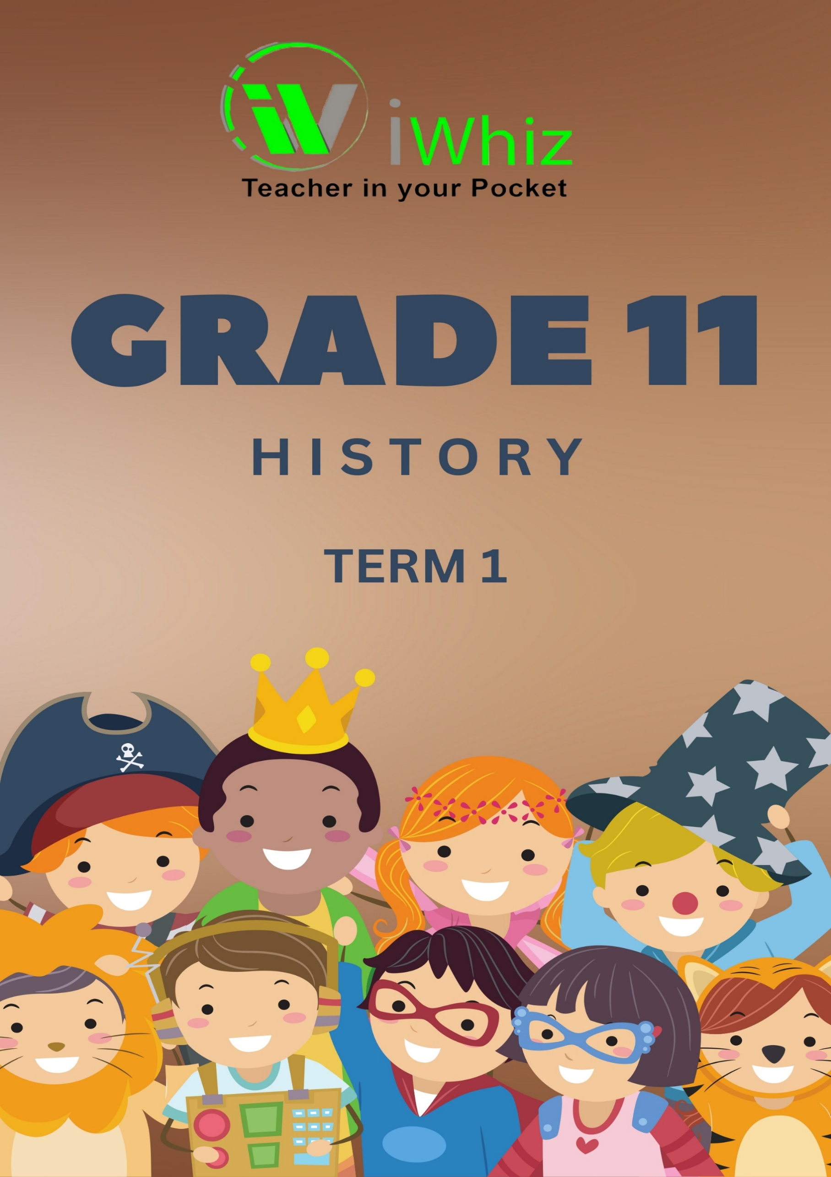



https://www.youtube.com/watch?v=SJ4_nONtYeY
WATCH FOR TESTIMONIALS

WATCH FOR TESTIMONIALS

Grade 11
History- Term 1 Test
Marks: 100 Time: 1 Hour

INSTRUCTIONS AND INFORMATION
- This question paper consists of TWO SECTIONS:

SECTION A: SOURCE-BASED QUESTIONS
QUESTION 1: COMMUNISM IN RUSSIA, 1900–1940
QUESTION 2: CAPITALISM IN THE USA, 1900–1940

SECTION B: ESSAY QUESTIONS
QUESTION 1: CAPITALISM IN THE USA, 1900–1940
- Each section counts 50 marks.

- When candidates answer questions, they are required to demonstrate application of knowledge, skills, and insight.

- Mere rewriting of the sources as answers will be to the disadvantage of candidates.

- Questions and subsections of questions must be numbered clearly and correctly using the same numbering system used in the question paper.

- Start each question on a new page and rule off at the end of each question.

- Write neatly and legibly.

SECTION A: SOURCE-BASED QUESTIONS [50 MARKS]
QUESTION 1:
WHAT CHALLENGES DID LENIN ENCOUNTER IN THE ESTABLISHMENT OF A COMMUNIST STATE?

Study Sources 1A, 1B and answer the sub-questions that follow.

SOURCE 1A
An extract on War Communism from Russia and the USSR 1905 - 1956 by N Kelly.
During the Civil War Lenin introduced a policy of war communism. The government took control of the economy. It was vital that the Red Army was supplied with the weapons and food which it needed to fight the war effectively. War communism was very effective in keeping the army supplied, but it led to widespread starvation among the peasants and workers of Russia.

Lenin set up the Supreme Council of National Economy to introduce war communism. Private trading was banned and profit-making was decreed to be exploitation. Factories with more than ten workers were taken over by the government and strict discipline was imposed in them. Strikes were illegal. In the countryside, peasants were encouraged to work harder still. The surplus crops they grew were taken by the government to feed the factory workers and the army. The peasants resented this.

They had won the right to own their land under the Communists, but now they wanted to profit from it by selling their crops. They did not see why they should have to give surplus produce to the government. The government also abolished money charges on such services as railways and post. This was to encourage the use of bartering instead of money. As inflation made the rouble almost worthless, many peasants did swap goods instead of using paper money.

SOURCE 1B
An extract on the New Economic Policy from Russia in Revolution by J Robertson
In March 1921 Lenin announced the ending of War Communism and the inauguration of a New Economic Policy. The basis of the NEP was:

The ending of requisitions from the peasants and the substitution of a fixed tax in kind (grain) - which by 1924 had become a money tax. Once this tax was paid, the peasant was free to do what he liked with what remained. He could use it himself, sell it to the state or sell it on the open market which was now made legal.

- Private enterprise was allowed in trade and small-scale industry.

- Compulsory labour ceased; the labour armies were disbanded, and bonuses were introduced for extra work.

- The currency was back on a sound footing and a regular system of taxation was introduced.
- Large-scale industry (coal, iron, steel, oil, electricity, railways) was to remain in the hands of the state.

1.1 Using Sources 1A, 1B and your own knowledge, define the following historical concepts:
1.1.1 War Communism (5)

______________________________________________________________________________________________________________________________________________________________________________________________________________________________________________________________________________________________________________________________________________________________________________________________________________________________________________________________________________________________________________________________________________________________________________________________________________________________________________________________________________________________________________________________

1.1.2 New Economic Policy (5)
________________________________________________________________________________________________________________________________________________________________________________________________________________________________________________________________________________________________________________________________________________________________________________________________________________________________________________________________________________________________________________________________________________________________________________________________________________________________________________

1.2 Explain, with reference to Sources 1A and 1B, how the implementation of War Communism and the New Economic Policy differed. (5)
________________________________________________________________________________________________________________________________________________________________________________________________________________________________________________________________________________________________________________________________________________________________________________________________________________________________________________________________________________________________________________________________________________________________________________________________________________________________________________
1.3 Compare and contrast War Communism and the New Economic Policy (NEP) in Soviet Russia. (5)

________________________________________________________________________________________________________________________________________________________________________________________________________________________________________________________________________________________________________________________________________________________________________________________________________________________________________________________________________________________________________________________________________________________________________________________________________________________________________________

1.4 What were the main objectives of War Communism, and how did it impact different segments of society such as peasants, workers, and the military? (5)
______________________________________________________________________________________________________________________________________________________________________________________________________________________________________________________________________________________________________________________________________________________________________________________________________________________________________________________________________________________________________________________________________________________________________________________________________________________________________________________________________________________________________________________________
1.5 How did Lenin attempt to address the economic challenges faced during the Civil War through the implementation of War Communism? (5)
______________________________________________________________________________________________________________________________________________________________________________________________________________________________________________________________________________________________________________________________________________________________________________________________________________________________________________________________________________________________________________________________________________________________________________________________________________________________________________________________________________________________________________________________
1.6 Discuss the role of the Supreme Council of National Economy in enforcing War Communism. (5)

______________________________________________________________________________________________________________________________________________________________________________________________________________________________________________________________________________________________________________________________________________________________________________________________________________________________________________________________________________________________________________________________________________________________________________________________________________________________________________________________________________________________________________________________
1.7 Explain the reasons behind the introduction of the New Economic Policy. How did the NEP aim to address the shortcomings of War Communism? (5)

________________________________________________________________________________________________________________________________________________________________________________________________________________________________________________________________________________________________________________________________________________________________________________________________________________________________________________________________________________________________________________________________________________________________________________________________________________________________________________
____________________________________________________________________________________________________________________________________________________________
____________________________________________________________________________________________________________________________________________________________
1.8 What changes were implemented under the NEP regarding taxation, trade, and private enterprise? (5)

______________________________________________________________________________________________________________________________________________________________________________________________________________________________________________________________________________________________________________________________________________________________________________________________________________________________________________________________________________________________________________________________________________________________________________________________________________________________________________________________________________________________________________________________
________________________________________________________________________________________________________________________________________________________________________________________________________________________________________________________________________________________________________________________

1.9 Why did Lenin and the Bolsheviks decide to retain state control over large-scale industries while allowing private enterprise in smaller industries under the NEP? (5)

______________________________________________________________________________________________________________________________________________________________________________________________________________________________________________________________________________________________________________________________________________________________________________________________________________________________________________________________________________________________________________________________________________________________________________________________________________________________________________________________________________________________________________________________
SECTION B: ESSAY QUESTIONS [50 MARKS]
QUESTION 1: CAPITALISM IN THE USA, 1900–1940
‘Franklin Roosevelt’s New Deal was successful in dealing with America’s economic problems in the 1930s.’

  - Do you agree with the statement? Substantiate your answer with relevant historical evidence.

____________________________________________________________________________________________________________________________________________________________________________________________________________________________________________________________________________________________________________________________________________________________________________________________________________________________________________________________________________________________________________________________________________________________________________________________________________________________________________________________________________________________________________________________________________________________________________________________________________________________________________________________________________________________________________________________________________________________________________________________________________________________________________________________________________________________________________________________________________________________________________________________________________________________________________________________________________________________________________________________________________________________________________________________________________________________________________________________________________________________________________________________________________________________________________________________________________________________________________________________________________________________________________________________________________________________________________________________________________________________________________________________________________________________________________________________________________________________________________________________________________________________________________________________________________________________________________
____________________________________________________________________________________________________________________________________________________________________________________________________________________________________________________________________________________________________________________________________________________________________________________________________________________________________________________________________________________________________________________________________________________________________________________________________________________________________________________________________________________________________________________________________________________________________________________________________________________________________________________________________________________________________________________________________________________________________________________________________________________________________________________________________________________________________________________________________________________________________________________________________________________________________________________________________________________________________________________________________________________________________________________________________________________________________________________________________________________________________________________________________________________________________________________________________________________________________________________________________________________________________________________________________________________________________________________________________________________________________________________________________________________________________________________________________________________________________________________________________________________________________________________________________________________________________________
____________________________________________________________________________________________________________________________________________________________________________________________________________________________________________________________________________________________________________________________________________________________________________________________________________________________________________________________________________________________________________________________________________________________________________________________________________________________________________________________________________________________________________________________________________________________________________________________________________________________________________________________________________________________________________________________________________________________________________________________________________________________________________________________________________________________________________________________________________________________________________________________________________________________________________________________________________________________________________________________________________________________________________________________________________________________________________________________________________________________________________________________________________________________________________________________________________________________________________________________________________________________________________________________________________________________________________________________________________________________________________________________________________________________________________________________________________________________________________________________________________________________________________________________________________________________________________
[25]

QUESTION 2: COMMUNIM IN RUSSIA 1900 T0 1940: STALIN’S INTERPRETATION OF MARXISM
“Through countless material and human sacrifices, within ten years, Stalin was able to transform a peasant society into a superpower”.

2.1 Do you agree with this statement? Critically discuss how Stalin, through his 5-year plans changed the economy of the Soviet Union.
____________________________________________________________________________________________________________________________________________________________________________________________________________________________________________________________________________________________________________________________________________________________________________________________________________________________________________________________________________________________________________________________________________________________________________________________________________________________________________________________________________________________________________________________________________________________________________________________________________________________________________________________________________________________________________________________________________________________________________________________________________________________________________________________________________________________________________________________________________________________________________________________________________________________________________________________________________________________________________________________________________________________________________________________________________________________________________________________________________________________________________________________________________________________________________________________________________________________________________________________________________________________________________________________________________________________________________________________________________________________________________________________________________________________________________________________________________________________________________________________________________________________________________________________________________________________________________
____________________________________________________________________________________________________________________________________________________________________________________________________________________________________________________________________________________________________________________________________________________________________________________________________________________________________________________________________________________________________________________________________________________________________________________________________________________________________________________________________________________________________________________________________________________________________________________________________________________________________________________________________________________________________________________________________________________________________________________________________________________________________________________________________________________________________________________________________________________________________________________________________________________________________________________________________________________________________________________________________________________________________________________________________________________________________________________________________________________________________________________________________________________________________________________________________________________________________________________________________________________________________________________________________________________________________________________________________________________________________________________________________________________________________________________________________________________________________________________________________________________________________________________________________________________________________________
____________________________________________________________________________________________________________________________________________________________________________________________________________________________________________________________________________________________________________________________________________________________________________________________________________________________________________________________________________________________________________________________________________________________________________________________________________________________________________________________________________________________________________________________________________________________________________________________________________________________________________________________________________________________________________________________________________________________________________________________________________________________________________________________________________________________________________________________________________________________________________________________________________________________________________________________________________________________________________________________________________________________________________________________________________________________________________________________________________________________________________________________________________________________________________________________________________________________________________________________________________________________________________________________________________________________________________________________________________________________________________________________________________________________________________________________________________________________________________________________________________________________________________________________________________________________________________
____________________________________________________________________________________________________________________________________________________________________________________________________________________________________________________________________________________________________________________________________________________________________________________________________________________________________________________________________________________________________________________________________________________________________________________________________________________________________________________________________________________________________________________________________________________________________________________________________________________________________________________________________________________________________________________________________________________________________________________________________________________________________________________________________________________________________________________________________________________________________________________________________________________________________________________________________________________________________________________________________________________________________________________________________________________________________________________________
[25]

