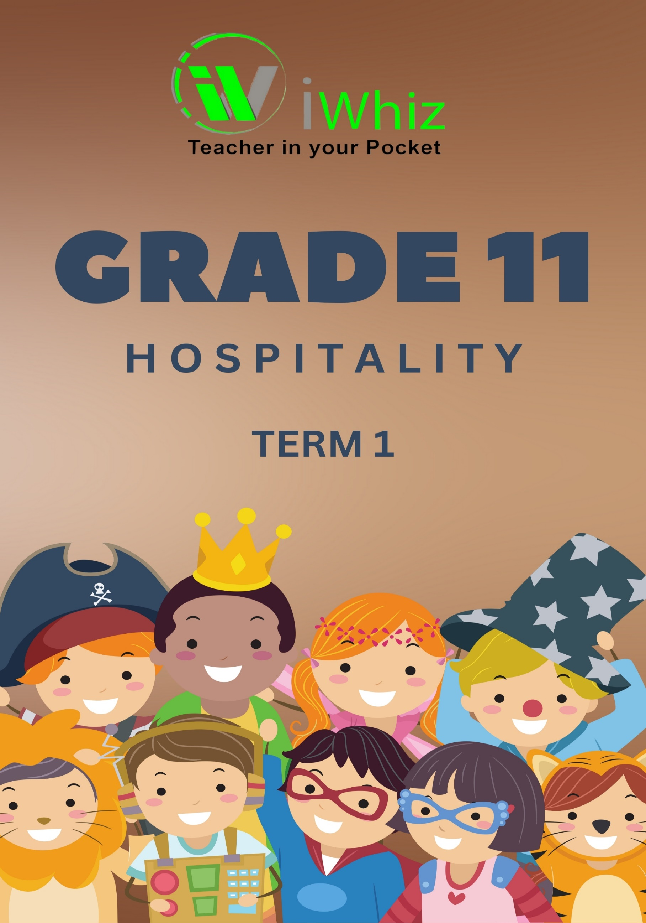



https://www.youtube.com/watch?v=SJ4_nONtYeY
WATCH FOR TESTIMONIALS

WATCH FOR TESTIMONIALS

Grade 11- Term 1 Test
Marks – 80 Duration - 1 hour 30 minutes

INSTRUCTIONS
- Answer ALL the questions.

- Read each question carefully before answering.

- Write your answers neatly and legibly.

- Number your answers correctly according to the question paper.

- Show all calculations clearly where required.

- Use full sentences for explanation-type questions.

- Keep your work clean and organised.

- If you make a mistake, cross it out neatly and rewrite your answer.

- The total marks for each question are indicated in brackets ( ).

- Manage your time wisely and ensure you complete all sections.

Question 1
(Choose the correct answer and write only the letter next to the question number.)

1.1 Which nutrient is responsible for growth and repair in the body? (1)
A. Carbohydrates
B. Proteins
C. Fats
D. Vitamins

1.2 What is the main function of yeast in bread-making? (1)
A. Adds sweetness
B. Gives colour to the crust
C. Helps the dough rise
D. Prevents spoilage

1.3 Which type of bread product is enriched with butter and eggs for a soft texture? (1)
A. Baguette
B. Brioche
C. Ciabatta
D. Rye bread

1.4 Which of the following table settings is used for formal dining? (1)
A. Buffet setting
B. Banquet setting
C. Silver service setting
D. Fast food setting

1.5 What is the main role of the sous chef in a kitchen brigade? (1)
A. Supervises the kitchen and assists the head chef
B. Prepares cold dishes and salads
C. Cleans dishes and utensils
D. Serves customers at the table

1.6 (Write only the number from COLUMN A and the corresponding letter from COLUMN B.)
COLUMN A (Term) | ANSWER | COLUMN B
1.6.1 Yeast fermentation |  | - Used to decorate cakes and pastries
1.6.2 Gluten |  | - Converts sugar into carbon dioxide
1.6.3 Piping bag |  | - A type of table setting
1.6.4 Napkin folding |  | - A protein that gives dough elasticity
1.6.5 Pastry brush |  | - Used to apply egg wash on dough
(5)

Question 2
- The earliest inhabitants, the Khoisan, inspired a dish made with a local ingredient. Name the dish and identify its ingredients.

___________________________________________________________________________
___________________________________________________________________________
___________________________________________________________________________
___________________________________________________________________________
(2)
- Define and describe street food.

___________________________________________________________________________
___________________________________________________________________________
___________________________________________________________________________
___________________________________________________________________________
___________________________________________________________________________
(2)
- Name a street food that is typically found along the West Coast.

___________________________________________________________________________
(2)
- Mealie meal is known as pap in South Africa. Provide three different names for pap dishes found in South Africa.

___________________________________________________________________________
___________________________________________________________________________
___________________________________________________________________________
(3)
- Which foods are served with pap?

___________________________________________________________________________
___________________________________________________________________________
___________________________________________________________________________
___________________________________________________________________________
___________________________________________________________________________
(2)

- What is meant by 'fusion cuisine'? Give two examples of South African fusion cuisine.

___________________________________________________________________________
___________________________________________________________________________
___________________________________________________________________________
___________________________________________________________________________
___________________________________________________________________________
___________________________________________________________________________
(4)
[15]
Question 3
- When setting tables, what do the terms 'silver', 'linen' and crockery refer to?

___________________________________________________________________________
___________________________________________________________________________
___________________________________________________________________________
___________________________________________________________________________
(4)
- Write a short paragraph about serviettes for a table setting.

___________________________________________________________________________
___________________________________________________________________________
___________________________________________________________________________
___________________________________________________________________________
___________________________________________________________________________
___________________________________________________________________________
___________________________________________________________________________
___________________________________________________________________________
(4)
- What is the point of using table numbers?

___________________________________________________________________________
___________________________________________________________________________
___________________________________________________________________________
___________________________________________________________________________
(2)

- Comment on the following tea menu for a birthday party. Is it well balanced, if not what are the problems? if you consider this a good menu, give your reasons.

Birthday cake made of cup cakes
Sausage rolls
Chicken pies
Meat balls
Mini kebabs
Milk tart
Variety of sandwiches

___________________________________________________________________________
___________________________________________________________________________
___________________________________________________________________________
___________________________________________________________________________
___________________________________________________________________________
___________________________________________________________________________
___________________________________________________________________________
___________________________________________________________________________
(5)
[15]
Question 4
- Preparing a successful meal starts with the principles of menu planning, as well as planning the menu. Provide five comments for each of these factors that will assist a new person who is preparing a three-course dinner.

_________________________________________________________________________________________________________________________________________________________________________________________________________________________________________________________________________________________________________________________________________________________________________________________________________________________________________________________________________________________________________________________________________________________________________________________________________________________________________________________________________________________________________________________________________________________________________________________________________________________________________________________________________________________________________________________________________________________________________________________________________________________________________________________________________________________________________________________________________________________________________________________________________________________________________________________________________________________________________________________________________________________________________________________________________________________________________________________________________________________________________________________________________________________________________________________________________________________________________________________________________________________________________________________________________________________________________________________________________________________________________________________________
(10)
- Draw a sketch of a table setting for a meal consisting of:
- cream of tomato soup
- fried fish and chips
- morogo
- ice cream and chocolate sauce.

(10)
- Explain how the kitchen brigade is structured?

________________________________________________________________________________________________________________________________________________________________________________________________________________________________________________________________________________________________________________________________________________________________________________________________________________________________________________________________________________________________________________________________________________________________________________________________________________________________________________
(3)
- Why is teamwork important in the kitchen brigade?

________________________________________________________________________________________________________________________________________________________________________________________________________________________________________________________________________________________________________________________(2)

- What are the main tasks of the head chef?

______________________________________________________________________________________________________________________________________________________________________________________________________________________________________________________________________________________________________________________________________________________________________________________________________________________________________________________________________________________________________________________________________________________________________________________________________________________________________________________________________________________________________________________________
(5)

- Explain how the restaurant brigade works in a large restaurant.

______________________________________________________________________________________________________________________________________________________________________________________________________________________________________________________________________________________________________________________________________________________________________________________________________________________________________________________________________________________________________________________________________________________________________________________________________________________________________________________________________________________________________________________________
(5)

- Compile a checklist that a service person needs to follow before going on duty.

__________________________________________________________________________________________________________________________________________________________________________________________________________________________________________________________________________________________________________________________________________________________________________________________________________________________________________________________________________________________________________________________________________________________________
(5)

