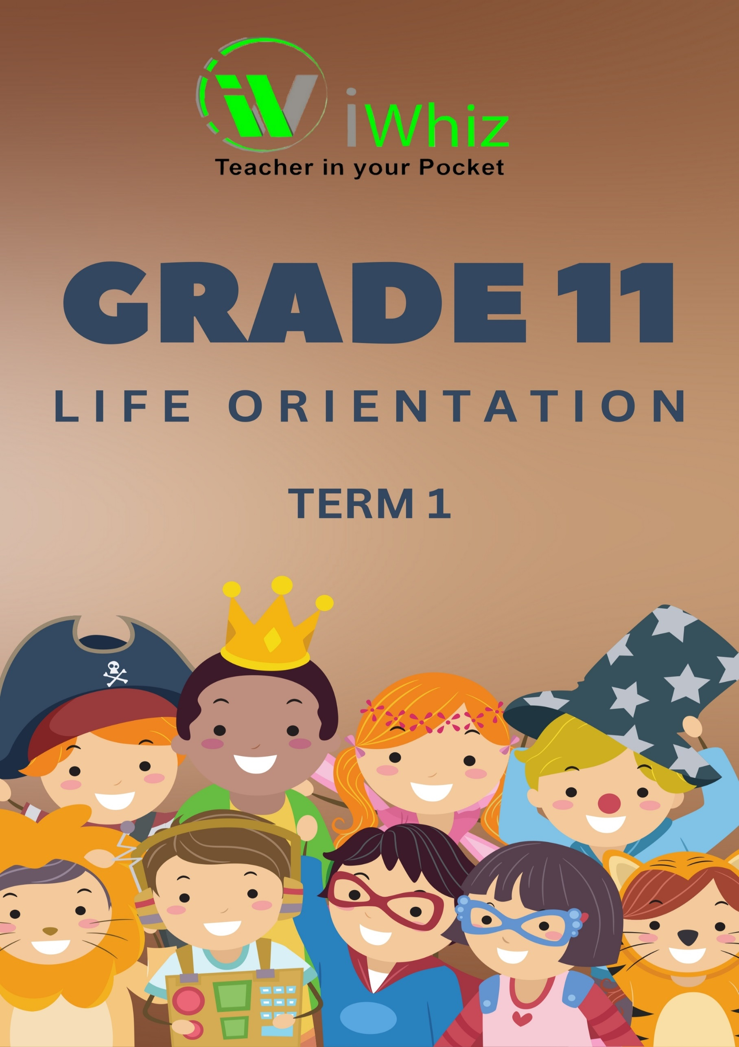

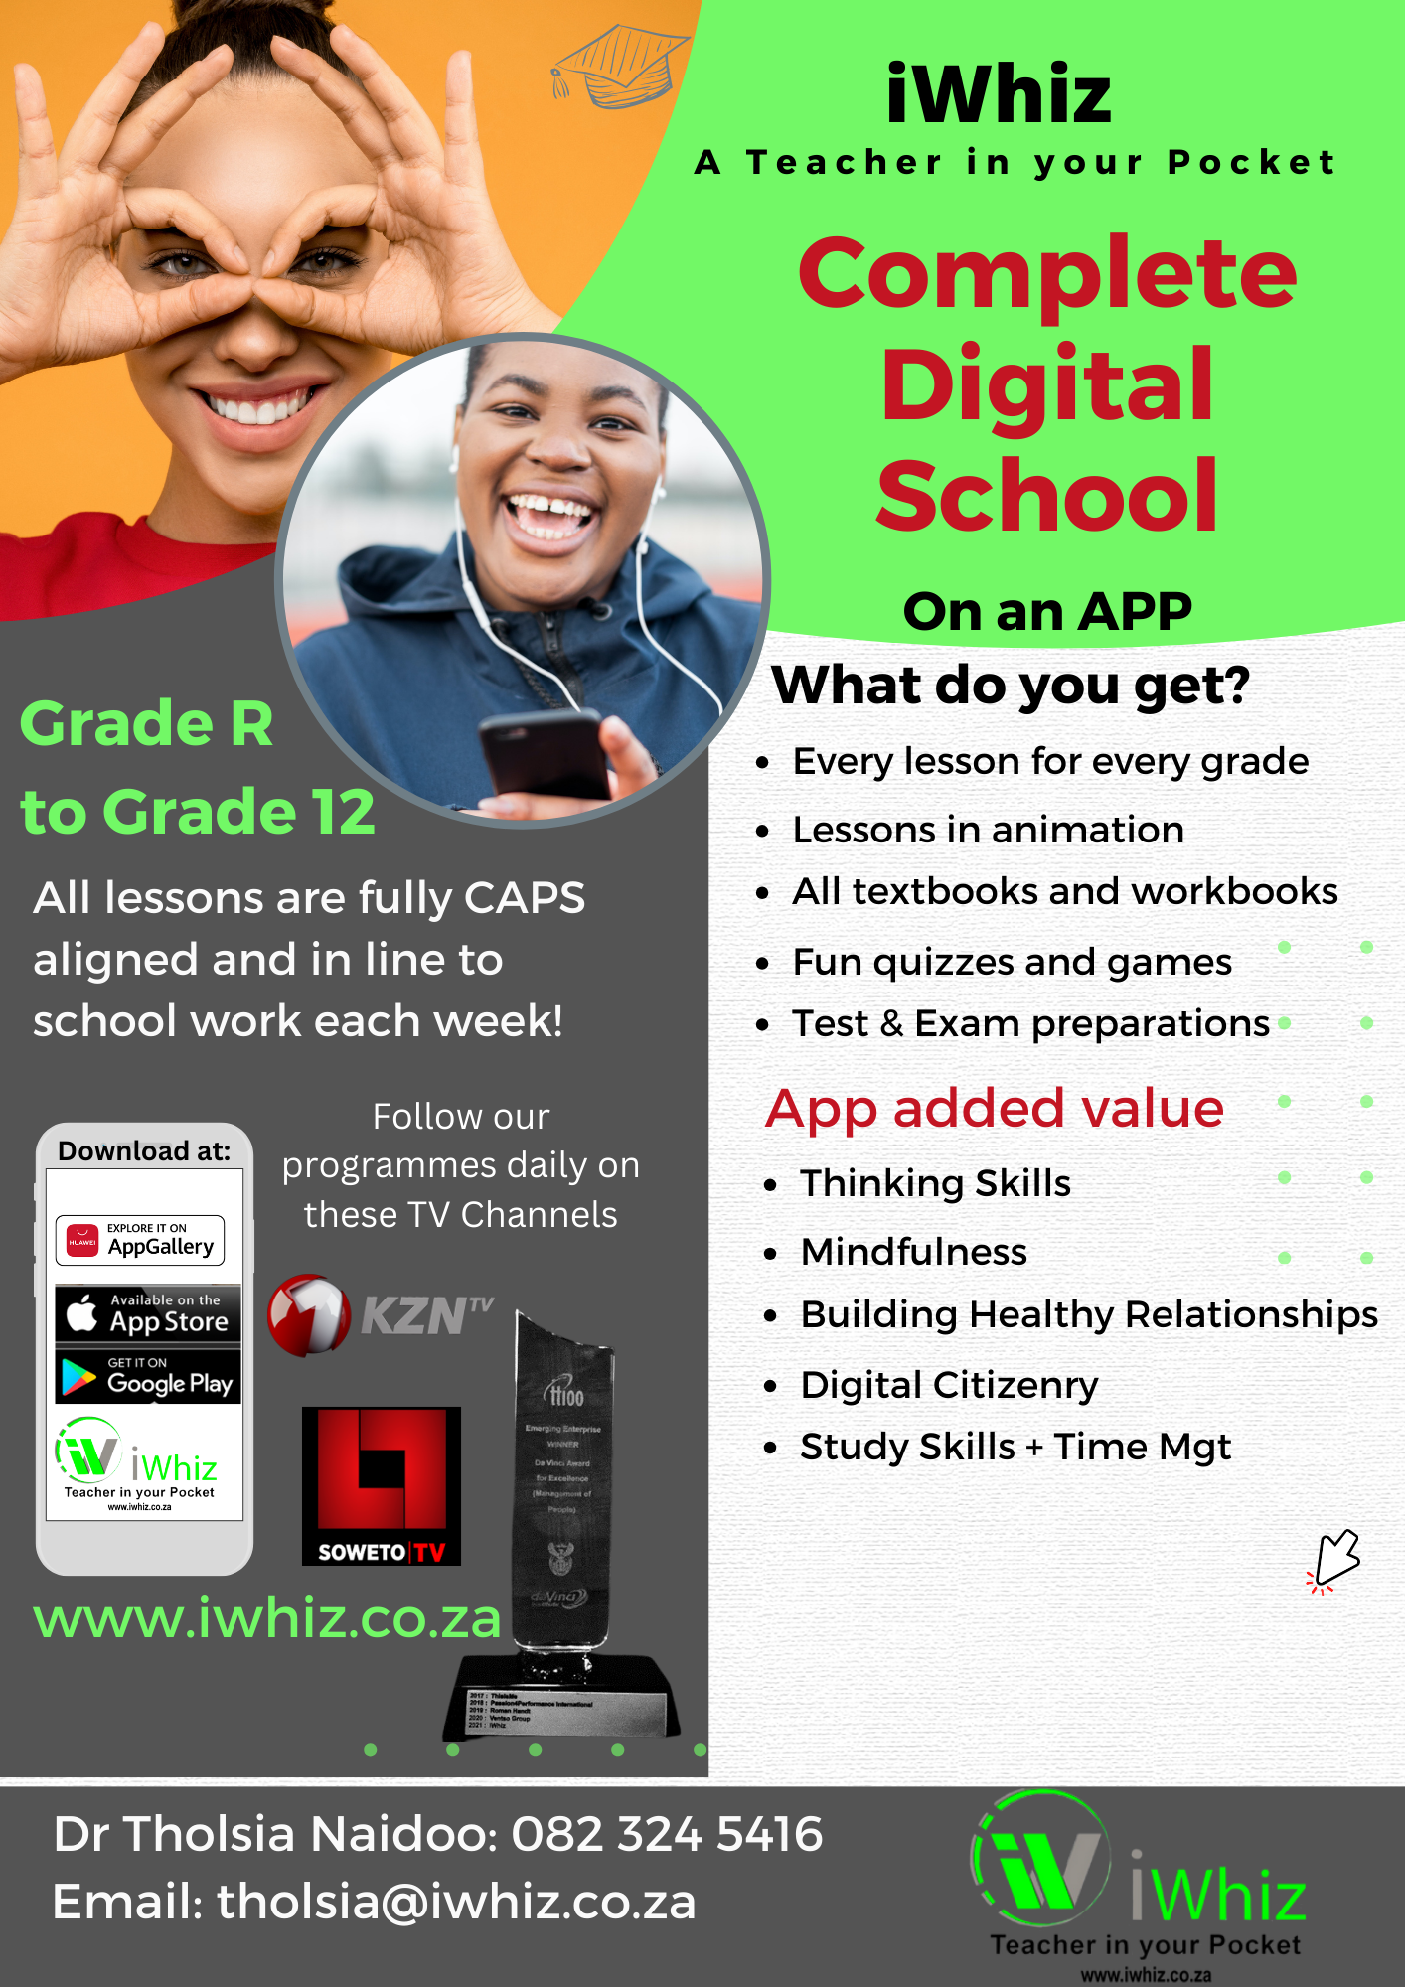

https://www.youtube.com/watch?v=SJ4_nONtYeY
WATCH FOR TESTIMONIALS

WATCH FOR TESTIMONIALS

Grade 11 – Term 1 Test

Marks – 60 Duration – 1 hour

INSTRUCTIONS AND INFORMATION

Read the following instructions carefully before answering the questions.
- Answer ALL the questions.

- Write ALL the answers in the ANSWER BOOK.

- Start the answers to each question at the top of a NEW page.

- Number the answers correctly according to the numbering system used in this question paper.

- Present your answers according to the instructions of each question.

- Use blue or black ink.

- Write neatly and legibly.

QUESTION 1: DEVELOPMENT OF SELF IN SOCIETY
Teenagers should be aware that digital footprints can harm their future lives and careers


  - Discuss THREE reasons why your digital footprint could be damaging to you when you apply for a job.
______________________________________________________________________________________________________________________________________________________________________________________________________________________________________________________________________________________________________________________________________________________________________________________________________________________________________________________________________________________________________________________________________________________________________________________________________________________________________________________________________________________________________________________________
(3x2) = (6)
  - Identify ONE right, responsibility and action when building relationships over social media.

____________________________________________________________________________________________________________________________________________________________________________________________________________________________________________________________________________________________________________________________________________________________________________________________________________________________________________________________________________________
(3 x 1 = 3)

  - As a Grade 11 learner who survived the social challenges of Grade 8, what advice would you give to someone who have been asked to send nude pictures.

__________________________________________________________________________________________________________________________________________________________________________________________________________________________________________________________________________________________________________________________________________________________________________________________________________________________________________________________________________________________________________________________________________________________________
(2 x 2 = 4)

  - Describe TWO types of social media platforms that teenagers would use. Include examples of how teenagers use these platforms to build relationships.

__________________________________________________________________________________________________________________________________________________________________________________________________________________________________________________________________________________________________________________________________________________________________________________________________________________________________________________________________________________________________________________________________________________________________________________________________________________________________________________________________________________________________________________________________________________________________________________________________________________________________________________________________________________________
(2 x 2 = 4)

QUESTION 2: CAREER AND CAREER CHOICES

2.1 Explain how an internship is different from a scholarship.
__________________________________________________________________________________________________________________________________________________________________________________________________________________________________________________________________________________________________________________________________________________________________________________________________________________________________________________________________________________________________________________________________________________________________
(2 x 2 = 4)

2.2. Explain how an internship is different to a learnership.
______________________________________________________________________________________________________________________________________________________________________________________________________________________________________________________________________________________________________________________________________________________________________________________________________________________________________________________________________________________________________________________________________________________________________________________________________________________________________________________________________________________________________________________________
(3 x 2 = 6)

2.3 Provide a Grade 11 THREE types of ethical behaviour they should show when in an
internship, learnership or scholarship programme.
________________________________________________________________________________________________________________________________________________________________________________________________________________________________________________________________________________________________________________________________________________________________________________________________________________________________________________________________________________________________________________________________________________________________________________________________________________________________________________
(3 x 2 = 6)

Study the following results of a grade 12 learner and answer the questions that follow:

English Home Language 81%
Afrikaans First Additional Language 21%
Mathematics 55%
Accounting 75%
Business studies 70%
Physical Science 28%
Life Orientation 83%

2.4. Explain the type of pass this learner achieves.

______________________________________________________________________________________________________________________________________________________________________________________________________________________________________________________________________________________________________________________________________________________________________________________________________
(1 x 2 = 2)

2.5 Explain to the learner the difference between a university qualification and a
qualification at a TVET college.

__________________________________________________________________________________________________________________________________________________________________________________________________________________________________________________________________________________________________________________________________________________________________________________________________________________________________________________________________________________________________________________________________________________________________
(2 x 2 = 4)

QUESTION 3: DEMOCRACY AND HUMAN RIGHTS
Read the extract below and answer the questions that follow
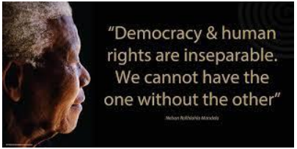

3.1 Describe, in your own words what ‘democracy’ is and give an example of where you
have seen a good example of it displayed and in South Africa.

________________________________________________________________________________________________________________________________________________________________________________________________________________________________________________________________________________________________________________________________________________________________________________________________________________________________________________________________________________________________________________________________________________________________________________________________________________________________________________
(1 + 2 = 3)

3.2 Critically evaluate the quote, ‘democracy and human rights are inseparable’.

________________________________________________________________________________________________________________________________________________________________________________________________________________________________________________________________________________________________________________________________________________________________________________________________________________________________________________________________________________________________________________________________________________________________________________________________________________________________________________
(3 x 2 = 6)

3.3 Discuss any THREE values as set out in the Constitution of South Africa that strives
to establish good governance.
________________________________________________________________________________________________________________________________________________________________________________________________________________________________________________________________________________________________________________________________________________________________________________________________________________________________________________________________________________________________________________________________________________________________________________________________________________________________________________
(3 x 2 = 6)
3.4 What are the advantages of having a democratic government.
________________________________________________________________________________________________________________________________________________________________________________________________________________________________________________________________________________________________________________________________________________________________________________________________________________________________________________________________________________________________________________________________________________________________________________________________________________________________________________
(2 x 1 = 2)
3.5 Why is transparency and accountability so important in a democratically governed
society?
______________________________________________________________________________________________________________________________________________________________________________________________________________________________________________________________________________________________________________________________________________________________________________________________________________________________________________________________________________________________________________________________________________________________________________________________________________________________________________________________________________________________________________________________(2 x 2 = 4)

