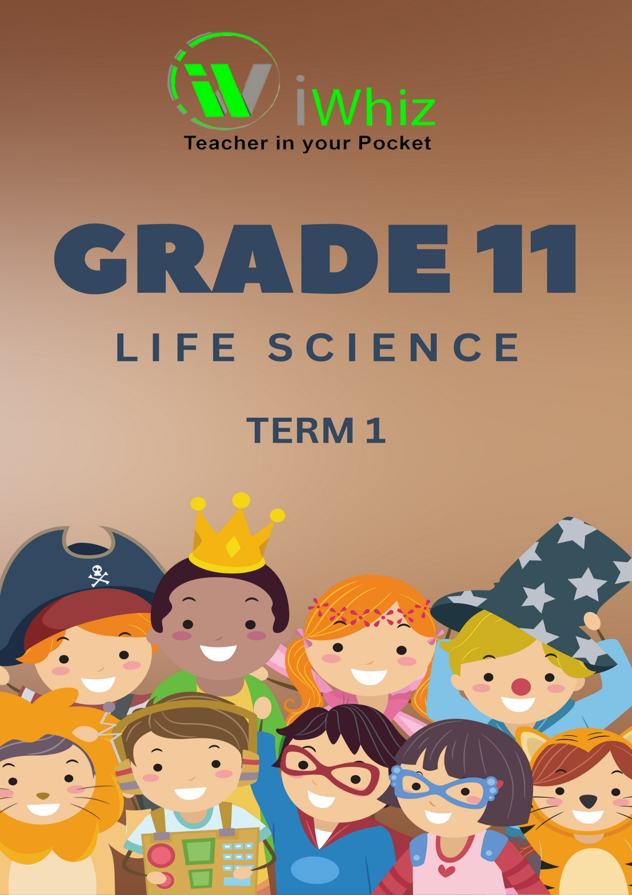



https://www.youtube.com/watch?v=SJ4_nONtYeY
WATCH FOR TESTIMONIALS

WATCH FOR TESTIMONIALS

Grade 11 – Term 1 Test

TOTAL MARKS – 50 DURATION – 1 HOUR

INSTRUCTIONS AND INFORMATION
Read the following instructions carefully before answering the questions.

- Answer ALL the questions.

- Write ALL the answers in the ANSWER BOOK.

- Start the answers to each question at the top of a NEW page.

- Number the answers correctly according to the numbering system used in this question paper.

- Present your answers according to the instructions of each question.

- Use blue or black ink.

- Draw diagrams, tables or flow charts only when asked to do so.

- The diagrams in this question paper are NOT necessarily drawn to scale.

- Do NOT use graph paper.

- You may use a non-programmable calculator, protractor and a compass.

- Write neatly and legibly.

SECTION A
QUESTION 1
  - Various options are provided as possible answers to the following questions. Choose the answer and write only the letter (A to D) next to the question number 1.1.1 to 1.1.3) in the ANSWER BOOK, for example 1.1.4 D.

    - Moss plants live in moist/ damp conditions because...
A. water is needed for fertilisation
B. moss plants have conducting tissues
C. moss plants produce spores
D. water is not needed for fertilisation

    - Pathogen that causes rabies...
- Virus
- Protozoan
- Bacterium
- Virus

    - The phylum Porifera which includes sponges is the least advanced of multicellular animals.

Which of the following is/are true for phylum Porifera?
- Coelomate X
- Asymmetrical
- No cephalisation
- Diploblastic X

- (I) and (II)
- (I), (II), (III) and (V)
- (II) and (III)
- (II) and (IV)
(3 x 2 = 6)

  - Give the correct biological term for each of the following descriptions. Write only the term next to the question number (1.2.1 to 1.2.4).

    - The phylum of all animals with a vertebral column in adults.

______________________________________________________________________________
(1)
1.2.2 The transfer of pollen from an anther to the stigma1

______________________________________________________________________________
(1)

    - The type of reproduction in plants that produces offspring with identical genetic
composition.

______________________________________________________________________________
(1)

  - Indicate whether each of the descriptions in COLUMN I applies to A ONLY, B ONLY, BOTH A AND B or NONE of the items in COLUMN II. Write A only, B only, both A and B or none next to the question number (1.3.1 to 1.3.5).

COLUMN I | COLUMN II
1.3.1 All animals in this phylum are sessile1 | A: Porifera  B: Annelida
1.3.2 Animals with a radial symmetry | A: Arthropoda  B: Chordata

1.3.1
______________________________________________________________________________
(2)
1.3.2
______________________________________________________________________________
(2)

  - The diagram below shows one of the phyla you studied.
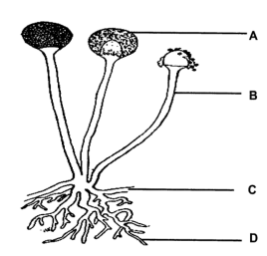

    - Identify the kingdom to which the above organism belongs.

____________________________________________________________________________________________________________________________________________________________
(1)

    - Give the LETTER and NAME of the part that:
(a) anchors fungus to substrate

____________________________________________________________________________________________________________________________________________________________
(2)

(b) provides branched horizontal covering on substrate.

____________________________________________________________________________________________________________________________________________________________
(2)

(c) produces mature spores

____________________________________________________________________________________________________________________________________________________________
(2)
TOTAL SECTION A: [20]

SECTION B
QUESTION 2
2.1 The diagram below represents a flower.
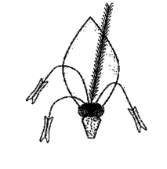

2.1.1 Name the agent of pollination for the above flower.

______________________________________________________________________________
(1)

2.1.2 List THREE characteristics of the flower that makes it adapted for the agent
mentioned in QUESTION 2.1.1

________________________________________________________________________________________________________________________________________________________________________________________________________________________________________________________________________________________________________________________
(3)
2.1.3 Name ONE advantage of asexual reproduction in plants
______________________________________________________________________________
______________________________________________________________________________
(1)
2.1.4 Explain why seedless vascular plants are able to grow taller than non-vascular
plants.

______________________________________________________________________________________________________________________________________________________________________________________________________________________________________________________________________________________________________________________________________________________________________________________________________
(2)

2.1.5 Give TWO adaptation of angiosperms that makes them survive on land.

____________________________________________________________________________________________________________________________________________________________________________________________________________________________________________________________________________________________________________________________________________________________________________________________________________________________________________________________________________________
(2)

2.2 Malaria causes over 400 000 deaths each year globally.

2.2.1 Name the protozoan that causes malaria

__________________________________________________________________________________________________________________________________________________________________________________________________________________________________________
(1)
2.2.2 Name the vector that spreads malaria
__________________________________________________________________________________________________________________________________________________________________________________________________________________________________________
(1)

2.2.3List TWO symptoms experienced by people with malaria

__________________________________________________________________________________________________________________________________________________________________________________________________________________________________________
(2)
2.2.4 Explain why malaria is only found in certain regions of Africa
__________________________________________________________________________________________________________________________________________________________________________________________________________________________________________
(2)

QUESTION 3
3.1 Scientists conducted an investigation to determine the effect of different
treatments on the amount of fungi that grows on bread.

The procedure was as follows:
- Five slices of bread were used and treated in different ways.
- Slice 1: was left dry
- Slice 2: added 20 ml tap water
- Slice 3: added 20 ml lemon juice
- Slice 4: added 20 ml sugar water
- Slice 5: added 20 ml bleach
- Each slice was placed in a zip-lock bag and kept in a cupboard for one week.
- After one week the slices were removed from the zip-lock bags and were observed the growth of the fungi.
- The percentage area covered by fungi in slices was calculated.

The results are shown in the table below.
TREATMENT ON BREAD AREA | COVERED BY FUNGI (96)
Dry bread | 0
Tap water | 25
Lemon juice | 30
Sugar water | 80
Bleach | 10

3.1.1 Name the independent variable of the investigation.

____________________________________________________________________________________________________________________________________________________________
(1)
3.1.2 Give ONE reason why the zip-lock bags were placed in a dark cupboard for
one week?

____________________________________________________________________________________________________________________________________________________________
(1)
3.1.3 Explain why the dry bread was included in the experiment.

________________________________________________________________________________________________________________________________________________________________________________________________________________________________________________________________________________________________________________________
(2)
3.1.4 State ONE way that the scientists can improve the reliability of the
investigation.

____________________________________________________________________________________________________________________________________________________________
(1)
3.1.5 Explain why fungi grows best on bread sprinkled with sugar water.

______________________________________________________________________________________________________________________________________________________________________________________________________________________________________________________________________________________________________________________________________________________________________________________________________
(2)
3.1.6 Give TWO ways in which the scientists ensured the validity of the results of
this investigation.

______________________________________________________________________________________________________________________________________________________________________________________________________________________________________________________________________________________________________________________________________________________________________________________________________
(2)
3.2 The diagrams below show organisms that belong to two different phyla.
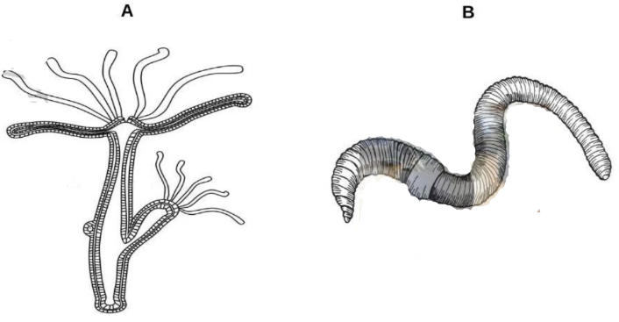

3.2.1 Name the kingdom to which both organisms belong.

______________________________________________________________________________
(1)
3.2.2 State the phyla to which organism A belongs.

______________________________________________________________________________
(1)
3.2.3 Give the type of symmetry of organism B?

______________________________________________________________________________
(1)

3.2.4 Describe the role of organism B as a decomposer.

__________________________________________________________________________________________________________________________________________________________________________________________________________________________________________
(1)
3.2.5 Identify the type of gut in the following two organisms:
(a) A

______________________________________________________________________________

(b) B

______________________________________________________________________________
(1 x 2 = 2)
TOTAL SECTION B: [30 MARKS]

