



https://www.youtube.com/watch?v=SJ4_nONtYeY
WATCH FOR TESTIMONIALS

WATCH FOR TESTIMONIALS

TOTAL: 100 MARKS TIME: 2 HOURS

INSTRUCTIONS AND INFORMATION
- Read ALL the questions carefully.

- Answer ALL the questions.

- Show ALL calculations clearly.

- Round off ALL final answers to TWO appropriately according to the given context unless stated otherwise.

- Units of measurements must be indicated where appliance.

- Diagrams are not drawn to scale.

- Write neatly and legibly.

Question 1

Mrs. Dlamini works as a seamstress. She stitches garments for customers and works 7.25 hours per day. She charges R95 per hour or part thereof.

Use the information above to answer the following questions.

  - Use the given information to answer the following:

    - Convert 7.25 hours to hours and minutes.

________________________________________________________________________________________________________________________________________________________________________________________________________________________________________________________________________________________________________________________
(2)

1.1.2 Explain the term "part thereof" according to the given context.

________________________________________________________________________________________________________________________________________________________________________________________________________________________________________________________________________________________________________________________
(2)

1.1.3 Determine the total amount of money Mrs. Dlamini will receive per day if she works
7.25 hours.

________________________________________________________________________________________________________________________________________________________________________________________________________________________________________________________________________________________________________________________
(3)

1.1.4 Calculate the number of hours worked if Mrs. Dlamini earns R3,990 in a week.

________________________________________________________________________________________________________________________________________________________________________________________________________________________________________________________________________________________________________________________
(3)
1.2 Mrs. Dlamini is considering increasing her rate to R120 per hour.

1.2.1 If she works 5 days a week, calculate her new weekly earnings.
______________________________________________________________________________________________________________________________________________________________________________________________________________________________________________________________________________________________________________________________________________________________________________________________________
(3)

1.2.2 If she increases her rate to R120 per hour, by what percentage has her rate
increased from R95?
____________________________________________________________________________________________________________________________________________________________________________________________________________________________________________________________________________________________________________________________________________________________________________________________________________________________________________________________________________________
(3)

1.2.3 If a customer pays R1,200 for a custom dress, how many hours would it take Mrs.
Dlamini to complete the order at her new rate?
____________________________________________________________________________________________________________________________________________________________________________________________________________________________________________________________________________________________________________________________________________________________________________________________________________________________________________________________________________________
(3)
Question 2
Great Hope is a private high school. In 2019 the school governing body prepared a budget for 2020 to be presented to the parents for their approval. TABLE 2 below shows the projected budget for 2020.

TABLE 2: PROJECTED BUDGET FOR 2020
INCOME |  | EXPENDITURE
Item | Amount (R) | Item | Amount (R)
School Fees | 1 237 500 | Salaries (teachers, secretaries, ancillary staff) | 1 705 852
Government Subsidy | 854 639 | Administration + Departmental Budgets | 180 100
Donations | 20 000 | Municipality (electricity, water, refuse coll.) | 122 659
Bad Debts Recovered | 4 512 | School Bus Insurance and Maintenance | 37 857
Sundry income | 2 300 | Grounds Maintenance | 115 203
Fund Raising | 34 821 | Text Books and Additional Stationery | 738 044
Tuck Shop | 15 017 | Sports Department Budget | 86 900
Stationery Fees | 350 000 | Sundry (miscellaneous) | 42 194
Interest Received | 1 948 | Annual Prize Giving | 20 000
 |  | Staff Professional Development | 15 000
 |  | Staff End of Year Function | 10 000
 |  | Computers Maintenance and Upgrade | 36 500
 |  | Capital Expense
 |  | Total Expenditure | 3 110 309
Total Income | 2 520 737 | Profit/Loss | -589 572

Use the information TABLE 2 above to answer the questions that follow.

2.1.1 Define the term "surplus" in this context.

________________________________________________________________________________________________________________________________________________________________________________________________________________________________________________________________________________________________________________________
(2)

2.1.2 Calculate the number of learners to be enrolled in 2020 if the school governing body
wants a 10% increase in the 2019 fees, which was R1 500 per month.

____________________________________________________________________________________________________________________________________________________________________________________________________________________________________________________________________________________________________________________________________________________________________________________________________________________________________________________________________________________
(4)
2.1.3 Explain the meaning of the negative sign (-) in the Profit/Loss amount.

________________________________________________________________________________________________________________________________________________________________________________________________________________________________________________________________________________________________________________________
(2)

2.1.4 One parent in the Annual General Meeting (AGM) made a proposal that the fees
for 2020 be increased to R2 500 to offset the deficit of R589 572. Verify with
calculations, whether this proposal is valid.

______________________________________________________________________________________________________________________________________________________________________________________________________________________________________________________________________________________________________________________________________________________________________________________________________
(4)
2.1.5 The school needs to buy a 16-Seater Quantum minibus for R412 900. The parents
agreed to add this amount as a capital expense. Calculate the new deficit when
parents agree to fees increase of R2 500.

____________________________________________________________________________________________________________________________________________________________________________________________________________________________________________________________________________________________________________________________________________________________________________________________________________________________________________________________________________________
(3)

2.1.6 Suggest ONE way of raising the minibus shortfall of R364 972 without further
increasing school fees.

____________________________________________________________________________________________________________________________________________________________________________________________________________________________________________________________________________________________________________________________________________________________________________________________________________________________________________________________________________________
(2)

Question 3
3.1
Mr Looney is tracking his body weight using the body mass index radar. He is currently weighing 83,5kg with a height of 1,7m.
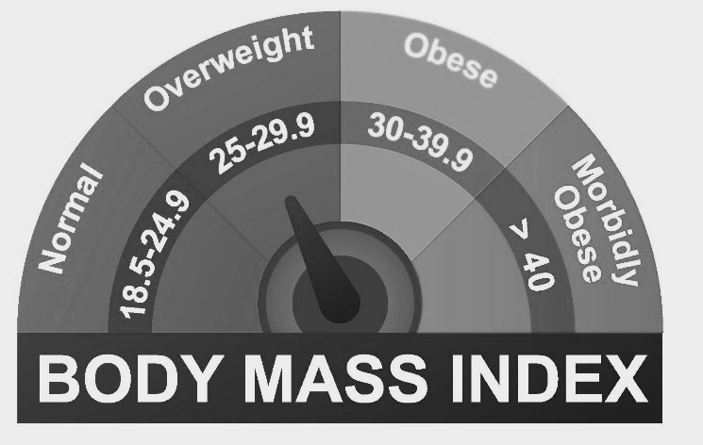
[source: https://www.wltx.com/article/news/health]
Use the information and the BMI radar above to answer the questions that follow.

3.1.1 Identify Mr Looney's weight status as indicated on the radar.
________________________________________________________________________________________________________________________________________________________________________________________________________________________________________________________________________________________________________________________
(2)
3.1.2 Calculate his body mass index round off to the nearest 1 decimal.
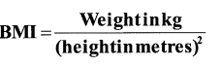
You may use the formula:

______________________________________________________________________________________________________________________________________________________________________________________________________________________________________________________________________________________________________________________________________________________________________________________________________________________________________________________________________________________________________________________________________________________________________________________________________________________________________________________________________________________________________________________________
(4)

3.1.3 Give any TWO advices Mr Looney should consider in order to be classified as normal.

____________________________________________________________________________________________________________________________________________________________________________________________________________________________________________________________________________________________________________________________________________________________________________________________________________________________________________________________________________________
(4)
3.1.4 Convert Mr Looney's weight to pounds if 1kg = 2.2 pounds.

____________________________________________________________________________________________________________________________________________________________________________________________________________________________________________________________________________________________________________________________________________________________________________________________________________________________________________________________________________________
(2)
3.2 ANNEXURE A shows the diagram of the tennis court with dimensions in metres.

Study the diagram in ANNEXURE A and answer the questions that follow. (See page 18)

3.2.1 Show by calculations that the width of the base line is 10.97m.

____________________________________________________________________________________________________________________________________________________________________________________________________________________________________________________________________________________________________________________________________________________________________________________________________________________________________________________________________________________
(2)
3.2.2 Hence, Calculate the perimeter of the whole tennis court.

You may use the formula: Perimeter of rectangle = 2×length + 2×width

__________________________________________________________________________________________________________________________________________________________________________________________________________________________________________________________________________________________________________________________________________________________________________________________________________________________________________________________________________________________________________________________________________________________________ (3)

3.2.3 Determine the length between baseline and the service line in metres.

________________________________________________________________________________________________________________________________________________________________________________________________________________________________________________________________________________________________________________________________________________________________________________________________________________________________________________________________________________________________________________________________________________________________________________________________________________________________________________
(4)
3.2.4 Calculate the area of ONE doubles alley in square metres.
You may use the formula: Area of a rectangle = length × width

__________________________________________________________________________________________________________________________________________________________________________________________________________________________________________________________________________________________________________________________________________________________________________________________________________________________________________________________________________________________________________________________________________________________________
(3)

3.3
On average a male tennis player with a weight of 70kg can burn approximately 583 calories per hour in a tennis games.

3.3.1 Determine how many calories will a male tennis player with 83.5kg in one hour.
____________________________________________________________________________________________________________________________________________________________________________________________________________________________________________________________________________________________________________________________________________________________________________________________________________________________________________________________________________________
(3)

3.3.2 A male tennis player with a weight of 83.5kg will lose more than 0.077kg, if he plays
consistently the tennis game. Verify this statement showing all calculations if 1
gram = 9 calories.
__________________________________________________________________________________________________________________________________________________________________________________________________________________________________________________________________________________________________________________________________________________________________________________________________________________________________________________________________________________________________________________________________________________________________
(4)

3.3.3 Calculate the number of hours a tennis player needs to play in order to lose 1600
calories.
__________________________________________________________________________________________________________________________________________________________________________________________________________________________________________________________________________________________________________________________________________________________________________________________________________________________________________________________________________________________________________________________________________________________________
(2)
[33]
Question 4

Miss Khan uses her fitness watch tracker and smartphone app to record her daily workout. Below is the table showing her results.
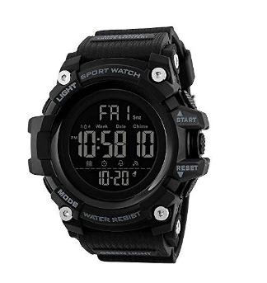
Table 4: Khan's daily running records
End time | 12:45
Steps covered | 5 426
Running time | 21min 00sec
Calories burnt | 1232 cal.
Distance covered | 5.89km
Daily step target | 6000
Source: https://www.google.com/url?

Study the information and Table 4 above to answer the questions that follow.

4.1 Write down the ratio of the steps covered to daily target steps in the simplest form.
__________________________________________________________________________________________________________________________________________________________________________________________________________________________________________
(2)
4.2 Show by calculations that her speed is 3min and 33sec per kilometre.
________________________________________________________________________________________________________________________________________________________________________________________________________________________________________________________________________________________________________________________
________________________________________________________________________________________________________________________________________________________________________________________________________________________________________________________________________________________________________________________
(3)

4.3 Name TWO other workout activities that miss Khan can track and record using her
fitness watch.

________________________________________________________________________________________________________________________________________________________________________________________________________________________________________________________________________________________________________________________
__________________________________________________________________________________________________________________________________________________________________________________________________________________________________________
(4)
4.4 Convert 5.89km to miles if 1mile = 1.608km.
________________________________________________________________________________________________________________________________________________________________________________________________________________________________________________________________________________________________________________________
__________________________________________________________________________________________________________________________________________________________________________________________________________________________________________
(2)
4.5 Miss Khan indicates that she needs to double her target steps to burn 2 464
calories. Show by calculations whether her claim is valid or not.
________________________________________________________________________________________________________________________________________________________________________________________________________________________________________________________________________________________________________________________
________________________________________________________________________________________________________________________________________________________________________________________________________________________________________________________________________________________________________________________
__________________________________________________________________________________________________________________________________________________________________________________________________________________________________________
(3)
[14]
Question 5
Anna owns a small bakery in her home, she pays R375 for electricity and water to her parents every month. TABLE 1 below shows her total monthly income and expenses for one month. The cost to produce one bread is R5.00

TABLE 1: Anna's Monthly income and expenses
Number of breads | 0 | 10 | 20 | 30 |  | 100 | 150 | 200
Expenses(R) | 375 | 425 | 475 | 525 |  | 875 | 1125 | 1375
Income(R) | 0 | 125 | 250 | 375 |  | 1250 | 1875 | 2500

Use TABLE 1 and information to answer the questions that follow.

5.1.1 Identify the dependant variable represented in TABLE 1 above.
________________________________________________________________________________________________________________________________________________________________________________________________________________________________________________________________________________________________________________________
____________________________________________________________________________________________________________________________________________________________
(2)

5.1.2 The equation to calculate Anna's total expenses is given as:

Total expenses = R375 + R5 × no. of breads produced.
Write down the equations to calculate her total income in the form of:
Total income = ...… x number of breads sold

________________________________________________________________________________________________________________________________________________________________________________________________________________________________________________________________________________________________________________________
____________________________________________________________________________________________________________________________________________________________
(3)

5.2
Anna uses a FOUR division type bread pan to bake her breads.
Dimensions of each rectangular compartment pan  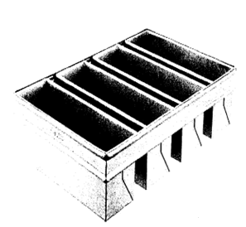  Length = 40cm  Width = 10cm  Height =10cm | Dimensions of each cylindrical compartment pan  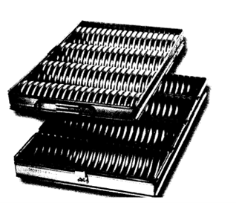  Height =42,5cm  Radius = 5,08cm  [Source: http://www.sheetmetalprocess.com/sale]
Use the information above to answer the questions that follow.

5.2.1 Calculate the volume of all four rectangular bread compartments. You may use
the formula:

Volume of a rectangular prism = length x width x height x 4

________________________________________________________________________________________________________________________________________________________________________________________________________________________________________________________________________________________________________________________________________________________________________________________________________________________________________________________________________________________________________________________________________________________________________________________________________________________________________________
(3)
5.2.2 The volume of ONE cylindrical bread compartment is 3 501,19 cm³.

Determine in grams which compartments between a cylindrical and a rectangular bread pan will have more mass. Note: 1 g = 1 cm³.

________________________________________________________________________________________________________________________________________________________________________________________________________________________________________________________________________________________________________________________________________________________________________________________________________________________________________________________________________________________________________________________________________________________________________________________________________________________________________________
(3)

5.2.3 Write down the unit ratio of the radius of a cylindrical compartment to the length
of rectangular compartment.

________________________________________________________________________________________________________________________________________________________________________________________________________________________________________________________________________________________________________________________________________________________________________________________________________________________________________________________________________________________________________________________________________________________________________________________________________________________________________________
(3)
5.2.4 Anna bakes her breads in an oven that is heated to standard temperature of
450°F.

Convert the temperature to degree Celsius using the following formula.

°C = (°F - 32°) ÷ 1,8

________________________________________________________________________________________________________________________________________________________________________________________________________________________________________________________________________________________________________________________________________________________________________________________________________________________________________________________________________________________________________________________________________________________________________________________________________________________________________________
(3)
[17]
TOTAL MARKS: 100

ANNEXURE A 