



https://www.youtube.com/watch?v=SJ4_nONtYeY
WATCH FOR TESTIMONIALS

WATCH FOR TESTIMONIALS

TOTAL: 100 MARKS TIME: 2 HOURS

INSTRUCTIONS AND INFORMATION
- This question paper consists of TEN questions.

- Read ALL the questions carefully.

- Answer ALL the questions.

- Show ALL calculations and units. Round off ALL answers to TWO decimal places.

- Candidates may use non- programmable, scientific calculators and drawing instruments.

- Take the value of gravitational force as 10 m/s.

- All dimensions are in millimetres, unless stated otherwise in the question.

- A formula sheet for your use is attached to this question paper.

- Write neatly and legibly.

Question 1
Choose the correct answer and write only the letter next to the question number.
1.1 Which of the following is a unit of force?
A. Joule
B. Newton
C. Pascal
D. Watt

1.2 What is the function of a cam and follower mechanism?
A. Convert rotational motion into linear motion
B. Increase friction in mechanical systems
C. Store electrical energy
D. Transfer electrical energy into mechanical motion

1.3 Which material is commonly used for making gears due to its high strength and
durability?
A. Aluminium
B. Mild Steel
C. Copper
D. Plastic

1.4 In a hydraulic system, pressure is transmitted:
A. Unequally in all directions
B. Only in the direction of applied force
C. Equally in all directions
D. Only through air

1.5 The efficiency of a machine is calculated using the formula:
A. Output work ÷ Input work × 100
B. Input work ÷ Output work × 100
C. Power × Time
D. Force × Distance

(10)
Question 2
  - Define the following terms:
a) Mechanical Advantage

________________________________________________________________________________________________________________________________________________________________________________________________________________________________________________________________________________________________________________________
(2)
b) Efficiency of a Machine
________________________________________________________________________________________________________________________________________________________________________________________________________________________________________________________________________________________________________________________
(2)
c) Tensile Strength

________________________________________________________________________________________________________________________________________________________________________________________________________________________________________________________________________________________________________________________
(2)

2.2 A force of 300N is applied to a machine to lift a load of 1200N.
Calculate the mechanical advantage.
________________________________________________________________________________________________________________________________________________________________________________________________________________________________________________________________________________________________________________________________________________________________________________________________________________________________________________________________________________________________________________________________________________________________________________________________________________________________________________
(3)
2.3 Study the diagram of the simple gear train below and answer the questions.
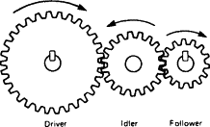

- Identify the type of motion in the system.

__________________________________________________________________________________________________________________________________________________________________________________________________________________________________________
(2)
- If the driver gear has 20 teeth and the driven gear has 40 teeth, calculate the gear ratio.

____________________________________________________________________________________________________________________________________________________________________________________________________________________________________________________________________________________________________________________________________________________________________________________________________________________________________________________________________________________ ______________________________________________________________________________
(3)
- If the driver gear rotates at 1000 rpm, calculate the speed of the driven gear.

________________________________________________________________________________________________________________________________________________________________________________________________________________________________________________________________________________________________________________________________________________________________________________________________________________________________________________________________________________________________________________________________________________________________________________________________________________________________________________
(3)
2.4 A hydraulic press system has an input force of 500N on a small piston with an area
of 0.02 m². The output piston has an area of 0.10 m².

- State Pascal’s Law.

____________________________________________________________________________________________________________________________________________________________________________________________________________________________________________________________________________________________________________________________________________________________________________________________________________________________________________________________________________________
(2)
- Calculate the output force.

________________________________________________________________________________________________________________________________________________________________________________________________________________________________________________________________________________________________________________________________________________________________________________________________________________________________________________________________________________________________________________________________________________________________________________________________________________________________________________
(3)

Question 3
3.1 A lever has a load arm of 0.5 m and an effort arm of 2 m.

Calculate:
- The velocity ratio of the lever.

____________________________________________________________________________________________________________________________________________________________________________________________________________________________________________________________________________________________________________________________________________________________________________________________________________________________________________________________________________________ ____________________________________________________________________________________________________________________________________________________________(3)
- The effort required to lift a 600 N load, assuming 100% efficiency.

______________________________________________________________________________________________________________________________________________________________________________________________________________________________________________________________________________________________________________________________________________________________________________________________________
(3)
3.2 Study the diagram below and answer the questions.
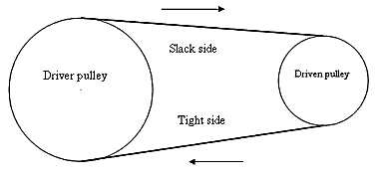

- Identify the type of belt drive system.

__________________________________________________________________________________________________________________________________________________________________________________________________________________________________________
(2)
- If the driver pulley has a diameter of 200 mm and the driven pulley has a diameter of 600 mm, calculate the velocity ratio.

________________________________________________________________________________________________________________________________________________________________________________________________________________________________________________________________________________________________________________________________________________________________________________________________________________________________________________________________________________________________________________________________________________________________________________________________________________________________________________
(3)

- If the driver pulley rotates at 1500 rpm, determine the speed of the driven pulley.

__________________________________________________________________________________________________________________________________________________________________________________________________________________________________________________________________________________________________________________________________________________________________________________________________________________________________________________________________________________________________________________________________________________________________
(3)

QUESTION 4: HYDRAULICS AND PNEUMATICS (20 marks)
4.1 Differentiate between hydraulic and pneumatic systems.

______________________________________________________________________________________________________________________________________________________________________________________________________________________________________________________________________________________________________________________________________________________________________________________________________________________________________________________________________________________________________________________________________________________________________________________________________________________________________________________________________________________________________________________________
(4)

4.2 Study the diagram of a hydraulic system below and answer the questions.
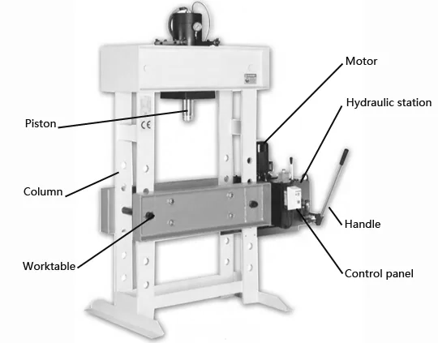

- Identify the function of the piston.

____________________________________________________________________________________________________________________________________________________________________________________________________________________________________________________________________________________________________________________________________________________________________________________________________________________________________________________________________________________ ______________________________________________________________________________
(2)
- Explain why hydraulic oil is used instead of water.

____________________________________________________________________________________________________________________________________________________________________________________________________________________________________________________________________________________________________________________________________________________________________________________________________________________________________________________________________________________(4)
- A hydraulic system has an input pressure of 200 kPa and an output force of 4000 N. Calculate the area of the output piston.

__________________________________________________________________________________________________________________________________________________________________________________________________________________________________________________________________________________________________________________________________________________________________________________________________________________________________________________________________________________________________________________________________________________________________
(4)

QUESTION 5: ENGINEERING MATERIALS & HEAT TREATMENT (20 marks)
5.1 Name four mechanical properties of engineering materials and describe each.

________________________________________________________________________________________________________________________________________________________________________________________________________________________________________________________________________________________________________________________________________________________________________________________________________________________________________________________________________________________________________________________________________________________________________________________________________________________________________________________________________________________________________________________________________________________________________________________________________________________________________________________________________________________________________________________________________________________________________
(8)
5.2 Explain the difference between hardening, tempering, and annealing in heat
treatment processes.

______________________________________________________________________________________________________________________________________________________________________________________________________________________________________________________________________________________________________________________________________________________________________________________________________________________________________________________________________________________________________________________________________________________________________________________________________________________________________________________________________________________________________________________________
(6)

5.3 A metal rod expands by 0.003 m when heated from 20°C to 100°C. If the original
length was 2 m, calculate the coefficient of linear expansion.

______________________________________________________________________________________________________________________________________________________________________________________________________________________________________________________________________________________________________________________________________________________________________________________________________________________________________________________________________________________________________________________________________________________________________________________________________________________________________________________________________________________________________________________________
(6)

