



https://www.youtube.com/watch?v=SJ4_nONtYeY
WATCH FOR TESTIMONIALS

WATCH FOR TESTIMONIALS

Physical Sciences - Term 1 Test

Total Marks – 100 Duration: 2 hours

INSTRUCTIONS AND INFORMATION
- This question paper consists of SEVEN questions.

- Answer ALL the questions in the space provided.

- Number the answers correctly according to the numbering system used in this question paper.

- You may use a non-programmable calculator.

- You may use appropriate mathematical instruments.

- You are advised to use the attached DATA SHEET.

- Show ALL formulae and substitutions in ALL calculations.

- Round off your final numerical answers to a minimum of TWO decimal places.

- Give brief motivations, discussions, etcetera where required.

Question 1
Four options are provided as possible answers to the following questions. Each question has only ONE correct answer.

- Which ONE of the following pairs represents a VECTOR and a SCALAR in that order?
- Displacement and Velocity
- Acceleration and Force
- Work and Mass
- Weight and Time

- Two bodies whose centres are "r" metres apart exert a gravitational force F1.41.5on each other. If the distance between them is halved whilst their masses remain the same, the new force that they will exert on each other will be....
- 2 F
- 4 F1
- 1/2 F
- 1/4 F

- Which of the following pairs of physical quantities are BOTH vectors?
- Displacement and speed
- Acceleration and force
- Force and mass
- Distance and electric field1.

- The resultant of two forces, X and Y acting at a common point O is shown below. The angle between the two forces is 90°.
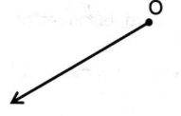
Which ONE of the following vector diagrams, not drawn to scale, is the correct representation of the directions of X and Y?
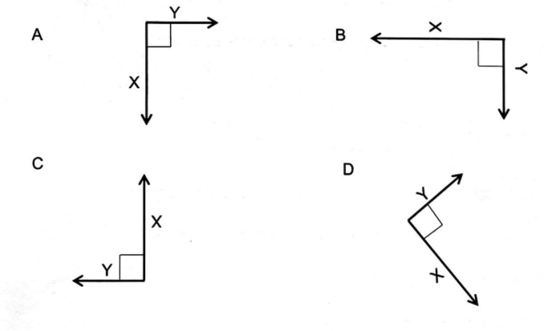
- A body of mass m is in a state of weightlessness. Which ONE of the following statements concerning the weight and inertia of the body is TRUE?
- The body has weight and experiences inertia.
- The body has no weight and does not experience inertia.
- The body has weight and does not experience inertia.
- The body has no weight and experiences inertia.

- The electrostatic force that two charged spheres exert on each other is F when they are placed a distance r metres apart. The charge on each sphere is now tripled and the distance between them is 1⁄2 r. The force that the spheres exert on each other will now be ...
- 9F
- 18 F
- 27 F
- 36 F

- A test charge is placed at point P in an electric field generated by a point charge. The magnitude of the electric field at point P is given by:
- The ratio of the force experienced by the test charge to the magnitude of the test charge.
- The product of the force experienced by the test charge and the magnitude of the test charge.
- The ratio of the force experienced by the test charge to the magnitude of the point charge.
- The product of the force experienced by the test charge and the magnitude of the point charge.
[14]
Question 2
2.1 Two forces, A and B, of magnitudes 500 N and 300 N respectively act on a point O in the directions shown below. The forces act on the same plane and are NOT drawn to scale.
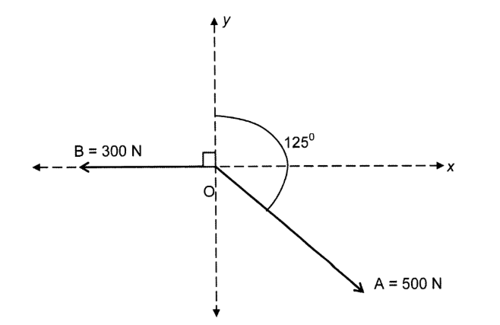
2.1.1 Define resultant force.

________________________________________________________________________________________________________________________________________________________________________________________________________________________________________________________________________________________________________________________
(2)
2.1.2 Calculate the magnitude of the resultant force.

____________________________________________________________________________________________________________________________________________________________________________________________________________________________________________________________________________________________________________________________________________________________________________________________________________________________________________________________________________________
__________________________________________________________________________________________________________________________________________________________________________________________________________________________________________
(5)

2.2 The apparatus shown below is used to determine the resultant of two co-planar forces F1 and F2. The pulleys are frictionless.
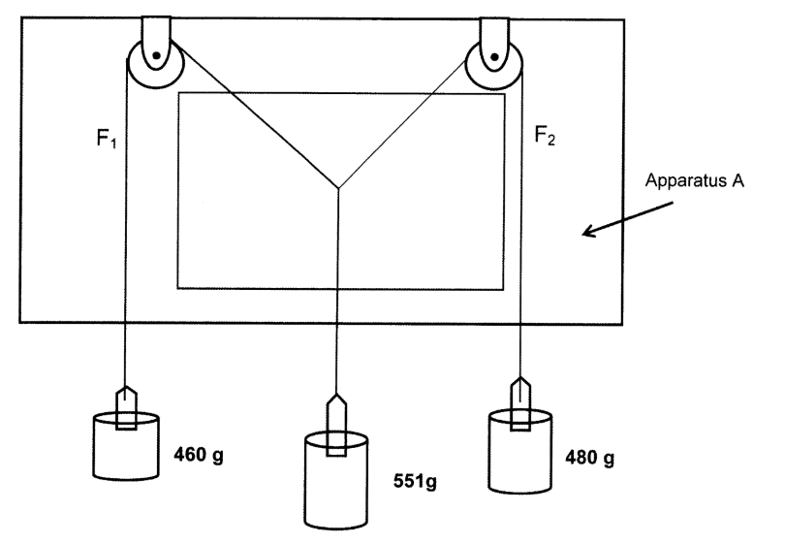
2.2.1 Write down the name of apparatus A shown above.
______________________________________________________________________________________________________________________________________________________________________________________________________________________________________________________________________________________________________________________________________________________________________________________________________
(1)

2.2.2 A mirror is used to plot the image of the string on the sheet of paper. Why is the use of the mirror recommended?

An incomplete diagram for the results of this investigation is given on the last page (page 21) of this question paper.
______________________________________________________________________________________________________________________________________________________________________________________________________________________________________________________________________________________________________________________________________________________________________________________________________
(1)
2.2.3 Complete the diagram using the scale 10mm represents 1 N and determine the magnitude of the resultant of F1 and F2. (see page 21) (6)

2.2.4 The 551 g mass piece is now removed. How will this affect the magnitude and direction of the resultant force determined in Question 2.2.3?

Choose from INCREASES, DECREASES OR REMAINS THE SAME. Give a reason for the answer.

______________________________________________________________________________________________________________________________________________________________________________________________________________________________________________________________________________________________________________________________________________________________________________________________________
(2)
[17]
Question 3
A light, inextensible rope is attached to a vertical wall at point X. A block of mass 2,1 kg is attached to the other end of the rope. The rope is pulled to the left by a horizontal force F of magnitude 28 N, applied at point Y, as shown in the diagram below. The rope makes an angle with the wall.
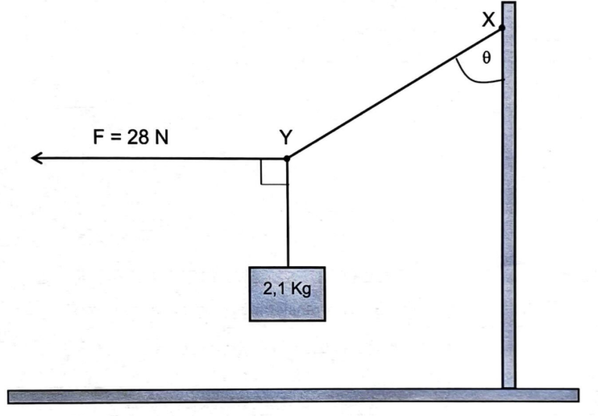

3.1 Draw a closed vector diagram to show ALL the forces acting at point Y. Include at least one angle in your diagram.

(4)
3.2 Calculate:
3.2.1 the tension in the rope

__________________________________________________________________________________________________________________________________________________________________________________________________________________________________________________________________________________________________________________________________________________________________________________________________________________________________________________________________________________________________________________________________________________________________
(3)
3.2.2 angle

__________________________________________________________________________________________________________________________________________________________________________________________________________________________________________________________________________________________________________________________________________________________________________________________________________________________________________________________________________________________________________________________________________________________________
(3)
[10]
Question 4
4.1 A Physical Sciences class sets up an experiment to investigate Newton's Second Law of motion. They set up the apparatus as shown below.
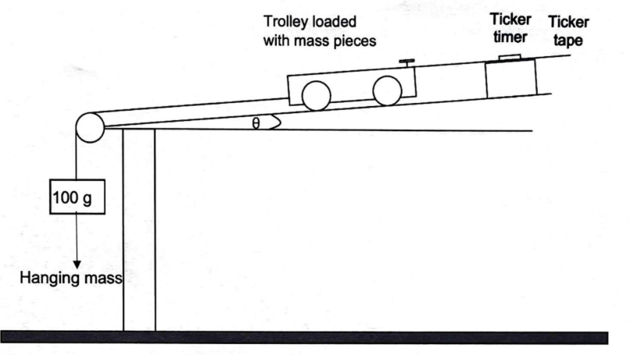
The net force acting on the trolley was increased by transferring mass pieces from the trolley to the hanging mass.

The experiment was done five times, and the data collected is shown below.
Readings | Hanging mass(g) | Net Force(N) | Acceleration(ms-2)
1 | 100 | 0.98 | 0,5
2 | 200 | 1.96 | 1.0
3 | 300 | 2.94 | 1.5
4 | 400 | 3.92 | 2.0
5 | 500 | X | Y

4.1.1 State Newtons Second Law of motion in words.

______________________________________________________________________________________________________________________________________________________________________________________________________________________________________________________________________________________________________________________________________________________________________________________________________
(2)
4,1.2 Write down an investigative question for this experiment.

______________________________________________________________________________________________________________________________________________________________________________________________________________________________________________________________________________________________________________________________________________________________________________________________________
(2)
4.1.3 State one variable that should be kept constant during the experiment.

__________________________________________________________________________________________________________________________________________________________________________________________________________________________________________
(1)
4.1.4 Write down the numerical values of X and Y given in the table.

______________________________________________________________________________________________________________________________________________________________________________________________________________________________________________________________________________________________________________________________________________________________________________________________________
(2)
4.2 A constant force F is applied to a 6 kg block to move it up a rough surface inclined at 60° to the horizontal. Force F, which is parallel to the incline, moves the block up the incline at CONSTANT VELOCITY. The block experiences a constant kinetic frictional force of 12,25 N.
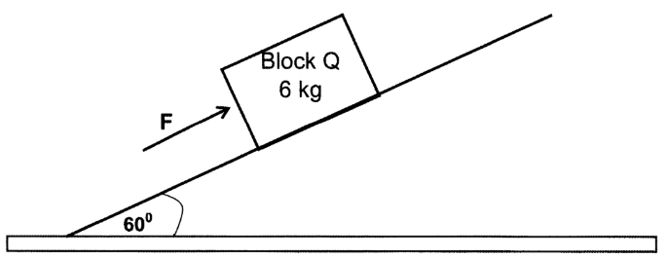

4.3.1 Draw a free body diagram showing all the forces acting on Block Q.

(4)
3.3.2 Calculate the magnitude of force F.

____________________________________________________________________________________________________________________________________________________________________________________________________________________________________________________________________________________________________________________________________________________________________________________________________________________________________________________________________________________
(4)
4.3.3 The angle of the incline is now increased to 75°.

How will this affect the magnitude of the velocity of the block as it moves UP the incline, if the force F acting on it remains constant? Choose from INCREASES, DECREASES OR REMAINS THE SAME.

______________________________________________________________________________________________________________________________________________________________________________________________________________________________________________________________________________________________________________________________________________________________________________________________________
(2)

Question 5
5.1 State Newton's law of Universal Gravitation in words.

______________________________________________________________________________________________________________________________________________________________________________________________________________________________________________________________________________________________________________________________________________________________________________________________________
(2)
5.2 Earth has a mass of 6 x 1024 kg and an average radius of 6,4 x 106 m. A communication satellite, mass 1500 kg, moves in a fixed circular orbit around the Earth.

The Earth exerts a force of magnitude 10 500 N on the satellite in order to keep it in the specified orbit.

Calculate the distance in kilometres of the satellite from the surface of Earth.

__________________________________________________________________________________________________________________________________________________________________________________________________________________________________________________________________________________________________________________________________________________________________________________________________________________________________________________________________________________________________________________________________________________________________________________________________________________________________________________________________________________________________________________________________________________________________________________________________________________________________________________________________________________________
(5)

5.3 A box of mass 100 kg is at rest on a rough horizontal surface. When a force of magnitude F is applied to the box at an angle of 15° to the horizontal, as shown in the diagram below, the box moves to the right at CONSTANT VELOCITY.
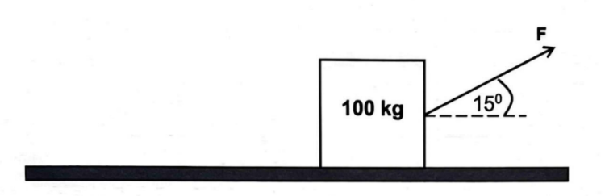
The co-efficient of kinetic friction between the box and the surface is 0,5.

5.3.1 Show that the magnitude of the normal force acting on the box is given by 980 -0,259 F.

______________________________________________________________________________________________________________________________________________________________________________________________________________________________________________________________________________________________________________________________________________________________________________________________________
(2)
5.3.2 Calculate the magnitude of the frictional force acting on the box in terms of F.
______________________________________________________________________________________________________________________________________________________________________________________________________________________________________________________________________________________________________________________________________________________________________________________________________
(2)
5.3.3 Hence calculate the magnitude of F.

________________________________________________________________________________________________________________________________________________________________________________________________________________________________________________________________________________________________________________________________________________________________________________________________________________________________________________________________________________________________________________________________________________________________________________________________________________________________________________
(3)
5.3.4 How will the magnitude of the frictional force change if the size of the angle is doubled?

Choose from INCREASES, DECREASES OR REMAINS THE SAME.

____________________________________________________________________________________________________________________________________________________________
(1)

5.4 A crane lifts two blocks of masses of 150 kg and 200 kg as shown in the diagram below. The 150 kg block accelerates upwards at 0,75 m·s-2.

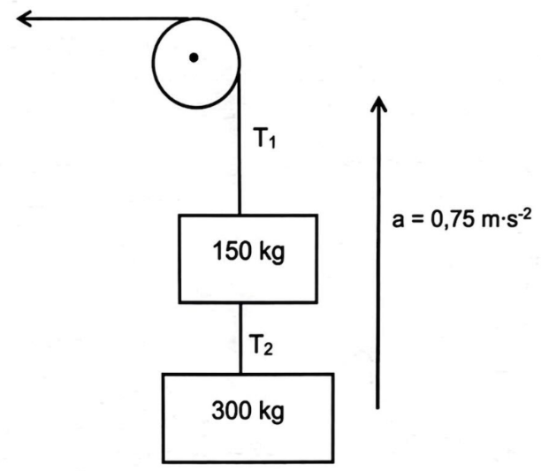

5.4.1 Draw a labelled free body diagram to show all the forces acting on the 150 kg block.

(3)
5.4.2 Calculate the magnitude of the tension T1.

____________________________________________________________________________________________________________________________________________________________________________________________________________________________________________________________________________________________________________________________________________________________________________________________________________________________________________________________________________________
(4)
[22]

Question 6
Consider the following molecules and answer the questions below:

6.1 Draw the Lewis structure for:
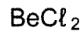
6.1.1

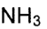
5.1.2

(2 x 2 = 4)

6.2 Indicate whether the COVALENT BONDS in the following molecules are POLAR or NON-POLAR.

6.2.1 HCl

______________________________________________________________________________
(1)
6.2.2 N₂

______________________________________________________________________________
(1)

6.2.3 CO₂

______________________________________________________________________________
(1)
6.3 Define the term dative covalent bond.

__________________________________________________________________________________________________________________________________________________________________________________________________________________________________________
(2)
6.4 Explain why the hydronium ion (H*) can form a dative covalent bond with NH₃.
__________________________________________________________________________________________________________________________________________________________________________________________________________________________________________
(2)

Question 7
7.1 Define the term electronegativity.

____________________________________________________________________________________________________________________________________________________________________________________________________________________________________________________________________________________________________________________________________________________________________________________________________________________________________________________________________________________
(2)
7.2 Explain the difference between a polar and a non-polar molecule.

____________________________________________________________________________________________________________________________________________________________________________________________________________________________________________________________________________________________________________________________________________________________________________________________________________________________________________________________________________________
(2)

7.3 The table below shows the properties of methane (CH₄) and chloromethane (CH₃CI).
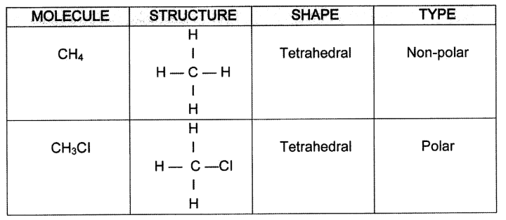

    - Explain why the CH4 molecule is non-polar

______________________________________________________________________________________________________________________________________________________________________________________________________________________________________________________________________________________________________________________________________________________________________________________________________
(2)
7.3.2 A chlorine (CI) atom replaces one of the hydrogen (H) atoms in the methane (CH4) molecule to form a chloromethane (CH3CI) molecule. Both molecules have the same shape.

Explain why the chloromethane (CH3CI) molecule that forms is polar.

__________________________________________________________________________________________________________________________________________________________________________________________________________________________________________________________________________________________________________________________________________________________________________________________________________________________________________________________________________________________________________________________________________________________________
(3)
TOTAL: 100
