



https://www.youtube.com/watch?v=SJ4_nONtYeY
WATCH FOR TESTIMONIALS

WATCH FOR TESTIMONIALS

Marks – 100 Duration – 2 Hours

INSTRUCTIONS
1. Answer ALL the questions.

2. Read each question carefully before attempting to answer.

3. Show all calculations clearly, and where necessary, round off answers to two
decimal places, unless stated otherwise.

4. Use a scientific calculator where necessary.

5. Write neatly and legibly.

6. Number your answers correctly according to the question paper.

7. Use appropriate mathematical notation and units where applicable.

8. Diagrams are not necessarily drawn to scale, so measurements should be
calculated unless stated otherwise.

9. If you make a mistake, cross it out neatly and rewrite your answer.

10. Manage your time wisely to complete all sections of the paper.

Question 1
- Consider the following graph paper with points plotted on it.
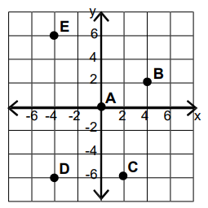

  - Which one of points A to E is plotted at the origin?

__________________________________________________________________
(1)
  - Give the coordinates of point B. 2 B

__________________________________________________________________
(1)
  - What is the x-coordinates of points C and D?

__________________________________________________________________
(2)
  - What are the y-coordinates of points D and E?

__________________________________________________________________
(2)
1.5 Consider a line that goes through points D and B.
1.5.1 Calculate the gradient of the line.
______________________________________________________________________________________________________________________________________________________________________________________________________________________________________________________________________________________________________________________________________________________________________________________________________
(3)
    - Calculate the y-intercept of the line.

______________________________________________________________________________________________________________________________________________________________________________________________________________________________________________________________________________________________________________________________________________________________________________________________________
(2)
    - Determine the equation of the line. -6 -4 -2 2 4 6 x -2 -4 D -6 C

______________________________________________________________________________________________________________________________________________________________________________________________________________________________________________________________________________________________________________________________________________________________________________________________________
(3)
1.6. Repeat question 1.5, but for a line that goes through points B and E.

______________________________________________________________________________________________________________________________________________________________________________________________________________________________________________________________________________________________________________________________________________________________________________________________________
(4)
  - Repeat question 1.5, but for a line that goes through points E and D.

______________________________________________________________________________________________________________________________________________________________________________________________________________________________________________________________________________________________________________________________________________________________________________________________________

  - Repeat question 1.5, but for a line that goes through points D and C.

______________________________________________________________________________________________________________________________________________________________________________________________________________________________________________________________________________________________________________________________________________________________________________________________________
(4)

1.9 Calculate the y-coordinate of the line that goes through points E and B for x= 9.

______________________________________________________________________________________________________________________________________________________________________________________________________________________________________________________________________________________________________________________________________________________________________________________________________
(1)

1.10 Calculate the y-coordinate of the line that goes through points D and B for x= 9

______________________________________________________________________________________________________________________________________________________________________________________________________________________________________________________________________________________________________________________________________________________________________________________________________
(1)
(20)

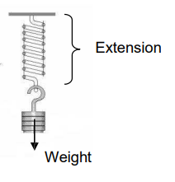
Question 2
2.1 An experiment is done to investigate the behaviour of a spring. The extension of the spring is measured for an increasing number of mass pieces that are attached to it. All the mass pieces have identical weights and one mass piece has a weight of 5 N. The following set of data is obtained.
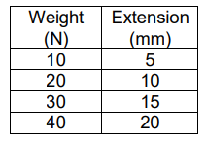

2.1.1 Which one of weight or extension is the dependent variable?

______________________________________________________________________________________________________________________________________________________________________________________________________________________________________________________________________________________________________________________________________________________________________________________________________
(2)

2.1.2 Draw a graph of these results by plotting weight on the x-axis and extension on the y-axis.

(5)
2.1.3 What is the relationship between extension and weight for this spring? Give a
reason for your answer.

______________________________________________________________________________________________________________________________________________________________________________________________________________________________________________________________________________________________________________________________________________________________________________________________________
(2)
    - Determine the gradient of the graph.

______________________________________________________________________________________________________________________________________________________________________________________________________________________________________________________________________________________________________________________________________________________________________________________________________
(2)
    - Determine the equation for this graph.

______________________________________________________________________________________________________________________________________________________________________________________________________________________________________________________________________________________________________________________________________________________________________________________________________
(3)
    - How many mass pieces cause an extension of 15 mm?

______________________________________________________________________________________________________________________________________________________________________________________________________________________________________________________________________________________________________________________________________________________________________________________________________
(2)
2.2 You want to "design" a formula to convert temperatures measured in °C to °F.

You use two thermometers, one calibrated in °C and the other in °F, to take the temperature of water in a beaker.

After that you heat the water slightly and take the temperature again. You repeat this process for a further two sets of readings and record your results as follows.

    - By inspecting the numbers, would you say this is a direct proportionality? Give a
reason for the answer.

______________________________________________________________________________________________________________________________________________________________________________________________________________________________________________________________________________________________________________________________________________________________________________________________________
(2)

    - Based on the pattern in the table, can you tell how much °F is the same as 30°C and 75°C?

______________________________________________________________________________________________________________________________________________________________________________________________________________________________________________________________________________________________________________________________________________________________________________________________________
(2)
(20)

Question 3
You plan a trip to Cape Town and want to get an idea of the relationship between your average speed and travelling time. The distance of your journey will be 1 200 km.

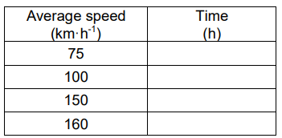

  - Complete the table and draw a graph of your results (if you do not have graph paper, just design simple graph paper yourself). Put average speed on the x-axis.

(5)

  - Identify the dependent and independent variables.

______________________________________________________________________________________________________________________________________________________________________________________________________________________________________________________________________________________________________________________________________________________________________________________________________

(2)
  - What type of relationship is this? Give a reason for your answer.

______________________________________________________________________________________________________________________________________________________________________________________________________________________________________________________________________________________________________________________________________________________________________________________________________
(3)

  - Use your graph to read off your average speed if you travel for 576 minutes.

______________________________________________________________________________________________________________________________________________________________________________________________________________________________________________________________________________________________________________________________________________________________________________________________________
(3)
  - Use a calculation to test your answer to the previous question.

______________________________________________________________________________________________________________________________________________________________________________________________________________________________________________________________________________________________________________________________________________________________________________________________________
(3)
(20)
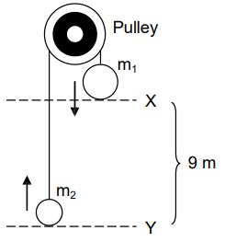
Question 4
The diagram represents an Atwood machine, which is a simple device used to study motion. In this case, it consists of a frictionless pulley and two mass pieces, m1 and m2, which are connected by a light, inelastic rope. The mass pieces are held stationary at positions X and Y; m1 is heavier than m2. When the mass pieces are released, you measure the distance moved by each mass piece from X.

Your values for m1 (called distance 1) are displayed in the following table:
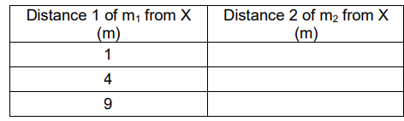

  - By analysing the diagram, complete the corresponding values for distance 2 from X.

______________________________________________________________________________________________________________________________________________________________________________________________________________________________________________________________________________________________________________________________________________________________________________________________________
(6)
  - Which one of distance 1 or distance 2 is the dependent variable?

______________________________________________________________________________________________________________________________________________________________________________________________________________________________________________________________________________________________________________________________________________________________________________________________________
(6)

  - Draw a piece of simple graph and plot this data.

(4)
  - Is this an example of an inverse proportionality? Give a reason for your answer.

______________________________________________________________________________________________________________________________________________________________________________________________________________________________________________________________________________________________________________________________________________________________________________________________________

(4)
(20)

Question 5
Determine the resultant vector in each of the following cases by means of a scale drawing. Test each of your answers by means of a calculation.

  - A displacement of 25 m, bearing of 010° and another displacement of 25 m; bearing 190°.

______________________________________________________________________________________________________________________________________________________________________________________________________________________________________________________________________________________________________________________________________________________________________________________________________
(4)
  - 15 N north and 19 N south.

______________________________________________________________________________________________________________________________________________________________________________________________________________________________________________________________________________________________________________________________________________________________________________________________________
(4)
  - 12,8 km in the direction E10°S and 14,2 km in the same direction.

__________________________________________________________________________________________________________________________________________________________________________________________________________________________________________________________________________________________________________________________________________________________________________________________________________________________________________________________________________________________________________________________________________________________________
(6)

  - 20 km in a direction of W20°N and 30 km in the opposite direction.

____________________________________________________________________________________________________________________________________________________________________________________________________________________________________________________________________________________________________________________________________________________________________________________________________________________________________________________________________________________
(6)
(20)

