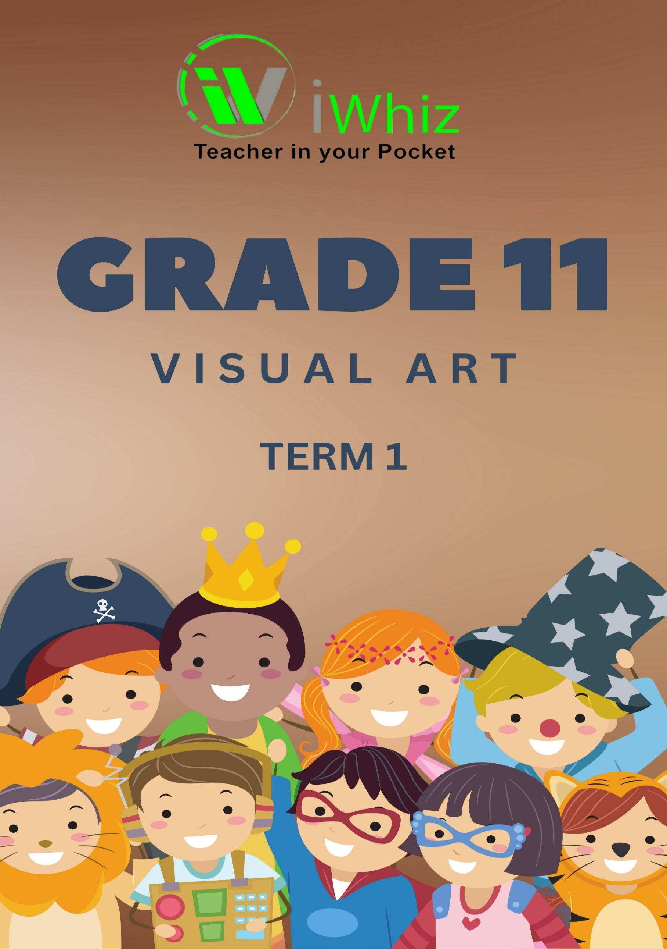



https://www.youtube.com/watch?v=SJ4_nONtYeY
WATCH FOR TESTIMONIALS

WATCH FOR TESTIMONIALS

Grade 11 – Term 1 Test
Marks – 100 TIME – 2 hours

INSTRUCTIONS AND INFORMATION
Read the following instructions carefully before answering the questions.

- Answer ALL the questions.

- Use full sentences and paragraphs. No bulleted phrases.

- 10 marks equal about one page but rather write too much than too little.

- Start the answers to each question at the top of a NEW page.

- Number the answers correctly according to the numbering system used in this question paper.

- Present your answers according to the instructions of each question.

- Do not use informal language and slang.

- Use SHORT, well-structured sentences.

- Use the correct terminology.

- Write neatly and legibly.

Question 1
This work was inspired by a photograph Rego saw in in a newspaper at the height of the war in Iraq, of an injured girl in a frilly dress after a bomb went off in Basra.
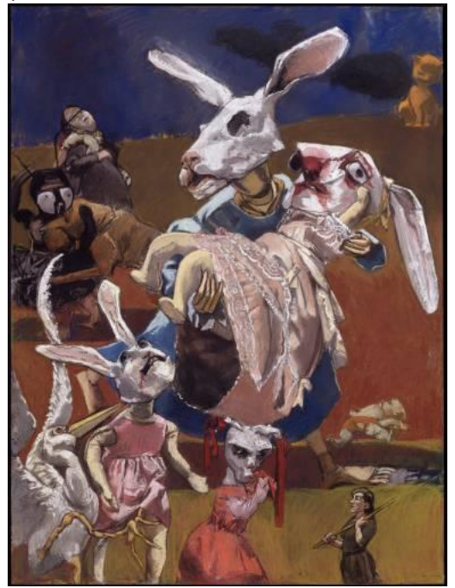
Paula Rego, War, pastel on paper, 2003

Answer the following questions on this artwork by Paula Rego.

- What’s going on in this artwork?
________________________________________________________________________________________________________________________________________________________________________________________________________________________________________________________________________________________________________________________
__________________________________________________________________________________________________________________________________________________________________________________________________________________________________________
(3)
- What was your first reaction to this artwork? Why do you think you had the reaction?
____________________________________________________________________________________________________________________________________________________________________________________________________________________________________________________________________________________________________________________________________________________________________________________________________________________________________________________________________________________
(3)
- Does your opinion about the artwork change the longer you look at it? Why?
____________________________________________________________________________________________________________________________________________________________________________________________________________________________________________________________________________________________________________________________________________________________________________________________________________________________________________________________________________________
(3)
- How did this artist use space?
____________________________________________________________________________________________________________________________________________________________________________________________________________________________________________________________________________________________________________________________________________________________________________________________________________________________________________________________________________________
(3)
- Which area of the artwork is emphasized by the artist? Why?
____________________________________________________________________________________________________________________________________________________________________________________________________________________________________________________________________________________________________________________________________________________________________________________________________________________________________________________________________________________
(3)

- How does your eye move through the artwork? What choices did the artist make to make that happen?
____________________________________________________________________________________________________________________________________________________________________________________________________________________________________________________________________________________________________________________________________________________________________________________________________________________________________________________________________________________
(3)
- How did the artist use balance and proportion?
____________________________________________________________________________________________________________________________________________________________________________________________________________________________________________________________________________________________________________________________________________________________________________________________________________________________________________________________________________________
(3)
- How would you describe this artwork to someone who has never seen it?
____________________________________________________________________________________________________________________________________________________________________________________________________________________________________________________________________________________________________________________________________________________________________________________________________________________________________________________________________________________
(3)
- What do you think this artist is trying to say in this artwork? What is the meaning or message?
____________________________________________________________________________________________________________________________________________________________________________________________________________________________________________________________________________________________________________________________________________________________________________________________________________________________________________________________________________________
(3)

- What juxtapositions do you notice?
____________________________________________________________________________________________________________________________________________________________________________________________________________________________________________________________________________________________________________________________________________________________________________________________________________________________________________________________________________________
(3)
- What was happening in history when this artwork was made? How does that change your understanding of the artwork?
____________________________________________________________________________________________________________________________________________________________________________________________________________________________________________________________________________________________________________________________________________________________________________________________________________________________________________________________________________________
(4)
- What is exciting about this artwork?
____________________________________________________________________________________________________________________________________________________________________________________________________________________________________________________________________________________________________________________________________________________________________________________________________________________________________________________________________________________
(3)
- What emotions do you feel when looking at this?
____________________________________________________________________________________________________________________________________________________________________________________________________________________________________________________________________________________________________________________________________________________________________________________________________________________________________________________________________________________
(3)

- Write a one-page visual analysis on the artwork. Structure your answer by using the following guidelines:
- Introduction with brief description
- Art elements
- Composition and focal point
- Technique
- Style
- Possible meanings and messages of the work
________________________________________________________________________________________________________________________________________________________________________________________________________________________________________________________________________________________________________________________
________________________________________________________________________________________________________________________________________________________________________________________________________________________________________________________________________________________________________________________
________________________________________________________________________________________________________________________________________________________________________________________________________________________________________________________________________________________________________________________
________________________________________________________________________________________________________________________________________________________________________________________________________________________________________________________________________________________________________________________
________________________________________________________________________________________________________________________________________________________________________________________________________________________________________________________________________________________________________________________
________________________________________________________________________________________________________________________________________________________________________________________________________________________________________________________________________________________________________________________
________________________________________________________________________________________________________________________________________________________________________________________________________________________________________________________________________________________________________________________
________________________________________________________________________________________________________________________________________________________________________________________________________________________________________________________________________________________________________________________
________________________________________________________________________________________________________________________________________________________________________________________________________________________________________________________________________________________________________________________
________________________________________________________________________________________________________________________________________________________________________________________________________________________________________________________________________________________________________________________
________________________________________________________________________________________________________________________________________________________________________________________________________________________________________________________________________________________________________________________
(10)

Question 2
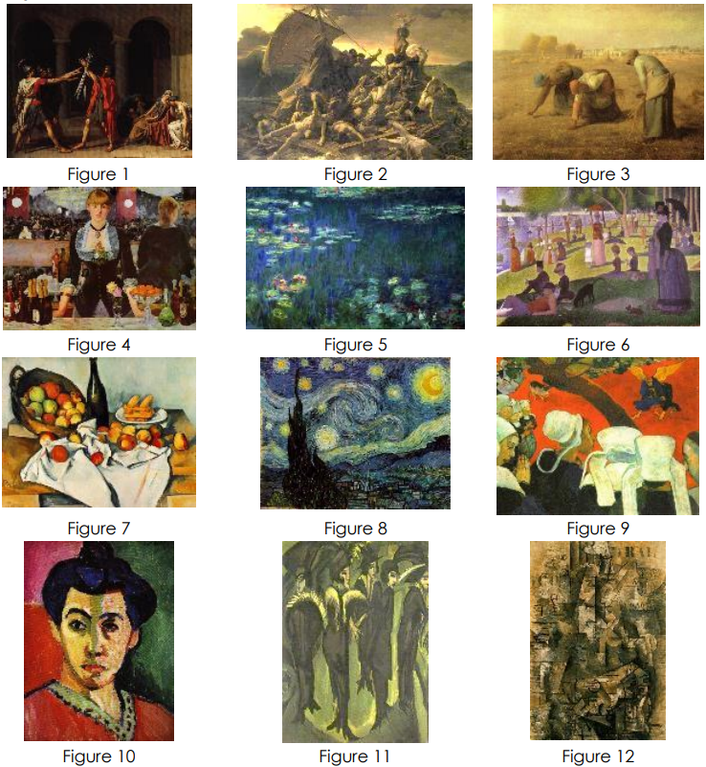
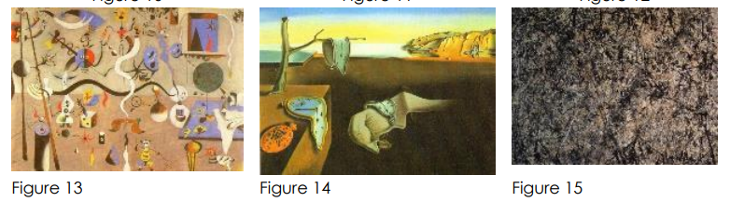
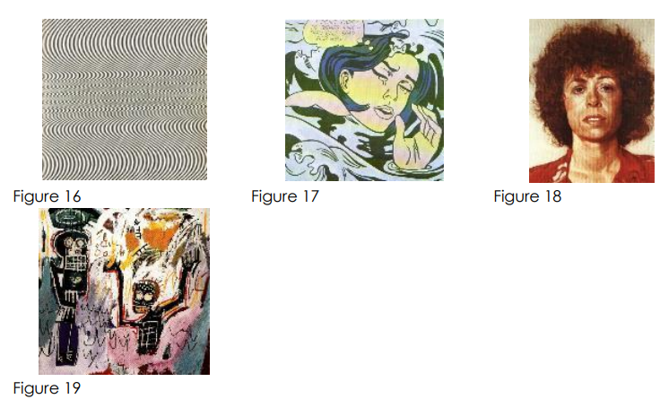

The artworks depicted in Figures 1 – 19 represent the work covered in Themes 1 – 3 and Themes 5 – 6. Answer the following questions.

- Identify the art movement of at least six artworks and provide at least THREE reasons why each artwork is part of the movement.

________________________________________________________________________________________________________________________________________________________________________________________________________________________________________________________________________________________________________________________
________________________________________________________________________________________________________________________________________________________________________________________________________________________________________________________________________________________________________________________
________________________________________________________________________________________________________________________________________________________________________________________________________________________________________________________________________________________________________________________
________________________________________________________________________________________________________________________________________________________________________________________________________________________________________________________________________________________________________________________
(5)

- Very briefly explain the subject matter depicted in Figures 1 – 12 and Figures 14 – 20.
________________________________________________________________________________________________________________________________________________________________________________________________________________________________________________________________________________________________________________________
________________________________________________________________________________________________________________________________________________________________________________________________________________________________________________________________________________________________________________________
________________________________________________________________________________________________________________________________________________________________________________________________________________________________________________________________________________________________________________________
________________________________________________________________________________________________________________________________________________________________________________________________________________________________________________________________________________________________________________________
(6)
- Which paintings depict real everyday scenes?
__________________________________________________________________________________________________________________________________________________________________________________________________________________________________________
(1)
- Which paintings depict an unreal scene or a scene created from the imagination?
__________________________________________________________________________________________________________________________________________________________________________________________________________________________________________
(1)
- Identify TWO paintings that can be described as naturalistic? Provide reasons for each of your answers.
________________________________________________________________________________________________________________________________________________________________________________________________________________________________________________________________________________________________________________________
________________________________________________________________________________________________________________________________________________________________________________________________________________________________________________________________________________________________________________________
(2)

- Identify TWO paintings that can be described as figurative? Provide reasons for each of your answers.
________________________________________________________________________________________________________________________________________________________________________________________________________________________________________________________________________________________________________________________
________________________________________________________________________________________________________________________________________________________________________________________________________________________________________________________________________________________________________________________
(2)

- Identify TWO paintings that can be described as expressionistic? Provide reasons for each of your answers.
________________________________________________________________________________________________________________________________________________________________________________________________________________________________________________________________________________________________________________________
________________________________________________________________________________________________________________________________________________________________________________________________________________________________________________________________________________________________________________________
____________________________________________________________________________________________________________________________________________________________
(2)

- Identify TWO paintings in which there are tendencies towards abstraction, although still figurative. Provide reasons for each of your answers.
________________________________________________________________________________________________________________________________________________________________________________________________________________________________________________________________________________________________________________________
________________________________________________________________________________________________________________________________________________________________________________________________________________________________________________________________________________________________________________________
(2)
- Identify TWO paintings that can be described as abstract? Provide reasons for each of your answers.
________________________________________________________________________________________________________________________________________________________________________________________________________________________________________________________________________________________________________________________
________________________________________________________________________________________________________________________________________________________________________________________________________________________________________________________________________________________________________________________
(2)
- Identify TWO paintings containing decorative elements? Provide reasons for each of your answers.
________________________________________________________________________________________________________________________________________________________________________________________________________________________________________________________________________________________________________________________
________________________________________________________________________________________________________________________________________________________________________________________________________________________________________________________________________________________________________________________
(2)
Question 3
- Identify the artists and title of artwork in Figure 1. Explain why this work was so revolutionary?
________________________________________________________________________________________________________________________________________________________________________________________________________________________________________________________________________________________________________________________
________________________________________________________________________________________________________________________________________________________________________________________________________________________________________________________________________________________________________________________
________________________________________________________________________________________________________________________________________________________________________________________________________________________________________________________________________________________________________________________
________________________________________________________________________________________________________________________________________________________________________________________________________________________________________________________________________________________________________________________
________________________________________________________________________________________________________________________________________________________________________________________________________________________________________________________________________________________________________________________
________________________________________________________________________________________________________________________________________________________________________________________________________________________________________________________________________________________________________________________
________________________________________________________________________________________________________________________________________________________________________________________________________________________________________________________________________________________________________________________
________________________________________________________________________________________________________________________________________________________________________________________________________________________________________________________________________________________________________________________
__________________________________________________________________________________________________________________________________________________________________________________________________________________________________________
(10)

- Figures 2 – 6 are examples of the following:
- Conceptual Art o Body Art
- Earth Art o Installations
- Performance Art

Identify the artwork for each and explain why it is a good example to explain the type of art
________________________________________________________________________________________________________________________________________________________________________________________________________________________________________________________________________________________________________________________
________________________________________________________________________________________________________________________________________________________________________________________________________________________________________________________________________________________________________________________
________________________________________________________________________________________________________________________________________________________________________________________________________________________________________________________________________________________________________________________
________________________________________________________________________________________________________________________________________________________________________________________________________________________________________________________________________________________________________________________
________________________________________________________________________________________________________________________________________________________________________________________________________________________________________________________________________________________________________________________
________________________________________________________________________________________________________________________________________________________________________________________________________________________________________________________________________________________________________________________
________________________________________________________________________________________________________________________________________________________________________________________________________________________________________________________________________________________________________________________
________________________________________________________________________________________________________________________________________________________________________________________________________________________________________________________________________________________________________________________
________________________________________________________________________________________________________________________________________________________________________________________________________________________________________________________________________________________________________________________
________________________________________________________________________________________________________________________________________________________________________________________________________________________________________________________________________________________________________________________
________________________________________________________________________________________________________________________________________________________________________________________________________________________________________________________________________________________________________________________
________________________________________________________________________________________________________________________________________________________________________________________________________________________________________________________________________________________________________________________
________________________________________________________________________________________________________________________________________________________________________________________________________________________________________________________________________________________________________________________
________________________________________________________________________________________________________________________________________________________________________________________________________________________________________________________________________________________________________________________
________________________________________________________________________________________________________________________________________________________________________________________________________________________________________________________________________________________________________________________
________________________________________________________________________________________________________________________________________________________________________________________________________________________________________________________________________________________________________________________
________________________________________________________________________________________________________________________________________________________________________________________________________________________________________________________________________________________________________________________
________________________________________________________________________________________________________________________________________________________________________________________________________________________________________________________________________________________________________________________
____________________________________________________________________________________________________________________________________________________________
(15)

