
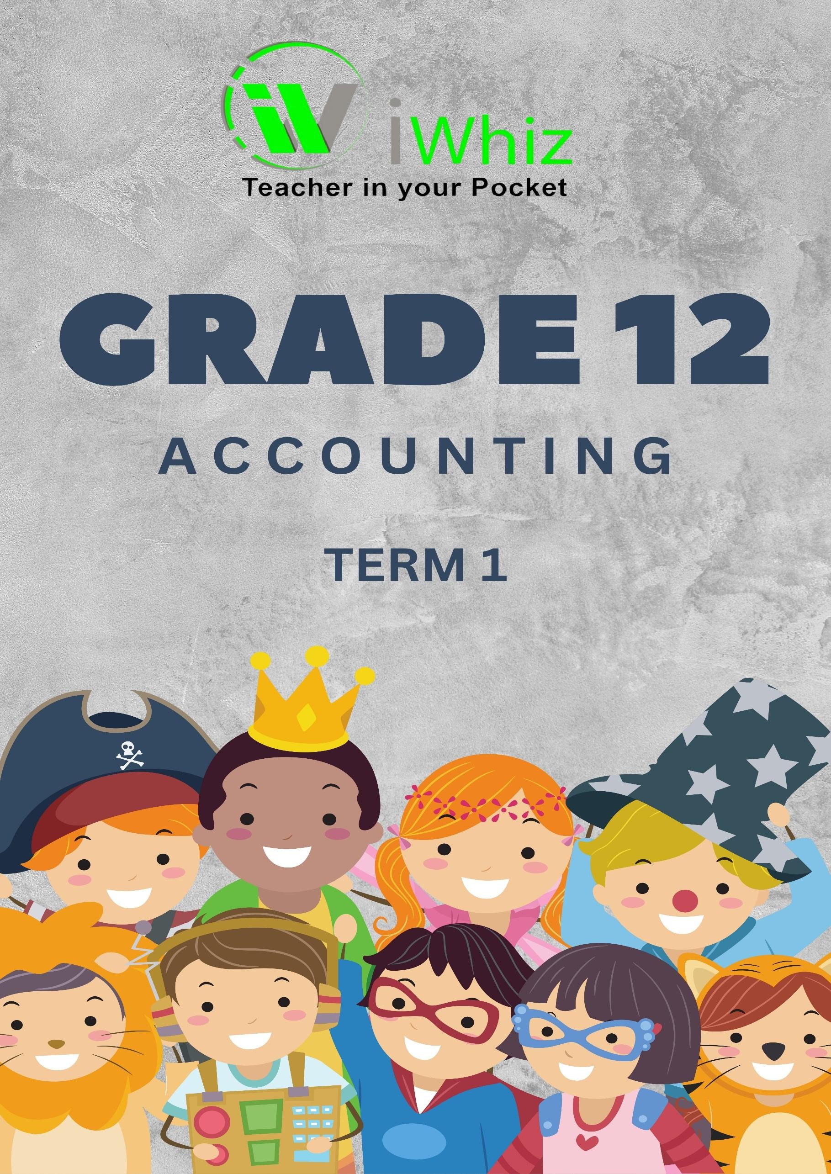



https://www.youtube.com/watch?v=SJ4_nONtYeY
WATCH FOR TESTIMONIALS

WATCH FOR TESTIMONIALS

Grade 12 Accounting Term 1 Test
Time: 3 Hours
Total Marks: 150

Instructions:
- Answer ALL questions.
- All calculations must be shown clearly.
- Use the prescribed format for financial statements where applicable.
- Write neatly and legibly.

SECTION A: (30 MARKS)
Multiple-Choice Questions
(Choose the correct answer for each question. Each question is worth 3 marks.)
1. Which of the following is a financial statement of a company? (3)
  - Income statement
  - Balance Sheet
  - Cash Flow Statement
  - All of the above
2. Which of the following accounts is classified as a current liability? (3)
- Bank
- Loan from shareholder
- Accounts payable
- Capital
- Which of the following would appear in the Cash Flow Statement? (3)
- Depreciation
- Share capital
- Sale of fixed assets
- Interest on loan
- Which of the following is an example of a non-current asset? (3)
  - Inventory
  - Accounts Receivable
  - Land and buildings
  - Bank overdraft
- Which of the following is NOT an accounting principle? (3)
  - Going concern
  - Matching principle
  - Prudence
  - Fixed cost principle

- The owner of a business withdrew money for personal use. Which of the following will be the effect on the accounting equation? (3)
  - Increase in assets and decrease in liabilities
  - Decrease in assets and decrease in capital
  - Increase in liabilities and decrease in assets
  - Decrease in liabilities and increase in assets

- Which of the following is a source document for recording the purchase of inventory on credit? (3)
  - Receipt
  - Invoice
  - Bank statement
  - Credit note

- What is the effect on the bank account when a cheque is issued to settle an outstanding debt? (3)
  - Increase in the bank account
  - Decrease in the bank account
  - No effect
  - Increase in liabilities

- Which of the following accounts is classified as equity? (3)
  - Accounts payable
  - Capital
  - Sales
  - Expenses
- The trial balance does not balance because of a(n): (3)
  - Error of omission
  - Error of commission
  - Error of principle
  - Mathematical error

SECTION B: (60 MARKS)
General Ledger and Trial Balance
Question 1
The following balances appeared in the general ledger of ABC Traders on 31 January 2025:

Account Name | Debit (R) | Credit (R)
Cash | 5,000
Accounts Payable |  | 2,000
Sales |  | 10,000
Rent Expense | 1,000
Capital |  | 8,000
Inventory | 3,500
Accounts Receivable | 2,500
Loan from bank |  | 4,000
Prepare the trial balance of ABC Traders as at 31 January 2025. (10)

Question 2
The following transactions took place during February 2025:
    - Purchased inventory worth R5,000 on credit.
    - Paid rent of R1,500 in cash.
    - Sold goods worth R7,500 on credit.
    - Received R3,000 from a debtor.

  - Journalize the above transactions in the general journal. (12)

  - Post the journal entries to the general ledger and prepare a trial balance. (12)

Question 3
The following balances were extracted from the trial balance of XYZ Ltd. on 28 February 2025:

Account | Debit (R) | Credit (R)
Sales |  | 15,000
Cost of Sales | 8,000
Sundry Expenses | 2,000
Accounts Payable |  | 5,000
Accounts Receivable | 3,000
Capital |  | 12,000
Bank | 1,000
Interest Income |  | 1,000
3.1. Prepare the Income Statement for the month ending 28 February 2025. (10)
  - Prepare the Statement of Financial Position (Balance Sheet) for the month ending 28 February 2025. (10)

SECTION C: (60 MARKS)
Accounting for Partnerships and Companies
Question 4
The following information is provided for the partnership of M & N for the year ending 31 December 2024:
    - Capital contributions:
o M: R40,000
o N: R60,000
    - Net profit for the year: R40,000
    - Drawings:
o M: R10,000
o N: R12,000
    - Interest on capital is to be allowed at 10%.

4.1. Calculate the interest on capital for each partner. (6)

4.2. Prepare the appropriation account for the year ending 31 December 2024. (8)
4.3. Prepare the capital accounts for each partner. (8)

Question 5
The following information is provided for ABC Ltd. for the year ending 31 December 2024:
        - Issued share capital: 100,000 shares at R2 each.
        - Retained earnings: R50,000.
        - Net profit after tax: R80,000.

5.1. Prepare the statement of changes in equity for the year ending 31 December 2024. (8)

5.2. Prepare the statement of comprehensive income (Income Statement) for the year ending 31 December 2024. (8)

Total Marks: 150

