
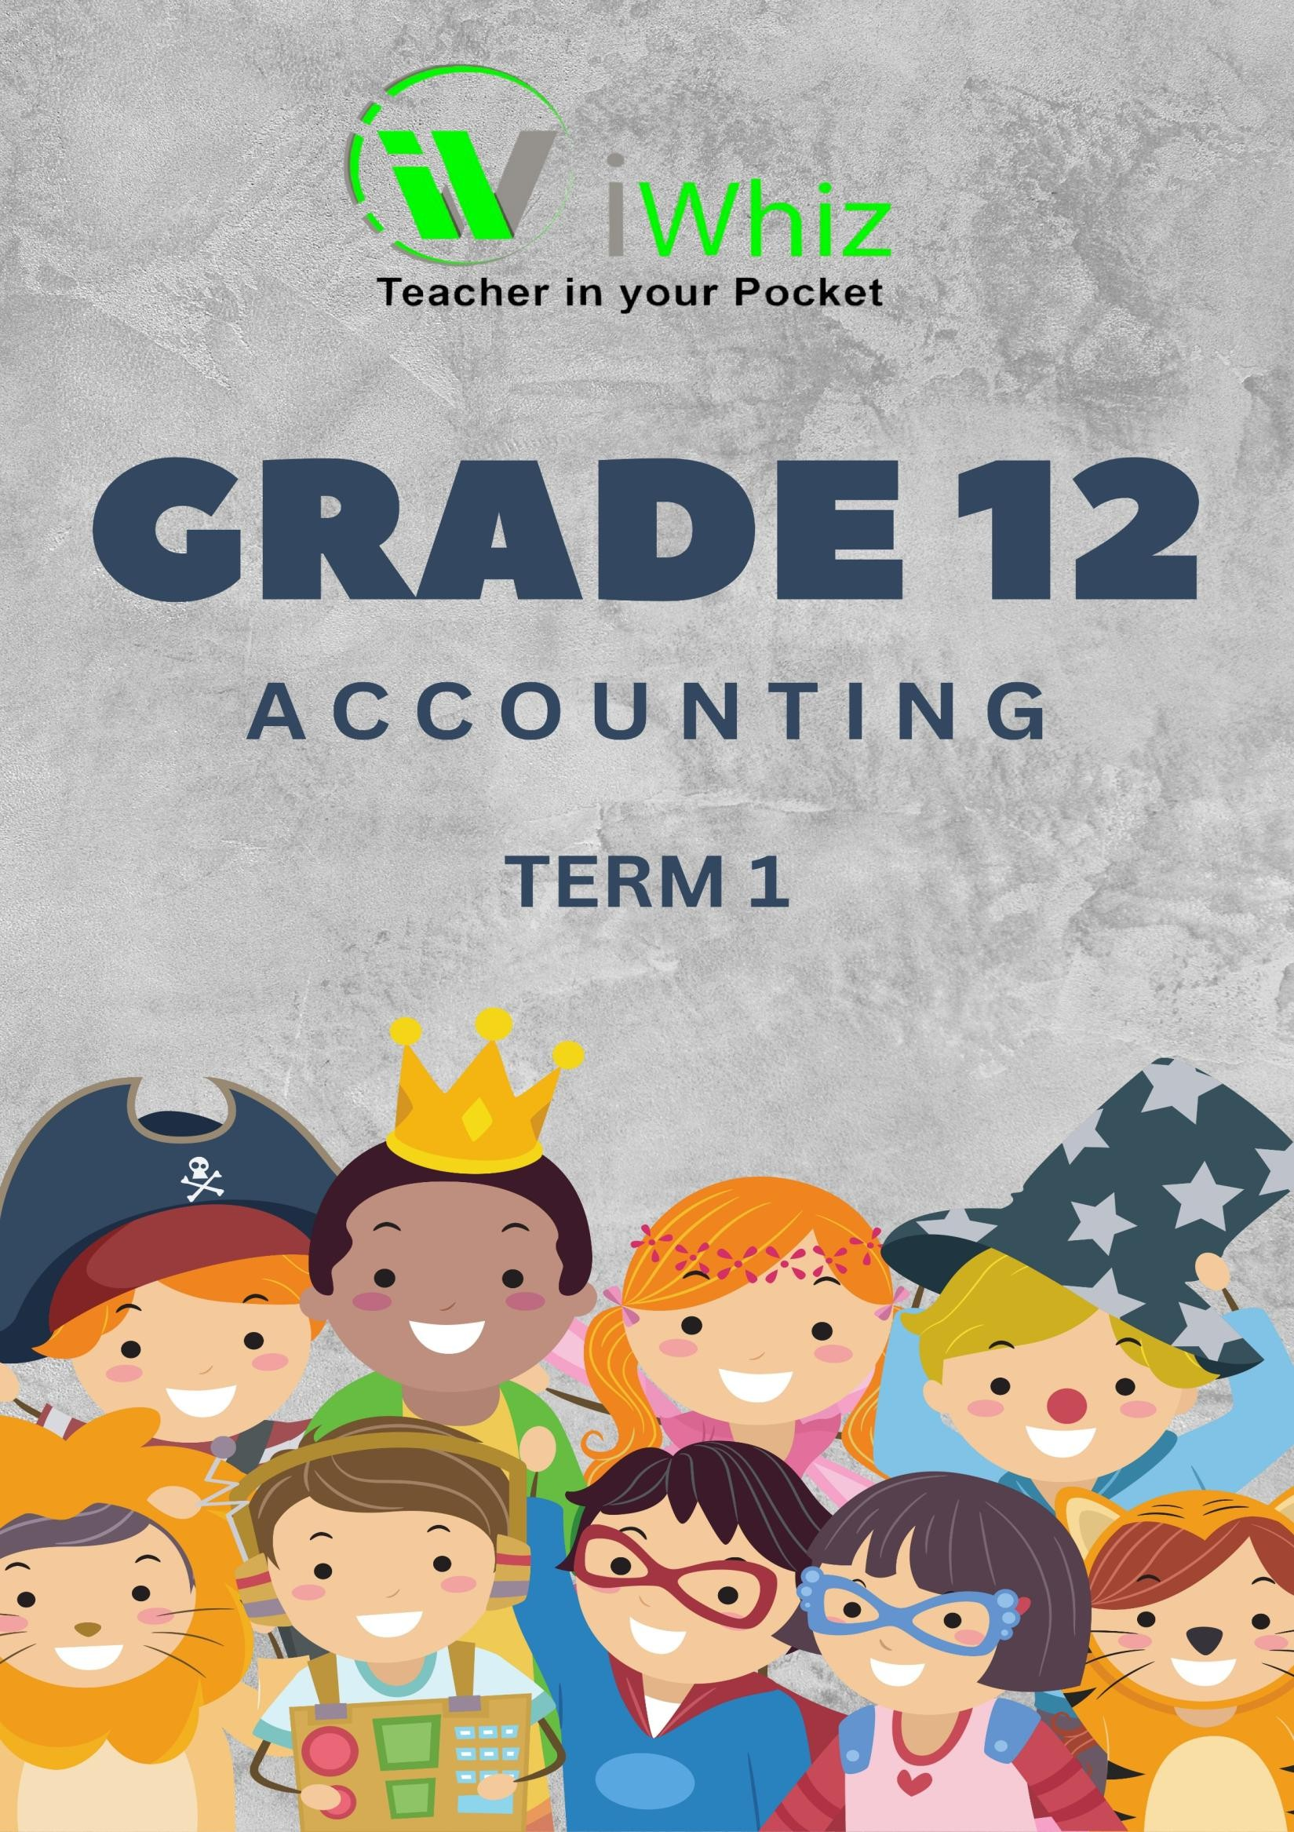



https://www.youtube.com/watch?v=SJ4_nONtYeY

WATCH FOR TESTIMONIALS

Grade 12 Accounting Term 1 Test Paper 2
Time: 3 Hours
Total Marks: 150

Instructions:
- Answer ALL questions.
- All calculations must be shown clearly.
- Use the prescribed format for financial statements where applicable.
- Write neatly and legibly.

SECTION A: (30 MARKS)

Internal Control and Business Concepts Question 1

  - Define internal control and explain its importance in a business environment. (5)

  - List and explain four internal control measures that businesses can implement to safeguard their assets (10)

  - Identify and explain three examples of fraud that could occur if proper internal controls are not in place. (9)

  - State two reasons why businesses should conduct regular stocktaking. (6)

SECTION B: (60 MARKS)

Accounting for Specific Transactions and Financial Statements Question 2
The following transactions took place during the month of February 2025 in the books of XYZ Ltd.:
Issued 5,000 shares at R10 each for cash.
    - Bought inventory worth R20,000 on credit from ABC Traders.
    - Paid creditors R15,000 by cheque.
    - Sold goods costing R12,000 for R20,000 on credit.
    - The owner withdrew R5,000 for personal use.

2.1. Record the journal entries for the above transactions. (15)

2.2. Post the journal entries to the general ledger and prepare a trial balance. (15)

Question 3
The following balances appeared in the general ledger of DEF Ltd. on 31 December 2024:

Account Name | Debit (R) | Credit (R)
Bank | 10,000
Sales |  | 50,000
Accounts Receivable | 30,000
Cost of Sales | 20,000
Loan from Bank |  | 15,000
Capital |  | 40,000
Rent Expense | 5,000
Accounts Payable |  | 10,000
  - Prepare the income statement for the year ending 31 December 2024. (12)
  - Prepare the Statement of Financial Position (Balance Sheet) as at 31 December 2024. (12)

SECTION C: (60 MARKS)

Partnerships, Companies, and Advanced Accounting Topics Question 4
The following information is available for the partnership of M & L for the year ending 31 December
2024:
    - Capital contributions:
o M: R30,000
o L: R45,000
    - Net profit for the year: R50,000
    - Drawings:
o M: R12,000
o L: R15,000
    - Interest on capital is to be allowed at 12% per annum.
    - The partnership agreement states that profits are shared in the ratio 2:3 (M:L).
  - Calculate the interest on capital for each partner. (8)

  - Prepare the appropriation account for the year ending 31 December 2024. (12)

  - Prepare the capital accounts for each partner. (12)

Question 5
The following information relates to ABC Ltd. for the year ending 31 December 2024:
    - Issued share capital: 200,000 shares at R5 each.
    - Net profit after tax: R100,000.
    - The dividend policy is 40% of the net profit.
    - Retained earnings as at 1 January 2024: R200,000.
    - The company bought back 10,000 shares at R6 each during the year.
      - Prepare the Statement of Changes in Equity for the year ending 31 December 2024. (12)

      - Prepare the Statement of Comprehensive Income (Income Statement) for the year ending 31 December 2024.
(12)

Total Marks: 150

