
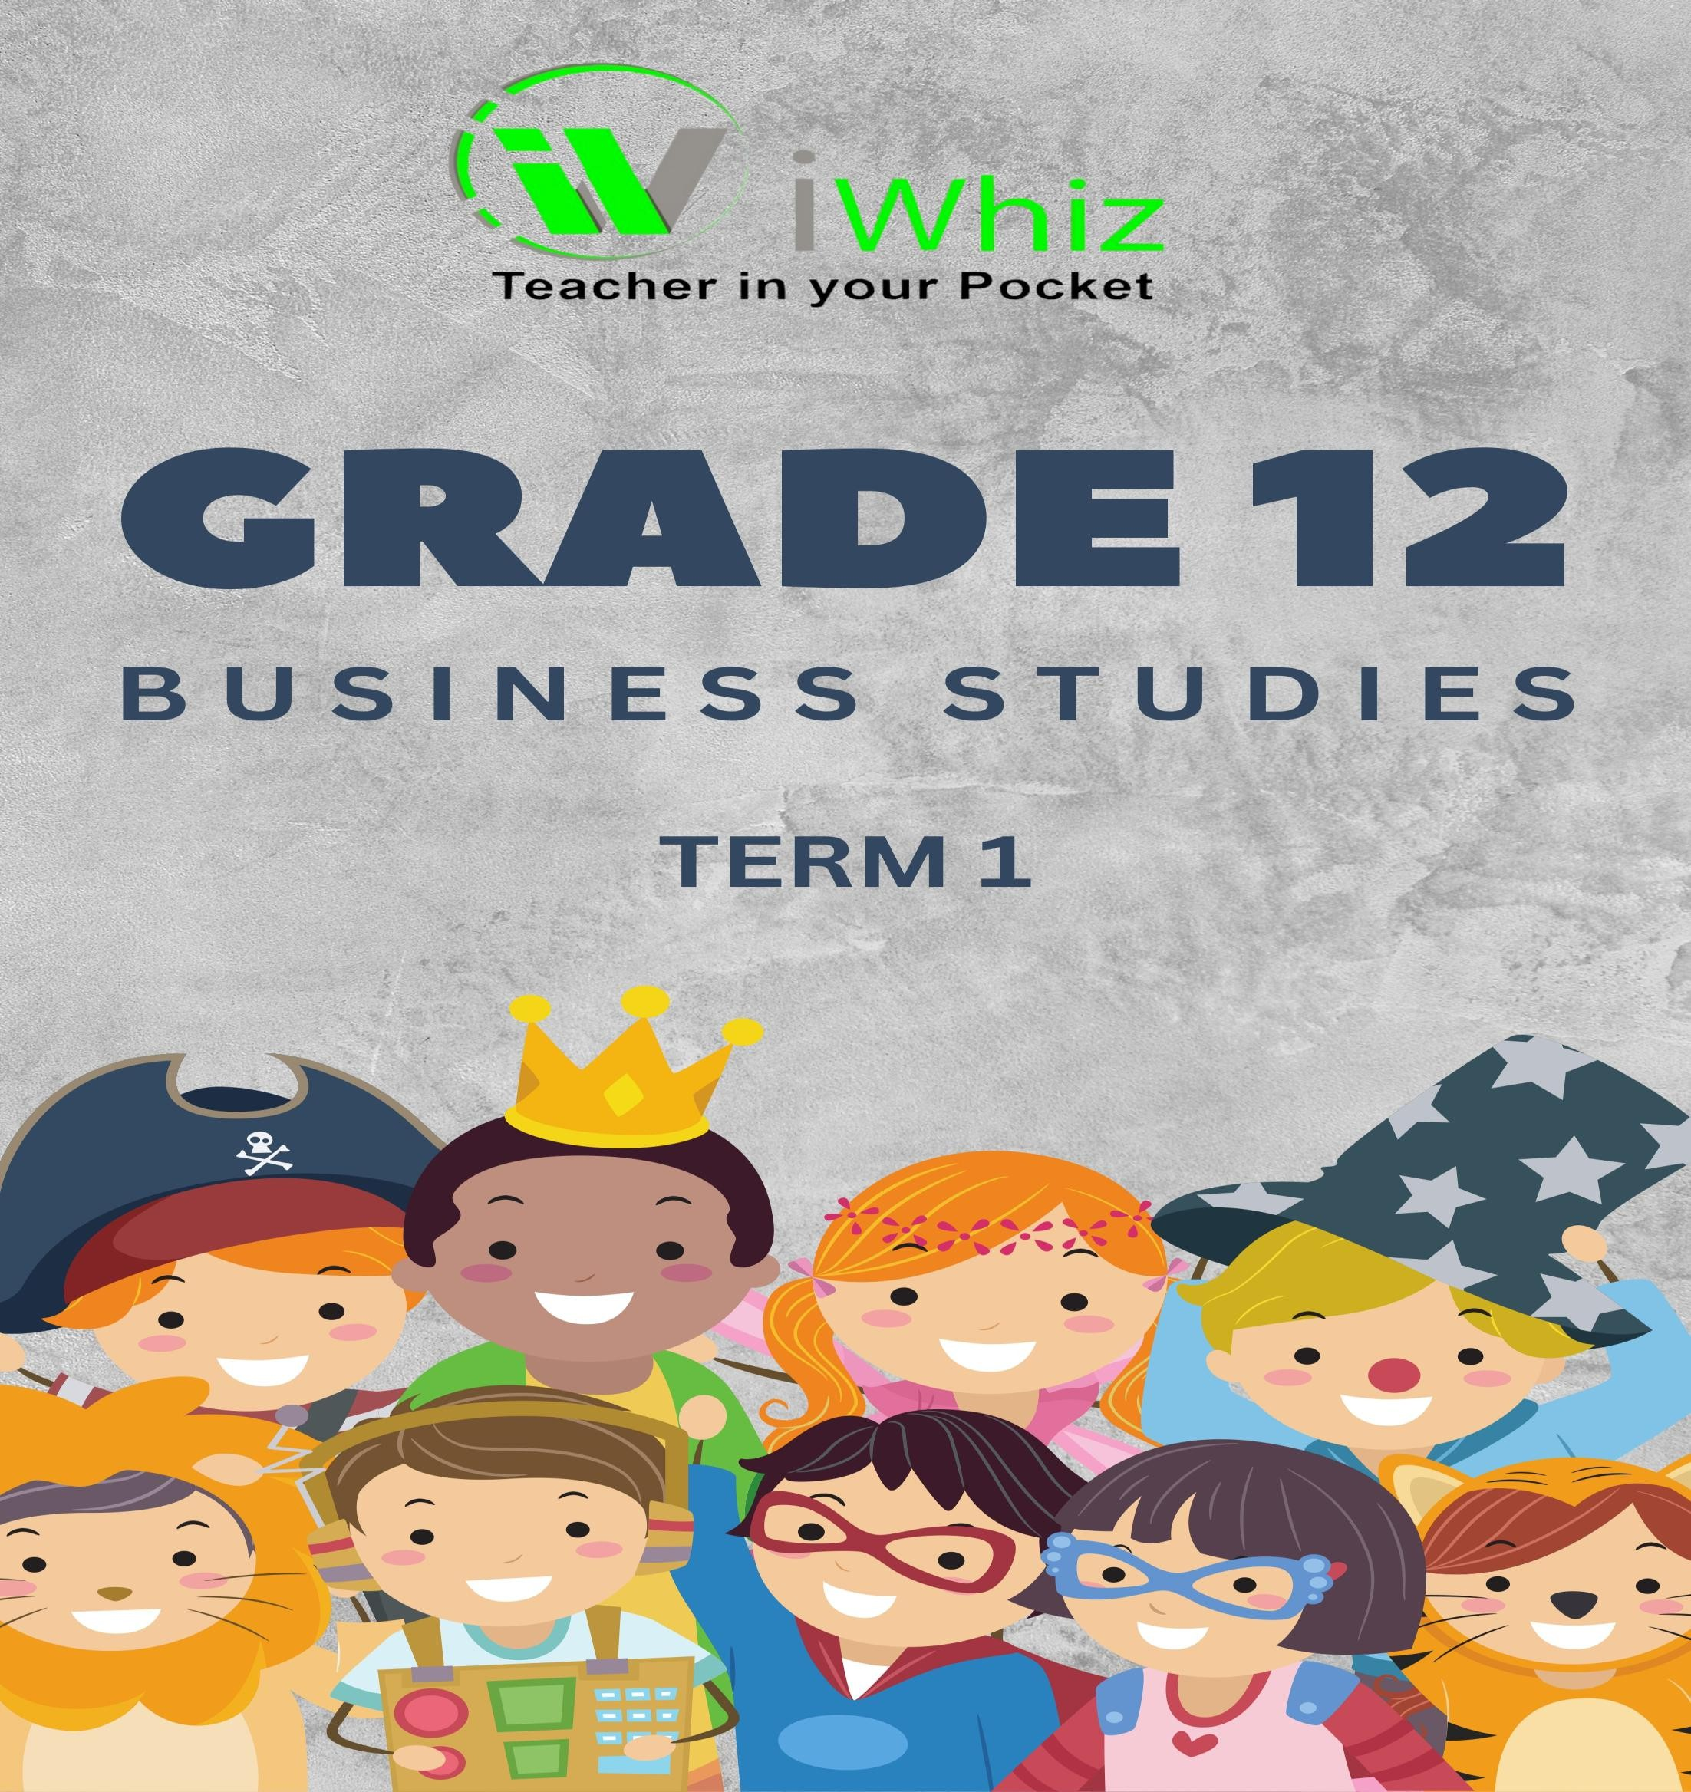



https://www.youtube.com/watch?v=SJ4_nONtYeY
WATCH FOR TESTIMONIALS

WATCH FOR TESTIMONIALS

GRADE 12 BUSINESS STUDIES: PAPER 1
TIME: 3 HOURS

TOTAL MARKS: 150

INSTRUCTIONS:
- This question paper consists of THREE sections:
  - SECTION A: 50 Marks (Compulsory)
  - SECTION B: 50 Marks
  - SECTION C: 50 Marks
- Answer all the questions in SECTION A.
- Answer any four (4) questions in SECTION B.
- Answer any three (3) questions in SECTION C.
- Start each question on a new page.
- Use the marks allocated for each question as a guide for the length of your answer.
- All questions in this paper must be answered in full sentences where applicable.
- Write neatly and legibly.

SECTION A: (50 MARKS) QUESTION 1: (50 Marks)

  - Multiple-Choice Questions (10)
Choose the correct answer from the options provided.
    - The primary objective of a business is:
- Profit maximization
- Providing jobs
- Meeting government regulations
- Promoting employee satisfaction

    - Which of the following is an example of a fixed cost for a business?
- Salaries of employees
- Raw materials
- Sales commission
- Electricity costs

    - A business that produces goods without using raw materials is operating in which sector?
- Primary sector
- Secondary sector
- Tertiary sector
- Quaternary sector

    - Which of the following acts regulates the protection of consumer rights in South Africa?
- Companies Act
- Labour Relations Act
- Consumer Protection Act
- Employment Equity Act

    - The process of creating and distributing goods to customers is known as:
- Marketing
- Retailing
- Logistics
- Manufacturing

(5 questions x 2 marks each = 10 marks)

1.2 True or False

State whether the following statements are TRUE or FALSE. Write only "True" or "False" next to the question number.

    - The Consumer Protection Act applies only to businesses that sell products online.
    - The Companies Act regulates the formation, operation, and closure of companies in South Africa.
    - Financial statements provide information on the business's market share.
    - Entrepreneurship plays a crucial role in economic development and job creation.
    - A monopoly occurs when there are many sellers offering similar products in the market.

(5 questions x 2 marks each = 10 marks)

1.3 Short Questions (10)

Answer the following questions briefly.
    - Define "business environment" and explain its significance. (2)

    - What is meant by "stakeholders" in a business context? (2)

    - Differentiate between "fixed costs" and "variable costs." (2)

    - State two characteristics of an entrepreneur. (2)

    - Name two types of business structures commonly found in South Africa. (2)

(5 questions x 2 marks each = 10 marks)

  - Case Study (20)

Read the following case study and answer the questions that follow:

Case Study:
EcoTech is a leading South African technology company specializing in environmentally friendly gadgets. However, due to the rapid growth of international competition, the company is facing challenges in maintaining its market share. EcoTech is considering implementing new marketing
strategies, streamlining operations to reduce costs, and improving customer satisfaction to remain competitive.
    - Identify and explain two reasons why EcoTech’s market share might be declining. (4)

    - Discuss two (2) strategies that EcoTech could use to regain market share. (6)

    - Explain the role of research and development (R&D) in helping EcoTech stay competitive. (4)

    - What are the possible legal factors that EcoTech should consider when making strategic decisions? (6)

SECTION B: (50 MARKS)
QUESTION 2:
Discuss the characteristics of a good business leader and explain how these characteristics contribute to the success of a business. (10)

QUESTION 3:
Explain the concept of the business cycle and discuss how it affects businesses in South Africa. Include the four phases of the business cycle in your response. (10)

QUESTION 4:
  - What is corporate social responsibility (CSR)? (3)

  - Discuss the importance of CSR for businesses in South Africa. Provide examples of CSR practices that businesses may engage in. (7)

QUESTION 5:
Evaluate the role of marketing in the success of a business. Discuss the four P’s of marketing (Product, Price, Place, Promotion) and how each contributes to business success. (10)

QUESTION 6:
Discuss the role and significance of labour relations in business, particularly in the South African context. (10)

SECTION C: (50 MARKS)
QUESTION 7:
Analyze the impact of globalization on South African businesses. Discuss both the opportunities and challenges that local businesses face as a result of globalization. (15)

QUESTION 8:
  - Define the term business ethics. (3)

  - Discuss the importance of ethical business practices and explain how unethical behavior can negatively impact a business. (7)

  - Explain the role of corporate governance in ensuring ethical conduct in businesses. (5)

QUESTION 9:
Explain the role of entrepreneurship in job creation and economic development in South Africa. Discuss the challenges faced by entrepreneurs in the South African context and propose solutions to overcome these challenges. (15)

QUESTION 10:
Evaluate the significance of financial management for businesses, particularly in terms of budgeting, forecasting, and cash flow management. Provide examples to support your answer. (15)

END OF QUESTION PAPER

