
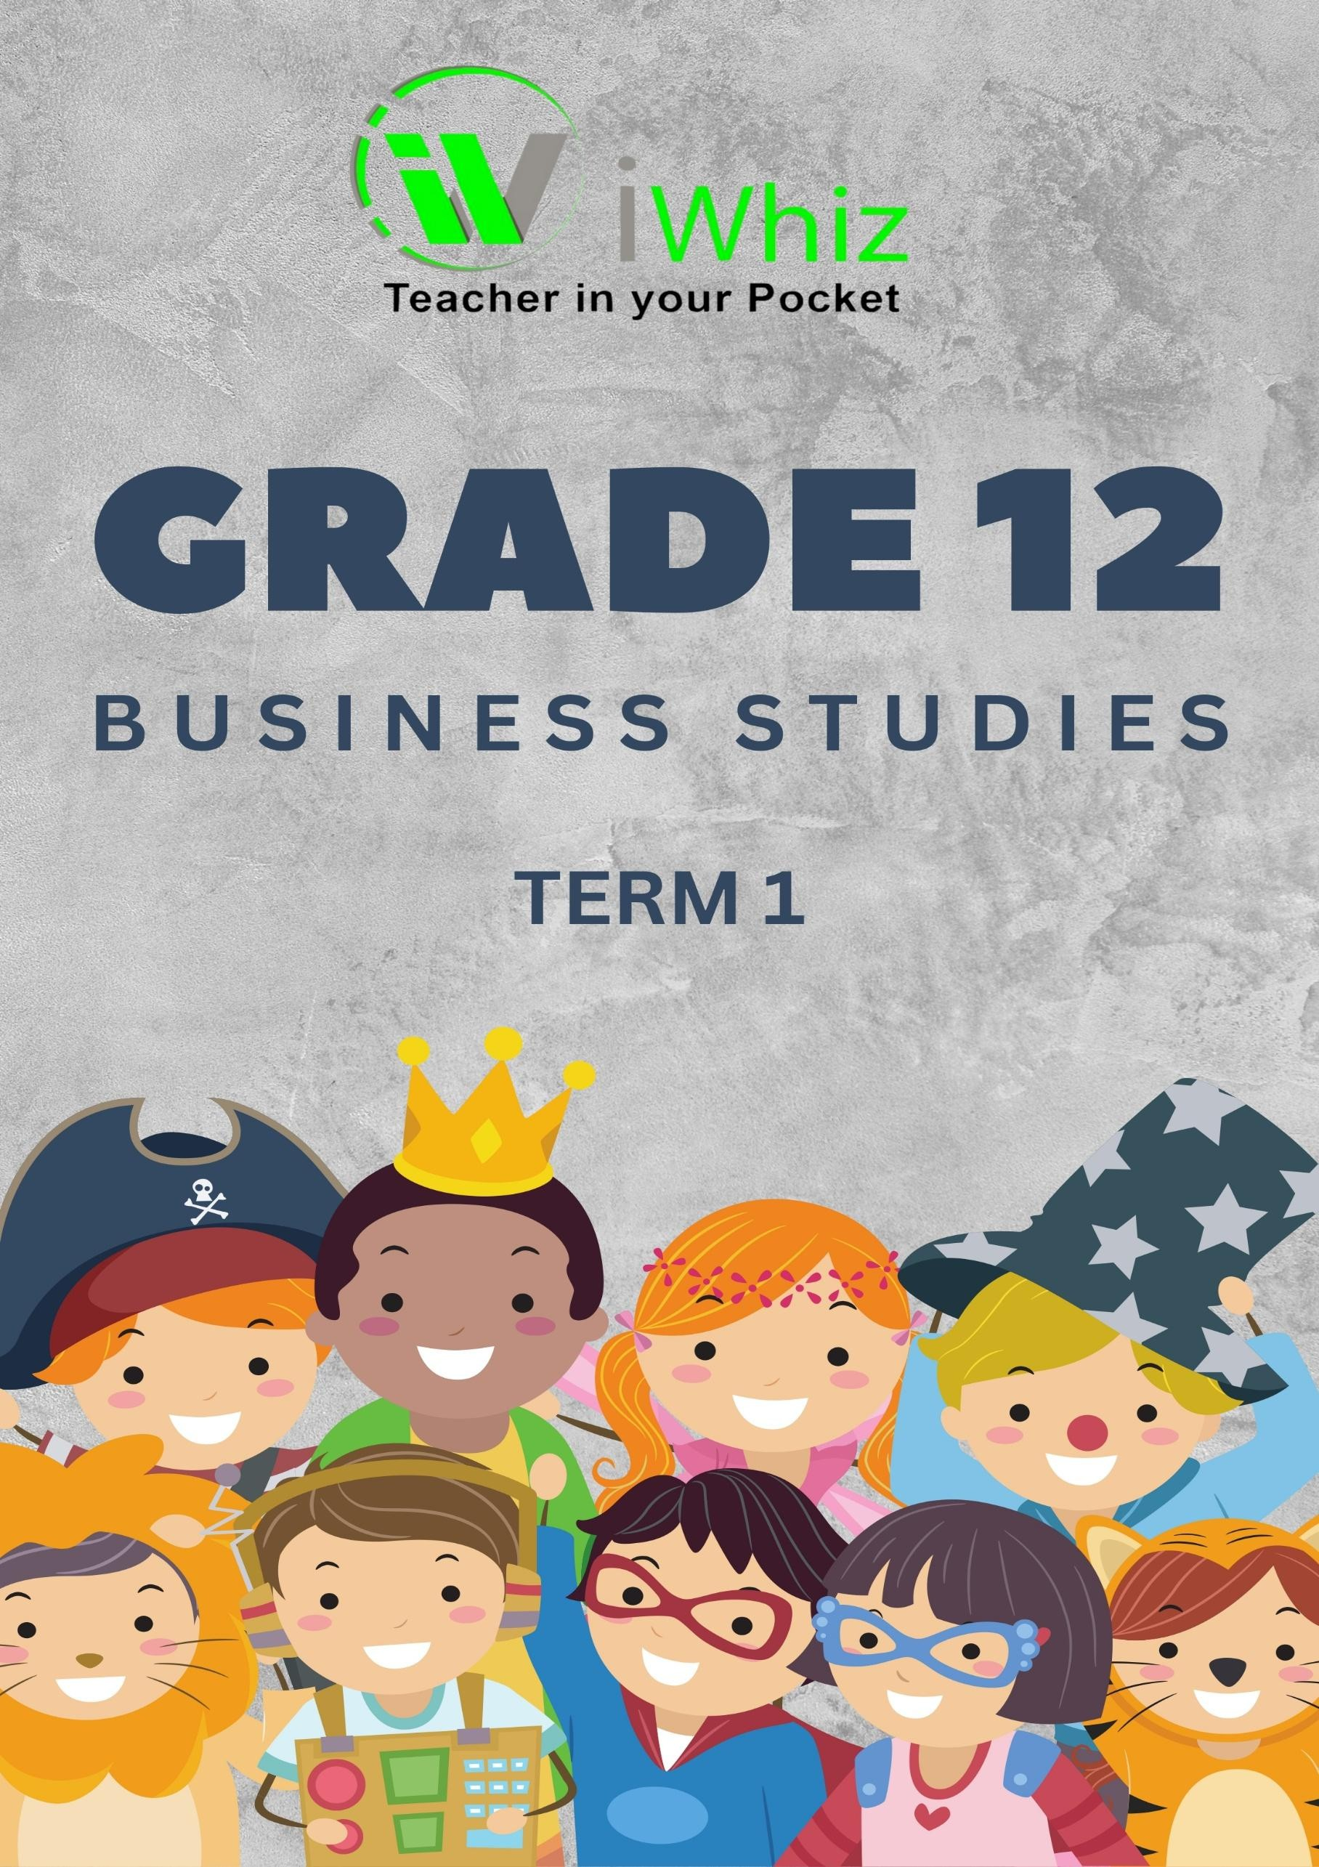



https://www.youtube.com/watch?v=SJ4_nONtYeY
WATCH FOR TESTIMONIALS

WATCH FOR TESTIMONIALS

GRADE 12 BUSINESS STUDIES: PAPER 2
TIME: 3 HOURS

TOTAL MARKS: 150

INSTRUCTIONS:
- This question paper consists of THREE sections:
  - SECTION A: 50 Marks (Compulsory)
  - SECTION B: 50 Marks
  - SECTION C: 50 Marks
- Answer all the questions in SECTION A.
- Answer any four (4) questions in SECTION B.
- Answer any three (3) questions in SECTION C.
- Start each question on a new page.
- Use the marks allocated for each question as a guide for the length of your answer.
- All questions in this paper must be answered in full sentences where applicable.
- Write neatly and legibly.

SECTION A: (50 MARKS)

QUESTION 1: (50 Marks)
  - Multiple-Choice Questions (10)
Choose the correct answer from the options provided.
    - Which of the following is an example of a financial objective for a business?
- To provide jobs to the community
- To maximize profits
- To improve employee satisfaction
- To ensure customer loyalty
    - Which of the following is the primary role of a trade union?
- To ensure the business profits are maximized
- To negotiate with employers on behalf of employees
- To improve business profitability
- To monitor business expenses
    - A business that deals with goods directly from the producer to the consumer is known as:
- Retailer
- Wholesaler
- Distributor
- Direct seller
    - Which of the following is a long-term source of finance for a business?
- Bank overdraft
- Trade credit
- Loan from a bank
- Share issue
    - The Profit and Loss Statement is an example of which type of financial statement?
- Income statement
- Cash flow statement
- Balance sheet
- Statement of changes in equity

(5 questions x 2 marks each = 10 marks)

1.2 True or False (5)

State whether the following statements are TRUE or FALSE. Write only "True" or "False" next to the question number.
1.2.1) The process of setting objectives for the business and creating strategies to achieve them is known as strategic planning.
1.2.2) A sole proprietorship is a business that is owned by one person and is registered as a separate legal entity.
1.2.3 Financial institutions offer business loans to businesses at very low interest rates to help them expand.
1.2.4) A franchise is a business model where a business owner licenses the rights to sell products or services under an established brand.
1.2.5) Depreciation refers to the gradual reduction in the value of an asset due to its use over time.

(5 questions x 2 marks each = 10 marks)

1.3 Short Questions (10)
Answer the following questions briefly.
1.3.1) Define the term "business objective." (2)

1.3.2) What is meant by "economies of scale"? (2)

1.3.3) Identify two challenges faced by small businesses in South Africa. (2)

1.3.4) Explain the concept of "market share" in business. (2)

1.3.5) Name two factors that could impact the success of an entrepreneur. (2)

(5 questions x 2 marks each = 10 marks)

Case Study (20)
Read the following case study and answer the questions that follow:

Case Study:
Café Delights is a local coffee shop that offers a wide variety of coffees and snacks. The business has seen steady growth in the past few years, but recently, competition from larger, international coffee chains has begun to affect its market share. To maintain its profitability and customer base, Café Delights is now considering strategies such as expanding its menu, offering loyalty programs, and improving customer service.

Questions:
    - Identify and explain two (2) external factors that could be contributing to Café Delights' declining market share. (4)

    - Suggest two (2) marketing strategies that Café Delights could use to maintain or increase its market share. (6)

    - Discuss the importance of customer loyalty for Café Delights, and how a loyalty program could help. (4)

    - Explain the concept of competitive advantage and how Café Delights could gain one. (6)

SECTION B: (50 MARKS)
QUESTION 2:
Discuss the importance of financial management in a business, with reference to key areas such as budgeting, forecasting, and managing cash flow. (10)

QUESTION 3:
Explain the difference between primary, secondary, and tertiary sectors of the economy. Discuss the role of each in the context of a South African economy. (10)

QUESTION 4:
Discuss the concept of risk management in a business environment. Explain the steps involved in identifying and managing risks. (10)

QUESTION 5:
Evaluate the role of information technology (IT) in modern business operations, focusing on both the benefits and potential risks associated with the use of IT. (10)

QUESTION 6:
Discuss the role of human resource management (HRM) in a business, with reference to recruitment, training, and employee relations. (10)

SECTION C: (50 MARKS)
QUESTION 7:
Analyze the impact of ethical business practices on the reputation of a company. Discuss how
ethical behavior can enhance a company’s long-term sustainability. (15)

QUESTION 8:
  - Define the term "business strategy". (3)

  - Discuss two (2) types of business strategies that companies can implement to gain a competitive advantage in their market. (7)

  - Explain the significance of corporate governance in promoting ethical practices in a company. (5)

QUESTION 9:
Explain the role of entrepreneurship in driving innovation and creating jobs in South Africa. Discuss the challenges entrepreneurs face and how these can be mitigated. (15)

QUESTION 10:
Evaluate the significance of corporate social responsibility (CSR) for South African businesses. Discuss how CSR initiatives can benefit both businesses and the broader community. (15)

