
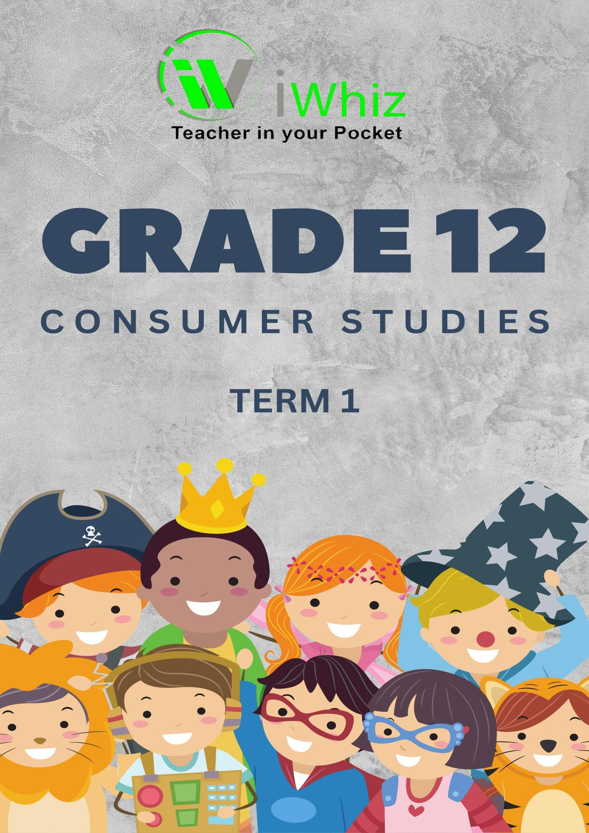

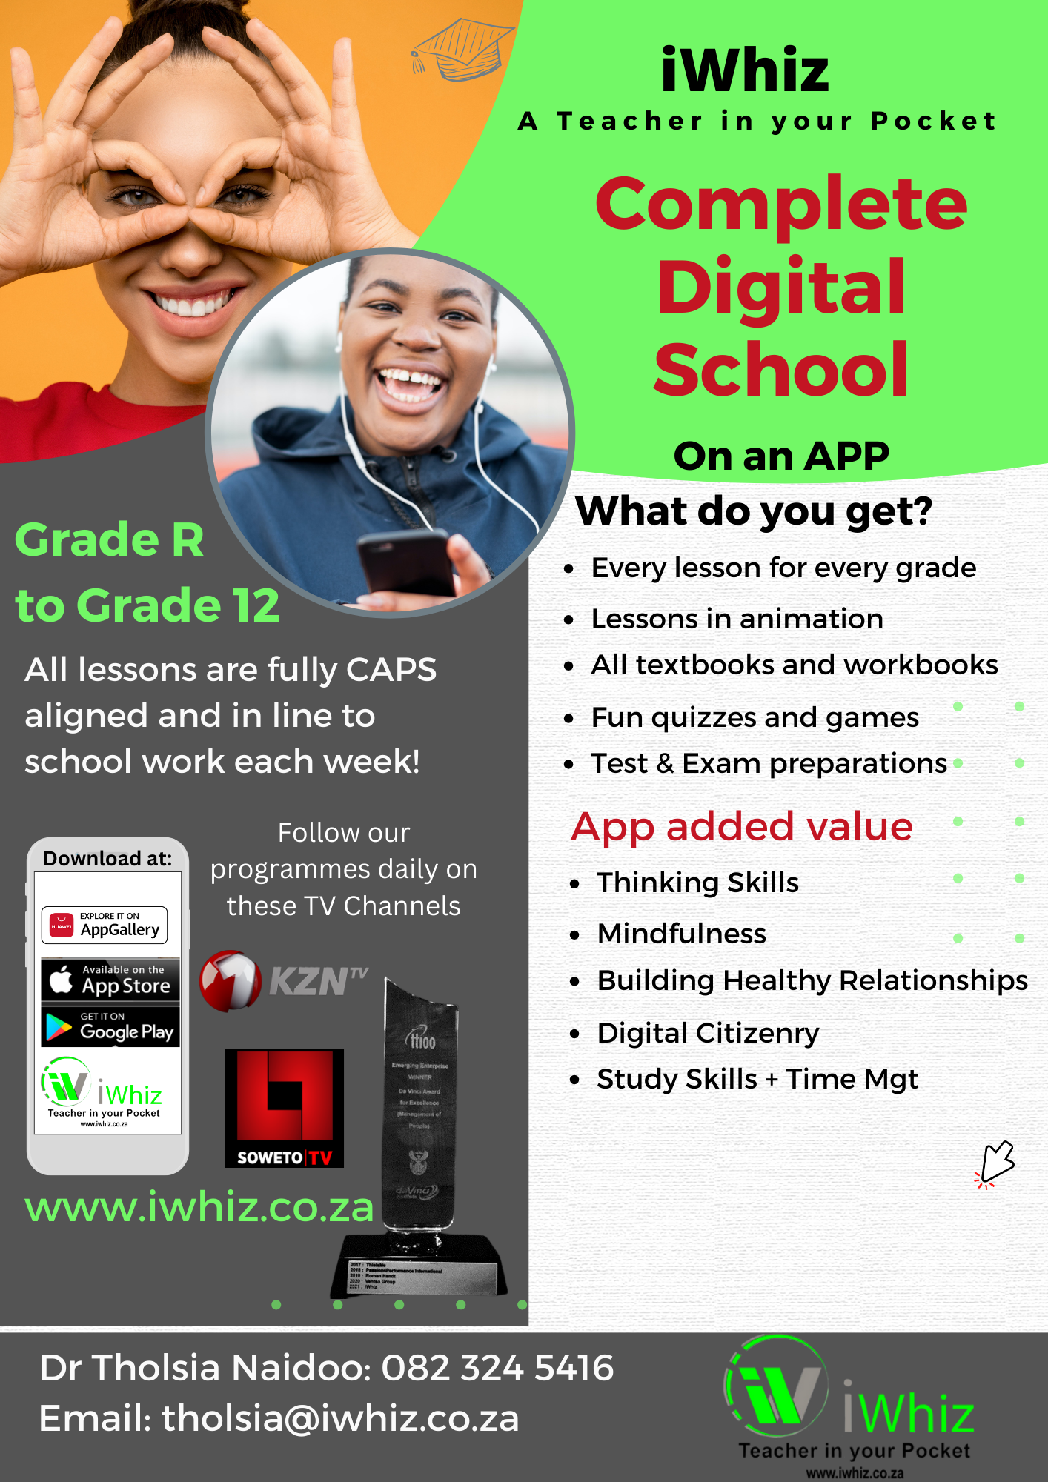

https://www.youtube.com/watch?v=SJ4_nONtYeY
WATCH FOR TESTIMONIALS

WATCH FOR TESTIMONIALS

GRADE 12 CONSUMER STUDIES: TERM 1 TEST
Time: 3 hours
Total Marks: 200

INSTRUCTIONS:
- Answer ALL the questions.
- This paper consists of four sections:
  - Section A: Multiple choice questions (20 marks)
  - Section B: Short-answer questions (50 marks)
  - Section C: Case study (30 marks)
  - Section D: Long-answer questions (50 marks)
- Show all workings for calculations.
- Read the questions carefully before answering.
- The use of a calculator is allowed.
- Write neatly and legibly.

SECTION A: MULTIPLE CHOICE QUESTIONS (20 marks)
Choose the correct answer from the options provided. Write only the letter (A, B, C, or D) next to the question number.
- Which of the following is an essential characteristic of a consumer product?
- It is always sold at a low price.
- It satisfies a need or want.
- It can only be used by individuals.
- It is advertised only in newspapers.

- Which of the following is an example of a service?
- A loaf of bread
- A cleaning service
- A television
- A book

- The purpose of the Consumer Protection Act is to:
- Protect consumers from unfair business practices.
- Regulate the production of goods and services.
- Ensure only local goods are sold in South Africa.
- Make goods and services more expensive for consumers.

- Which one of the following is a right of a consumer under the Consumer Protection Act?
- The right to purchase goods on credit.
- The right to cancel contracts without any penalties.
- The right to fair and honest advertising.
- The right to buy goods at discounted prices.

- What is meant by the term ‘consumer redress’?
- Complaints that are ignored by companies.
- Compensation or solutions provided to consumers for faulty goods or services.
- Consumer marketing strategies.
- The improvement of product quality.

- Which of the following is an example of a durable good?
- A pair of shoes.
- A mobile phone.
- A can of soda.
- A weekly magazine.

- What does the term ‘budgeting’ refer to?
- Calculating the total income of a business.
- Planning for the income and expenses of an individual or household.
- Estimating the profits of a company.
- Saving money for retirement.

- What does a warranty generally provide for consumers?
- A replacement of goods with no additional cost.
- A guarantee of product availability.
- A free service in case of product damage.
- A promise for free advertising.

- Which of the following actions can help consumers in managing debt?
- Ignoring overdue payments.
- Establishing a debt management plan.
- Using credit to buy luxuries.
- Investing in high-risk stocks.

- What is the role of a consumer forum?
- To protect the interests of businesses.
- To help consumers make informed decisions.
- To set the prices of goods and services.
- To provide free products to consumers.

- Which of the following would be an example of unethical marketing?
- Providing clear information about a product.
- Making exaggerated claims about the benefits of a product.
- Offering discounts on all items.
- Providing accurate product labeling.

- Which of the following is a disadvantage of using credit to purchase goods?
- Immediate access to goods.
- High interest rates and additional costs.
- No need for a deposit.
- Improved credit score.

- Which type of good is most often purchased using the concept of impulse buying?
- Durable goods.
- Necessities.
- Non-durable goods.
- Luxury goods.
- What is the primary reason for the establishment of the National Consumer Commission (NCC) in South Africa?
- To provide loans to consumers.
- To regulate product prices.
- To enforce the Consumer Protection Act.
- To sell products to consumers at discounted prices.

- What is meant by the term ‘consumer sovereignty’?
- Consumers can control prices in the market.
- Consumers make the final decisions about what is produced in an economy.
- Consumers are protected from all market risks.
- Consumers have a right to unlimited credit.

- A company recalls a product due to safety concerns. This is an example of which type of responsibility?
- Ethical responsibility.
- Legal responsibility.
- Voluntary responsibility.
- Customer responsibility.

- Which of the following is an example of a non-tangible product?
- A laptop.
- A gym membership.
- A refrigerator.
- A car.

- Which is a primary reason for increasing consumer education?
- To increase consumer spending.
- To help consumers make informed choices.
- To make businesses more profitable.
- To reduce government spending.

- What is the purpose of the Food Labelling Regulations in South Africa?
- To help consumers identify where food is produced.
- To ensure that food is always organic.
- To provide consumers with nutritional and ingredient information.
- To make food more affordable.

- What is the purpose of budgeting for consumers?
- To avoid paying taxes.
- To prevent overspending and ensure financial stability.
- To increase spending on luxury goods.
- To avoid investing in savings accounts.

SECTION B: SHORT-ANSWER QUESTIONS (50 marks)
Answer the following questions briefly:
- Define the term “consumer rights” and list four examples of consumer rights in South Africa. (6 marks)

- Discuss the role of advertising in consumer decision-making. (6 marks)

- Explain how the Consumer Protection Act assists consumers in South Africa. (8 marks)
- What are the advantages and disadvantages of using credit to make purchases? (8 marks)

- List and explain five steps consumers can take to manage their personal finances effectively. (8 marks)

- What is the difference between durable and non-durable goods? Provide examples of each. (6 marks)

- Describe the process a consumer can follow if they want to file a complaint with the National Consumer Commission (NCC). (6 marks)

SECTION C: CASE STUDY (50 marks)
Read the following case study and answer the questions below: Case Study:
Maria is a 25-year-old professional who recently purchased a laptop from a well-known retailer in Johannesburg. After one month, the laptop started malfunctioning, and Maria was unable to boot the laptop or use several key features. She contacted the retailer to report the issue, but the store refused to replace the laptop, citing that their warranty did not cover such faults. Maria is now unsure what to do next.
Questions:
- Explain Maria’s consumer rights under the Consumer Protection Act regarding the faulty laptop. (10 marks)
- What steps should Maria take to resolve the issue with the retailer? (10 marks)

- Discuss the role of warranties and guarantees in consumer protection, using Maria’s case as an example. (10 marks)

- Suppose Maria decides to approach the National Consumer Commission. What process should she follow? (10 marks)
- Evaluate the importance of consumer education in preventing situations like the one Maria faced. (10 marks)

SECTION D: LONG-ANSWER QUESTIONS (80 marks)
Answer the following questions in detail:
- Discuss the concept of “ethical consumerism.” How can consumers make ethical choices when purchasing goods and services? (20 marks)
- Analyze the impact of advertising on consumer behavior, including the influence of social media on the purchasing decisions of teenagers. (20 marks)
- Explain the different types of consumer protection mechanisms available in South Africa. How do these mechanisms help in ensuring fair trade and consumer safety? (20 marks)
- Discuss the concept of “consumer debt” and explain the causes and consequences of over- indebtedness. What can consumers do to avoid falling into debt traps? (20 marks)

