
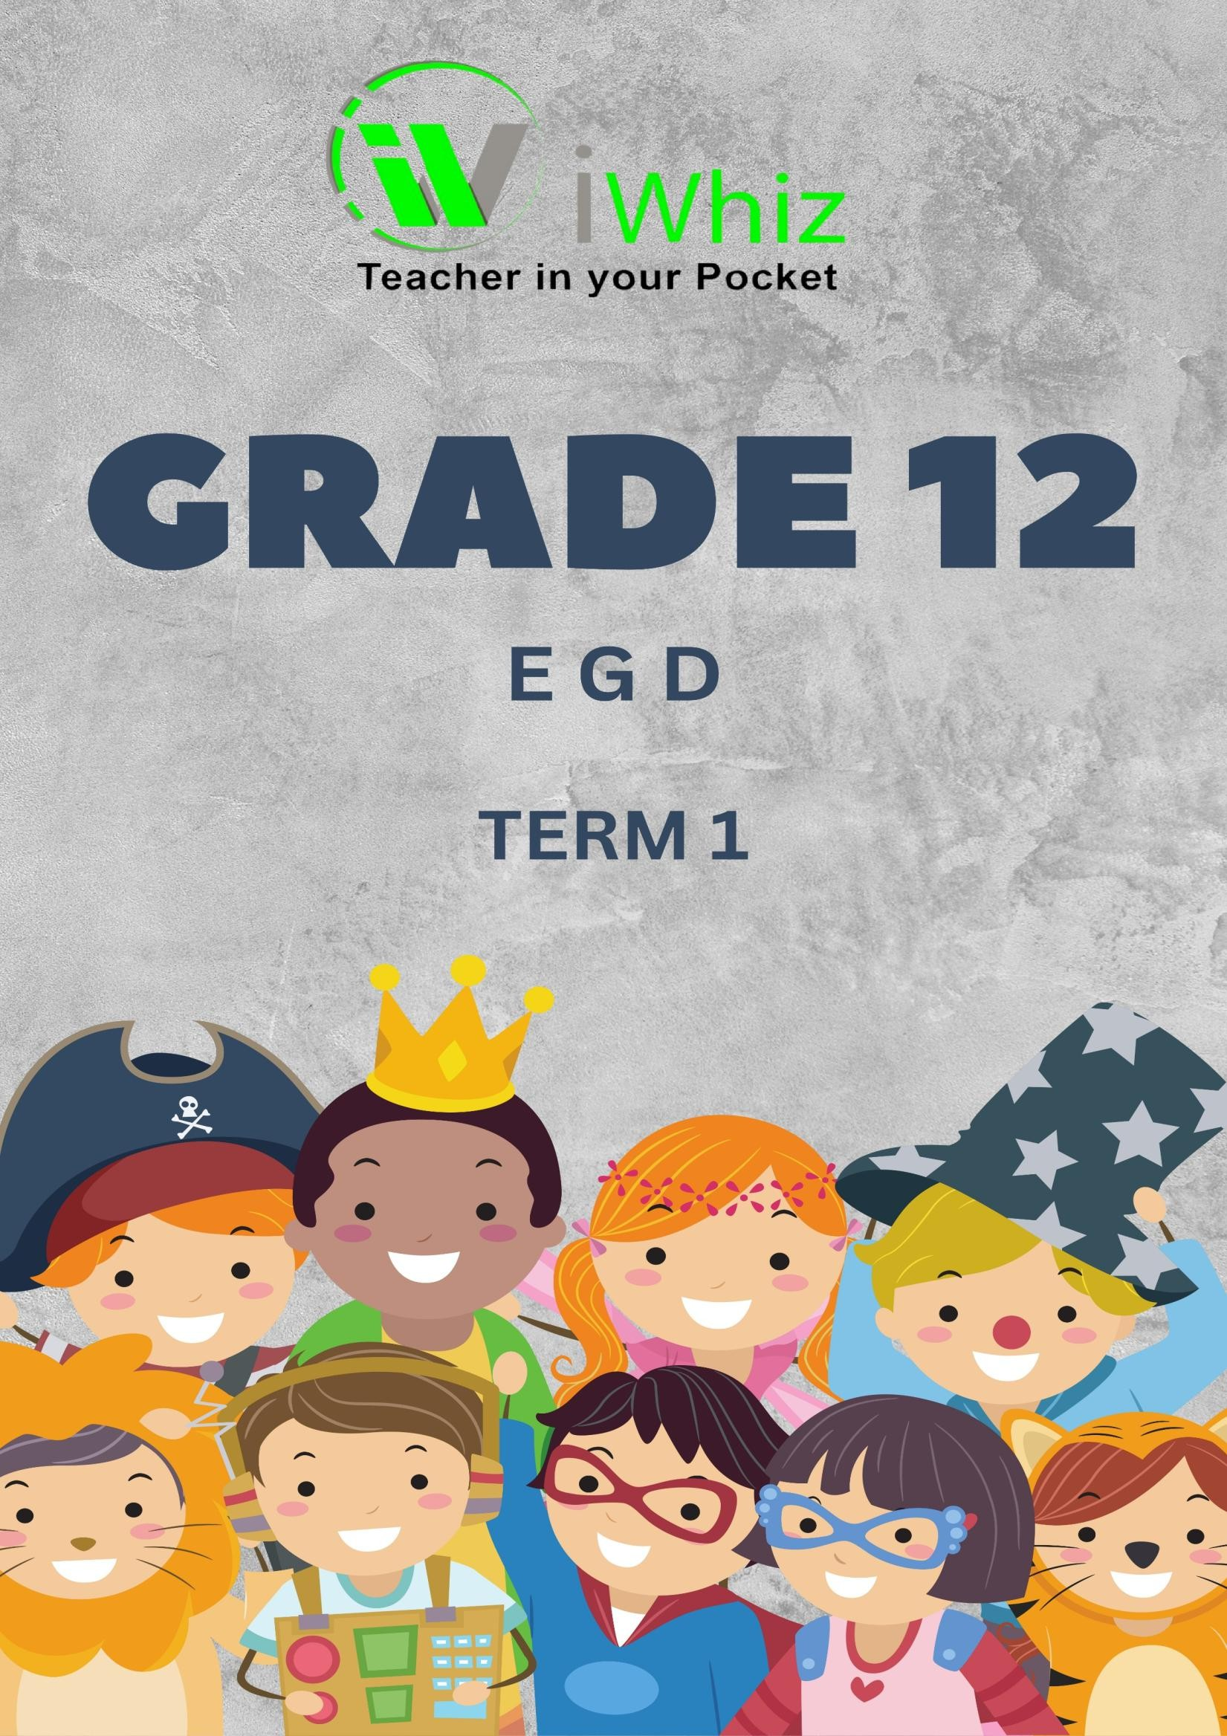



https://www.youtube.com/watch?v=SJ4_nONtYeY

WATCH FOR TESTIMONIALS

ENGINEERING GRAPHICS AND DESIGN GRADE 12
TERM 1 MARCH TEST TIME: 3 HOURS
TOTAL: 150 MARKS
INSTRUCTIONS AND INFORMATION:
- This question paper consists of four questions.
- Answer all questions in the provided answer book.
- All drawings must be done using the correct drawing instruments.
- All construction lines must be shown.
- All dimensions are in millimeters (mm) unless stated otherwise.
- Candidates may not use any program function keys on their calculators.
- Marks will be awarded for neatness, accuracy, and presentation

QUESTION 1: ANALYTICAL AND MECHANICAL DRAWING (30 MARKS)

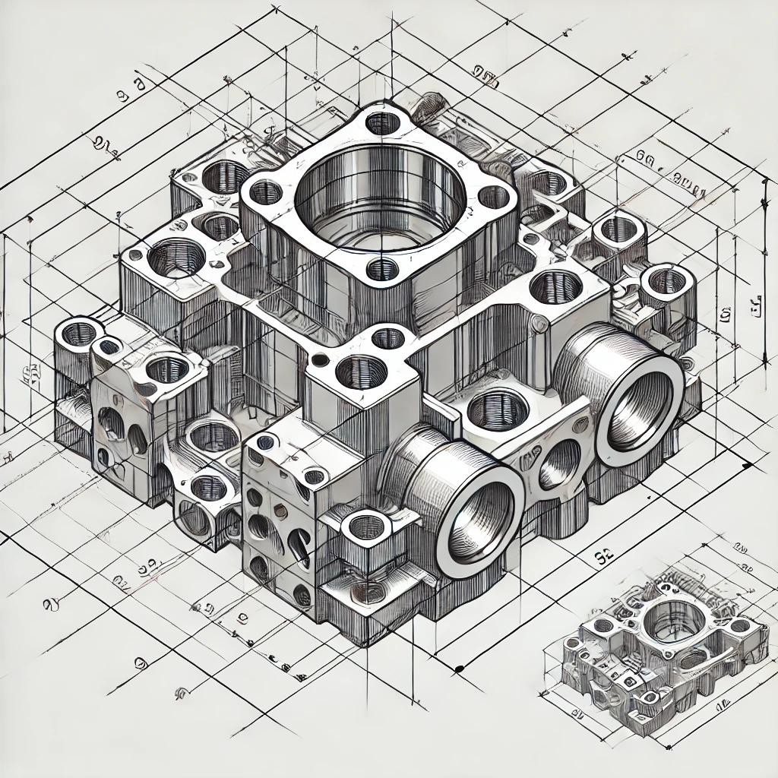
  - Given the orthographic views of a mechanical component, complete the missing third view in first- angle projection. Show all hidden details. (15)

  - Convert the given isometric drawing of a machine part into two orthographic views in third-angle projection. Show all necessary hidden details. (15)

QUESTION 2: PICTORIAL DRAWING (40 MARKS)
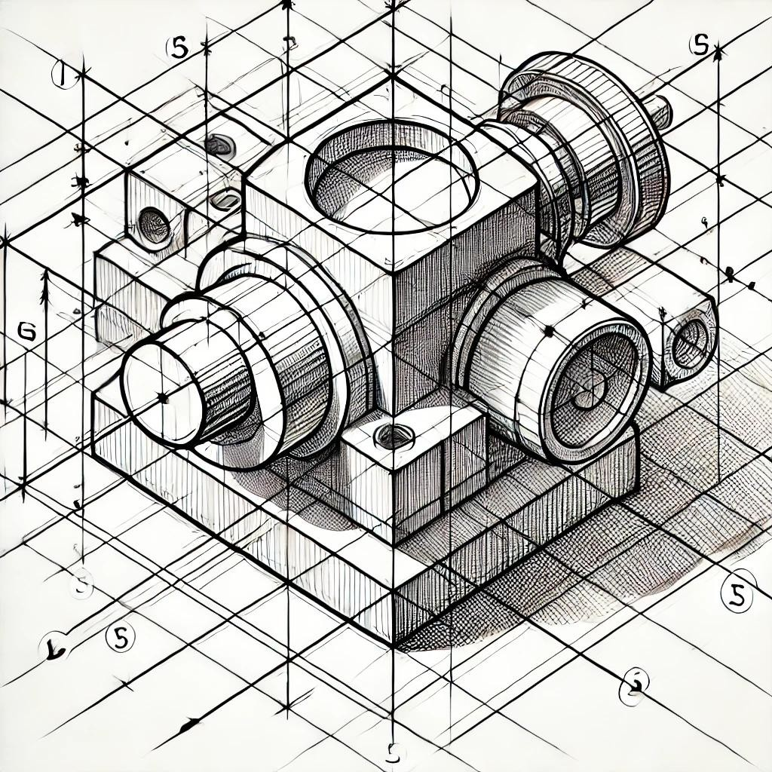
  - Using the given orthographic views, draw the isometric view of the object. Clearly indicate the starting point. (25)

  - Given a perspective drawing with missing lines, complete the two-point perspective drawing of the object. (15)

QUESTION 3: CIVIL DRAWING (40 MARKS)
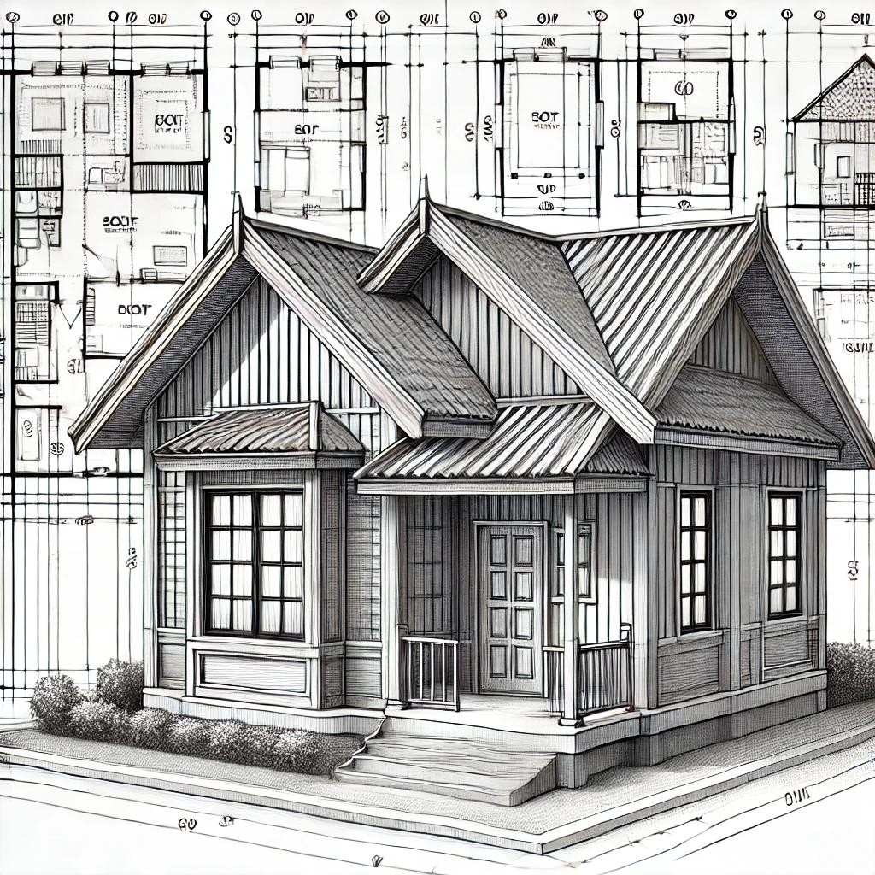
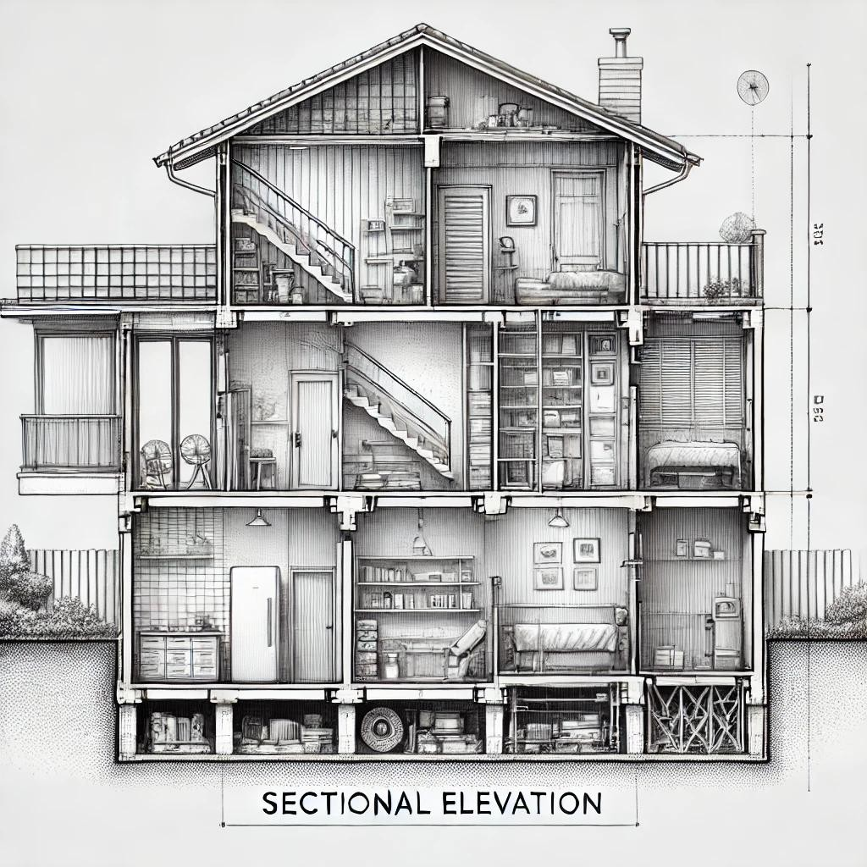

  - Given the floor plan of a small residential building, draw the west elevation according to the standard conventions. (20)

  - Complete the sectional elevation as per the instructions provided on the drawing sheet. Indicate all necessary details such as roof structure, walls, and foundation. (20)

QUESTION 4: LSA AND INTERSECTION (40 MARKS)
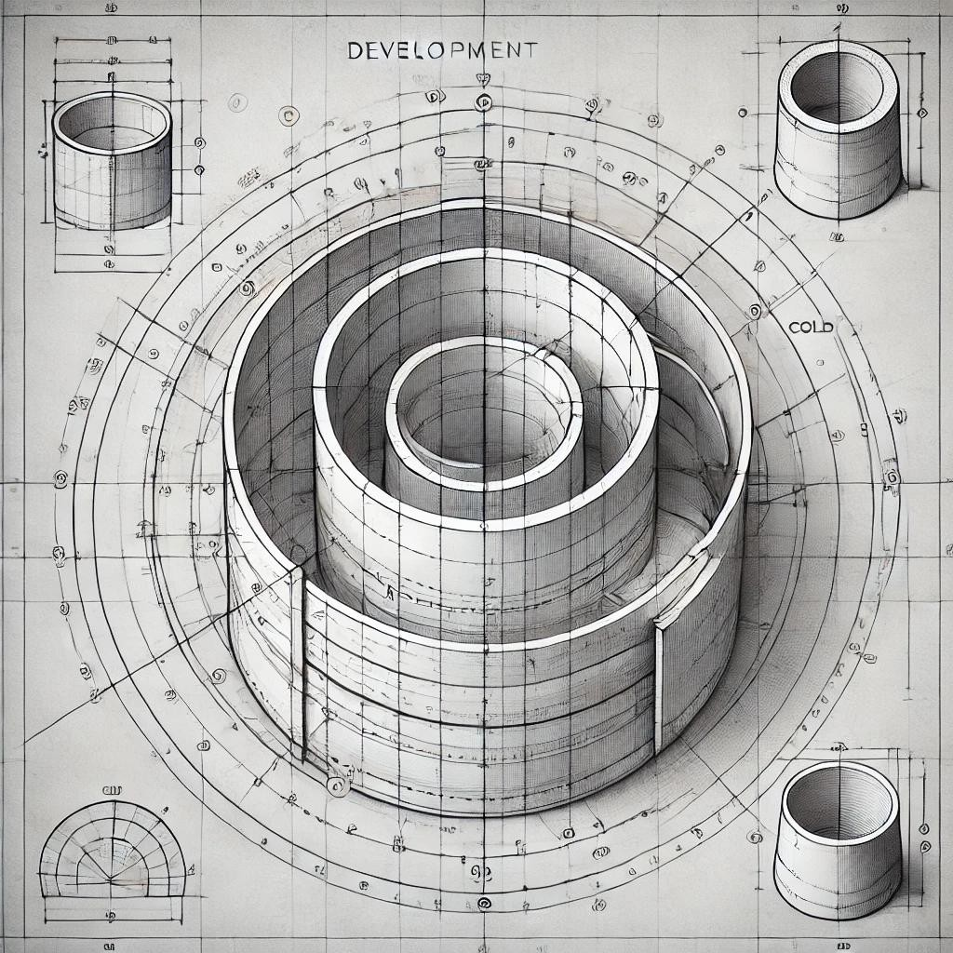

  - Given a cone and cylinder intersecting, draw the development of the surface of the cylinder. Clearly indicate all fold lines. (20)

  - Construct the true shape of the section obtained when a prism is cut by an inclined plane. (20)

TOTAL: 150 MARKS

