
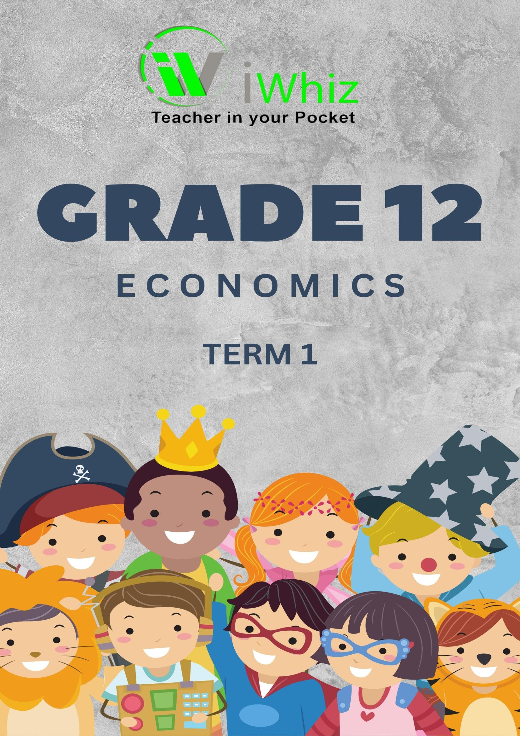



https://www.youtube.com/watch?v=SJ4_nONtYeY
WATCH FOR TESTIMONIALS

WATCH FOR TESTIMONIALS

Grade 12 Economics: Paper 1
Time: 3 hours
Total Marks: 150

Instructions:
- This question paper consists of THREE sections:
  - Section A: Multiple Choice Questions (20 marks)
  - Section B: Short-Answer Questions (70 marks)
  - Section C: Extended-Response Questions (60 marks)
- Answer ALL the questions.
- Start your answer to each question on a new page.
- Use the correct economic terms and concepts when answering questions.
- All calculations must show the formula used and the steps taken to arrive at the answer.
- The use of a calculator is allowed.
- Ensure that you follow the instructions and allocate time wisely.
- No books, notes, or electronic devices are allowed in the exam room.

SECTION A: Multiple Choice Questions (20marks) Instructions:
- Choose the correct answer for each of the following questions.
- Each question is worth 1 mark.
- Which of the following is a characteristic of a market economy?
- Government control over production and distribution
- Private ownership of resources and production
- Central planning of the economy
- High levels of government subsidies

- The law of demand states that:
- As the price of a good rises, the quantity demanded increases
- As the price of a good rises, the quantity demanded decreases
- The demand for all goods is elastic
- Price has no impact on demand

- Which of the following is NOT an example of a public good?
- Street lighting
- National defense
- A privately-owned shopping mall
- Clean air

- The South African Reserve Bank’s primary function is:
- To regulate the stock market
- To manage inflation
- To collect taxes
- To provide financial services to businesses

- Which economic indicator is used to measure the total value of all final goods and services
produced within a country’s borders?
- Consumer Price Index (CPI)
- Gross Domestic Product (GDP)
- Unemployment Rate
- Producer Price Index (PPI)

- Which of the following describes a monopolistic market structure?
- One seller and many buyers
- Many sellers with differentiated products
- One seller and one buyer
- Many sellers and many buyers with identical products

- Which of the following would likely cause an increase in inflation in an economy?
- A decrease in government spending
- An increase in the money supply
- A decrease in consumer demand
- A rise in interest rates

- Which of the following is an example of a fiscal policy tool?
- Setting interest rates
- Adjusting the money supply
- Changing government spending and taxation
- Regulating the exchange rate

- If the government increases taxes, what is likely to happen?
- Increased consumer spending
- Decreased consumer spending
- Increased investment by businesses
- Increased exports

- What is meant by the term “market failure”?
- When demand exceeds supply
- When the government intervenes to control prices
- When the market fails to allocate resources efficiently
- When there is no competition in the market

- Which of the following is considered a factor of production?
- Money
- Technology
- Labor
- Government policies

- What is the main aim of monetary policy?
- To increase government spending
- To control inflation and stabilize the currency
- To regulate business competition
- To collect taxes

- Which of the following best describes inflation?
- An increase in the value of money
- A decrease in the general price level
- A rise in the general price level of goods and services
- A decrease in consumer demand

- The price mechanism helps in:
- Balancing the demand and supply of goods in the market
- Ensuring that all goods are subsidized
- Setting wages for labor
- Controlling inflation directly

- Which of the following would likely lead to an increase in exports from South Africa?
- A rise in the value of the South African rand
- An increase in tariffs on imported goods
- A decrease in the exchange rate value of the rand
- A reduction in international trade agreements

- Which of the following is true about a perfect competition market structure?
- There are few firms in the market
- There are no barriers to entry
- Firms have significant control over prices
- Firms sell differentiated products

- What is the main goal of economic policy in South Africa?
- To reduce government spending
- To promote equitable growth and reduce unemployment
- To increase imports
- To increase inflation

- The production possibility frontier (PPF) shows:
- The level of inflation in the economy
- The maximum possible combinations of two goods that can be produced
- The total value of goods produced
- The market price of goods in the economy

- What is meant by the term "opportunity cost"?
- The cost of all inputs used in production
- The cost of the next best alternative foregone when making a decision
- The total amount of money spent on a product
- The economic cost of taxes and tariffs

- What is the primary objective of a government’s monetary policy?
- To stabilize the stock market
- To increase employment
- To control inflation
- To reduce government spending

SECTION B: Short-Answer Questions (70 marks)
- Define the following concepts: (10 marks each)
  - Microeconomics

  - Macroeconomics

- Explain how the concept of price elasticity of demand (PED) affects a firm’s pricing decisions.
Provide an example to illustrate your answer. (10 marks)

- Discuss the causes of income inequality in South Africa and suggest possible measures to reduce inequality.
(10 marks)

- What are the advantages and disadvantages of a market economy? (10 marks)

- Explain the role of government in an economy. Refer to fiscal policy and monetary policy in your answer.
(10 marks)

- Discuss how unemployment affects the South African economy. Mention its impact on social, economic, and fiscal aspects.
(10 marks)

SECTION C: Extended-Response Questions (60 marks)
Instructions:
- Answer all the questions in this section.
- Each question is worth 30 marks.
- Evaluate the causes and consequences of inflation in South Africa. What measures can the government implement to control inflation without causing excessive unemployment?
(30 marks)
- Discuss the relationship between economic growth and economic development in South Africa. How can these two concepts be balanced in the current economic climate?
(30 marks)

