
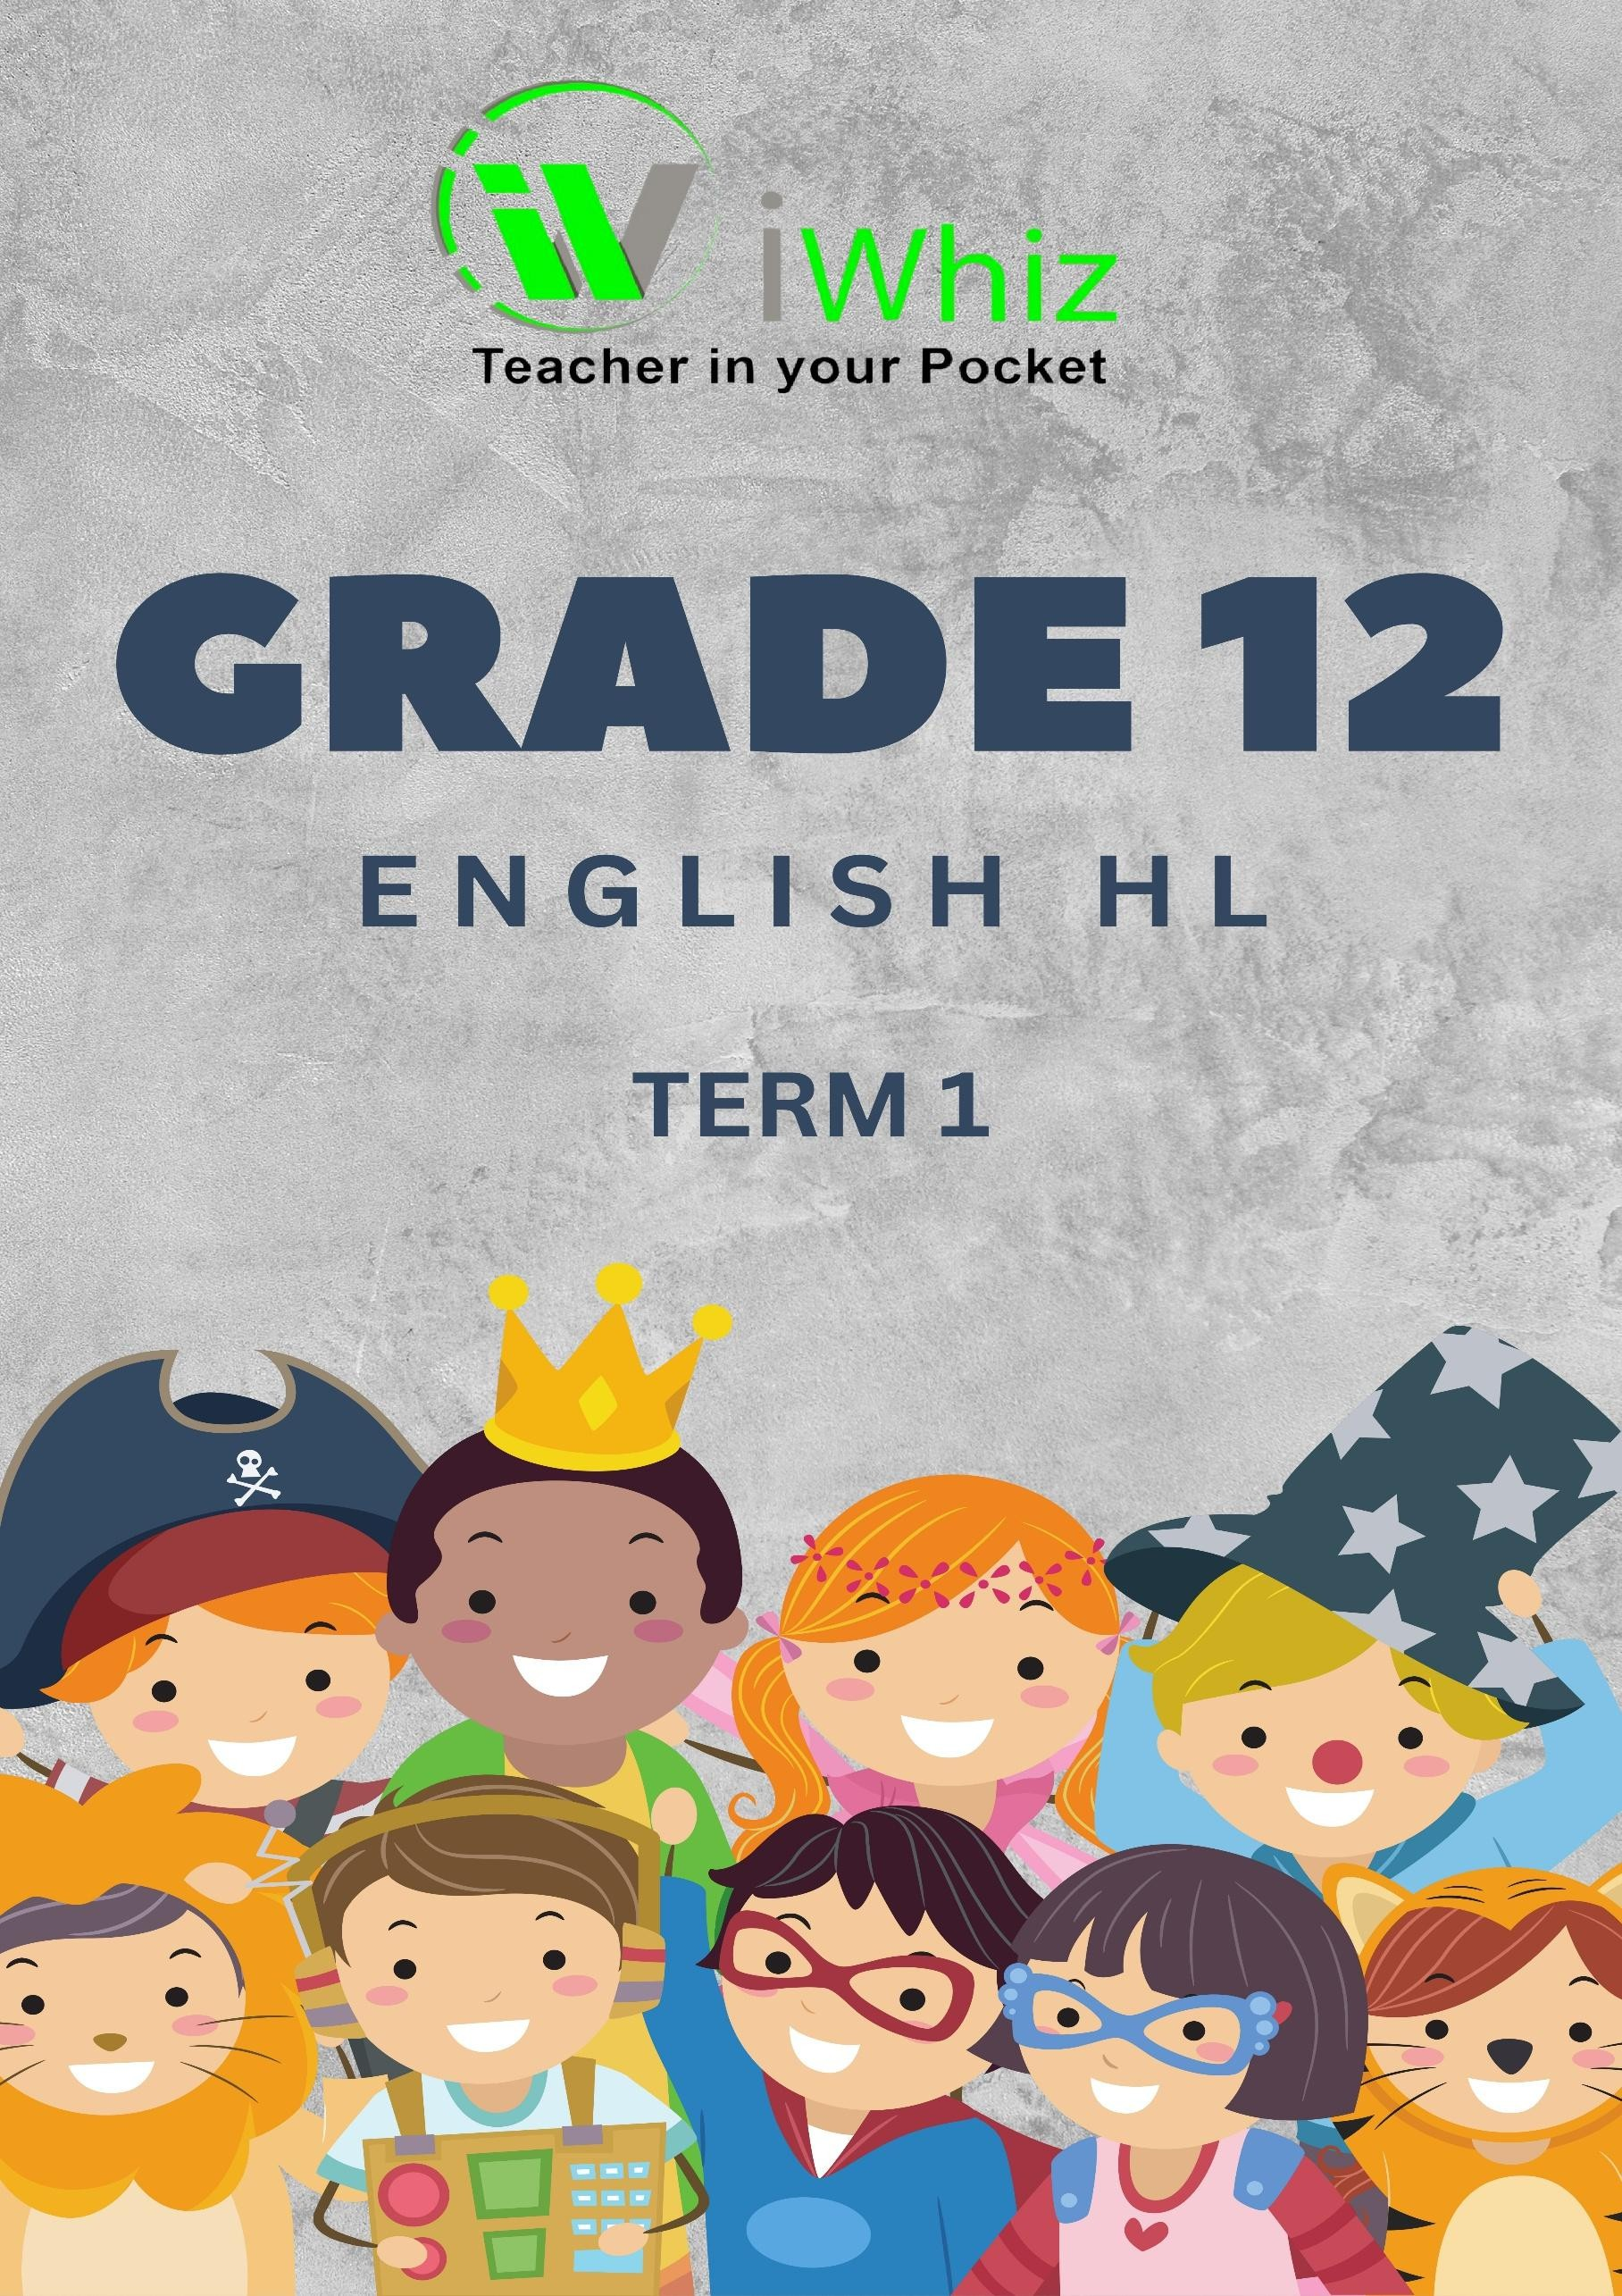

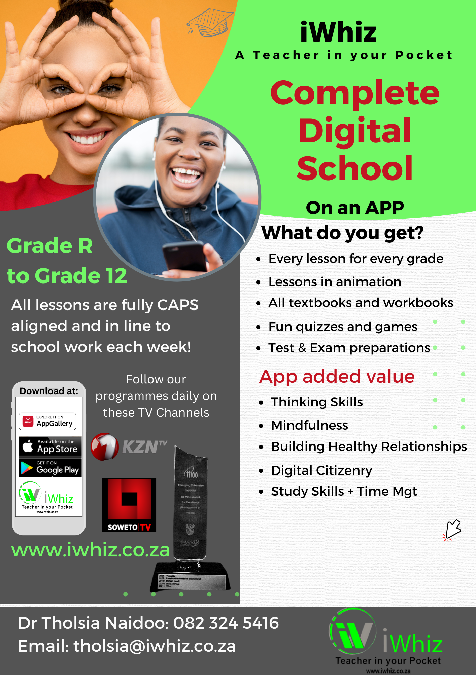

https://www.youtube.com/watch?v=SJ4_nONtYeY

WATCH FOR TESTIMONIALS

GRADE 12 ENGLISH HOME LANGUAGE TERM 1 TEST
TIME: 2 HOURS
TOTAL: 100 MARKS

INSTRUCTIONS:
- Read all instructions carefully.
- Answer all questions in the spaces provided.
- Write neatly and legibly.
- This paper consists of three sections:
  - Section A: Comprehension (30 marks)
  - Section B: Summary (10 marks)
  - Section C: Language in Context (30 marks)
  - Section D: Essay Writing (30 marks)

SECTION A: COMPREHENSION (30 MARKS)
Read the following passage carefully and answer the questions that follow. The Power of Education in South Africa
In the heart of South Africa, where the echoes of the past still linger, education stands as the beacon of hope for millions. From the bustling streets of Johannesburg to the quiet rural villages of the Eastern Cape, young learners wake up each morning with dreams of a brighter future. However, the reality of education in South Africa is complex, shaped by historical inequalities,
economic challenges, and the resilience of its people.
South Africa’s education system has undergone significant changes since the fall of apartheid in 1994. The introduction of a
democratic government brought with it the promise of equal education for all. The barriers that once kept black students from accessing quality education were dismantled, and policies were introduced to create an inclusive learning environment.
However, nearly three decades later, many challenges remain.
One of the major issues facing the education sector is the disparity between urban and rural schools. While some schools in metropolitan areas boast modern facilities, well-trained teachers, and access to digital learning tools, many rural schools
struggle with overcrowded classrooms, a lack of resources, and poor infrastructure. In some villages, children walk long distances to school, only to be met with leaking roofs and outdated textbooks. The government has implemented several
initiatives, such as the National School Nutrition Programme and improved funding for underprivileged schools, but progress remains slow.
Another critical issue is the high dropout rate. According to recent studies, a significant percentage of students do not complete their matric exams. Many young people leave school early due to financial constraints, having to support their
families, or losing hope in an education system that does not always translate into job opportunities. Unemployment remains a pressing concern, with many graduates struggling to find work in an economy that has yet to recover from the COVID-19
pandemic and other financial setbacks.
Despite these challenges, South Africa has witnessed remarkable stories of perseverance. Many young individuals from
disadvantaged backgrounds have defied the odds, excelling in their studies and achieving great success. Take, for example, Dr. Sandile Kubheka, who made history as South Africa’s youngest doctor at the age of 20. Coming from a small town in KwaZulu- Natal, Dr. Kubheka’s journey reflects the transformative power of education and determination.
Furthermore, organizations and individuals are working tirelessly to bridge the educational gap. Non-profit organizations such as the Student Sponsorship Programme and the Tomorrow Trust provide financial aid and mentorship to students from
disadvantaged backgrounds. Corporate sponsorships and government bursaries have also opened doors for students who might otherwise have been denied opportunities.
The rise of technology in education has also played a crucial role in addressing some of these disparities. Online learning
platforms, digital libraries, and virtual tutoring have provided alternative ways for students to access knowledge. While internet accessibility remains a challenge in some areas, the potential of e-learning continues to grow, offering new possibilities for the
future of education in South Africa.
Looking ahead, education remains the most powerful tool for transforming South Africa. Addressing issues such as inequality, infrastructure, and access to quality teaching will require collective efforts from the government, private sector, and civil
society. But with resilience, innovation, and a shared commitment to progress, South Africa’s youth can rise above their circumstances and create a future that is filled with promise.
As Nelson Mandela once said, “Education is the most powerful weapon which you can use to change the world.” For South Africa, investing in education is not just about personal success—it is about the nation’s ability to move forward, to heal from its past, and to build a society where every child has the opportunity to reach their full potential.

  - Give a suitable title for the passage. (2)

  - Identify the main idea of the passage. (3)

  - What tone does the author use in paragraph 3? Provide evidence from the text. (3)

  - Explain the meaning of the following words as used in the passage:

- Resilience (2)

- Adversity (2)

  - What is the author's perspective on the issue discussed in the passage? (3)

  - Identify and explain any two persuasive techniques used in the passage. (4)

  - What is the significance of the concluding paragraph? (3)

  - Provide a summary of the passage in your own words in 5 sentences. (8)

SECTION B: SUMMARY (10 MARKS)
Read the following passage and summarise it in 80-90 words.

The Challenge of Youth Unemployment in South Africa
Youth unemployment remains one of the most pressing challenges in South Africa. With an official unemployment rate among young people reaching over 60%, many graduates and school leavers
find themselves without job opportunities, despite having qualifications. This crisis has far-reaching consequences, affecting not only individuals but also the broader economy and social stability of the country.
One of the main reasons for high youth unemployment is the skills mismatch between what the education system provides and what the job market requires. Many young people complete their schooling without the necessary technical skills or work experience needed for available jobs.
Additionally, industries such as manufacturing and agriculture, which traditionally provided
employment to many, have declined due to economic downturns and technological advancements.
Another contributing factor is the lack of entrepreneurship support. While some young people have business ideas, limited access to funding and mentorship prevents them from turning these ideas
into successful enterprises. Moreover, job seekers in rural areas and townships often face additional challenges, such as poor transport systems and fewer economic opportunities.
To address this crisis, both government and private sector initiatives are crucial. Programs that
provide skills training, work experience, and financial support for small businesses can help bridge the gap. Investing in technology-driven industries and encouraging youth entrepreneurship are also vital steps toward reducing unemployment. Only through a collective effort can South Africa create
sustainable job opportunities for its young population and ensure a prosperous future for all.

INSTRUCTIONS:
- Your summary must be in full sentences.
- Do not include examples or unnecessary details.
- You must write in your own words.
- Indicate the word count.


SECTION C: LANGUAGE IN CONTEXT (30 MARKS)
QUESTION 1: ANALYSING ADVERTISEMENTS (10 MARKS)

  - What product or service is being advertised? (2)

  - Identify and explain two persuasive techniques used in the advertisement. (4)

  - Who is the target audience of the advertisement? Justify your answer. (2)

  - How does the image contribute to the effectiveness of the advertisement? (2)

QUESTION 2: EDITING AND LANGUAGE STRUCTURES (10 MARKS)
Read the following passage and correct any errors in grammar, spelling, and punctuation.
South Africa is a country that faces many challenges, including high unemployment rates, poverty
and a struggling education system. Despite these issues, there is a strong sense of resilience among its people. Many young individuals strive to create better futures for themselves, working hard in
school and seeking opportunities for growth. However, government policies do not always support them effectively, leading too frustration and lack of progress. In addition, access to quality
education and skills development remain a issue, especially in rural areas. If more effort was put into investing in young people, the country could see significant improvements in its economy and social stability.

  - Rewrite the corrected paragraph. (5)

  - Identify and explain two language errors in the passage. (4)

  - Provide a synonym for the word significant as used in the passage. (1)

QUESTION 3: FIGURATIVE LANGUAGE (10 MARKS)
  - Identify and explain the following figures of speech from the passage below:
- Simile (2)

- Metaphor (2)

- Personification (2)

- Hyperbole (2)

  - Rewrite the following sentence in the active voice:
"The award was won by the talented young writer." (2)

SECTION D: ESSAY WRITING (30 MARKS) INSTRUCTIONS:
    - Choose ONE of the following topics and write an essay of 250-300 words.
    - Plan your essay before writing.
    - Use proper paragraphing and structure.
    - Ensure coherence, logical flow, and originality. TOPICS (CHOOSE ONE):
- "The role of social media in shaping today’s youth."
- "The power of resilience in overcoming challenges."
- "South Africa’s future: Hope or despair?"
- Write a descriptive essay on a place that holds special meaning for you.

