




https://www.youtube.com/watch?v=SJ4_nONtYeY

WATCH FOR TESTIMONIALS

GRADE 12 HISTORY TERM 1 MARCH TEST PAPER TOTAL: 150 MARKS
TIME: 3 HOURS
INSTRUCTIONS AND INFORMATION
- This question paper consists of THREE sections: SECTION A, SECTION B, and SECTION C.
- Answer ALL questions in SECTION A.
- Answer TWO questions in SECTION B.
- Answer ONE question in SECTION C.
- Write neatly and legibly.

SECTION A: SOURCE-BASED QUESTIONS
(Answer ALL questions in this section.)

QUESTION 1: THE COLD WAR
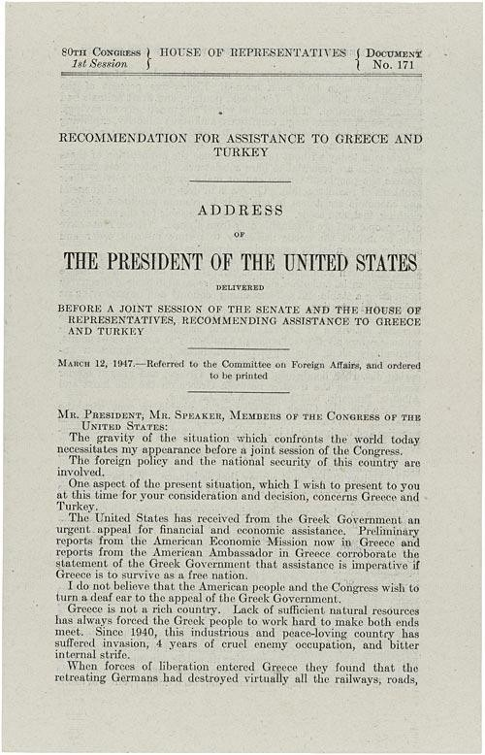
Study the sources provided and answer the questions that follow. SOURCE A

SOURCE B
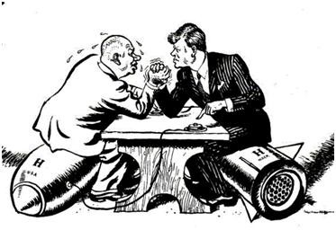

  - Refer to Source A.
    - Define the term ‘Cold War’ in your own words. (2)

    - Explain the main ideological differences between the USA and USSR. (4)

    - What does the source suggest about the causes of the Cold War? (4)

  - Refer to Source B.
    - Identify two ways in which the USA tried to contain communism. (2)

    - How does this source reflect the Truman Doctrine? (4)

    - Comment on the reliability of this source for a historian studying the Cold War. (6)

  - Compare Source A and Source B. Explain how these sources either support or contradict each other regarding the Cold War. (6)

  - Use all the sources and your own knowledge to write a paragraph (about 8 lines) on the impact of the Cold War on global politics. (6)

[30 marks]

SECTION B: ESSAY QUESTIONS
(Answer TWO questions from this section.)
QUESTION 2: THE RISE OF THE USSR AS A SUPERPOWER
Discuss the reasons behind the rise of the USSR as a superpower after World War II. (30)

QUESTION 3: APARTHEID SOUTH AFRICA (1948–1960)
Critically analyse the reasons for the implementation of apartheid in South Africa and its impact on the lives of black South Africans between 1948 and 1960. (30)

QUESTION 4: DECOLONISATION IN AFRICA
Evaluate the factors that led to decolonisation in Africa after World War II, with specific reference to Ghana and Congo. (30)
[60 marks]

ESSAY 1

ESSAY 2

C: EXTENDED WRITING
(Answer ONE question from this section.)
QUESTION 5: THE BERLIN CRISIS (1948–1949)
Write an essay discussing the causes, key events, and consequences of the Berlin Crisis of 1948– 1949. (30)

QUESTION 6: THE SHARPEVILLE MASSACRE (1960)
Analyse the causes and consequences of the Sharpeville Massacre and how it influenced the anti- apartheid struggle in South Africa. (30)

QUESTION 7: THE VIETNAM WAR
Assess the impact of the Vietnam War on the USA and the world at large. (30)
[30 marks]

TOTAL: 150 MARKS

