
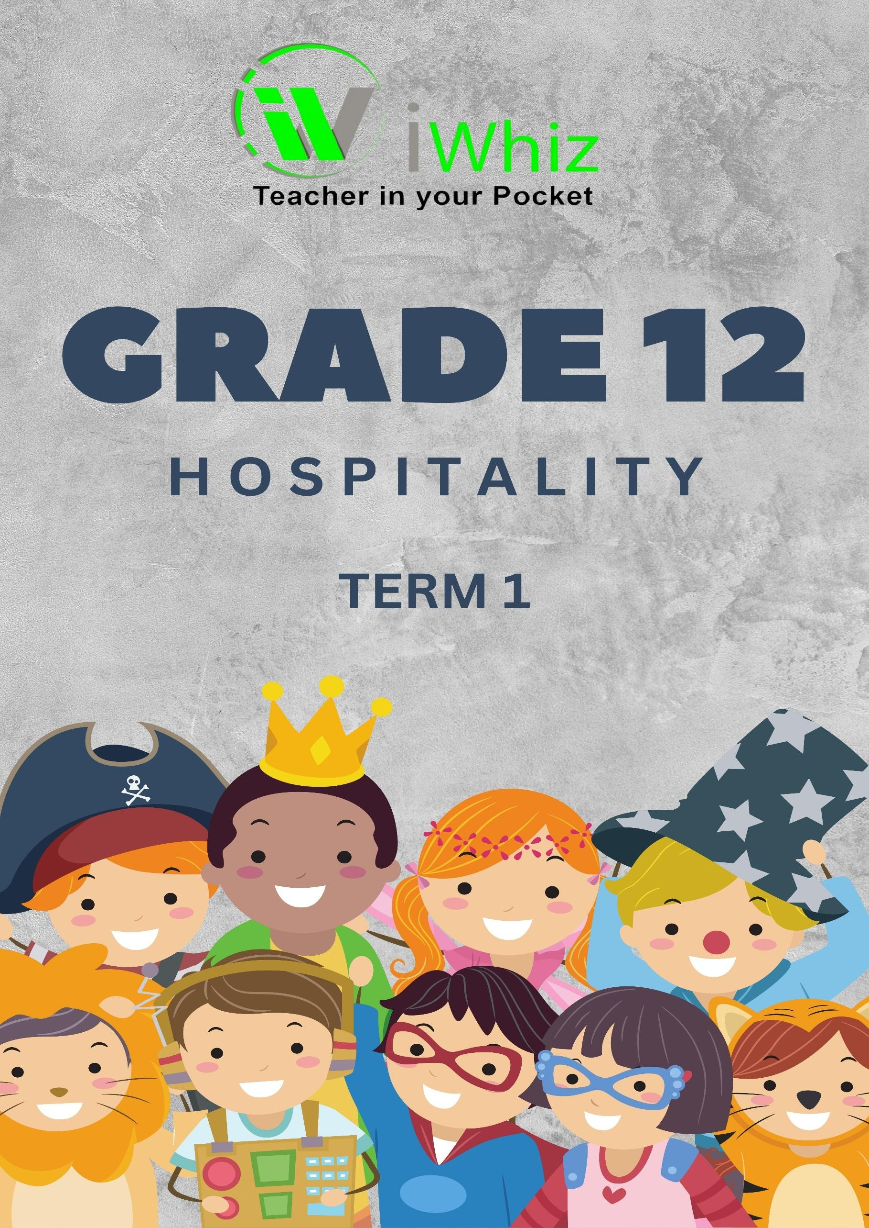



https://www.youtube.com/watch?v=SJ4_nONtYeY

WATCH FOR TESTIMONIALS

GRADE 12
HOSPITALITY STUDIES TERM 1 TEST
MARKS: 200
TIME: 3 HOURS

INSTRUCTIONS AND INFORMATION:
- This question paper consists of FOUR sections:
  - SECTION A: Short Questions (40 marks)
  - SECTION B: Hospitality Concepts and Health & Safety (50 marks)
  - SECTION C: Nutrition, Menu Planning, and Food Commodities (60 marks)
  - SECTION D: Food Service and Customer Care (50 marks)
- Answer ALL the questions.
- Read all questions carefully before answering.
- Use the mark allocation as a guide to the length of your answers.
- Write neatly and legibly.

SECTION A: SHORT QUESTIONS (40 MARKS)
Answer all questions in this section.

Multiple Choice Questions (10 x 1 = 10 marks)
    - Which of the following is the correct temperature range for storing frozen foods?
- 5°C - 10°C
- -1°C - 4°C
- -18°C or lower
- 0°C - 5°C
    - What is the correct term for the process of removing harmful bacteria from surfaces?
- Contamination
- Sterilization
- Cross-contamination
- Sanitization
    - Which of the following is a dry-heat cooking method?
- Boiling
- Steaming
- Roasting
- Poaching
    - The best type of fire extinguisher to use for an oil-based kitchen fire is:
- Water
- CO₂ (Carbon Dioxide)
- Foam
- Dry Powder

    - HACCP is a food safety system that stands for:
- Hazard Analysis and Critical Control Points
- Health and Consumer Catering Procedures
- Hospitality and Catering Control Process
- Hygiene and Contamination Control Plan

    - What is the primary reason for wearing a chef’s uniform in the kitchen?
- To make the chef look professional
- To keep the chef warm
- To maintain hygiene and safety standards
- To identify staff members

    - Cross-contamination occurs when:
- Food is stored at the correct temperature
- Harmful bacteria transfer from one surface or food to another
- Hands are washed regularly
- Food is properly cooked
    - Which of the following is NOT a function of protein in the body?
- Building and repairing tissues
- Providing energy
- Strengthening bones and teeth
- Supporting the immune system
    - Which of these is an example of a complete protein source?
- Beans
- Rice
- Chicken
- Bread
    - Which of the following is a legal requirement for food handlers?
- Wearing makeup in the kitchen
- Keeping nails short and clean
- Using excessive perfume
- Eating in the food preparation area

Match the descriptions in Column A with the correct terms in Column B. Write only the letter of the correct answer. (10 marks)

COLUMN A | COLUMN B
1.2.1 Cooking food in boiling water for a short time then plunging it into ice water | A. Sautéing
1.2.2 The process of bacteria spreading from one surface to another | B. Blanching
1.2.3 Small, bite-sized appetizers served before a meal | C. Cross- contamination
1.2.4 A menu where each item is priced separately | D. Canapés
1.2.5 Frying quickly over high heat with little oil | E. A la carte
1.2.6 The process of cooking food using steam | F. Poaching
1.2.7 A type of food service where guests serve themselves from a spread of dishes | G. Buffet
1.2.8 The process of beating air into egg whites to form a foam | H. Whisking
1.2.9 Cooking food slowly in liquid at a temperature just below boiling | I. Simmering
1.2.10 A mixture of oil and vinegar used as a salad dressing | J. Emulsion

Complete the following sentences using the correct word from the list provided: (Hygiene, 5, FIFO, Cross-contamination, 4, Chef’s, Sanitization, Simmering, Poaching, Emulsion). (10 marks)

    - The ideal storage temperature for fresh dairy products is between and degrees Celsius.

    - The correct way to lift a heavy object in the kitchen is to bend at the and not at the waist.

    - The system ensures that the oldest stock is used first in food storage.

    - occurs when harmful bacteria transfer from one surface or food to another.

    - The correct method to cook eggs without their shell in gently simmering water is called .

    - Maintaining proper in the kitchen helps prevent food contamination and foodborne illnesses.

    - The process of removing harmful microorganisms from surfaces using chemicals or heat is known as .

    - The cooking method where food is cooked in liquid just below the boiling point is called .

    - A mixture of two liquids that normally do not blend, such as oil and vinegar, is called an .

    - A uniform is worn in professional kitchens to maintain hygiene and safety.

State whether the following statements are TRUE or FALSE. If false, provide the correct statement. (10 marks)

    - Cross-contamination occurs when raw and cooked foods are stored separately.

    - The HACCP system is designed to manage and ensure workplace safety.

    - A chef's uniform is purely for aesthetic purposes and has no functional benefit.

    - The FIFO system ensures that older stock is used before newer stock.

    - Boiling is a dry-heat cooking method.

    - Bacteria multiply rapidly in the temperature danger zone of 5°C - 60°C.

    - Food should be thawed at room temperature for faster defrosting.

    - Wearing jewellery in the kitchen is recommended for hygiene purposes.

    - A la carte menus offer individual pricing for each dish.

    - Simmering requires a higher temperature than boiling.

SECTION B: HOSPITALITY CONCEPTS AND HEALTH & SAFETY (50 MARKS)

Explain the following terms related to the hospitality industry:
    - Customer service (2)

    - Housekeeping (2)

    - Food hygiene (2)

    - Occupational health and safety (2)

  - List FIVE personal hygiene practices that food handlers must follow. (5)

  - Discuss FOUR consequences of poor hygiene in a hospitality establishment. (8)

  - Identify and explain THREE potential hazards in a commercial kitchen. (6)

  - Explain the correct procedures for handling and storing cleaning chemicals safely. (5)

  - Describe the step-by-step process of washing hands correctly in a hospitality environment. (5)

  - Suggest FOUR ways to prevent cross-contamination in a professional kitchen. (4)

  - Explain how a kitchen layout can influence food safety. (4)

SECTION C: NUTRITION, MENU PLANNING, AND FOOD COMMODITIES (60 MARKS)
  - Define the term “balanced diet” and explain its importance in menu planning. (5)

  - Identify and explain the functions of the following nutrients in the body:
    - Proteins (4)

    - Carbohydrates (4)

    - Fats (4)

    - Vitamins (4)

    - Minerals (4)

  - Discuss THREE factors that should be considered when planning a menu for a hospital. (6)

  - Name and describe THREE different types of menus used in the hospitality industry. (6

  - Explain how food presentation affects customer satisfaction in a restaurant. (5)

  - Identify FOUR methods of moist-heat cooking and provide an example of a dish for each. (8)

  - Differentiate between convenience foods and fresh foods. Provide TWO advantages and TWO disadvantages of each. (6)
  - Discuss the impact of food allergies and dietary restrictions on menu planning. (4)

SECTION D: FOOD SERVICE AND CUSTOMER CARE (50 MARKS)
  - Explain the importance of professional behaviour when serving guests in a hospitality establishment. (5)

  - Identify and explain FOUR basic principles of customer care. (8)

  - Discuss THREE effective ways to handle customer complaints in the hospitality industry. (6)

  - Explain the role of communication skills in providing good customer service. (6)

  - Differentiate between formal and informal service styles. Provide an example of each. (6)

  - Name FOUR types of table settings used in hospitality establishments and explain when each is used. (8)

  - Explain how teamwork contributes to efficiency in a hospitality environment. (5)

TOTAL: 200 MARKS

