
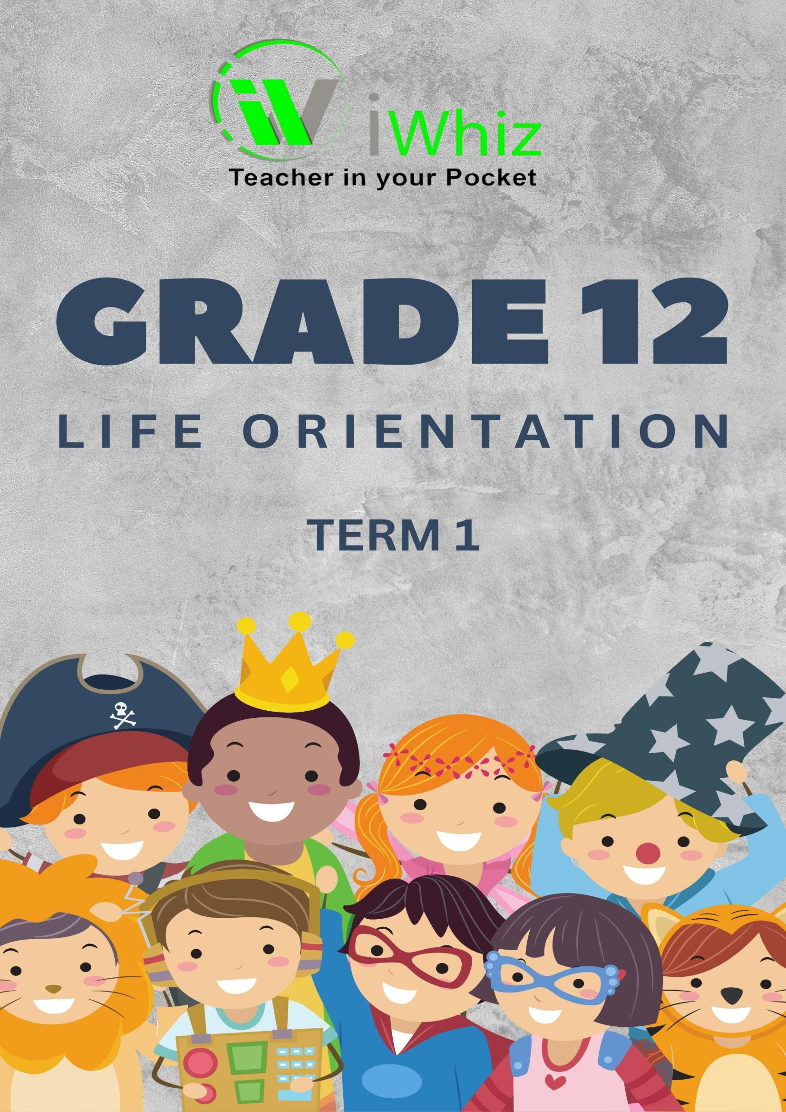

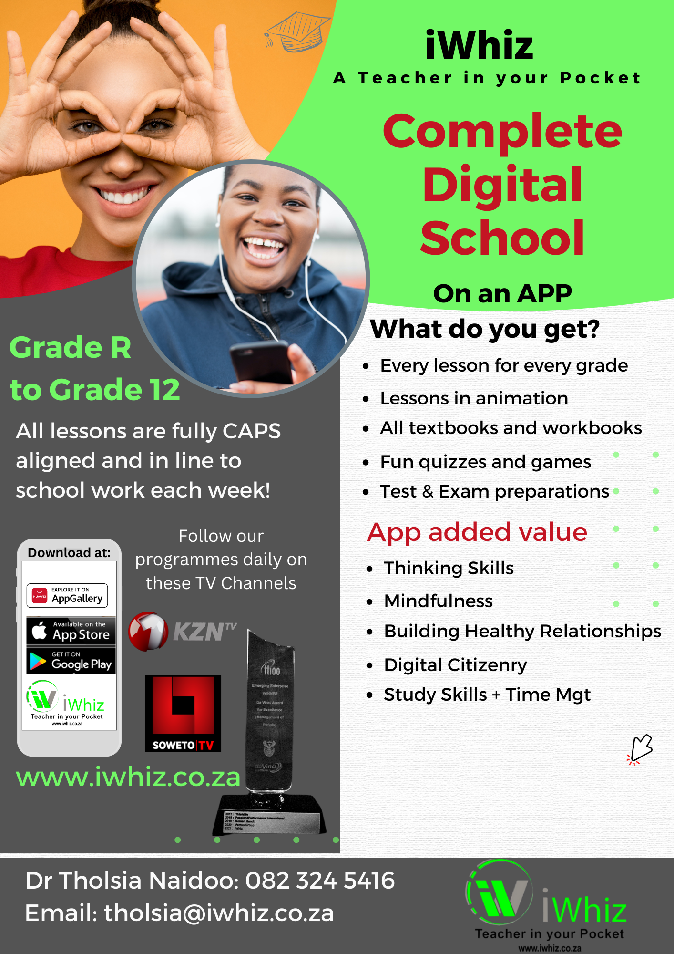

https://www.youtube.com/watch?v=SJ4_nONtYeY
WATCH FOR TESTIMONIALS

WATCH FOR TESTIMONIALS

LIFE ORIENTATION GRADE 12
MARKS: 90
TIME: 2 HOURS

INSTRUCTIONS AND INFORMATION
- This question paper consists of THREE sections:
- Section A: (20 marks)
- Section B: (30 marks)
- Section C: (40 marks)
- Answer ALL the questions.
- Number your answers correctly according to the numbering system used in this question paper.
- Write neatly and legibly.
- Only black or blue ink may be used.

SECTION A (20 MARKS)
Answer ALL the questions.
QUESTION 1
  - Choose the correct answer from the options given. Write only the letter (A–D) next to the question number. (5 x 2 = 10)
    - The process of making informed choices about career and further education is called:
- Career Counselling
- Career Decision-Making
- Career Development
- Career Guidance

    - The Constitution of South Africa promotes human rights through the:
- Bill of Rights
- National Assembly
- Criminal Procedure Act
- Labour Relations Act

    - Which of the following is NOT a financial responsibility?
- Budgeting
- Saving
- Overspending
- Paying taxes

    - A common effect of substance abuse is:
- Improved concentration
- Increased productivity
- Health deterioration
- Better financial management

    - An example of a strategy to manage stress effectively is:
- Ignoring problems
- Regular exercise
- Procrastination
- Isolation

  - Match the terms in Column A with their correct descriptions in Column B. Write only the question number and the corresponding letter. (5 x 1 = 5)

Column A |  | Column B
1.2.1 Peer pressure |  | A. A document that outlines human rights in South Africa
1.2.2 Bill of Rights |  | B. Choosing subjects or careers wisely for the future
1.2.3 Time management |  | C. The ability to withstand and recover from difficulties
1.2.4 Career decision-making |  | D. The influence of friends or social groups to behave in a certain way
1.2.5 Resilience |  | E. Planning and using time effectively

  - Answer the following questions
    - Define the term "social justice."

    - Identify TWO consequences of poor financial planning.

    - Explain how human rights can be protected in schools.

    - Suggest ONE way in which learners can contribute to environmental sustainability.

    - Why is self-awareness important in career decision-making?

SECTION B (30 MARKS)
Answer ALL questions in full sentences.
QUESTION 2
  - Discuss the importance of setting short-term and long-term goals in personal development. (6)

  - Explain THREE ways in which stress can negatively affect a Grade 12 learner’s academic performance. (6)
  - Identify and discuss THREE rights contained in the Bill of Rights and their importance in everyday life. (9)

  - Describe THREE responsible ways of using social media to prevent cyberbullying. (9)

SECTION C (40 MARKS)
Answer TWO questions in essay format.

QUESTION 3
Discuss the impact of substance abuse on an individual’s well-being, family relationships, and future career prospects. Suggest possible solutions to address this issue. (20)

QUESTION 4
Examine the role of media in shaping societal values and attitudes towards gender equality. Provide examples to support your answer. (20)
QUESTION 5
Explain the importance of financial literacy for young adults. Discuss how budgeting, saving, and investing can contribute to financial independence. (20)

TOTAL: 90 MARKS

