




https://www.youtube.com/watch?v=SJ4_nONtYeY
WATCH FOR TESTIMONIALS

WATCH FOR TESTIMONIALS

GRADE 12 LIFE SCIENCES TERM 1 EXAMINATION TIME: 2 HOURS
TOTAL: 100 MARKS

INSTRUCTIONS AND INFORMATION:
- This question paper consists of three sections: Section A, Section B, and Section C.
- Answer ALL the questions.
- Write neatly and legibly.
- Number your answers correctly according to the numbering system used in this question paper.
- Use the mark allocation as a guide for the length of your responses.

SECTION A (20 MARKS)
QUESTION 1
  - Various possible answers are provided for each question. Choose the correct answer and write down only the letter (A–D) next to the question number. (5 x 1 = 5)
    - Which of the following organelles is responsible for cellular respiration?
- Ribosome
- Mitochondrion
- Nucleus
- Chloroplast
    - The process of diffusion involves:
- Movement of water across a membrane
- Movement of molecules from low to high concentration
- Movement of molecules from high to low concentration
- Absorption of food in the intestines
    - Enzymes are:
- Lipids
- Carbohydrates
- Proteins
- Nucleic acids
    - Which component of the blood is responsible for transporting oxygen?
- White blood cells
- Platelets
- Red blood cells
- Plasma
    - The part of the brain responsible for coordination and balance is the:
- Medulla oblongata
- Cerebrum
- Hypothalamus
- Cerebellum
  - Give the correct biological term for each of the following descriptions. (5 x 1 = 5)

    - The functional unit of the kidney.
    - The hormone that regulates blood sugar levels.
    - The process by which plants lose water vapor from their leaves.
    - The pigment responsible for absorbing light energy during photosynthesis.
    - The phase of mitosis where chromosomes line up at the cell’s equator.

  - Match the items in Column A with the correct description in Column B. Write only the letter next to the question number. (5 x 2 = 10)

Column A |  | Column B
1.3.1 Alveoli |  | A. Carries impulses to the central nervous system
1.3.2 Neuron |  | B. Site of gas exchange in the lungs
1.3.3 Enzyme |  | C. Increases the rate of chemical reactions
1.3.4 Synapse |  | D. A gap between two neurons
1.3.5 Artery |  | E. Carries blood away from the heart

SECTION B (50 MARKS)
QUESTION 2 (25 marks)
  - Study the diagram of a plant cell below and answer the questions that follow.

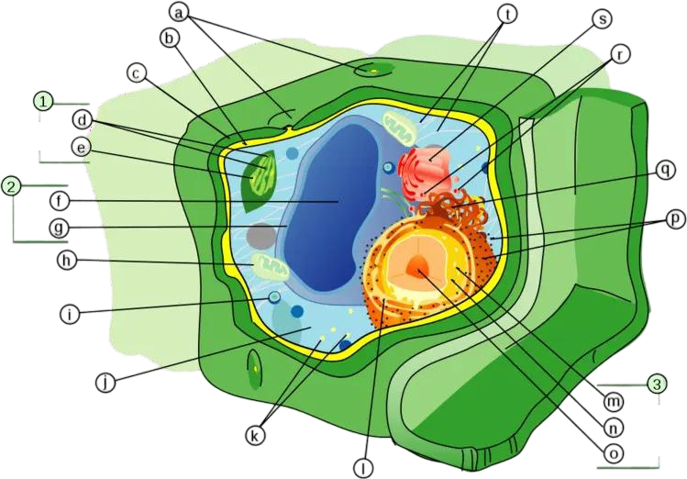

    - Identify structures A, B, and C. (3)

    - State ONE function of each of the structures identified in 2.1.1. (3)

    - Explain TWO differences between plant and animal cells. (4)

  - The following results were obtained from an investigation on the effect of temperature on enzyme activity. Answer the questions that follow.

Temperature (°C) | Enzyme Activity (Rate of Reaction)
10 | Low
20 | Moderate
30 | High
40 | Very High
50 | Moderate
60 | Low

    - What is the optimal temperature for enzyme activity? (1)

    - Explain why enzyme activity decreases at very high temperatures. (3)

    - How would the activity change if the pH level was altered significantly? (3)

  - Describe how the human circulatory system ensures efficient transport of oxygen. (8)

QUESTION 3 (25 marks)
  - The diagram below represents the structure of a nephron in the kidney. Answer the questions that follow.
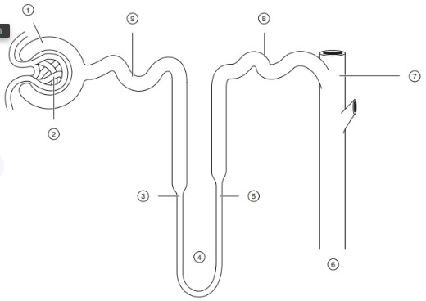
    - Identify structures labelled 7, 8, and 9. (3)

    - Describe the process of ultrafiltration in the nephron. (4)

    - Explain how the kidney maintains homeostasis in the human body. (5)

  - Explain the role of the nervous system in reflex actions, using an example. (5)

  - Describe THREE differences between the sympathetic and parasympathetic nervous systems. (6)

SECTION C (30 MARKS)
QUESTION 4 (Essay Question)
Write an essay in which you describe the process of cellular respiration, including glycolysis, the Krebs cycle, and the electron transport chain. Include the importance of ATP in cellular processes. (30)

