
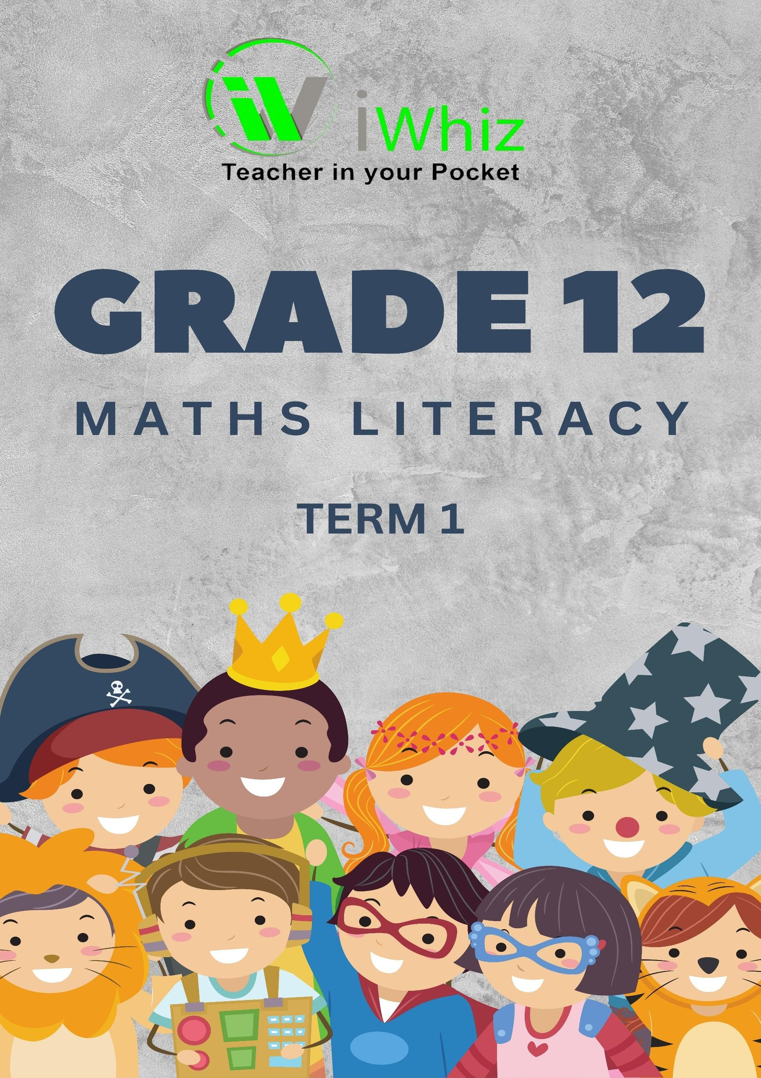



https://www.youtube.com/watch?v=SJ4_nONtYeY
WATCH FOR TESTIMONIALS

WATCH FOR TESTIMONIALS

GRADE 12
MATHEMATICAL LITERACY
TERM 1 TEST PAPER TIME: 2 HOURS
TOTAL MARKS: 100

INSTRUCTIONS AND INFORMATION:
- This question paper consists of five questions.
- Answer all the questions.
- Use an approved calculator where necessary and show all calculations.
- Round off all final answers to two decimal places, unless stated otherwise.
- Write neatly and legibly.

QUESTION 1: FINANCE (20 MARKS)

VAT Calculation (4)
A shop sells a television for R4,999 (excluding VAT). Calculate: 1.1.1 The VAT amount (15%) 1.1.2 The total price including VAT

Interest Calculation (6)
A savings account earns 8% simple interest per annum. A customer deposits R12,000 for 3 years. 1.2.1 Calculate the total interest earned. 1.2.2 Determine the final amount in the account after 3 years.

Budgeting (10)
Below is Thabo’s monthly budget:

Income/Expense | Amount (R)
Salary | 18,000
Rent | 5,500
Groceries | 3,200
Transport | 1,800
Entertainment | 1,500
Savings | 2,000
Other Expenses | ?

    - Calculate the amount allocated to Other Expenses. (2)
    - Determine Thabo’s total expenses. (2)
    - Calculate Thabo’s remaining balance after all expenses. (2)
    - Express the savings as a percentage of his salary. (4)

QUESTION 2: MEASUREMENT (20 MARKS)

Perimeter and Area (8)
A rectangular garden has a length of 12m and a width of 7m.

    - Calculate the perimeter of the garden. (2)

    - Calculate the area of the garden. (2)

    - If the owner wants to place a fence around the garden at R150 per meter, calculate the total cost. (4)

Volume (6)
A water tank is in the shape of a cylinder with a radius of 2m and a height of 3m.
    - Calculate the volume of the tank using the formula V =π r²h (Use π = 3.14). (4)

    - 2.2.2 If the tank is filled to 75% of its capacity, determine the volume of water in the tank. (2)

  - Scale and Conversions (6) A map has a scale of 1:50,000.
    - A road measures 8cm on the map. Calculate the real distance in kilometres. (4)

    - Convert 2500 millilitres to litres. (2)

QUESTION 3: DATA HANDLING (20 MARKS)

Representing Data (8)
A class of 10 learners wrote a test.
Their marks were: 45, 60, 75, 55, 80, 65, 70, 50, 85, 90
    - Arrange the marks in ascending order. (2)

    - Determine the median. (2)

    - Calculate the mean (average) mark. (2)

    - Identify the mode if applicable. (2)

Probability (6)
A bag contains 5 red balls, 3 blue balls, and 2 green balls.
    - What is the probability of picking a blue ball? (2)

    - What is the probability of picking a red or green ball? (4)

Graph Interpretation (6)
The following table shows monthly rainfall (mm) for six months:

Month | Jan | Feb | Mar | Apr | May | Jun
Rainfall (mm) | 120 | 85 | 90 | 75 | 65 | 50

    - What was the highest rainfall month? (2)

    - Calculate the average monthly rainfall. (4)

QUESTION 4: MAPS, PLANS, AND TIMETABLES (20 MARKS)

Distance and Speed (8)
A bus travels 420 km in 6 hours.
    - Calculate the average speed of the bus. (2)

    - If the bus stops for 30 minutes during the trip, calculate the actual travel time. (2)

    - Determine how long it would take to travel 280 km at the same speed. (4)

  - Reading a Timetable (6) A school timetable shows:

Subject | Time
Maths | 08:00 - 09:30
English | 09:30 - 10:30
Break | 10:30 - 11:00
Science | 11:00 - 12:30

    - How long is the Maths lesson? (2)

    - How much time is spent in class before the break? (2)

    - If the school day ends at 14:30, how much total learning time is there? (2)

Direction and Navigation (6)
    - What is the opposite direction of North-East? (2)

    - If a person walks 1.5 km South, then 2 km West, how far are they from their starting point using the Pythagorean Theorem? (4)

QUESTION 5: PROBABILITY AND REAL-LIFE APPLICATIONS (20 MARKS)

Business Profit and Loss (10)
A bakery sells cakes for R120 each. It costs R70 to make one cake.
    - Calculate the profit per cake. (2)

    - If 200 cakes are sold, determine the total profit. (3)

    - If the bakery pays R3,500 rent, how many cakes must be sold to cover this cost? (5)

Household Electricity Usage (10)
A household uses the following appliances daily:

Appliance | Power (Watt) | Hours Used
Fridge | 150 | 24
TV | 200 | 5

    - Calculate the total energy used in kilowatt-hours (kWh) per day. (4)

    - If electricity costs R2.50 per kWh, determine the daily electricity cost. (3)

    - Calculate the monthly cost (30 days). (3)

