




https://www.youtube.com/watch?v=SJ4_nONtYeY
WATCH FOR TESTIMONIALS

WATCH FOR TESTIMONIALS

GRADE 12
PHYSICAL SCIENCES TERM 1 TEST
TIME: 2 Hours
TOTAL: 100 Marks

INSTRUCTIONS AND INFORMATION
- This question paper consists of three sections:
- Section A: Multiple Choice (20 marks)
- Section B: Structured Questions (50 marks)
- Section C: Data Response and Calculations (30 marks)

- Answer all the questions.
- Show all calculations and round off final answers to two decimal places where applicable.
- Use g = 9.8 m/s² where necessary.
- Write neatly and clearly.
- The periodic table and relevant formulae are provided at the end of the paper.

SECTION A: MULTIPLE CHOICE QUESTIONS (20 MARKS)
Circle the correct letter for each question. Each question is worth 2 marks.
- Which of the following is a vector quantity?
- Mass
- Speed
- Distance
- Displacement
- Newton’s Second Law of Motion states that:
- Objects in motion stay in motion unless acted upon by an external force.
- The force acting on an object is equal to its mass multiplied by its acceleration.
- Every action has an equal and opposite reaction.
- The total energy of an isolated system remains constant.
- Which of the following forces is NOT a contact force?
- Friction
- Tension
- Normal Force
- Gravitational Force
- Which statement about electrostatics is correct?
- Like charges attract.
- Unlike charges repel.
- Charge is measured in ohms.
- Charge is measured in coulombs.
- The SI unit of work is:
- Newton
- Joule
- Watt
- Pascal

SECTION B: STRUCTURED QUESTIONS (50 MARKS)
QUESTION 6: KINEMATICS (10 Marks)
  - A car accelerates uniformly from rest to a velocity of 25 m/s in 5 seconds. Calculate:
    - The acceleration of the car. (3)

    - The distance travelled during this time. (3)

  - A stone is thrown vertically upwards at 20 m/s. Ignore air resistance and calculate:
    - The maximum height reached by the stone. (2)

    - The time taken to reach the maximum height. (2)

QUESTION 7: FORCES (10 Marks)
7.1 Define Newton’s Second Law of Motion in words. (2)

7.2 A 10 kg object is pulled with a force of 50 N on a rough surface. The frictional force acting on the object is 10 N. Calculate:
7.2.1 The net force acting on the object. (2)
7.2.2 The acceleration of the object. (3)

7.2.3If the object starts from rest, calculate its velocity after 4 seconds. (3)

QUESTION 8: WORK, ENERGY, AND POWER (10 Marks)
  - A box of mass 5 kg is lifted to a height of 3 m. Calculate:
    - The gravitational potential energy gained by the box. (3)

8.2 A 2 kW motor is used to lift a load. How much time will it take to lift a 100 kg object to a height of 5 m? (4)

8.3 State the principle of conservation of mechanical energy. (3)

QUESTION 9: ELECTROSTATICS (10 Marks)
9.1) Two identical charges of +5 μC each are placed 2 m apart in a vacuum. Calculate the electrostatic force between them. (3)

9.2) Define Coulomb’s Law. (2)
9.3) If the distance between the charges in question 9.1 is doubled, what happens to the force? Show calculations. (3)

9.4) Explain the difference between conduction and induction in charging an object. (2)

SECTION C: DATA RESPONSE AND CALCULATIONS (30 MARKS) QUESTION 10: ELECTRIC CIRCUITS (15 Marks)
  - A circuit consists of a 12V battery, a 4Ω resistor, and an unknown resistor R connected in series.
The total current is 2 A.
10.1.1 Calculate the total resistance in the circuit. (3)

10.1.2 Determine the value of resistor R. (3)

10.2.1 Define Ohm’s Law. (2)

10.3 A 60 W bulb operates at 220 V. Calculate:
10.3.1 The current through the bulb. (3)
10.3.2 The resistance of the bulb. (4)

QUESTION 11: MECHANICS – MOMENTUM (15 Marks)
11.1) A 2 kg ball moving at 8 m/s collides with a stationary 3 kg ball. After the collision, the 2 kg ball moves at 2 m/s. Calculate the velocity of the 3 kg ball after the collision. (5)

11.2) Define the principle of conservation of momentum. (3)

11.3) A force of 20 N acts on a 4 kg object for 5 seconds. Calculate the impulse experienced by the object. (3)

11.4) If the object in question 11.3 was initially at rest, determine its final velocity after the 5 seconds. (4)

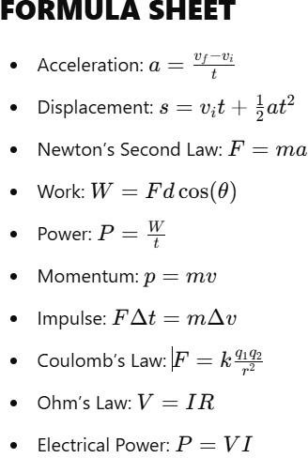

END OF PAPER

