
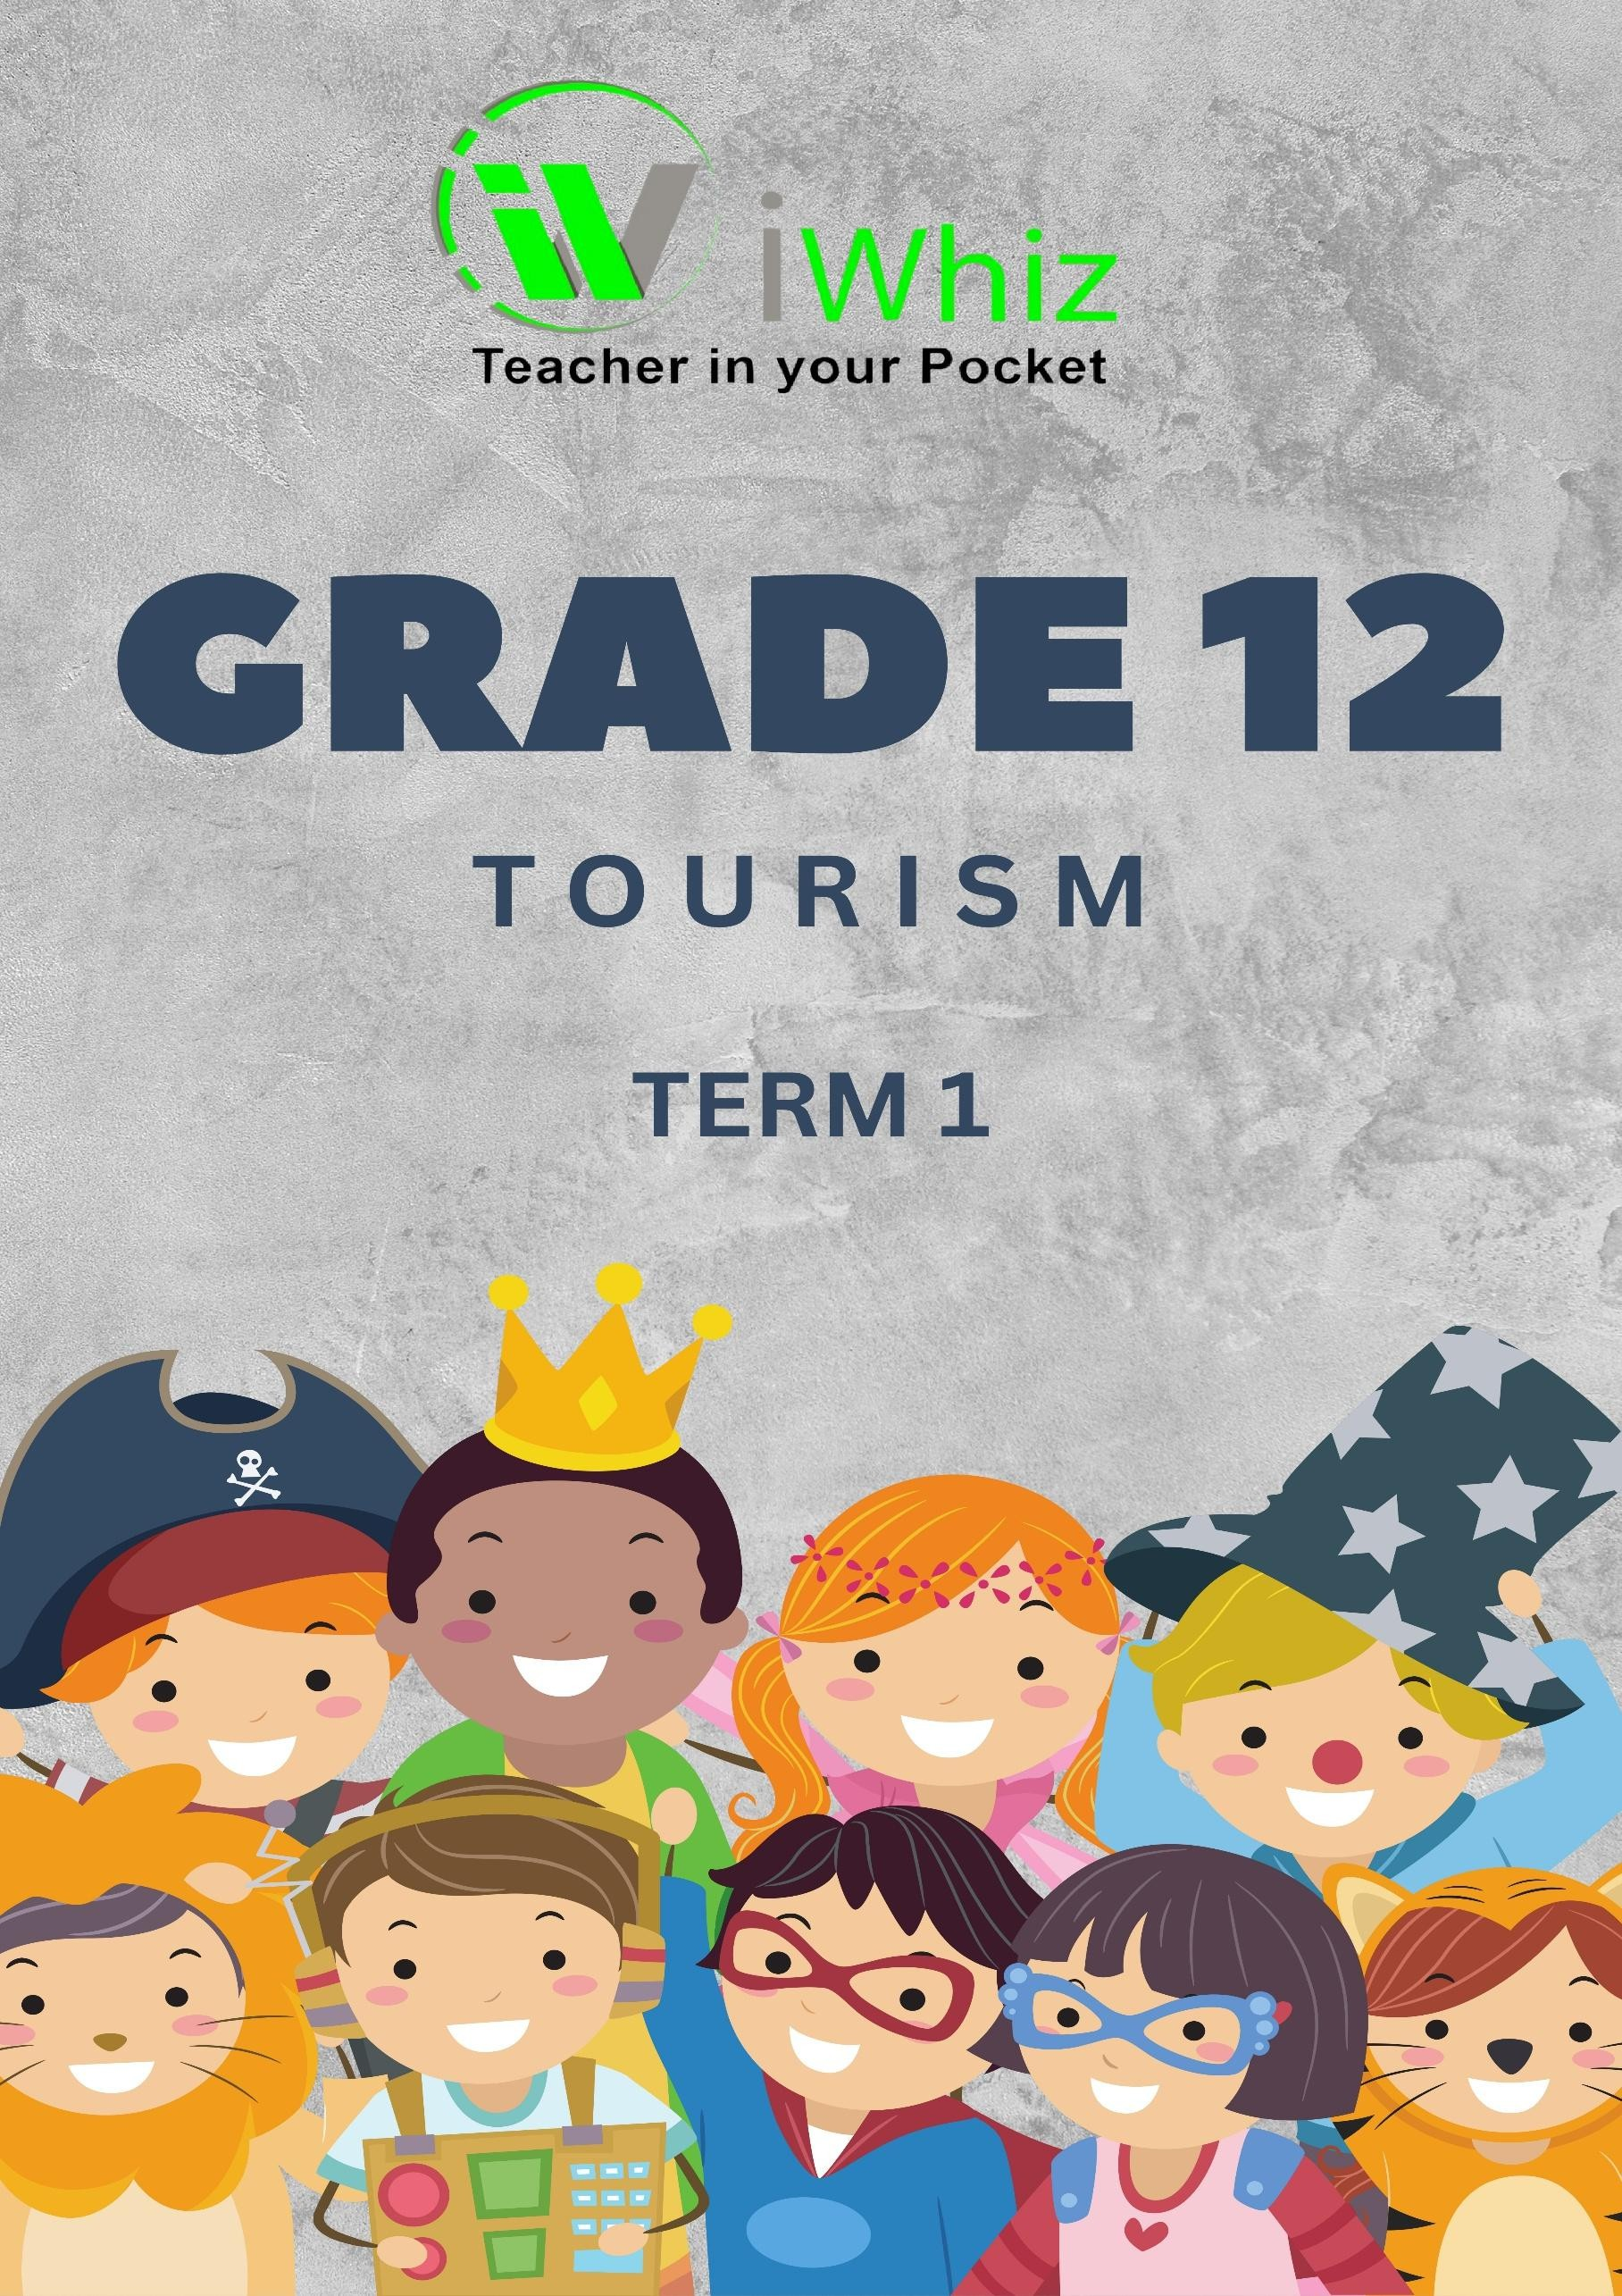


https://www.youtube.com/watch?v=SJ4_nONtYeY
WATCH FOR TESTIMONIALS

WATCH FOR TESTIMONIALS

GRADE 12
TOURISM TERM 1 TEST 2025 TIME: 3 HOURS
TOTAL: 200 MARKS

INSTRUCTIONS AND INFORMATION:
- This question paper consists of four sections:
- SECTION A: Short Questions (40 marks)
- SECTION B: Map Work and Tour Planning (50 marks)
- SECTION C: Tourism Attractions, Cultural and Heritage Tourism (60 marks)
- SECTION D: Sustainable and Responsible Tourism, Domestic, Regional, and International Tourism (50 marks)
- Answer ALL questions.
- Read each question carefully before answering.
- Number the answers correctly according to the numbering system used in this question paper.
- Write neatly and legibly.

SECTION A: SHORT QUESTIONS (40 MARKS)
  - Multiple-choice questions: Choose the correct answer from the given options. Write only the letter (A–D) next to the question number. (10x1=10)
    - Which of the following is an example of a natural tourist attraction?
- Robben Island
- Table Mountain
- Apartheid Museum
- Union Buildings
    - Which factor is the most important when planning a holiday budget?
- Weather conditions
- Exchange rates
- The number of social media followers
- The color of the suitcase

    - Which mode of transport is commonly used for long-haul international travel?
- Bus
- Train
- Aéroplane
- Bicycle
    - What is the main purpose of a travel itinerary?
- To list all expenses of a trip
- To provide a schedule of planned activities
- To advertise travel destinations
- To inform tourists of visa requirements
    - Which organization is responsible for promoting South African tourism internationally?
- SAFA
- SABC
- South African Tourism
- SANRAL
    - Which of the following is an example of cultural tourism?
- Visiting a theme park
- Attending a traditional Zulu wedding
- Shopping at a mall
- Staying at a luxury resort
    - What does "ecotourism" focus on?
- Encouraging mass tourism in cities
- Promoting environmentally responsible travel
- Increasing profits for travel agencies
- Building new hotels in protected areas

    - Which of the following is a key factor in sustainable tourism?
- High levels of tourist spending
- Preservation of cultural and natural heritage
- Construction of large tourist resorts
- Fast-paced tourism development
    - Which South African city is famous for its annual Minstrel Carnival?
- Johannesburg
- Durban
- Cape Town
- Pretoria

    - What is the main advantage of domestic tourism?
- Requires a passport and visa
- It is usually more affordable than international travel
- It involves long-haul flights
- D. It excludes heritage sites

  - Match Column A with Column B. Write only the correct letter from Column B next to the corresponding question number in Column A. (10x1=10)

Column A |  | Column B
1.2.1 Heritage Site |  | A. Travelling within one's own country
1.2.2 Visa |  | B. Protection of natural areas
1.2.3 Domestic tourism |  | C. Official permission to enter a country
1.2.4 Ecotourism |  | D. Kruger National Park
1.2.5 UNESCO |  | E. An international tourism organization
1.2.6 Self-catering accommodation |  | F. A place where tourists prepare their own meals
1.2.7 Tour operator |  | G. Plans and sells tour packages
1.2.8 Cultural tourism |  | H. Attending an Indian Diwali festival in Durban
1.2.9 Exchange rate |  | I. Value of one currency compared to another
1.2.10 Sustainable tourism |  | J. Tourism that benefits present and future generations

  - Identify the correct term for each of the given definitions. (10x1=10)
    - The amount of money needed to exchange one currency for another.
    - A travel document allowing entry into a foreign country.
    - The practice of protecting natural environments and local cultures in tourism.
    - A holiday where tourists plan and book their own accommodation and activities.
    - A journey that involves visiting multiple destinations.
    - A location recognized by UNESCO for its cultural or natural significance.
    - A person who guides tourists and provides information about places.
    - An example of a man-made tourist attraction.
    - Tourism that involves adventure activities like hiking and rafting.
    - A document containing a traveller’s planned activities and schedule.

  - Fill in the missing words in the following tourism-related statements. (10x1=10)
    - The main reason tourists visit the Kruger National Park is to see .
    - An example of an international airport in South Africa is .
    - tourism involves travel within one's own country.
    - The currency used in South Africa is the .
    - A tourist visiting the Eiffel Tower is engaging in tourism.
    - The study of maps and navigation is known as .
    - The organization responsible for global tourism statistics is .
    - is the capital city of South Africa.
    - An example of a natural disaster that could affect tourism is .
    - A person who travels for leisure or business is called

SECTION B: MAP WORK AND TOUR PLANNING (50 MARKS)
Study the given map of South Africa and answer questions related to:
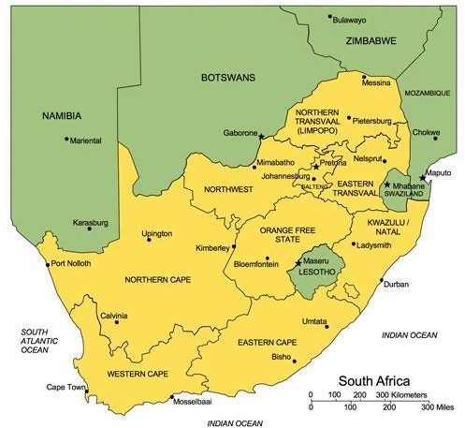

2.1 The identification of provinces and major tourist attractions (10)

2.2 Route planning for a self-drive tour including distances and estimated travel time (10)

2.3 Discuss five factors that influence tourists when choosing travel destinations. (10)

2.4 Explain the role of tour guides in ensuring a successful travel experience. (10)

2.5 Compare the advantages and disadvantages of using public transport versus renting a vehicle when traveling. (10)

SECTION C: TOURISM ATTRACTIONS, CULTURAL AND HERITAGE TOURISM (60 MARKS)
  - World-renowned tourist attractions (10 marks)
    - Identify the country where each attraction is located. (3)

    - Explain how these attractions contribute to their country’s tourism economy. (3)

    - Name one challenge faced by these attractions due to over-tourism. (2)

    - Suggest one way to protect these attractions for future generations. (2)

  - South African tourism attractions (10 marks)
    - Name two major South African tourist attractions and state which provinces they are located in. (4)

    - Discuss the significance of cultural heritage sites in promoting tourism in South Africa. (6)

  - Cultural tourism in South Africa (20 marks)
    - Define cultural tourism and provide one example. (4)

    - Explain how cultural tourism benefits local communities. (4)

    - Identify two South African cultural festivals and discuss their impact on tourism. (6)

    - Discuss the role of museums and historical sites in cultural tourism. (6)

  - Heritage tourism and UNESCO World Heritage Sites (20 marks)
    - Define heritage tourism. (2)

    - Name and describe any two UNESCO World Heritage Sites in South Africa. (8)

    - Explain why UNESCO World Heritage Sites are important for global tourism. (4)

    - Discuss two challenges faced by heritage sites in South Africa. (6)

SECTION D: SUSTAINABLE AND RESPONSIBLE TOURISM, DOMESTIC, REGIONAL, AND INTERNATIONAL TOURISM (50 MARKS)

  - Sustainable and responsible tourism (20 marks)
    - Define sustainable tourism and responsible tourism. (4)

    - Explain three principles of sustainable tourism. (6)
    - Discuss the role of eco-friendly lodges and green hotels in sustainable tourism. (6)

    - Suggest two strategies to reduce the negative impact of tourism on the environment. (4)

  - Domestic, regional, and international tourism (30 marks)
    - Define domestic, regional, and international tourism, and provide one example of each. (6)

    - Discuss three advantages of domestic tourism for South Africa’s economy. (6)

    - Explain how exchange rates can influence international travel decisions. (6)

    - Compare the benefits of regional tourism versus international tourism for a country’s economy. (6)

    - Identify two challenges faced by international tourists when visiting South Africa and suggest possible solutions. (6)

END OF PAPER

