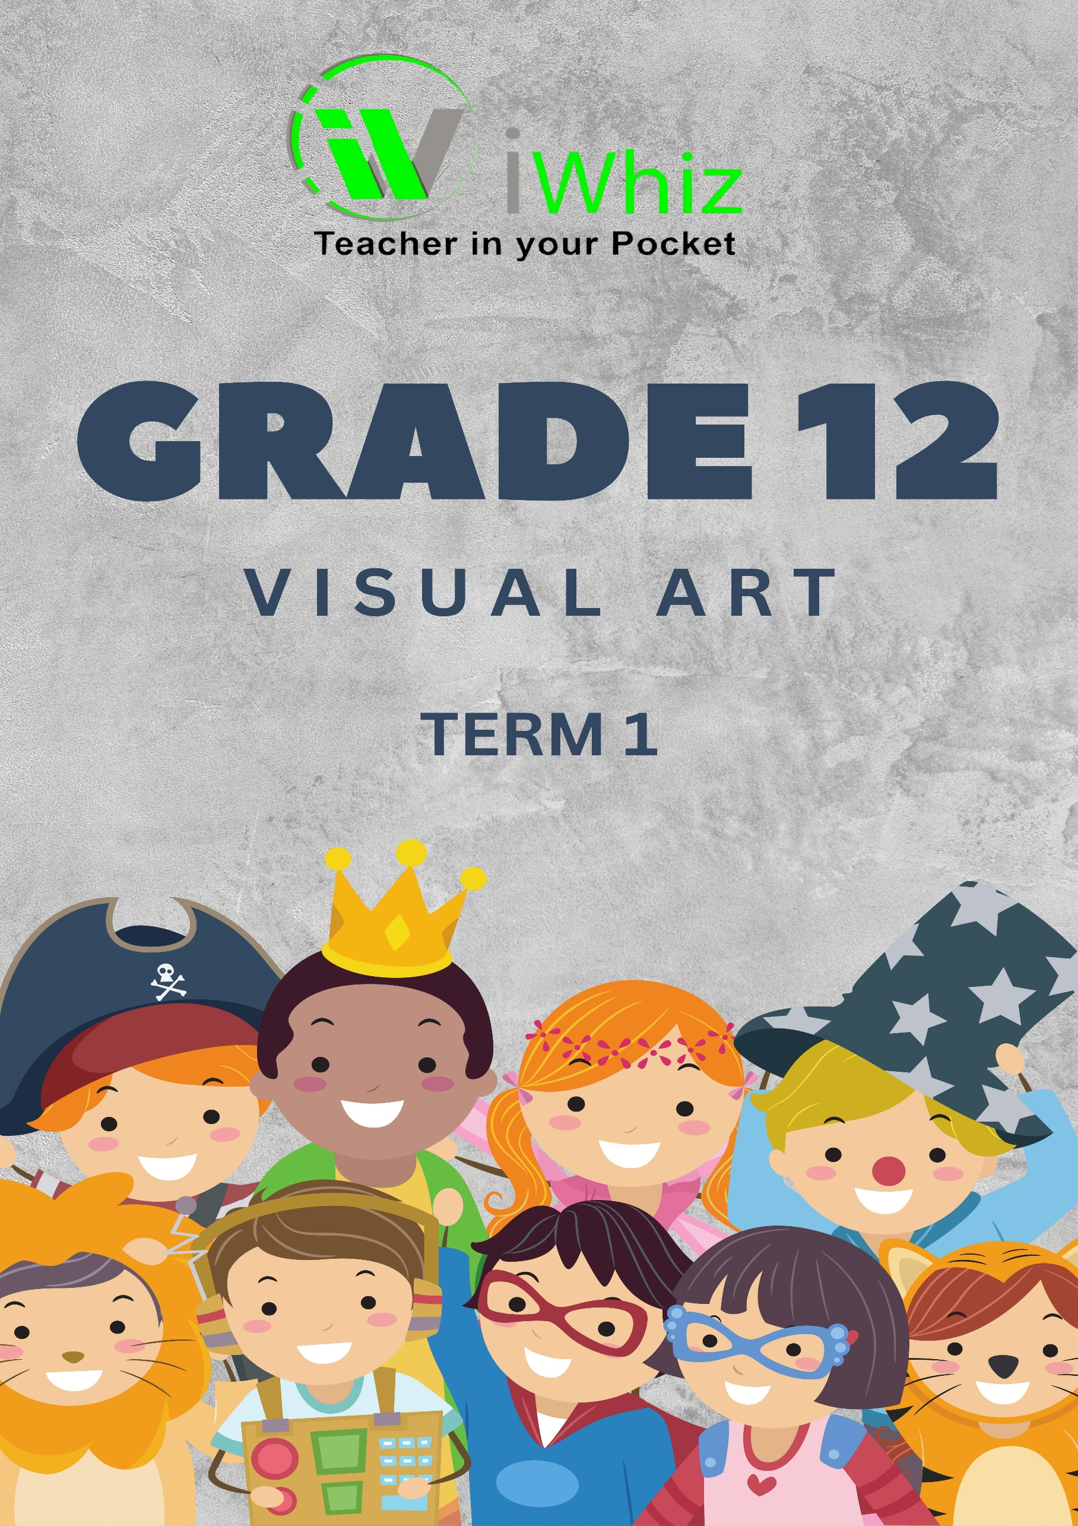

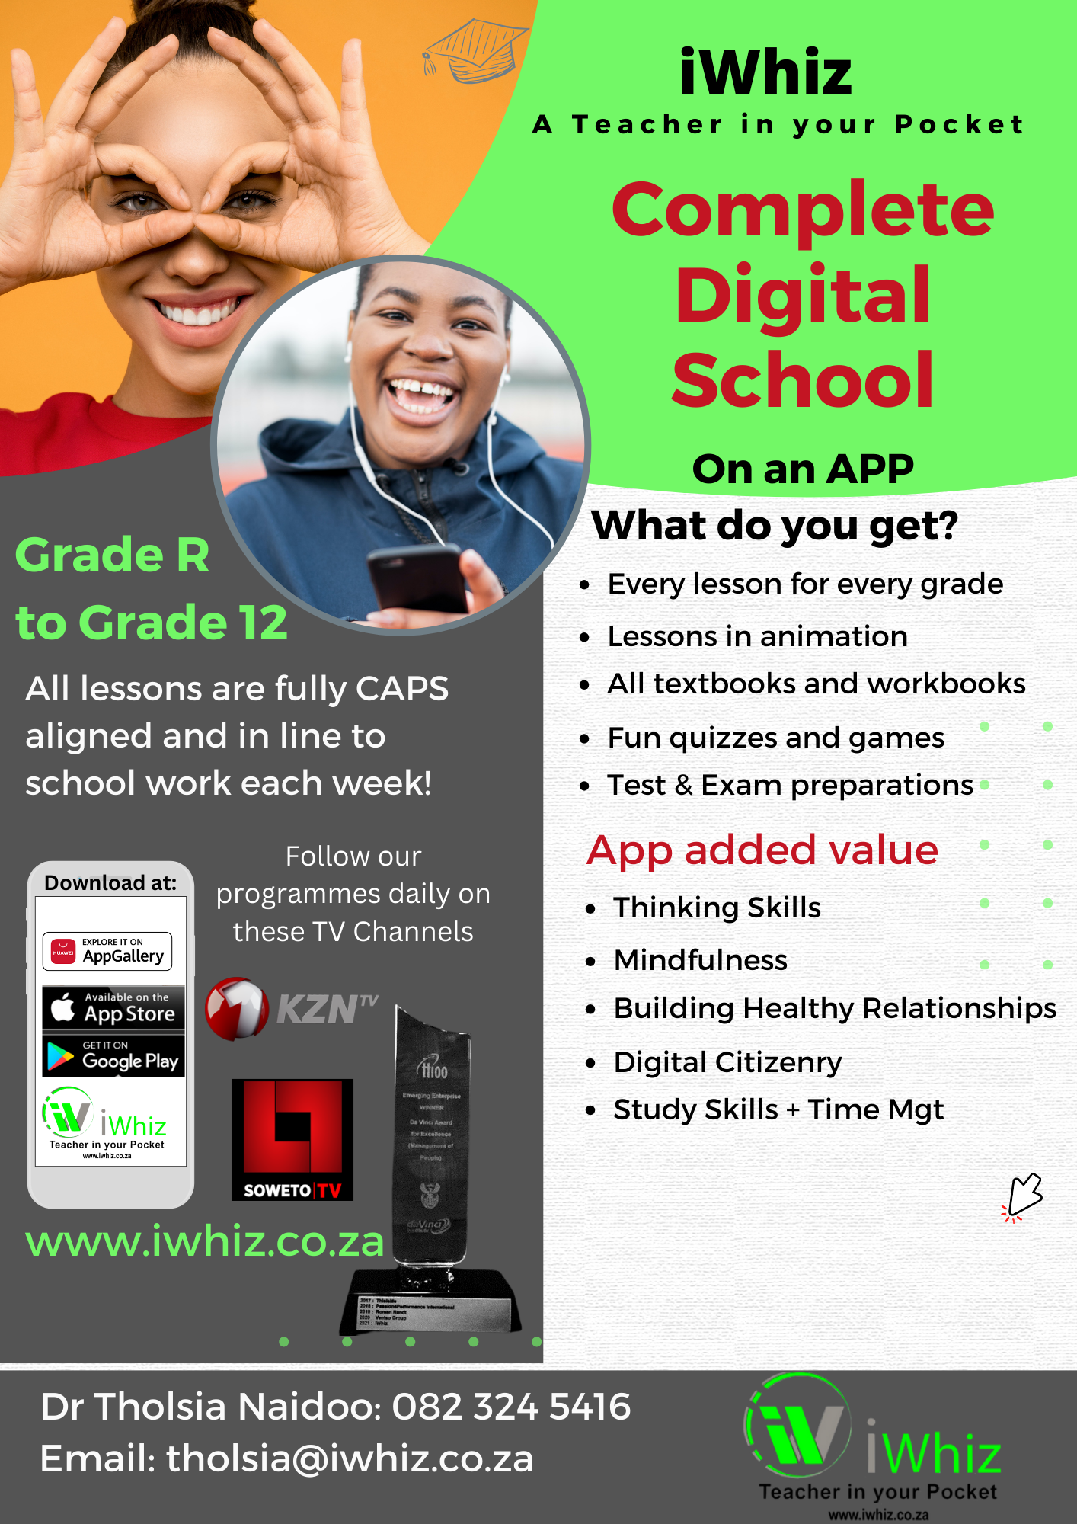

https://www.youtube.com/watch?v=SJ4_nONtYeY
WATCH FOR TESTIMONIALS

WATCH FOR TESTIMONIALS

GRADE 12 VISUAL ARTS TERM 1 TEST TIME: 3 HOURS
TOTAL: 100 MARKS
INSTRUCTIONS AND INFORMATION:
- This question paper consists of TWO sections:
- SECTION A: Visual Analysis (50 marks)
- SECTION B: Essay (50 marks)
- Answer ALL the questions.
- Read questions carefully before answering.
- Use full sentences when writing your answers.
- You may use diagrams to support your answers where appropriate.
- Ensure that your handwriting is clear and legible.

SECTION A: VISUAL ANALYSIS (50 MARKS)
Answer ALL the questions in this section.
QUESTION 1 (20 marks)
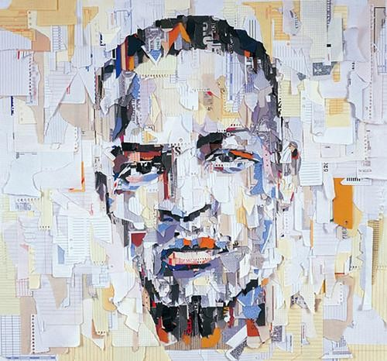
Study the provided image of an artwork and answer the following questions:

  - Identify the artist, title, and medium of the artwork. (3)

  - Discuss the use of the following elements and principles of art in the artwork:
    - Colour (3)

    - Line (3)

    - Texture (3)

    - Balance (3)

  - What is the possible meaning or message conveyed by the artwork? Support your answer with evidence from the artwork. (5)

QUESTION 2 (15 marks)
Compare and contrast two South African artworks from different historical periods or styles. Your response should include:
  - The names of the artists and titles of the artworks. (4)

  - A discussion of the differences in style, technique, and subject matter. (6)

  - How do these artworks reflect the socio-political context of their time? (5)

QUESTION 3 (15 marks)
  - Explain how contemporary South African artists use mixed media to create artworks. (5)

  - Choose a South African artist who works with mixed media and describe one of their artworks. (5)

  - How does the choice of materials contribute to the meaning of the artwork? (5)

SECTION B: ESSAY (50 MARKS)
Answer ONE of the following essay questions in approximately 1½ - 2 pages.
QUESTION 4 (50 marks)
"Art is a reflection of society." Discuss this statement by referring to at least THREE South African artworks from different artists. Your discussion should include:
- A description of each artwork.
- The socio-political themes addressed in each work.
- How the artist's personal background influences their work.
- Your personal interpretation of the artworks.

QUESTION 5 (50 marks)
Art movements have shaped and influenced South African art history. Discuss the role and impact of one art movement (e.g., Resistance Art, Abstract Expressionism, or Conceptual Art) in South Africa. Your discussion should include:
- The key characteristics of the movement.
- At least TWO artists associated with the movement.
- An analysis of how this movement has influenced contemporary South African art.
- Your own opinion on the relevance of this movement today.

END OF EXAMINATION

