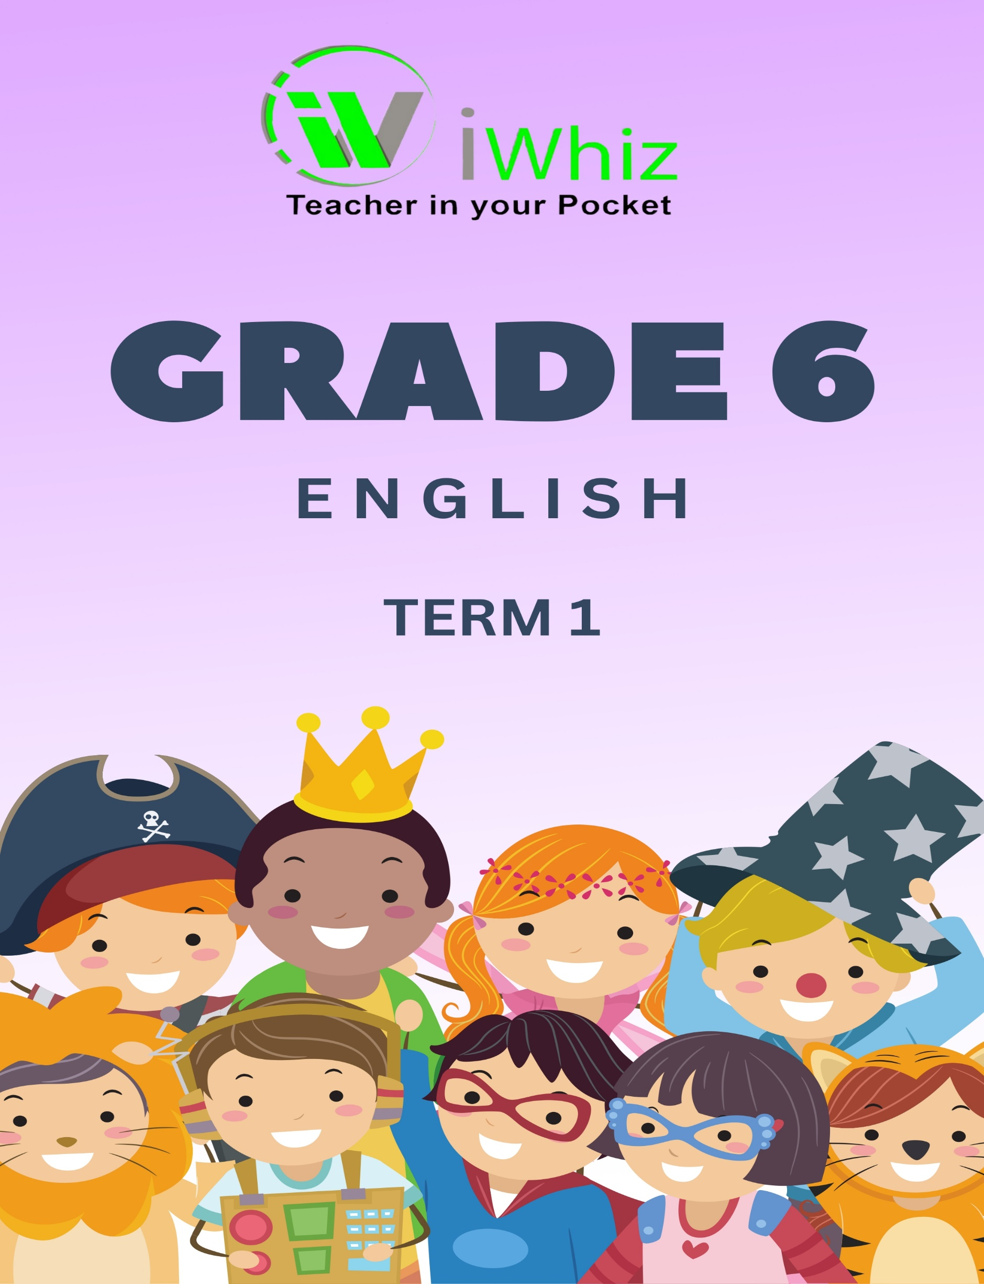


English Grade 6- Term 1 Test
Time: 1 hour 30 minutes Marks: 50
Instructions
- Read all the instructions carefully.

- This question paper contains 3 sections.

- Answer all the questions in the spaces provided.

- Where there are multiple-choice questions, circle only the letter of the correct answer.

- This question paper contains three sections.

- Label the answers according to the numbering system in this question paper.

- Leave a line after each question.

- Write neatly and legibly

Section A:
Question 1: Multiple Choice Questions (15 marks)
Circle the correct answer
- Which of the following is a noun?
- Quickly
- Happiness
- Run
- Beautiful

- Identify the pronoun in the sentence: “She gave him the book.”
- She
- Gave
- Him
- Book

- Choose the correct verb to complete the sentence: “They to the park every Saturday.”
- Goes
- Going
- Gone
- Go

- Which sentence demonstrates correct subject-verb agreement?
- The dogs run fast
- The dog run fast
- The dogs runs fast
- The dog running fast

- Select the sentence with the correct punctuation
- I can’t wait to see you
- I cant wait to see you.
- I can't wait to see
- I can't wait to see!

- Which of the following is a synonym for “happy”?
- Sad
- Joyful
- Angry
- Tired

- What is the antonym of “difficult”?
- Easy
- Hard
- Simple
- Complicated

- Which of the following is a correctly punctuated sentence?
- My brother, who is younger than me, plays soccer.
- My brother who is younger than me plays soccer.
- My brother who is younger than me plays, soccer.
- My brother who, is younger than me plays soccer.

- Choose the correct form of the adjective: “This is the book I’ve ever read.”
- More interesting
- Most interesting
- Interesting
- Interesting

- Which of the following sentences is a compound sentence?
- I went to the store and bought some milk
- I went to the store
- I went to the store because I needed milk
- I went to the store, but it was closed

- Identify the adverb in the sentence: “She sings beautifully.”
- She
- Sings
- Beautifully
- None
- Which of the following is a correctly capitalized sentence?
- my friend lives in cape town.
- My friend lives in Cape Town.
- My friend lives in cape town.
- my friend lives in Cape town.

- Choose the correct preposition to complete the sentence: “The cat jumped the table.”
- On
- In
- Under
- Over

- Which of the following is a simp[e sentence?
- Although it was raining, we went for a walk
- I enjoy reading books and playing games
- She smiled and waved at me
- The sun set behind the mountains

- Select the sentence with correct punctuation.
- “Where are you going” she asked.
- “Where are you going?” she asked.
- “Where are you going.” she asked.
- “Where are you going” she asked?

Section B:
Question 1: Matching (15 marks)
Match the grammatical term to its correct example. Write your answers in the middle block of the table.
Grammatical Term | Answer | Example
1. Noun |  | - She sings beautifully.
2. Pronoun |  | - The cat jumped over the table.
3. Verb |  | - He is a doctor.
4. Adverb |  | - She gave him the book.
5. Adjective |  | - He runs fast.
6. Preposition |  | - The quick brown fox jumps over the lazy dog.
7. Conjunction |  | - She is taller than her brother.
8. Interjection |  | - I am going to the store.
9. Article |  | - Wow! That was amazing!
10. Subject |  | - The book on the table is mine.
11. Object |  | - The book is on the table.
12. Possessive Pronoun |  | - I have a red car.
13. Simple Sentence |  | - The dog barked loudly.
14. Compound Sentence |  | - I wanted to go to the park, but it started raining.
15. Complex Sentence |  | - Although it was raining, we went for a walk.

Section C:
Question 3: Short Questions (20 marks)
Please answer the following questions
- Define a noun and provide three examples. (3)

- What is the difference between a common noun and a proper noun? Provide examples. (4)

- Explain the function of a pronoun in a sentence. (3)

- Write a sentence using the verb “run” in the past tense. (3)

- Identify the subject and predicate in the sentence: “The dog barked loudly at the stranger.” (4)

- List and explain the three types of conjunctions with examples. (3)

Grand Total: 50 marks

