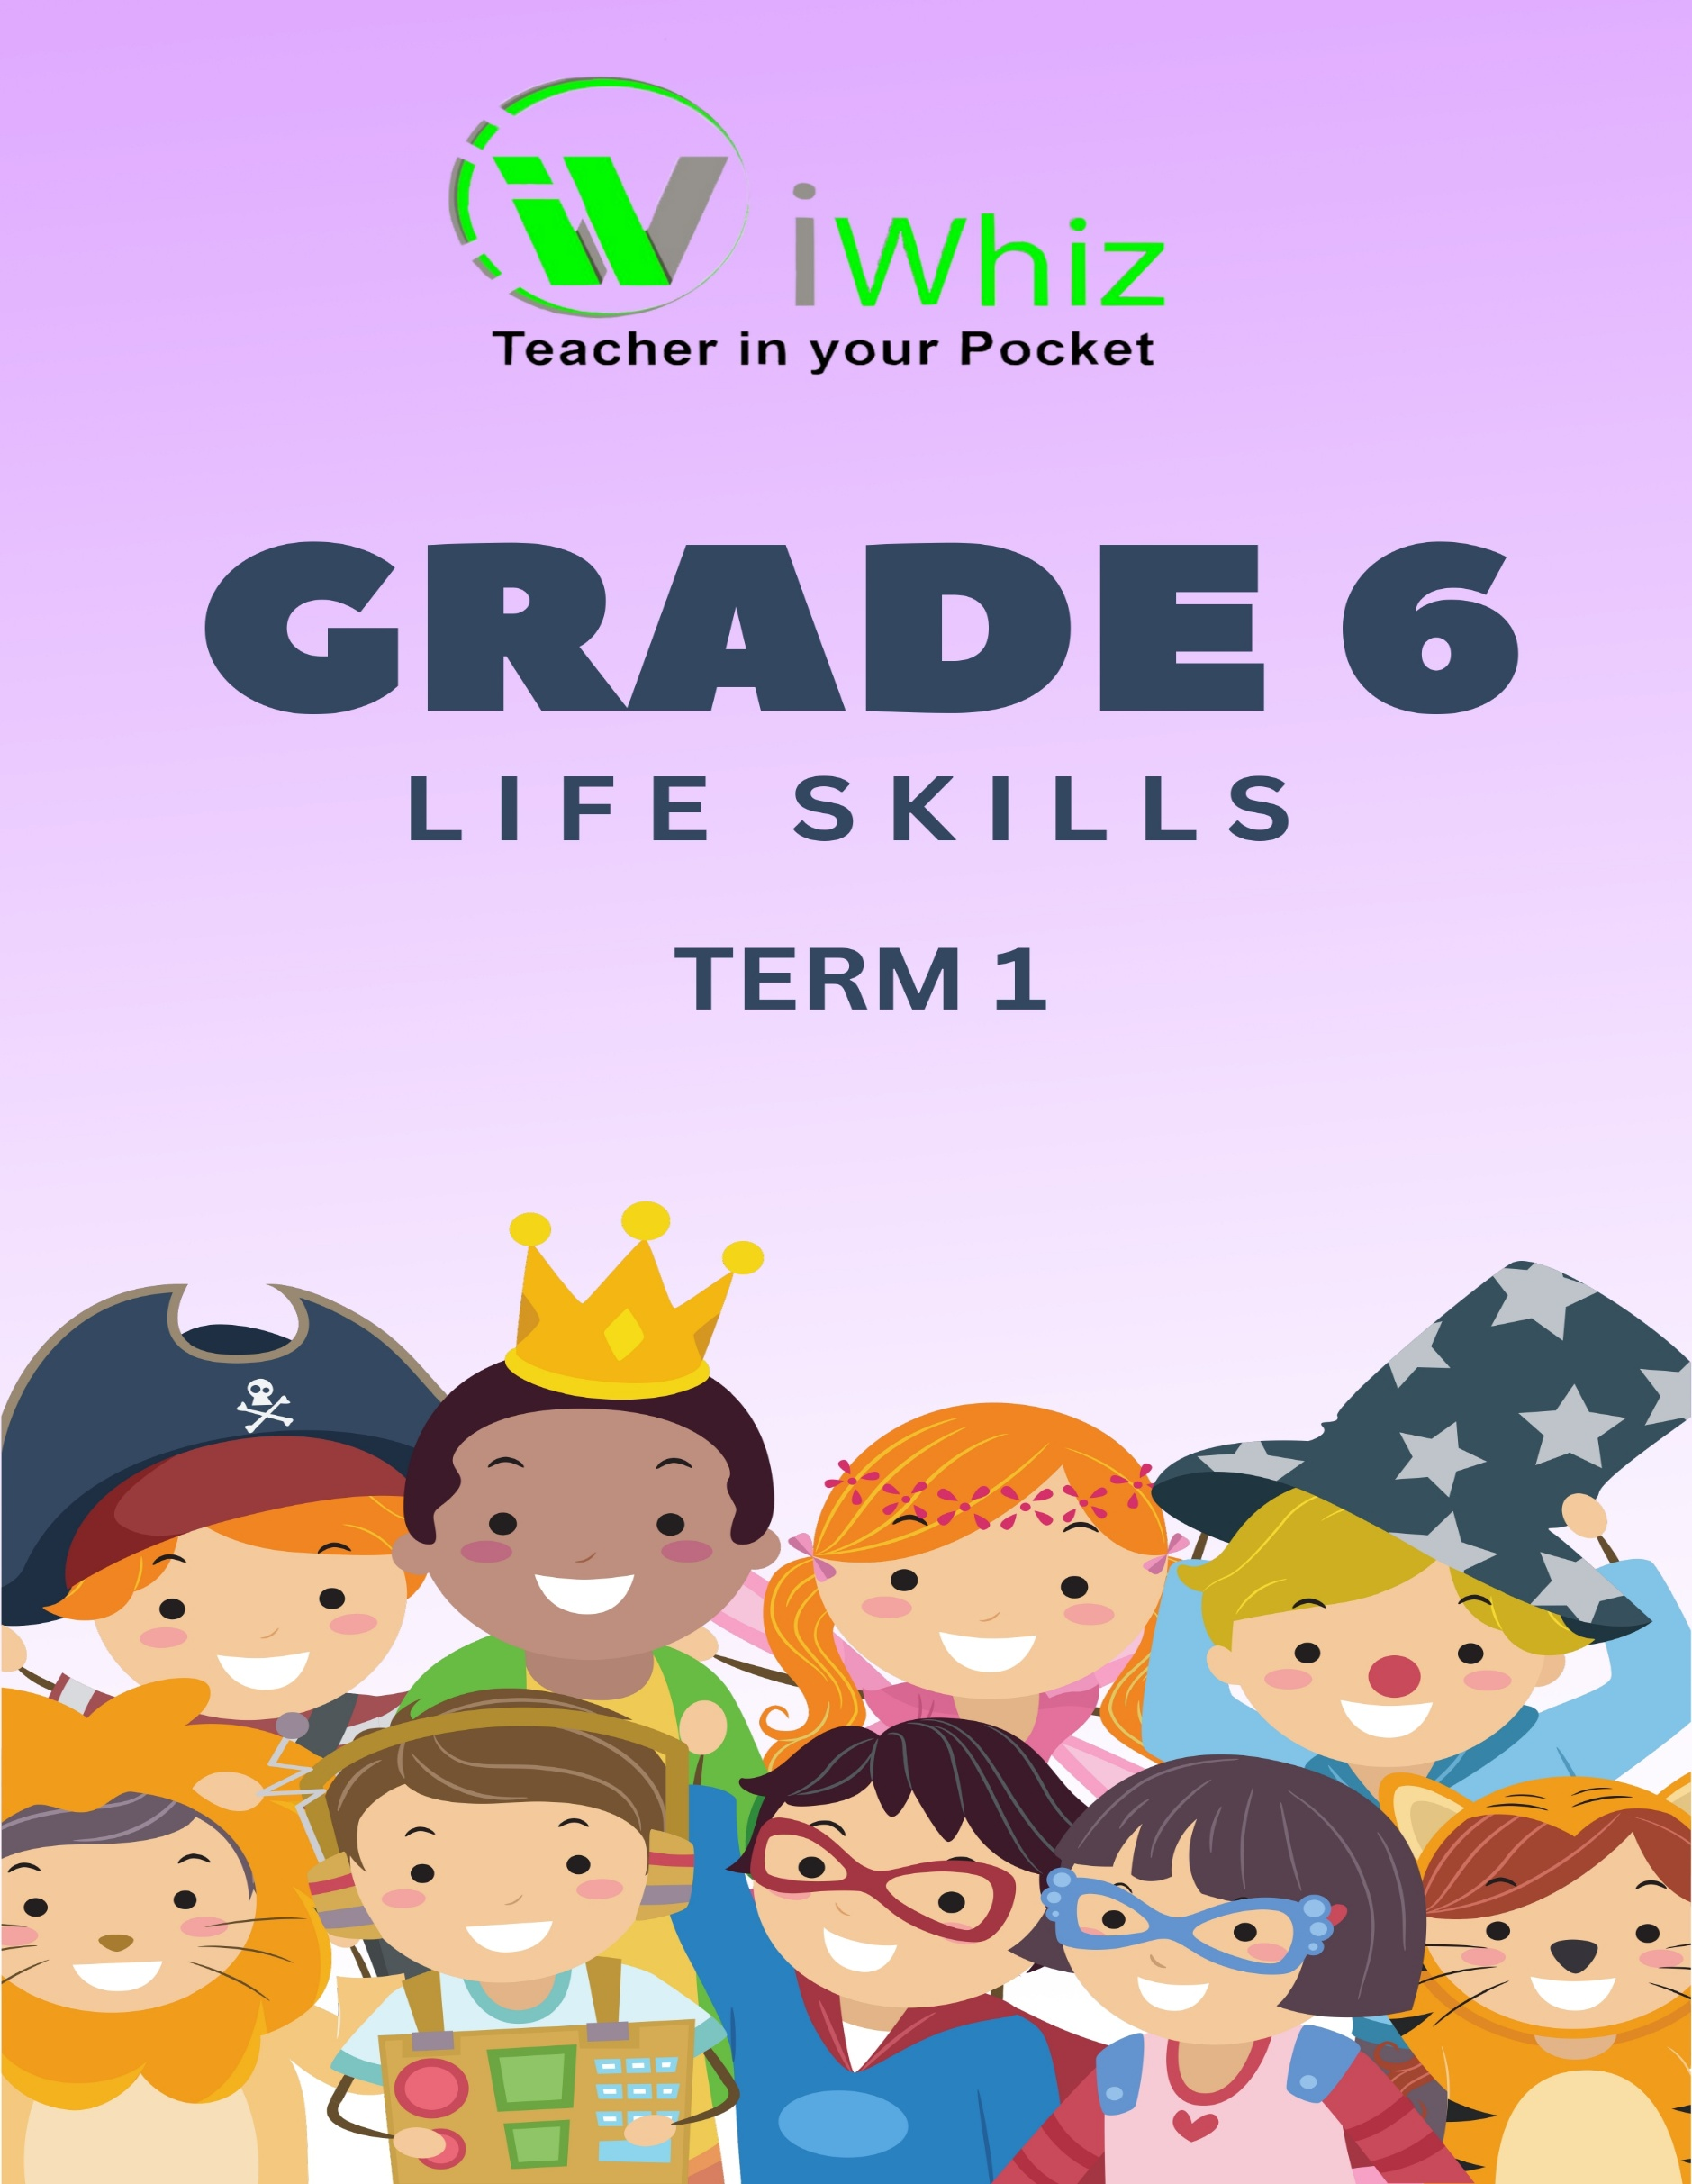
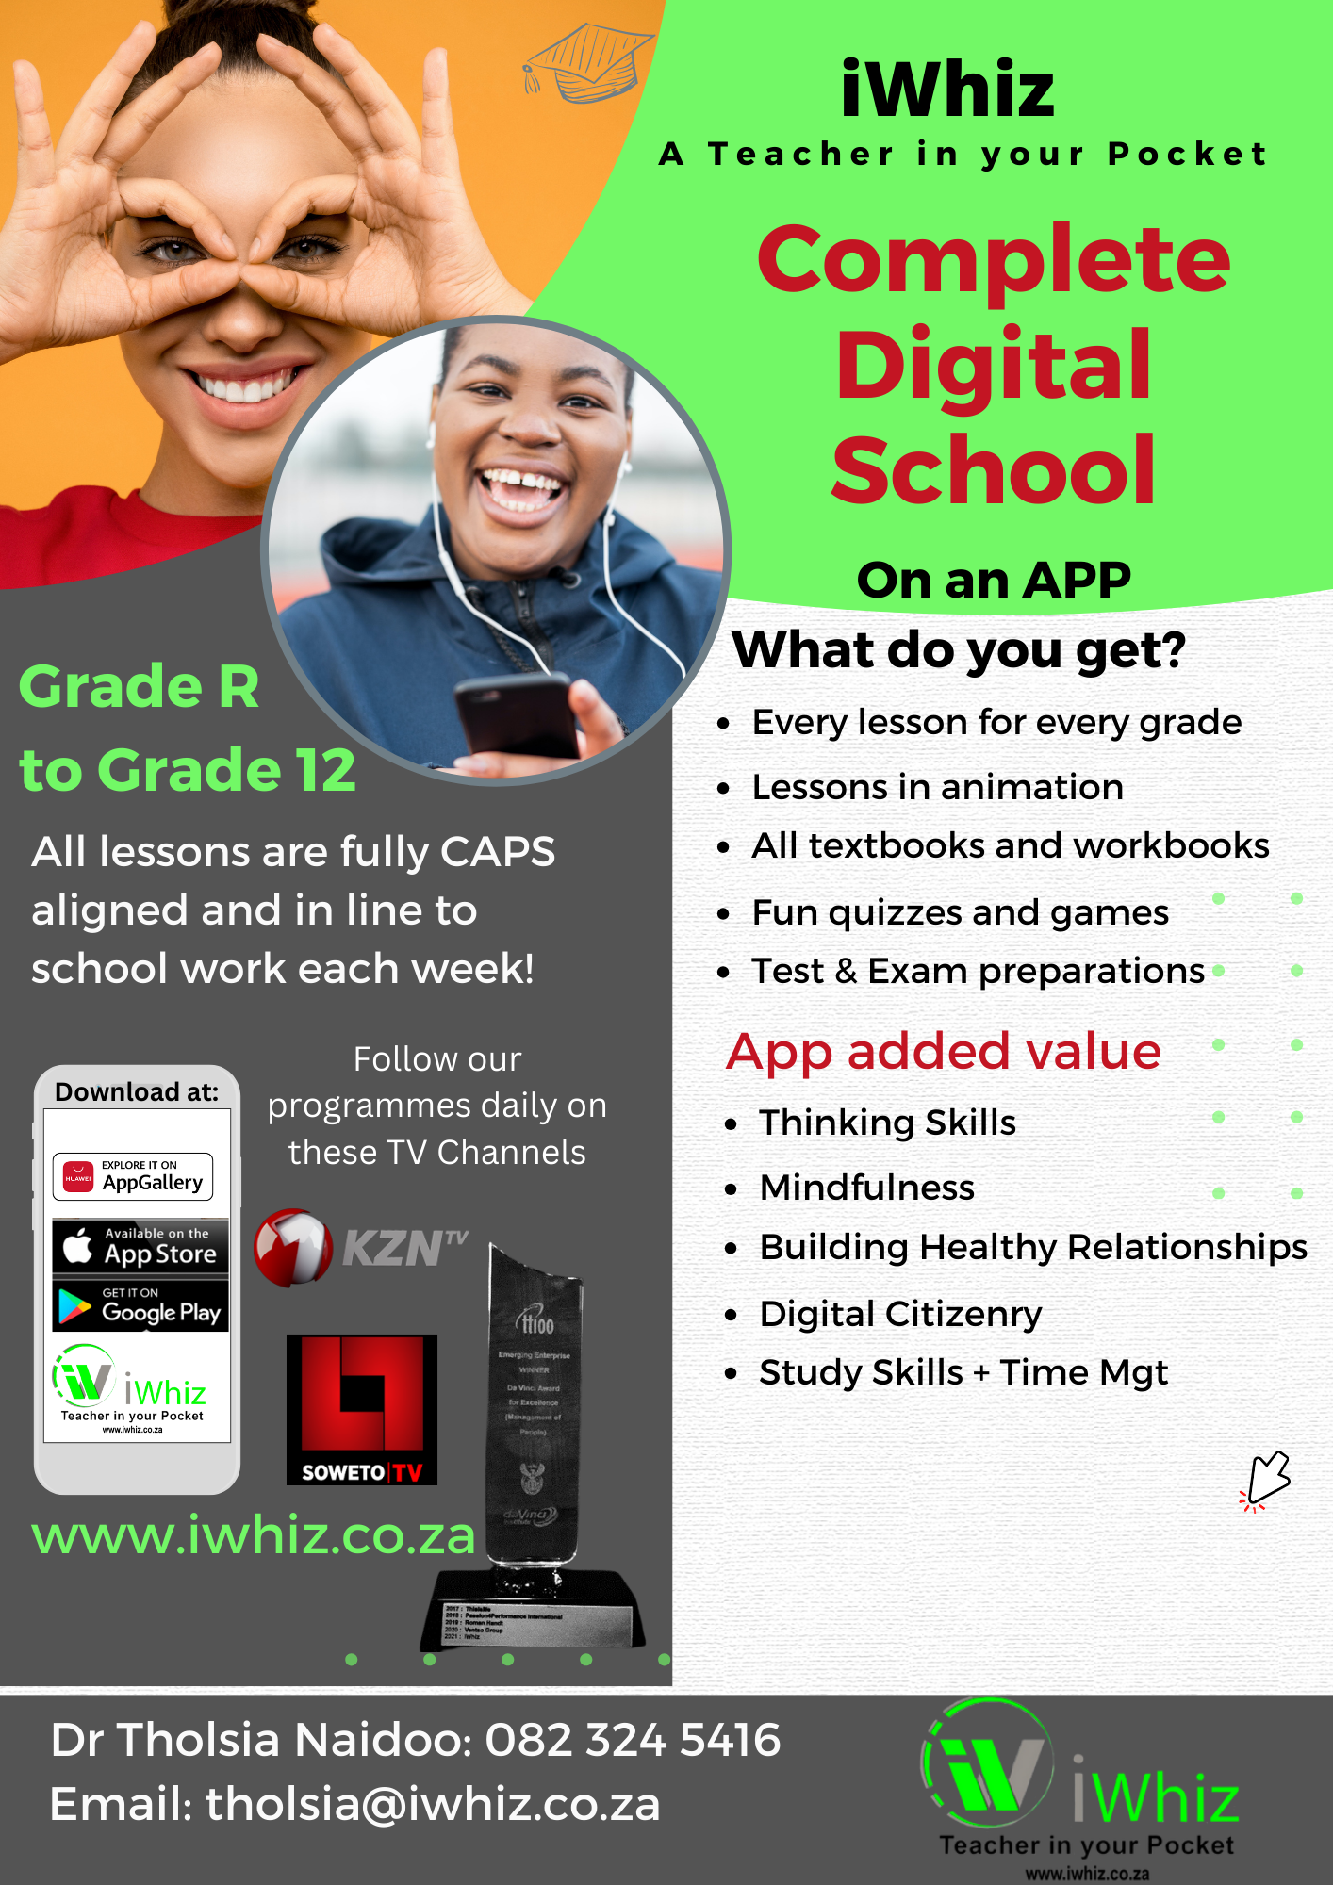
Life Skills- Term 1 Test
Time: 1 Hour Marks: 50
Instructions
- This question paper consists of THREE sections i.e. SECTION A, B and C.

- All questions are compulsory.

- Answer all the questions in the spaces provided.

- Read all the instructions carefully before answering each question.

- Use the space provided to answer the questions.

- In the multiple-choice questions sections, circle the correct answer.

- Write neatly and legible.

Section A:
Question 1: Multiple Choice Questions (15 marks)
- Choose the correct answer from the options provided.
- Each question is worth 1 mark.
- Circle the correct letter (A, B, C, or D).

- What is the best way to show respect for others? (1)
- Ignoring their opinions
- Listening and being kind
- Always disagreeing with them
- Making fun of them

- Which of the following is a healthy way to manage stress? (1)
- Ignoring your feelings
- Talking to someone you trust
- Staying isolated
- Overworking

- Which of these is an example of good hygiene? (1)
- Washing hands before meals
- Not brushing your teeth
- Wearing dirty clothes
- Avoiding showers

- What should you do if you see someone being bullied? (1)
- Join in the bullying
- Stay silent and do nothing
- Tell a trusted adult about it
- Laugh along with the bully

- Why is it important to set goals? (1)
- To become rich and famous
- To improve and grow as a person
- To make others jealous
- To avoid working hard

- Which of the following is a characteristic of good friendship? (1)
- Trust and support
- Control and manipulation
- Secrets and lies
- Constant competition

- What does self-esteem mean? (1)
- How others think of you
- How much money you have
- How you feel about yourself’
- How popular you are

- How can you contribute to your community? (1)
- By starting indoors all day
- By volunteering and helping others
- By criticizing everything around you
- By being selfish

- What is the purpose of exercise? (1)
- To make you tired
- To improve your physical and mental health
- To waste time
- To show off to others

- What is a positive way to handle conflict with a friend? (1)
- Yelling at them
- Ignoring the problem
- Talking it out calmly
- Giving them the silent treatment

- Which of the following is a harmful effect of substance abuse? (1)
- It improves your health
- It can damage your body and mind
- It makes your more popular
- It helps you sleep better

- What should you do if you feel unsafe at school? (1)
- Stay quiet and ignore it
- Report it to a teacher or adult
- Try to solve the problem on your own
- Keep it to yourself

- Which of the following is a sign of a healthy relationship? (1)
- Constant arguing
- Mutual respect and care
- One person always controlling the other
- Avoiding each other’s feelings

- Why is it important to follow the rules at school? (1)
- To get the teacher to like you
- To keep a safe and respectful environment
- To make your friends happy
- To avoid punishment

- What does it mean to have good communication skills? (1)
- Talking without listening
- Only speaking when you are angry
- Listening carefully and expressing yourself clearly
- Keeping your thoughts to yourself

Section B:
Question 1: Matching (15 marks)
- Match the items in Column A with the correct description in Column B.
- Write the letter of the correct answer next to the number.
Column A | Answer | Column B
- Empathy |  | - The ability to understand and share someone else’s feelings
- Peer Pressure |  | - The act of showing kindness and care for others
- Hygiene |  | - Feeling forced to do something because of others' influence
- Positive Self-Talk |  | - Speaking to yourself in an encouraging and supportive way
- Self-Care |  | - Taking care of your physical and emotional needs
- Boundaries |  | - Knowing what is acceptable behavior in relationships
- Substance Abuse |  | - The harmful use of drugs, alcohol, or tobacco
- Conflict Resolution |  | - A method of resolving disagreements calmly and fairly
- Respect |  | - Treating others with kindness, honesty, and fairness
- Assertiveness |  | - Expressing your opinions, feelings, and beliefs in a clear, respectful manner
- Health |  | - Physical well-being and the state of being free from illness or injury
- Mental Health |  | - Emotional, psychological, and social well-being
- Social Media |  | - A platform to interact with friends, share posts, and communicate online
- Responsibility |  | - Accepting the consequences of your actions and decisions
- Friendship |  | - relationship built on trust, care, and mutual understanding

Section C:
Question 3: Short Answer Questions (20 marks)
- Answer the following questions in complete sentences.
- Each question is worth 4 marks.

- Explain what self-esteem is and why it is important for your mental well-being. (4)

- How can practicing good hygiene contribute to your overall health? Give two examples. (4)

- What does it mean to be an active listener in a conversation? Why is this an important skill? (4)

- Describe how you can practice healthy conflict resolution with a friend. (4)

- How can you use positive self-talk to improve your confidence and well-being? (4)

Total Marks: 50

