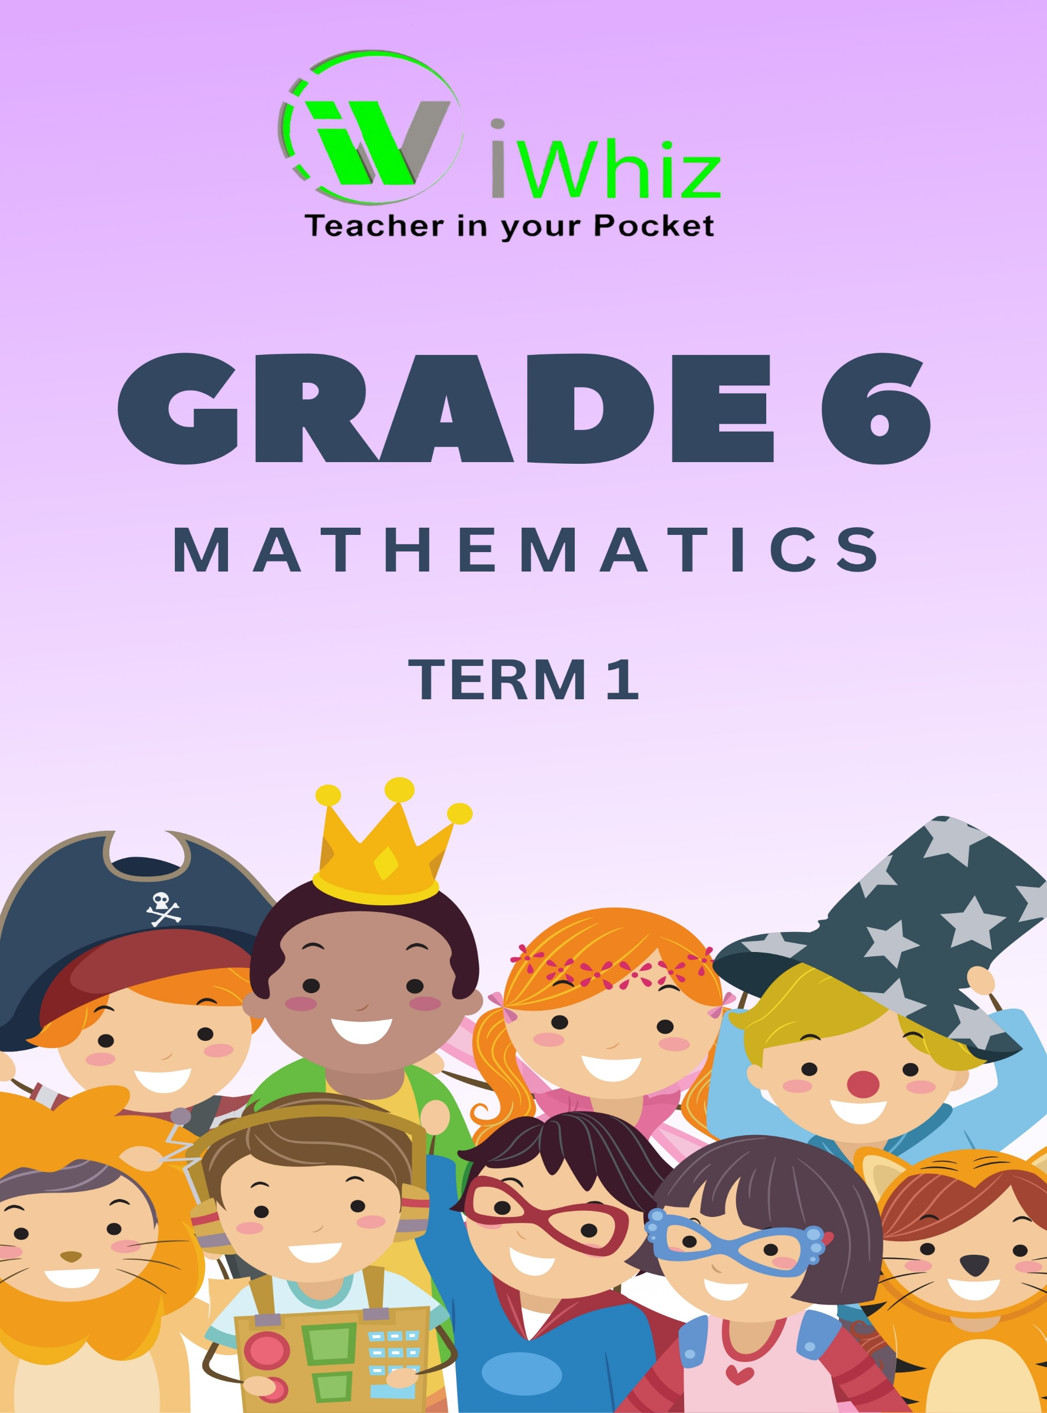

Grade 6 Term 1 Test
Time 1 hour and 30 minutes Marks: 50
Instructions:
- Answer all the questions.

- Write your name and date.

- No calculators allowed.

- Show calculations as requested on question paper.

- The marks allocated are an indication of the number of steps per calculation.

- Check your answers.

- Use a ruler for drawing lines.

- Write neatly and legibly

Section A
Question 1: Multiple Choice Questions [15 marks]
Circle the letter of the correct answer.
- Which of the following numbers is divisible by 9? (1)
- 234
- 455
- 378
- 521

- What is the value of the digit 7 in the number 275 493? (1)
- 7
- 70 000
- 7000
- 700

- Which of the following represents four hundred thousand, thirty-five thousand and twenty-seven? (1)
- 400 035 027
- 435 027
- 400 335 27
- 4 035 027

- Which of the following is the correct expanded notation for 34 782? (1)
- 3 + 4 + 7 + 8 + 2
- 30 000 + 4 000 + 700 + 80 + 2
- 3 × 10 000 + 4 × 1 000 + 7 × 100 + 8 × 10 + 2 × 1
- 3 × 10 + 4 × 100 + 7 × 1 000 + 8 × 10 000 + 2 × 100 000

- Which number is 10 000 more than 456 832? (1)
- 556 832
- 466 832
- 457 832
- 546 832

- Calculate: 8 652 ÷ 4 = ? (1)
- 2163
- 2113
- 2136
- 2166

- Which of the following is NOT a common multiple of 4 and 6? (1)
- 12
- 24
- 30
- 36

- What is the LCM of 8 and 12? (1)
- 4
- 24
- 48
- 96

- Which of the following is a prime number? (1)
- 51
- 57
- 67
- 91

- The product of a number and 7 is 56. What is the number? (1)
- 7
- 8
- 49
- 63

- In a pattern, the rule is "multiply by 3". If the first number is 2, what is the 5th number? (1)
- 162
- 54
- 486
- 81
- Which of the following fractions is equivalent to $\frac{3}{4}$ ? (1)
- $\frac{6}{7}$
- $\frac{6}{8}$
- $\frac{9}{12}$
- $\frac{6}{12}$

- What is 2/3 of 24? (1)
- 8
- 12
- 16
- 18

- How many $\frac{1}{4}$ cups will fill a 2-cup container? (1)
- 4
- 6
- 8
- 12

- Convert 3.25 to a mixed number: (1)
- $\frac{31}{5}$
- $314$
- $\frac{31}{2}$
- $\frac{32}{5}$

Question 2: Matching [15 marks]
Match the items in Column A with the correct answers in Column C. Write only the letter (A-0) next to question number (1-15).
No. | Column A | Answer | Column B
1. | 47,805 rounded to the nearest 1,000 |  | 1, 2, 3, 6, 9, 18
2. | 8 × 12 |  | 0.75
3. | HCF of 24 and 36 |  | 60
4. | $\frac{2}{5}$ as a decimal |  | 121
5. | 0.25 as a fraction |  | 125
6. | Half of 150 |  | 75
7. | 64 ÷ 8 |  | 96
8. | 5³ |  | 80%
9. | $\frac{3}{4}$ as a decimal |  | 48 000
10. | Number of minutes in 2 ½ hours |  | 12
11. | 50% of 120 |  | 8
12. | 144 ÷ 12 |  | 0.4
13. | 11² |  | 1/4
14. | Factors of 18 |  | 150
15. | 4/5 as a percentage |  | 12

Question 3: Basic Operations (8 marks)
- Calculate 5724 + 3658. (2)

- Subtract 8945 - 6372. (2)

- Multiply 46 ×7. (2)

- Divide 1848 ÷ 6. (2)

Section B:
Question 1: Number Patterns & Place Value (6 marks)
- Complete the pattern: 3,6,12,24, __, __ (2)

- Write 47 085 in expanded notation. (2)

- Round 368 479 to the nearest 10 000. (2)

Section C
Question 1: Fractions & Decimals (6 marks)
- Write $\frac{3}{5}$ as a decimal. (2)

- What is $\frac{2}{3}$ of 36? (2)

- Convert 4.75 into a mixed number. (2)

Total marks: 50

