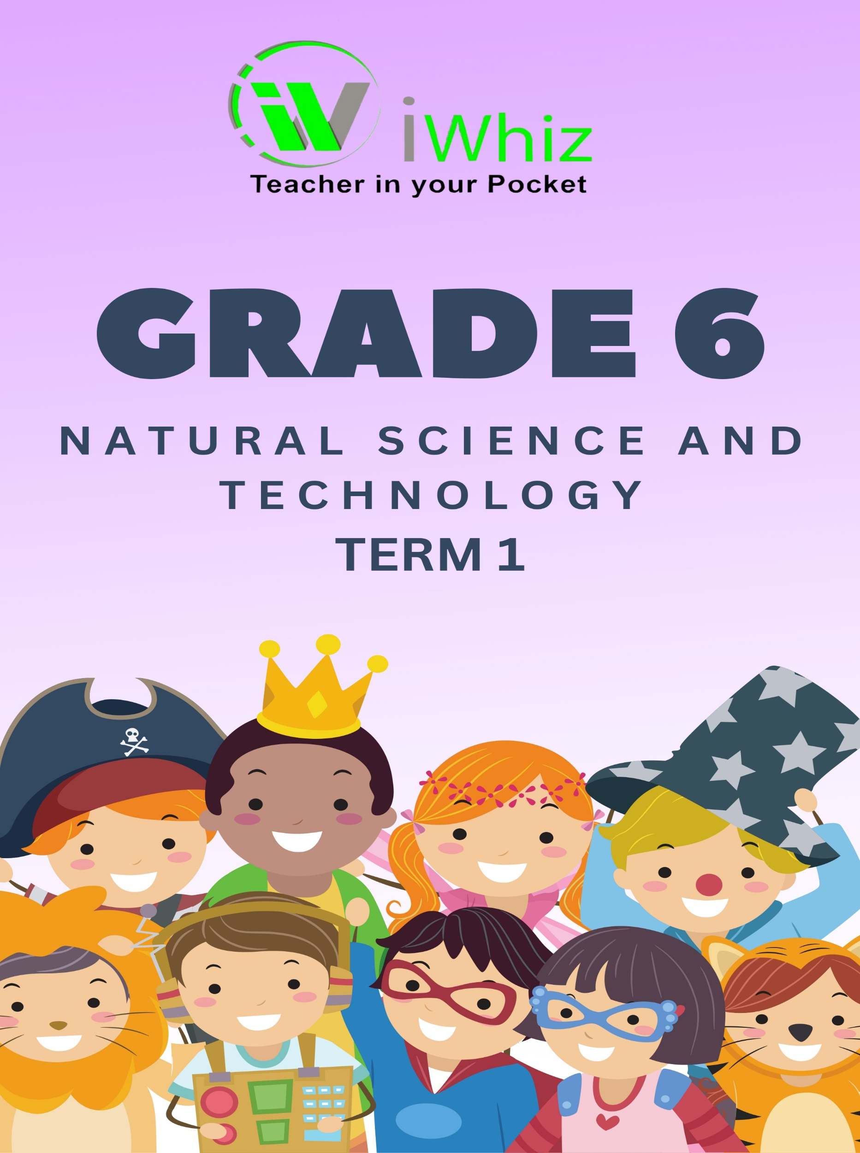

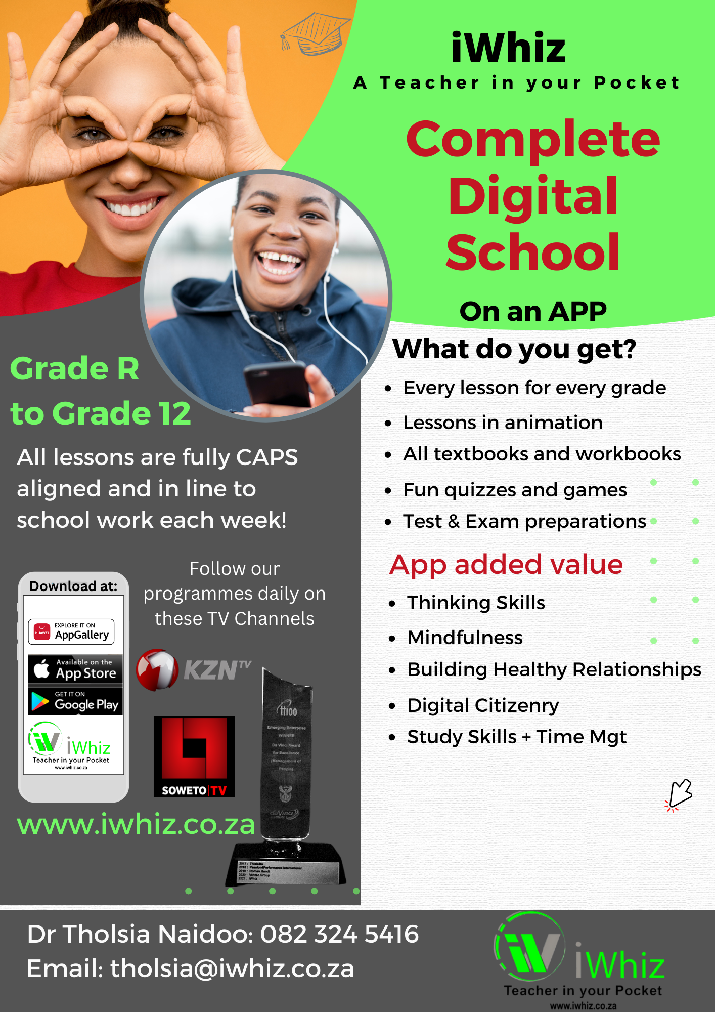
Term 1 Test
Marks: 50 Time: 1 Hour
Instructions:
- Answer all the questions.

- Read each question carefully before answering it.

- Pay attention to the mark allocations.

- Plan your time carefully.

- Write your answers in the spaces provided.

- In the multiple-choice question section, you must circle the correct answer.

- Write neatly and legibly.

Section A:
Question 1: Multiple Choice Questions (15 marks)
Choose the correct answer and write only the letter (A, B, C, or D) next to the corresponding question number.
- Which of the following is a renewable source of energy?
A. Coal
B. Natural gas
C. Solar energy
D. Nuclear energy

- What is the primary function of the roots in a plant?
A. To produce flowers
B. To anchor the plant and absorb water and nutrients
C. To attract pollinations
D. To produce seeds

- Which of the following is a non-renewable resource?
A. Wind
B. Sunlight
C. Coal
D. Water

- What is the process by which plants make their own food using sunlight?
A. Respiration
B. Photosynthesis
C. Transpiration
D. Germination

- Which of the following is a characteristic of living organisms?
A. Ability to move
B. Ability to reproduce
C. Ability to grow
D. All the above

- Which layer of the Earth is composed mainly of solid iron and nickel?
A. Crust
B. Mantle
C. Outer core
D. Inner core

- What causes the four seasons on Earth?
A. Earth’s distance from the sun
B. Earth's rotation on its axis
C. Earth's tilt on its axis
D. Earth's revolution around the sun

- Which of the following is greenhouse gas?
A. Oxygen
B. Carbon dioxide
C. Nitrogen
D. Argon

- What is the main source of energy for the Earth’s weather system?
A. The Moon
B. The Sun
C. The Earth’s core
D. The oceans

- Which of the following is a characteristic of a solid?
A. Definite shape and volume
B. Indefinite shape and definite volume
C. Indefinite shape and volume
D. Definite shape and indefinite volume

- Which of the following is a method of heat transfer?
A. Conduction
B. Convection
C. Radiation
D. All the above
- Which of the following is a non-living component of an ecosystem?
A. Animals
B. Plants
C. Soil
D. Bacteria

- What is the term for the movement of water from the Earth’s surface to the atmosphere and back?
A. Precipitation
B. Evaporation
C. Water cycle
D. Condensation

- Which of the following is a renewable resource?
A. Coal
B. Wind
C. Natural gas
D. Oil

- Which of the following is a characteristic of grass?
A. Definite shape and volume
B. Indefinite shape and volume
C. Definite shape and indefinite volume
D. Indefinite shape and definite volume

Section B:
Question 2: Matching (15 marks)
Match the terms in Column A with the correct descriptions in Column B. Write only the letter (A–O) in the middle block.
Column A | Answer | Column B | Marks
- Sojourner |  | - Revolution | 1
- Telescope |  | - Crater | 1
- Unmanned |  | - Telescope | 1
- Space Rover |  | - Moon | 1
- Curiosity |  | - Axis | 1
- The movement of one body around another in space |  | - The new robotic rover for NASA | 1
- A rocky body that travels around a planet |  | - An object intentionally placed into orbit in outer space | 1
- The line that passes through the Centre of an object |  | - Is used to look into space and gather information | 1
- A large circular hole with a rim around it |  | - Is used to collect rock and soil samples and take photographs of the surface of the Moon and Mars | 1
- An instrument that magnifies distant objects |  | - The first robotic rover to land on another planet | 1
- Photosynthesis |  | - Process by which plants make food using sunlight | 1
- Food additives |  | - Process in which plants make their own food using light energy from the sun. | 1
- Balanced diet |  | - Process by which plants make food using sunlight | 1
- Food Processing |  | - Substance added to food to preserve its flavour or improve its taste and appearance. | 1
- Food Webs |  | - A way in which raw foods are changed into final food products. | 1
Section C:
Question 3: Short Answer Questions (20 marks)
Answer the following questions in complete sentences.

- Define energy and explain its importance in daily life. (4 marks)
__________________________________________________________________________________________________________________________________________________________________________________________________________________________________________________________________________________________________________________________________________________________________________________________________________________________________________________________________________________________________________________________________________________________________

- Describe the three states of matter and provide an example of each. (6 marks)
__________________________________________________________________________________________________________________________________________________________________________________________________________________________________________________________________________________________________________________________________________________________________________________________________________________________________________________________________________________________________________________________________________________________________

- Explain the role of decomposers in an ecosystem. (3 marks)
________________________________________________________________________________________________________________________________________________________________________________________________________________________________________________________________________________________________________________________________________________________________________________________________________________________________________________________________________________________________________________________________________________________________________________________________________________________________________________
- What causes the four seasons on Earth? (3 marks)
__________________________________________________________________________________________________________________________________________________________________________________________________________________________________________________________________________________________________________________________________________________________________________________________________________________________________________________________________________________________________________________________________________________________________

- Describe the water cycle and its significance to life on Earth. (4 marks)
________________________________________________________________________________________________________________________________________________________________________________________________________________________________________________________________________________________________________________________________________________________________________________________________________________________________________________________________________________________________________________________________________________________________________________________________________________________________________________

Total marks: 50

