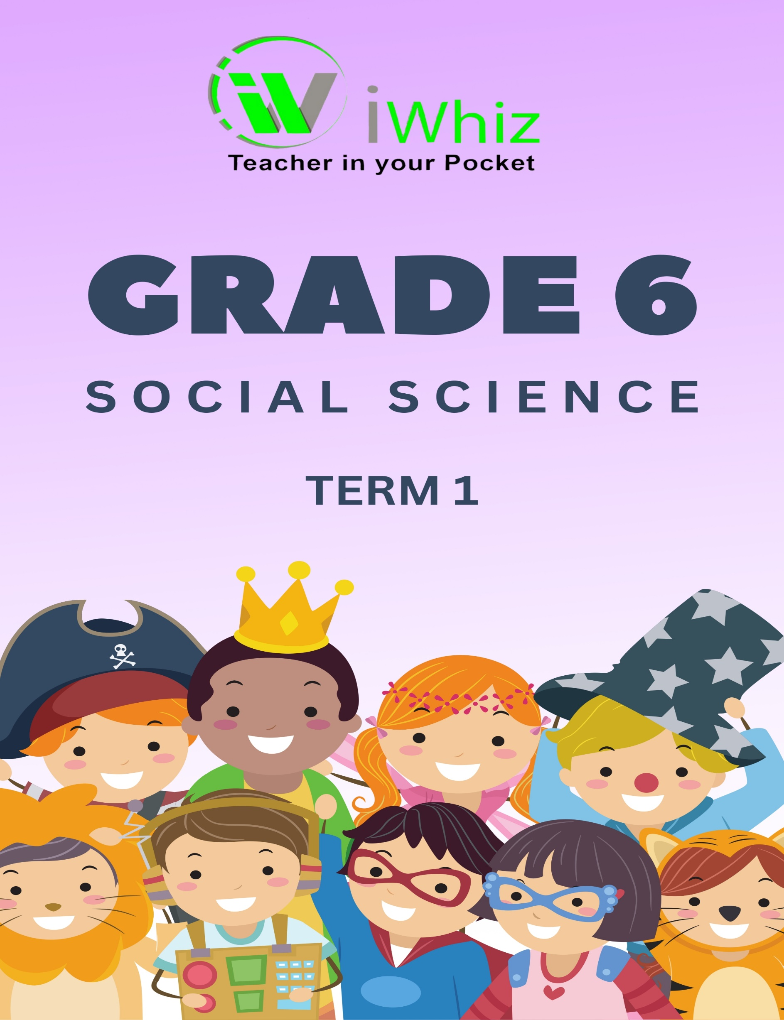
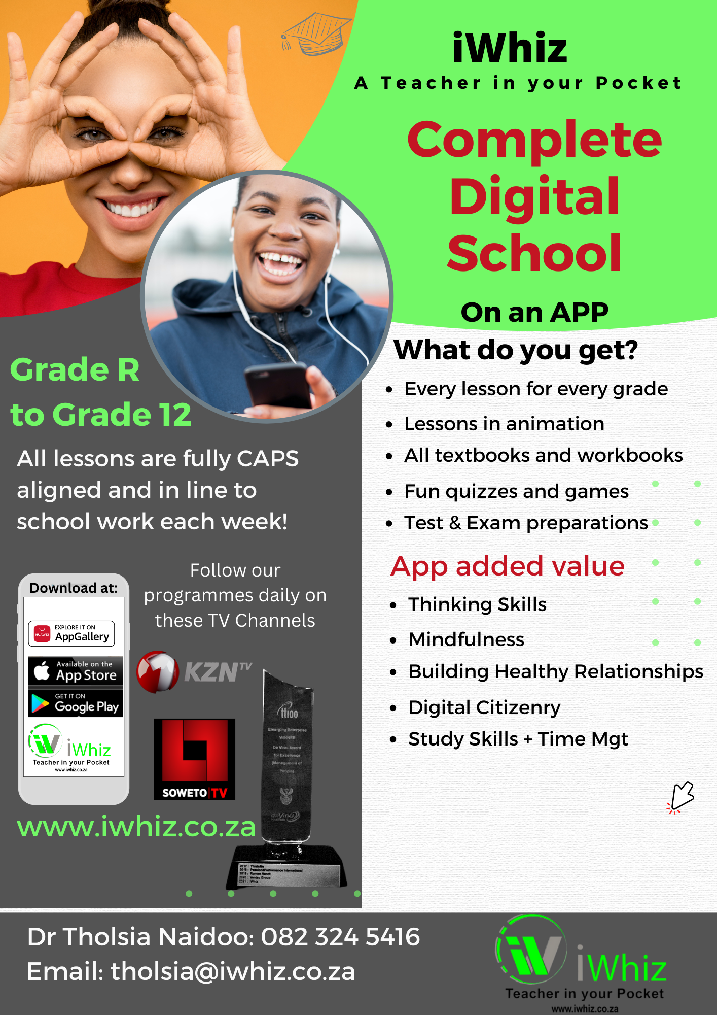
Term 1 Test
Time: 1 hour Marks: 55
Instructions:
- Answer all questions in blue or black ink.

- Read each question carefully before answering it.

- Pay attention to the mark allocations.

- Use the mark allocations as a guide to the length of your answers.

- This question paper has three sections, answer all.

- Plan your time carefully.

- Write your answers in the spaces provided.

- Write neatly and legibly.

Section A:
Question 1: Multiple Choice Questions (20 marks)
- Choose the correct answer from the options provided.
- Each question is worth 1 mark.
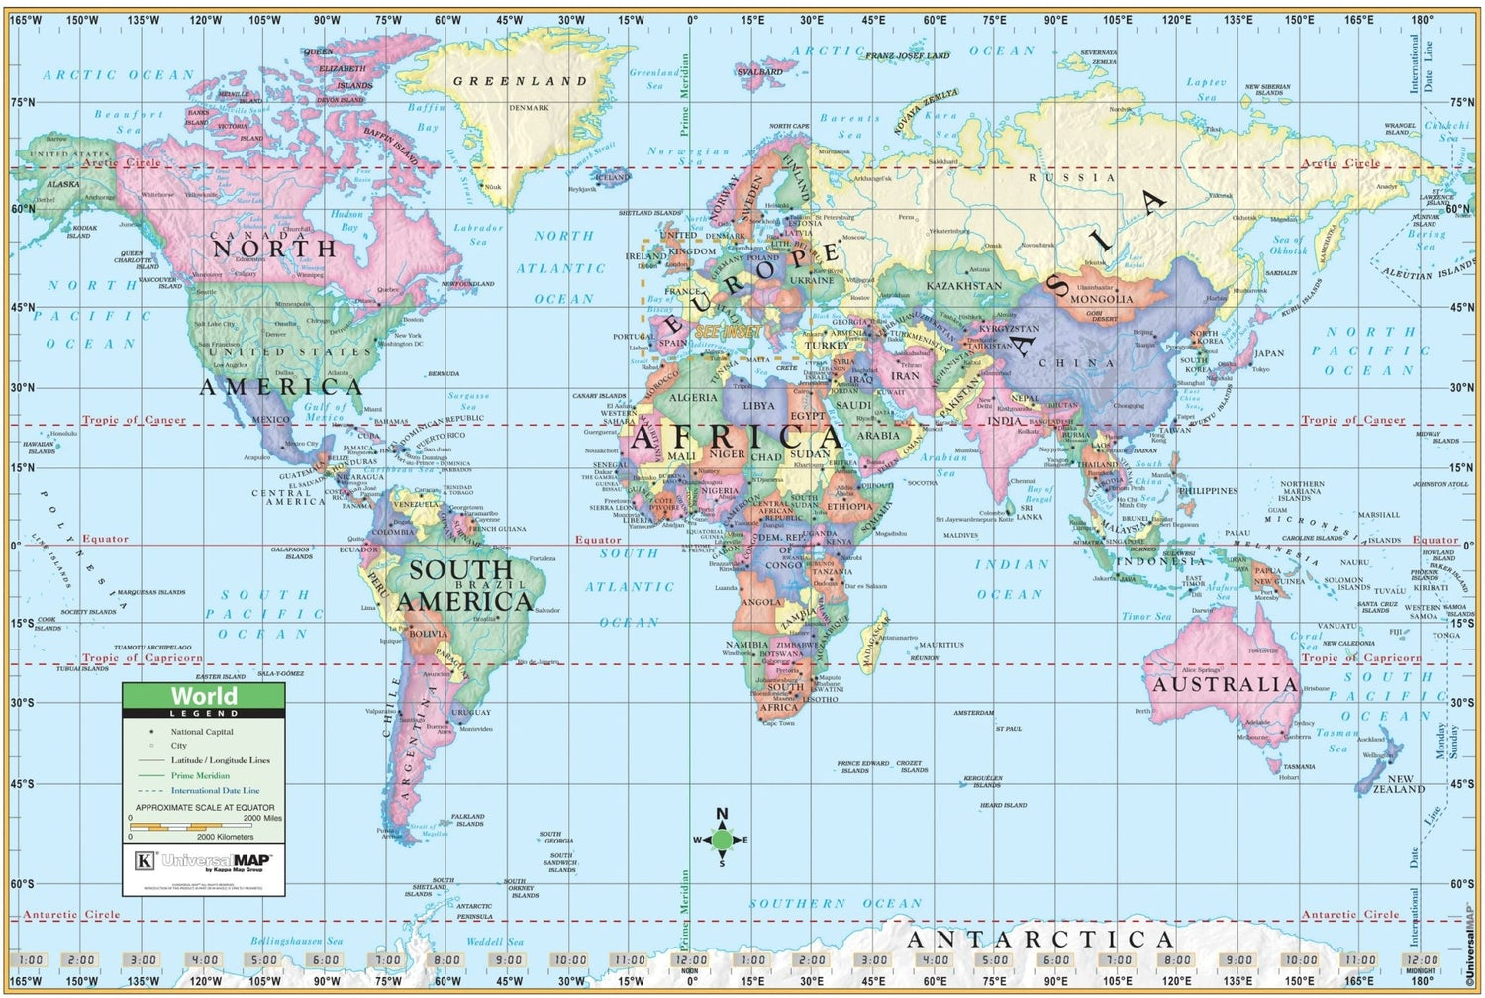
- Circle the correct letter (A, B, C, or D).

- Name the two hemispheres in which each island is found.
- Madagascar: ____________. (2)
- Iceland: ____________. (2)
- Cuba: ___________. (2)
- New Zealand: ___________. (2)

- Give the name of the line of latitude or longitude at each degree:
- 0° latitude: ________________________________________ (1)
- 90° N latitude: _____________________________________ (1)
- 90°S latitude: ______________________________________ (1)
- 0° longitude: _______________________________________ (1)

- Give the latitude and longitude of each city:
- Addis Ababa: ____________________________________________ (2)
- Sydney: _________________________________________________ (2)

- Locate and name the cities at these latitudes and longitudes:
- 23°N 88°E latitude: ________________________________________ (2)
- 40°N 116°E latitude: ________________________________________ (2)

Section B: Matching (15 marks)
Question 2
Match the items in Column A with the correct description in Column B.
Write the letter of the correct answer next to the number.
Column A | Answer | Column B
- The world’s three largest cities (2013) |  | - Mozambique, Eswatini, Lesotho
- The world’s three biggest forests |  | - Two hemispheres
- The world’s three largest oceans |  | - The Nile River
- The world’s three longest rivers |  | - Hemisphere
- Three countries that border KwaZulu-Natal |  | - The north pole
- Three provinces that border KwaZulu-Natal |  | - iSimangaliso Wetland Park, Hluhluwe-iMfolozi Park, uKhahlamba-Drakensberg Park
- Where is the land below 500m found? |  | - Australia
- Three nature reserves in KwaZulu-Natal |  | - The south pole
- Another word to describe the shape of the Earth |  | - Russia, Brazil, Canada
- The northern hemisphere is between the equator and… |  | - Mount Everest
- The southern hemisphere is between the equator and the… |  | - Coastal Plain,
- Every place is in how many hemispheres? |  | - Tokyo, Jakarta, Chóngqing
- Which mountain is the highest peak on Earth? |  | - Gauteng, Mpumalanga, Eastern Cape
- Which continent is known as the "Land Down Under"? |  | - Pacific, Atlantic, Indian
- What is the longest river in the world? |  | - Nile, Amazon, Chang Jiang

Section C: Short Answer Questions (20 marks)
Question 3
Answer the following questions in complete sentences.
- Provide evidence to show the Mapungubwe has two different social classes: a rich and powerful ruling class and a class of ordinary people.? (5)

- What did the Kings of Mapungubwe use to show off their wealth and power? (5)

- Describe how Arab traders travelled from India to the east coast of Africa. (2)

- In What ways did the rulers of Great Zimbabwe further develop and expand the culture of Mapungubwe? (2)

- Which famous trade route did Marco Polo travel on during his journey to China in the 13th century? (2)

- During the time of the Kingdom of Mapungubwe (circa 13th century), Marco Polo traveled east for trade. Which major empire in the East did he visit, and what valuable goods were commonly traded along his route? (2)

- The high stone walls on Great Zimbabwe Hill were built after 1200 AD. What was the purpose of these walls, and what do they reveal about the society that built them? (2)

Total: 55 marks

