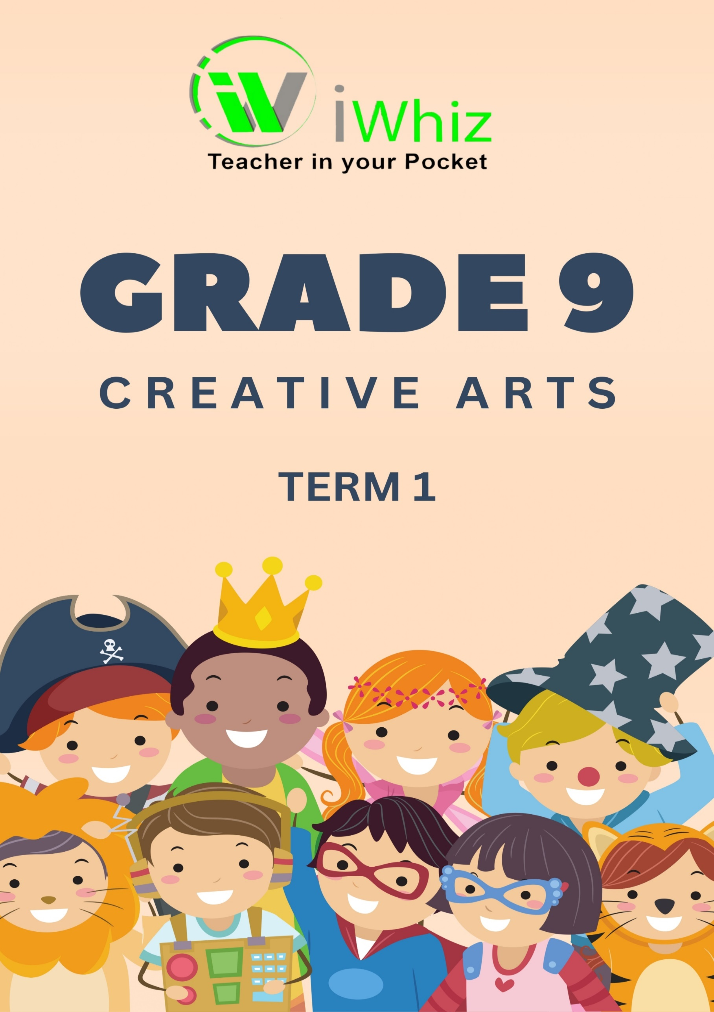

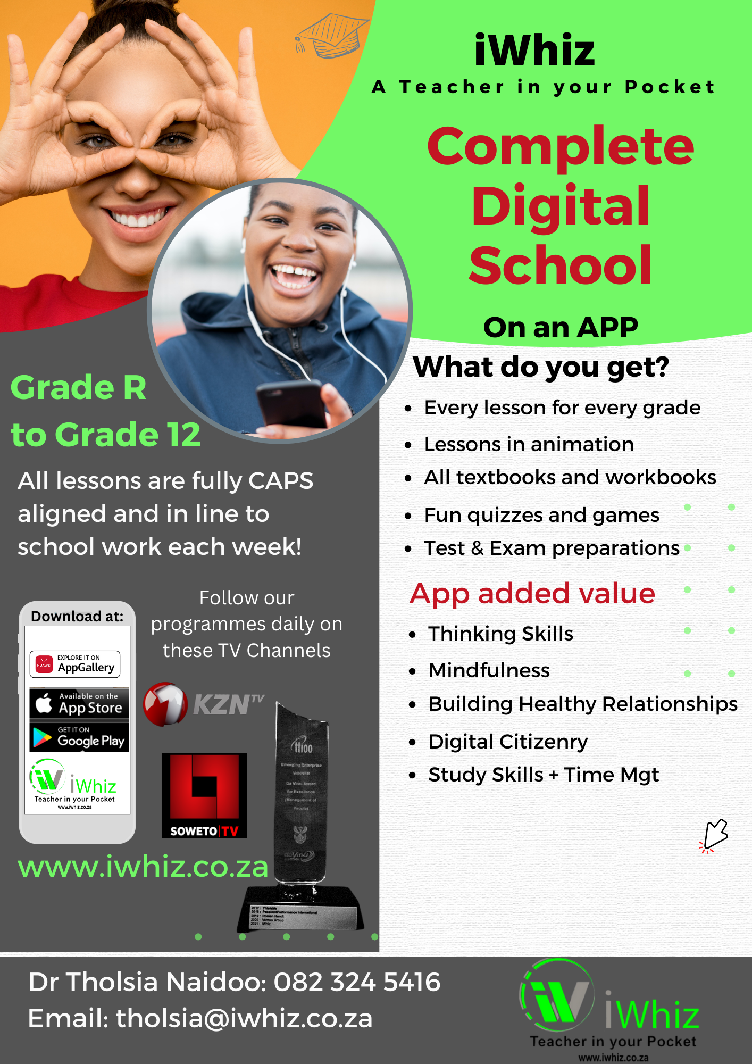

https://www.youtube.com/watch?v=SJ4_nONtYeY
WATCH FOR TESTIMONIALS

WATCH FOR TESTIMONIALS

GRADE 9 CREATIVE ARTS MARKS: 50
TIME: 1 HOUR
SECTION A: MULTIPLE CHOICE AND MATCHING COLUMNS
Question 1
- Which element of dance refers to the movements of the body, including steps, gestures, and jumps?
a) Space
b) Time
c) Energy
d) Action
- Which of the following is a characteristic of traditional African dance?
a) Slow and graceful movements
b) Isolation of one body part only
c) Strong rhythmic patterns and storytelling
d) Silent performances without drums
- Which of the following is NOT a basic dance principle?
a) Alignment
b) Balance
c) Flexibility
d) Melody
- In music, which element refers to the speed of a piece?
a) Tempo
b) Rhythm
c) Dynamics
d) Melody
- What is the name of the five-line staff used to notate music?
a) Bar line
b) Clef
c) Stave
d) Notehead
- Which musical term refers to the volume of a sound?
a) Tempo
b) Harmony
c) Dynamics
d) Pitch
- In drama, what is the term for the use of movement without words to express emotions and actions?
a) Mime
b) Improvisation
c) Projection
d) Dialogue
- What is a key feature of melodrama?
a) Realistic characters and subtle emotions
b) Exaggerated characters and dramatic music
c) No spoken dialogue
d) Long, silent performances

- The role of the director in a theatre production is to:
a) Design costumes
b) Manage lighting and sound
c) Guide actors and oversee the artistic vision
d) Write the script

- Which of the following is an example of a traditional South African musical instrument?
a) Violin
b) Marimba
c) Flute
d) Trumpet

(10)
Question 2
Match the terms in column A with the correct description in column B. Write only the letter of the correct answer next to the space provided.
Column A | Column B
- Choreography | - The speed of a musical piece
- Call and response | - Loudness or softness of sound
- Tempo | - A storytelling method in music and drama
- Timbre | - The art of designing dance movements
- Facial expression | - The tone or quality of a musical sound
- Stage directions | - Instructions for actor movement in a script
- Canon in dance | - A sequence where dancers perform one after another
- Pitch | - The highness or lowness of a sound
- Rhythm | - A pattern of sounds and silences in music
- Projection | - Speaking loudly and clearly on stage

- __________________________________________________________________________________
- __________________________________________________________________________________
- __________________________________________________________________________________
- __________________________________________________________________________________
- __________________________________________________________________________________
- __________________________________________________________________________________
- __________________________________________________________________________________
- __________________________________________________________________________________
- __________________________________________________________________________________
- __________________________________________________________________________________
(10)
TOTAL SECTION 1: 20 MARKS

SECTION C: STRUCTURED QUESTIONS (30 marks)
Answer the following questions in full sentences.
- Explain the role of body language in drama and give two examples of how it is used in performances. (5)

- Describe three characteristics of indigenous South African music and name one traditional instrument used in this music style. (5)

- Identify and explain three types of energy in dance, with examples of movements for each. (5)

- What is the difference between rhythm and tempo in music? Provide an example for each concept. (5)

- Discuss two reasons why teamwork is important in a dance performance. (5)

- Why is voice projection important in theatre, and what techniques can actors use to improve it? (5)

TOTAL SECTION B: 30 MARKS

